

**Timetables**

Create a timetable for a typical weekday before lockdown and a typical weekday during lockdown. Use the grids below or create you own.

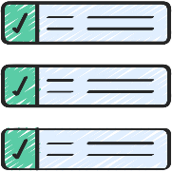

Compare the two timetables, using the following to help:

* What time do you get up? Is it the same/different on each timetable?
* Is your morning routine the same?
* How much time do you spend doing schoolwork on each timetable?
* What time do you go to bed? Do you get more or less sleep on the lockdown timetable?
* Which timetable has the most routine?
* Which timetable would you prefer as your typical weekday?

During lockdown

Before lockdown

|  |  |  |  |  |  |  |  |  |  |  |  |
| --- | --- | --- | --- | --- | --- | --- | --- | --- | --- | --- | --- |
| Time |  |  |  |  |  |  |  |  |  |  |  |
| Activity |  |  |  |  |  |  |  |  |  |  |  |

|  |  |  |  |  |  |  |  |  |  |  |  |
| --- | --- | --- | --- | --- | --- | --- | --- | --- | --- | --- | --- |
| Time |  |  |  |  |  |  |  |  |  |  |  |
| Activity |  |  |  |  |  |  |  |  |  |  |  |