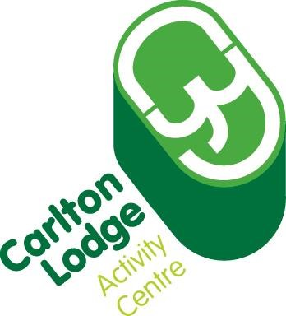

**Clothing and Kit**

**Requirements**

**To ensure the comfort and safe**

**ty of your child during activity sessions we recommend that they bring**

**the following kit:**

**Waterproof Coat**

**Waterproof Trousers**

**Warm Jumpers/Fleeces**

**Old Jogging Bottoms for Water sports**

**Jogging Bottoms (for dry activities)**

**Shorts**

**T**

**shirt**

**Spare socks and underwear**

**Sun Hat**

**Swimwear for water sports**

**1**

**old towel for after water sports**

**1**

**old pair of trainers for water sports**

**1**

**pair of trainers for dry activities**

**Wellies**

**Sun c**

**ream**

**Black bin liner labelled with name for wet clothes**

**Jeans are not recommended for activities**

**due to poor thermal properties.**

**Please make sure all clothing is clearly named.**

**All specialist equipment will be provided by the centre**