Free new resources for North Yorkshire residents
Ourplace is the gateway into online courses for all parents, grandparents or carers who live in North Yorkshire. The courses aim to support the most difficult job in the world!
The first course is an antenatal course developed by Registered Midwives and health professionals and called ‘Understanding pregnancy, labour, birth and your baby‘ and does what it says in the title! Information about giving birth plus learning about the baby’s brain and how to optimise your relationship with the baby.
The second is a postnatal course ‘Understanding your baby‘. It was developed by health visitors and clinical psychologists, and other health professionals and is for parents of babies from 0 to 12 months.
The third is our main course for parents of children aged between 6 months and 19 years: ‘Understanding your child‘. This was also developed by child psychologists and specialist health and education professionals.
There is also a short course: ‘Understanding your teenager’s brain’ which can explain some of the changes in teenagers’ behaviour by understanding what is happening in their brain.
The courses are delivered in modules and can be worked through at your own pace and can be accessed on laptops, mobile phones, tablets etc by logging on to:
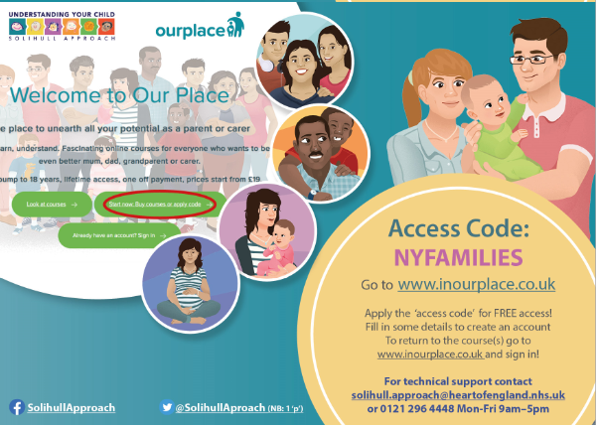
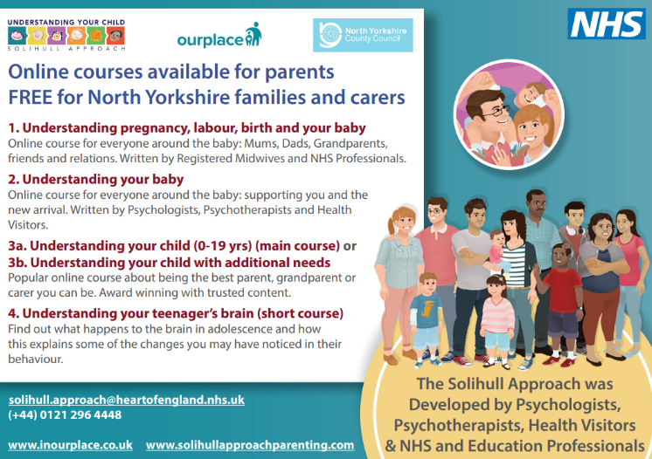
www.inourplace.co.uk and entering the access code: NYFAMILIES

