Crayke C of E Primary Needs You!
Could you help to sponsor a class to receive TWO brand new books?

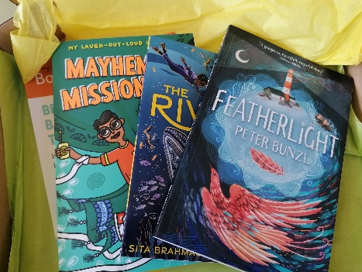
- One book box costs JUST £16.50!
- Each box will usually contain two books and is sent directly to the class for them to excitedly open up.
- Books will be new releases.
- Often, books are signed by the author.
- There is a new box sent out each half term – that’s 6 boxes per class, per year.
- Books will be posted to arrive at the end of JULY, SEPTEMBER, NOVEMBER, JANUARY, MARCH, MAY.
- They will gradually build up a collection of high-quality fiction, non-fiction and poetry from a range of authors, for children to develop their love of reading and explore something new. You could help to leave a legacy in your chosen class!
- Postage is INCLUDED in the price!

To donate a box:
Please go to the appropriate link below. Only one box required each half term.
Please note that if you click on more than one link it may automatically add a different class box to your basket, so please check before you purchase.

The deadline for getting a box sent to us this half term, is ordering by Tuesday 25th May.

To buy the Class 1 box (Reception) :
https://www.paypal.com/cgi-bin/webscr?cmd=_s-xclick&hosted_button_id=QGW36FLNEZR7W

Class 2 (Year 1 and 2) box:
https://www.paypal.com/cgi-bin/webscr?cmd=_s-xclick&hosted_button_id=2MEFZU9LTTPYA

Class 3 (Year 3 and 4) box:
https://www.paypal.com/cgi-bin/webscr?cmd=_s-xclick&hosted_button_id=F4VMRAVUY7F4U

Class 4 (Year 5 and 6) box:
https://www.paypal.com/cgi-bin/webscr?cmd=_s-xclick&hosted_button_id=CMHGGNSDBLGZ6
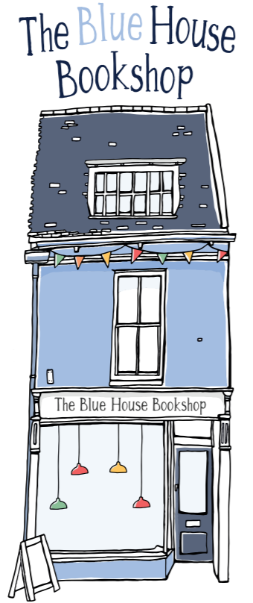

There are SO many more books that we desperately need for our children across the school. Please consider purchasing from our local Blue House Bookshop wish list, which also helps us to earn more money back to spend on EVEN MORE books for our school!
https://thebluehousebookshop.co.uk/shop-here/ols/categories/crayke-c-of-e-primary-school-wish-list?page=1

