
Crayke C of E Primary School

FOLLOW YOUR PATHWAY AND WE GROW TOGETHER WITH CONFIDENCE
Respect Friendship Forgiveness Determination

Dear Parents and Carers,

It’s beginning to look a lot like Christmas!
We were thrilled this week to receive a Christmas tree from Dawnay Farm Christmas Trees (details below), collected by our very own Christmas Elf Mrs Pegram.



We are sure you will agree that the tree looks super. It was wonderful to be able to come together as a whole school to continue the Crayke tradition of each child adding their own individual decoration to the tree whilst we sung carols together. A lovely way to get into the festive spirit!

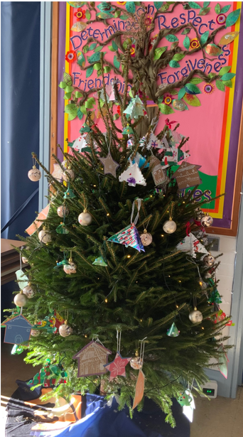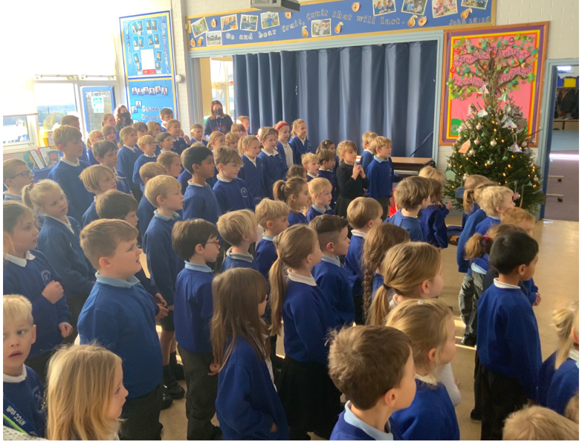

Extra layers - Reminder
As the colder weather continues, please do remember that children are welcome to add extra layers including long sleeved tops underneath their school polo shirts.
We continue to need to keep the building well-ventilated which does mean that the rooms aren’t as warm as they usually are.

Flu vaccinations
Last week the annual flu vaccinations took place in school for those children who were present and where consent had been given. Should your child have been absent on Tuesday and/or you now wish for them to have the vaccination, please contact 01423 553115 to make an appointment or attend a drop-in clinic. The vaccination team advised that the nearest and soonest appointments will be held at Thirsk Town Hall on Saturday 11 December between 9am and 3pm.

Covid Symptoms
Thank you for your continued cooperation in ensuring that if your child is displaying Covid symptoms they stay off school and obtain a PCR test. If someone in your household tests positive please let us know immediately. Guidance is that all close contacts in your household (adults and children) should have a PCR test if anyone gets symptoms. Due to the current increase in cases and us wanting to be highly vigilant in keeping everyone as safe as possible, we are currently being advised that children should self-isolate until results are received (usually within 24 hours).

A reminder that the main symptoms of COVID-19 remain:
- a fever (temperature 37.8 ̊C or higher)
- a new continuous cough
- or a change to/loss of taste or smell.

However, other commonly reported symptoms of the Delta variant include headache, sore throat, tiredness, and cold-like symptoms, so please be aware of these as well and stay at home and seek testing if you are in any doubt.

Nativity Performances – Apple and Beech Classes

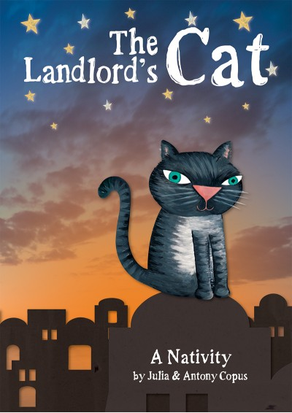
We continue to hope that we may be able to host nativity performances of “The Landlord’s Cat” in school with a live audience. As stated last week, our aim is to put on two performances on Wednesday 15 December at 9:30am and 2:15pm. It is highly likely that there will be a number of restrictions in place in order to ensure everyone’s safety at these events. This will include a limit on tickets, a request to wear face coverings (unless exempt) and to take a Lateral Flow Test within 24 hours of the show. You will also be advised to wear your warmest (Christmas?!) jumpers as we will need to keep doors open to ensure adequate ventilation throughout the building.
We are hopeful that we can also provide a recorded version of the performance which will be available to view online for family members who are unable to attend the show in person.
Further details will follow next week.

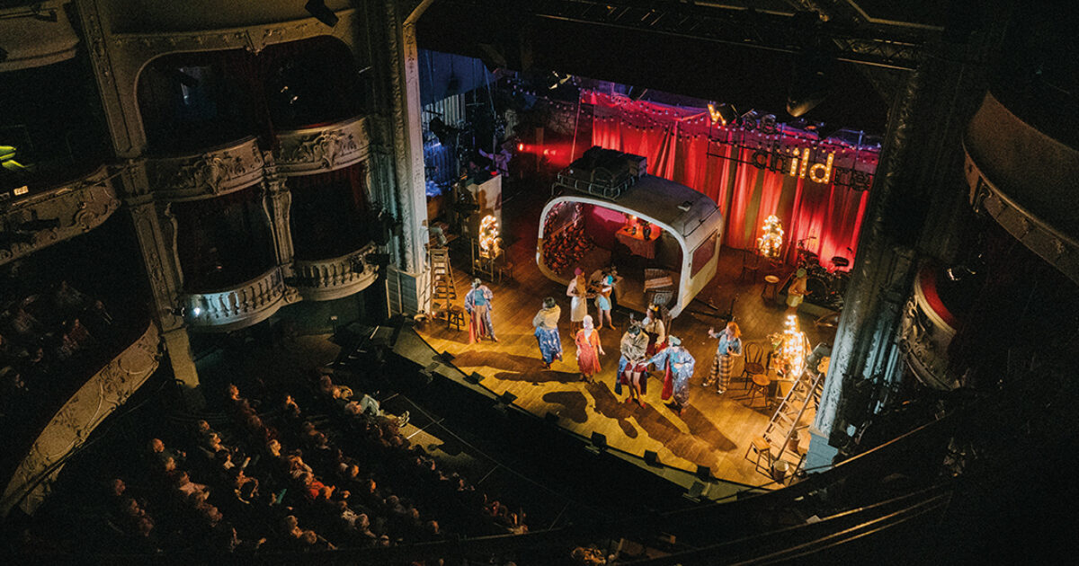
York Theatre Royal – Pantomime
Friday 10 December
All parents and carers should have received a webpost with details about next week’s pantomime visit yesterday. The online consent form which requires completion before the end of the school day on Wednesday 8 December is available here:
https://forms.office.com/r/kkKq83aumG
As I am sure you can appreciate, it is an incredibly busy time for Mrs Bacon in the office at the moment, so if you can complete this short consent form without the need for her having to chase you, I would be enormously grateful.
OAK CLASS will be having a PE lesson before we depart. Please can they come to school wearing their uniform and bring their PE kit with them.
Thank you.

After School Clubs
Please note that there will be NO homework club for Year 5/6 next week and sessions will resume next term.

We are in the process of finalising our club offer for the Spring Term and will provide further details in due course.

Staffing – Spring Term 2022
Please see below the staffing structure for the Spring Term.

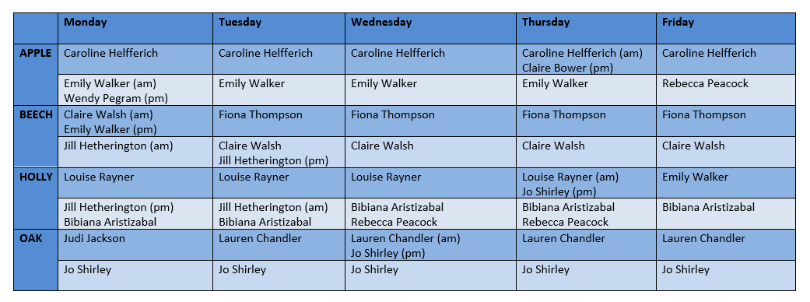

 Stars of the Week
Stars | Class 1 | Class 2 | Class 3 | Class 4
Stars | Fenton Ward | Dexter Bird | Percy Ollive | Will Gilleard
Stars | Fenton Ward | Scarlett Woodhouse | Alice Unsworth | Emma Swiers

Team Points

- Red  | 633 | Yellow | 2815
Blue | 561 | Green | 470

Attendance and Punctuality
Children will be marked late if they arrive after 9.00am
*Any Covid-related absences are not included in our attendance figures
Please do help us in our mission to ensure that children are in school on time so that valuable learning time is not missed at the start of the day.

This week’s attendance figures: 93.5% School Target: 96%

Apple (CH): 95.7% 6 lates (4 children) | Beech (FT): 97.3% 2 lates (1 child)
Holly (LR): 91% 4 lates (4 children) | Oak (LC): 90.7% 0 lates

PE Kits

PE Kits  w/c 6 Dec | Tuesday | Wednesday | Thursday | Friday
APPLE (CH) |  |  | X
BEECH (FT) |  | X
HOLLY (LR) |  | X
OAK (LC) | X |  |  | X – PLEASE WEAR SCHOOL UNIFORM AND BRING PE KIT
Please do ensure that on PE days, the children wear their hoodies, school jumpers or cardigans alongside white or blue t-shirts and black or navy shorts or jogging bottoms.
Children in Apple Class bring their kits to school on a Monday; take them home each Friday.

Upcoming Events – Christmas

 INFORMATION REGARDING CHRISTMAS @ CRAYKE 2021 
Here are some important dates for your diaries as we approach the end of term. Please note that events may be subject to change or cancellation at any time, including at very short notice, if Covid cases continue to rise. We are grateful for your co-operation.

Date | Event
Friday 3 December | CHASA Christmas Disco – Sports Hall (4:30pm – 6:30pm)
Monday 6 December | Christmas cards can be brought in from today*
Friday 10 December | Whole School visit to York Theatre Royal - Pantomime
Monday 13 December | Deadline for Christmas cards to be brought into school*
Monday 13 December | Nativity Dress Rehearsal
Tuesday 14 December | Christmas Lunch
Tuesday 14 December | Christmas Party afternoon –  Children in Apple, Beech and Holly classes wear party outfit all day; Oak class bring an outfit to change into on return to school after swimming
Wednesday 15 December | Nativity Performance 1 – 9:30am  Nativity Performance – 2:15pm
Thursday 16 December | Distribution of Christmas cards
Friday 17 December | Christmas Jumper Day – children are welcome to wear non-uniform and Christmas jumpers.  End of term -2:30pm
*Please ensure that Christmas cards are clearly labelled with first name, surname and class to ensure safe delivery to the correct recipient!

Online Advent Calendar
As the festive season approaches, your family may be interested in using this resource which has been shared by the Diocese of York https://advent-calendar.online/york/
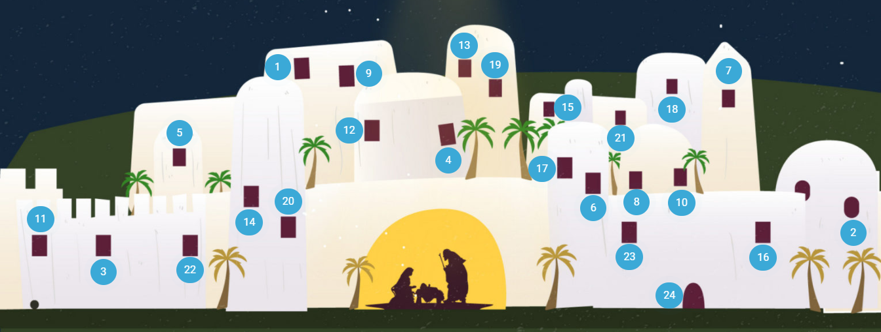

 Spotlight on… Music

Yesterday the children were treated to a wonderful demonstration of a wide variety of musical instruments and joined in with some lovely Christmas singing.

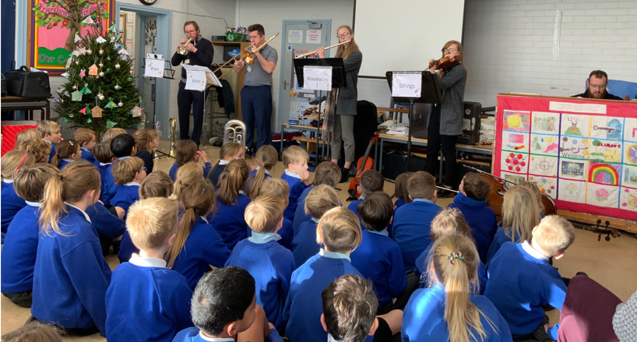

The Instrumental Team from North Yorkshire County Music Service are keen to be able come into school to teach music lessons, should you be interested in this opportunity for your child.
There are many instruments available and there is the option of either individual or group lessons.

Further details about the music service are available on the leaflet and letter (attached on the following page) or via their website: www.northyorkshiremusichub.co.uk

We have a small number of leaflets and letters available in hard copy format in the office. Should you wish to receive one, please contact Mrs Bacon on admin@


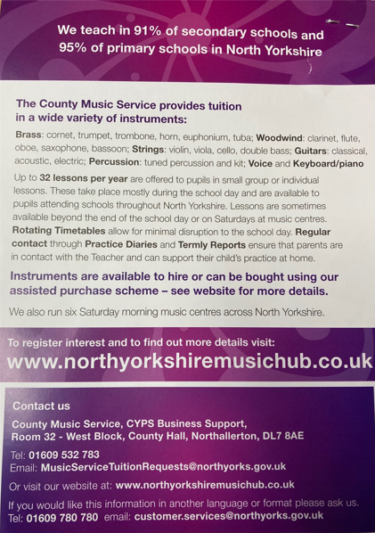

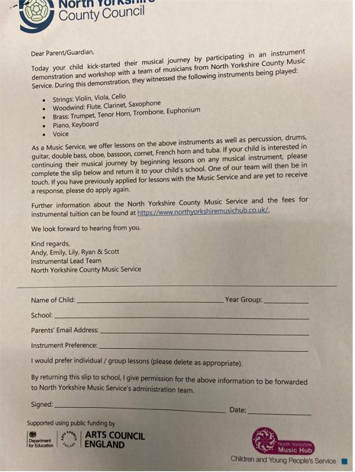

Extra-Curricular Clubs – Autumn Term 2021
We are delighted to be able to offer a wide range of clubs for our children. After school activities for children in Apple Class will commence after Christmas to enable them to settle into school this term.
Some clubs have limited capacity and places will be allocated on a first come first served basis. In the event of a club being fully booked, your child’s name will be added to a waiting list and you will be advised if a place becomes available. Booking is not required for lunchtime clubs. For after school clubs run by school staff (denoted with *) please email Mrs Bacon on admin@crayke.n-yorks.sch.uk to book a place.
Lunchtime Clubs
Club | Leader | Day | Group
Philosophy | Miss Walker | Tuesday | Year 5/6
Skipping | Mrs Helfferich | Wednesday | All
Reading Ambassadors | Mrs Rayner | Thursday | Successful candidates
School Council | Miss Thompson | Friday | Successful candidates
Unique Sports | Mr Montgomery | Friday | All

After School Clubs
We respectfully ask you to collect your children promptly at the end of clubs and to check the collection time below carefully. Thank you.
Monday | STEM (fee paid direct to provider)  3:30pm – 4:30pm  Years 3 – 6  Discovery-ICE  LAST SESSION: 13 DECEMBER
Tuesday |  | Multi-sports (Fee paid direct)  3:30 – 4:30pm  Year 1-6  Mr Cromack  LAST SESSION: 7 DECEMBER
Wednesday |  | Spanish* (no charge)  3:30pm – 4:15pm  Year 4 - 6  Mrs Aristizabal  LAST SESSION: 8 DECEMBER
Thursday | Forest Schools* (no charge)  3:30pm – 4:15pm  Year 3/4  Mrs Helfferich  LAST SESSION: 9 DECEMBER |  | Football (fee paid direct)  3:30pm – 4:30pm  Years 1 – 3  York City Football Club  LAST SESSION: 9 DECEMBER
Friday | Unique Sports (fee paid direct to provider)  3:30 – 4:30pm  Years 1-6  Simon Carson Sports School  LAST SESSION: 3 DECEMBER |  | GOAL (fee paid direct to provider)  3:30 – 4:30pm  Years 1-6  Simon Carson Sports School  LAST SESSION: 3 DECEMBER
**PLEASE NOTE: Clubs will run unless you are notified otherwise**
School Lunch Menu

AUTUMN TERM  2021 | Week 1  w/c 6 Dec | Week 2  w/c 13 Dec
Monday | Beef burger in a bun  Chipped potatoes  Peas and carrots  Sticky date and apple bars with custard  Fresh fruit or yogurt | Connie’s Chicken Quesadilla and rice  Sweetcorn & green beans  Sliced wholemeal bread  Sultana and oat cookie  Fresh fruit or yogurt
Tuesday | Minced beef cottage pie  Green beans & sweetcorn  Crusty bread  Cheese and crackers  Fresh fruit or yogurt | CHRISTMAS LUNCH!  
Wednesday | Roast chicken  Sage & onion stuffing & gravy  Roast potatoes  Medley of vegetables  50/50 bread  Fruit muffin  Fresh fruit or yogurt | Sausage toad in the hole with onion gravy  Creamy mashed potato  Broccoli and swede  Herbie bread  Fruit mousse  Fresh fruit or yogurt
Thursday | Mexican tortilla boats  Savoury rice  Carrots and broccoli  Pitta bread  Fresh fruit or yogurt | Cheese and tomato pizza  Diced potatoes  Crunchy veg sticks  Apple & berry crumble & custard  Fresh fruit or yogurt
Friday | Fish and sweet potato cake  Jacket potato  Baked beans and peas  HM wholemeal bread  Chocolate banana sponge and chocolate sauce  Fresh fruit or yogurt | Fish fingers  Tomato ketchup  Chipped potatoes  Carrots and peas  Pumpkin seed bread  Fruit shortcake  Fresh fruit or yogurt

CHASA News


CHASA School Disco Friday 3rd December - Crayke Sports Hall

CHASA School Disco at Crayke Sports Hall - Friday 3rd December 4.30pm to 6.30pm

Wristband tickets are on sale NOW for the school disco – your Year Rep will have these:

Reception – Hannah Davies
Year 1 – Katie Liddell / Louise Beeson
Year 2 – Victoria Cain
Year 3 – Becky Stubbins
Year 4 – Helen Champion
Year 5 – Sarah Sayner
Year 6 – Stacey Short

£3 per ticket which includes unlimited squash.
Children will need their school water bottle for squash/water which can be topped up whenever they want!
Crisps, sweets, face painting, glow sticks and more will be available at the disco so please remember to bring pocket money.

Children need to have their name, a parent’s mobile number and any allergy/intolerance information written on their wrist band before they arrive.
The bar will be open and mulled wine and mince pies will be available for parents who would like to stay.

We hope to see you there!
Kind Regards
CHASA

Advent Crayke Family Service December 5th


Please come & join us on Sunday December 5th at 10.30am, with refreshments from 10.15. We would love to see you!
If you haven’t been before, this is an informal lay-led worship for all ages (and we mean all ages!) with singing, readings, prayer & an activity and lasts about 30 mins.
If you have any queries, do contact Fiona, our Churchwarden on 01347 823131.
(Please note there will not be a Family Service in January; next one Feb 6th 2022)

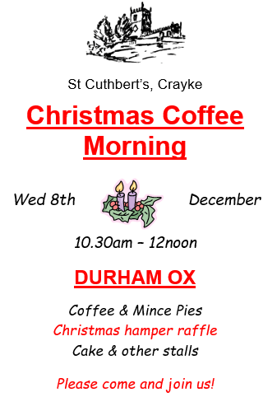

Crayke Carol Service Tuesday Dec 21st 6pm

Do join us for plenty of joyful worship and singing of carols – it will be so good to celebrate together after such a challenging year.
There will be mulled wine & mince pies afterwards & time for fellowship.
We look forward to welcoming you!

Community News

Something exciting is coming to North Yorkshire Libraries this Christmas! We’re challenging children aged 4-11 to read four library books between 20th November and Christmas to win stickers, prizes, a certificate, and a special Christmas gift…. And we haven’t forgotten the little ones, Buzzy Bee has something exciting for them too! Think you can take on the challenge? Pop into your local library, give us a call, or follow us on Facebook for more information.

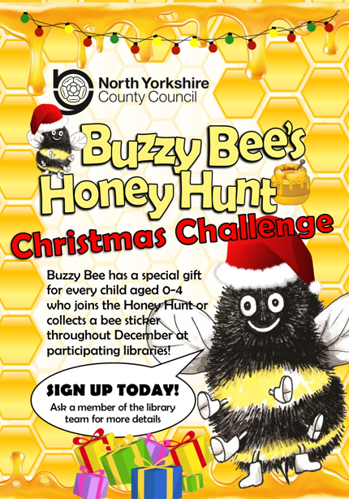

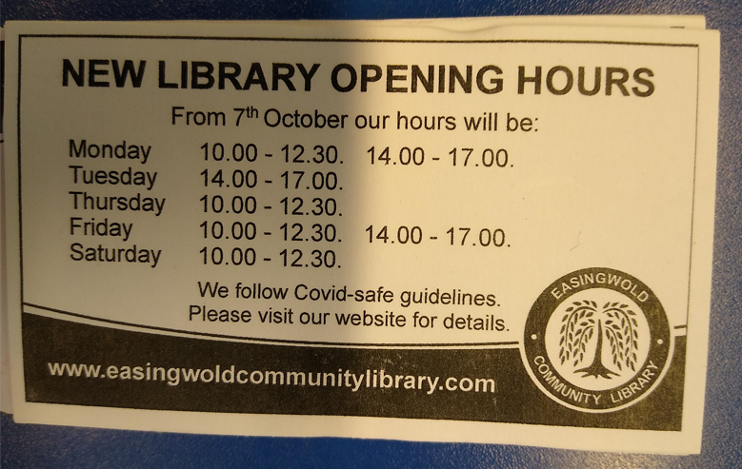

Diary Dates – Autumn Term 2021

Date | Time | Event | Audience
Fri 3 December | 4:30-6:30pm | CHASA Christmas Disco | All welcome
Fri 10 December | Afternoon | Pantomime visit – York Theatre Royal | Whole School
Wed 15 December | 9:30am & 2:15pm | Nativity Performances | Apple & Beech Classes (R/1/2)
Fri 17 December | 2:30pm | School closes | Whole school

Term Dates – Academic Year 2021/2022

Monday 20 December – Monday 3 January 2022 | School Closed – Christmas Holiday
Tuesday 4 January 2022 | School closed to pupils – Training Day
Wednesday 5 January 2022 | School Reopens
Monday 21 February–Friday 25 February 2022 | School Closed – HALF TERM
Monday 28 February 2022 | School Reopens
Monday 11 April – Friday 22 April 2022 | School Closed – Easter Holiday
Monday 25 April 2022 | School closed to pupils – Training Day
Tuesday 26 April 2022 | School Reopens
Monday 2 May 2022 | School closed – May Day Bank Holiday
Monday 30 May – Friday 3 June 2022 | School Closed – HALF TERM
Monday 6 June 2022 | School Reopens
Friday 22 July 2022 | Last day of term for pupils
Monday 25 July 2022 | School closed to pupils – Training Day

Safeguarding concerns
A reminder that if you have any concerns about a child, please do not hesitate to get in contact by emailing headteacher@crayke.n-yorks.sch.uk
Please also be aware that as a school we subscribe to Operation Encompass, whereby we are notified of any incidences of domestic violence where a pupil at our school has been present.

Financial Assistance Free School Meals
If you are encountering financial difficulties at this time and would like a strictly confidential conversation about support that can be provided, please do not hesitate to get in touch.

Judi Jackson
Headteacher
headteacher@crayke.n-yorks.sch.uk

