
Crayke C of E Primary School

FOLLOW YOUR PATHWAY AND WE GROW TOGETHER WITH CONFIDENCE
Respect Friendship Forgiveness Determination

Dear Parents and Carers,

An early newsletter this week, as we will be out of school for most of the day tomorrow and there are some important reminders about the pantomime below.

Pantomime Visit - Reminders
There is much excitement and anticipation throughout school as we all prepare to set off for York tomorrow for our whole school pantomime visit, after an early lunch.

We are really grateful to Mr Ollive who was able to come into school on Monday to lead an assembly about the theatre and about what the children can expect during the performance. It helped to prepare the children and to give them chance to ask questions. He managed not to reveal any spoilers about the production!

Some important reminders for tomorrow are as follows:
- Oak Class need to wear their school uniform and bring their PE kit.
- All other children need to wear uniform (NOT PE kit)
- Please ensure that your child brings their water bottle
- Please ensure that your child wears a warm coat as we are walking through York
- We will send a text to all parents when we leave York with an estimated time of return to school. Currently, this is expected to be approximately 4:30pm but please check your phone on Friday afternoon for an update.
- We will be bringing the children back into school and dismissing them from the playground in the usual way. Please congregate in the car park as usual to collect them.
- Please be mindful about where you park when you come to collect your children. Two large coaches will be trying to park as near to school as possible. If they are unable to stop safely, it will delay the process for all involved.
- The school bus will NOT be running tomorrow afternoon so please make alternative arrangements for collection if your child/ren normally travel by bus.

Pantomime – Charity Donation
We are thrilled that your generous sponsorship donations have paid for the visit in its entirety, including travel and a snack at the interval. We even had just enough money left over to be able to donate to York Theatre Royal towards their “Pay It Forward” scheme. This means that a ticket will be distributed through local charities to give the gift of theatre to those most in need this Christmas.

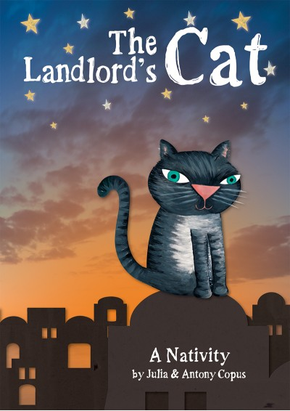
Nativity Performances – Apple and Beech Classes
We remain optimistic that we will be able to perform “The Landlord’s Cat” next week with a live audience. Tickets will be distributed on Monday in your child/ren’s book bags.

Please remember the following measures in place to help keep everyone safe:
- We advise a lateral flow test to be taken within 24 hours of you attending school for the performance.
- We respectfully ask you to wear a mask throughout the performance.
- We advise that you wear warm clothes as the hall will need to be well ventilated.
- We regret that toilet facilities will be unavailable.

Swimming – Oak Class – Final Session Tuesday 14 December
Next Tuesday will be Oak Class’ final swimming lesson and they will be able to enjoy a fun session at the pool.

Next term swimming – Holly Class
We are pleased to inform you that next term Holly Class (Y3/4) will be going swimming. We are mindful of the lessons that they missed earlier in their school years and so we are grateful that they will have this opportunity next term. The children will have a block of six sessions, starting on Wednesday 2 March 2022. As the lesson time will be 11:15am, the children in Holly Class will all require packed lunches on swimming days.

After School Clubs
Please note that the ONLY club on next week will be STEM Club (Monday)
We are in the process of finalising our club offer for the Spring Term and will provide further details in due course.

Dance Workshop – Oak Class
Next Wednesday afternoon, Oak Class will be lucky enough to have a Christmas dance workshop led by Kelly Goodwin from Curve Dance. They will spend the afternoon at the Sports Hall and will be back at school by the end of the day as usual. Therefore, in a change to normal arrangements, next week Oak Class will need to wear their PE kits on Tuesday, Wednesday and Friday.

PE Kits

PE Kits  w/c 13 Dec | Tuesday | Wednesday | Thursday | Friday
APPLE (CH) |  |  | X
BEECH (FT) |  |  |  | X
HOLLY (LR) |  | X |  | X
OAK (LC) | X | X |  | X
Please do ensure that on PE days, the children wear their hoodies, school jumpers or cardigans alongside white or blue t-shirts and black or navy shorts or jogging bottoms.
Children in Apple Class bring their kits to school on a Monday; take them home each Friday.

Upcoming Events – Christmas

 INFORMATION REGARDING CHRISTMAS @ CRAYKE 2021 
Here are some important dates for your diaries as we approach the end of term. Please note that events may be subject to change or cancellation at any time, including at very short notice, if Covid cases continue to rise. We are grateful for your co-operation.

Date | Event
Friday 10 December | Whole School visit to York Theatre Royal – Pantomime  Estimated time of return to school – 4:30pm
Monday 13 December | Nativity Dress Rehearsal  Performing to the other children
Tuesday 14 December | Christmas Lunch
Tuesday 14 December | Christmas Party afternoon –  Children in Apple, Beech and Holly classes wear party outfit all day; Oak class bring an outfit to change into on return to school after swimming
Wednesday 15 December | Nativity Performance 1 – 9:30am  Nativity Performance – 2:15pm
Thursday 16 December | Deadline for bringing in Christmas cards
Friday 17 December | Christmas Jumper Day – children are welcome to wear non-uniform and Christmas jumpers.  End of term -2:30pm
*Please ensure that Christmas cards are clearly labelled with first name, surname and class to ensure safe delivery to the correct recipient!

Online Advent Calendar
As the festive season approaches, your family may be interested in using this resource which has been shared by the Diocese of York https://advent-calendar.online/york/
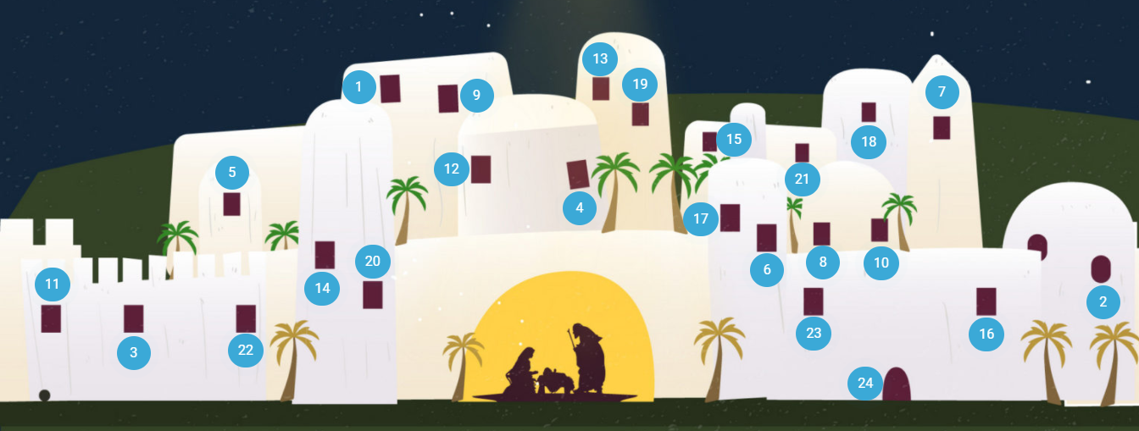

School Lunch Menu

AUTUMN TERM  2021 | Week 2  w/c 13 Dec
Monday | Connie’s Chicken Quesadilla and rice  Sweetcorn & green beans  Sliced wholemeal bread  Sultana and oat cookie  Fresh fruit or yogurt
Tuesday | CHRISTMAS LUNCH!  
Wednesday | Sausage toad in the hole with onion gravy  Creamy mashed potato  Broccoli and swede  Herbie bread  Fruit mousse  Fresh fruit or yogurt
Thursday | Cheese and tomato pizza  Diced potatoes  Crunchy veg sticks  Apple & berry crumble & custard  Fresh fruit or yogurt
Friday | Fish fingers  Tomato ketchup  Chipped potatoes  Carrots and peas  Pumpkin seed bread  Fruit shortcake  Fresh fruit or yogurt

School Lunch Menu

SPRING TERM  2022 | Week 1  w/c 3 & 24 Jan, 14 Feb, 14 March, 4 April | Week 2  w/c 10 & 31 Jan, 28 Feb, 21 March | Week 3  w/c 17 Jan, 7 Feb, 7 & 28 March
Monday | Cheese & Tomato Pizza  Diced potatoes  Peas and sweetcorn  Chocolate Crunch  Fresh fruit or yogurt | Pasta Bolognaise  Sweetcorn & green beans  Oat and sultana cookie  Fresh fruit or yogurt | Chicken Korma & Rice  Cauliflower & Green Beans  Chocolate Cornflake pudding  Fresh fruit or yogurt
Tuesday | Chicken & Broccoli  Pasta Bake  Green beans & carrots  Cheese and crackers  Fresh fruit or yogurt | Chicken & Vegetable Pie with baby potatoes  Seasonal medley of veg  Cheese and crackers  Fresh fruit or yogurt | Creamy Mac & cheese  Broccoli & sweetcorn  Fresh fruit salad or yogurt
Wednesday | Savoury Minced Beef & Yorkshire Pudding  Roast potatoes  Medley of vegetables  Fruit Jelly & Ice Cream  Fresh fruit or yogurt | Roast Pork and apple sauce with gravy  Creamy mashed potato  Broccoli and carrots  Creamy Rice Pudding & peaches  Fresh fruit or yogurt | Roast Chicken with Sage & Onion Stuffing & Gravy  Roast potatoes  Spring cabbage and carrots  Banana & Custard  Fresh fruit or yogurt
Thursday | Sausage, Mash &  Onion Gravy  Roast Parsnips and broccoli  Apple Crumble with custard  Fresh fruit or yogurt | Sweet Lentil Curry & Rice  Peas and sweetcorn  Chocolate orange sponge & chocolate sauce  Fresh fruit or yogurt | Nacho Beef Bake  Rice  Sweetcorn & Green Beans  Berry sponge & custard  Fresh fruit or yogurt
Friday | Fish Fingers  Chipped potatoes  Baked beans and peas  Fruity Jam sponge  Fresh fruit or yogurt | Crunchy Breaded (Salmon) Fish  Chipped potatoes  Green Beans and Carrots  Fruity Flapjack  Fresh fruit or yogurt | Harry Ramsdens battered fish  Chipped potatoes  Peas and sweetcorn  Carrot cake  Fresh fruit or yogurt

Church News

Crayke Carol Service Tuesday Dec 21st 6pm

Do join us for plenty of joyful worship and singing of carols – it will be so good to celebrate together after such a challenging year.
There will be mulled wine & mince pies afterwards & time for fellowship.
We look forward to welcoming you!

Community News

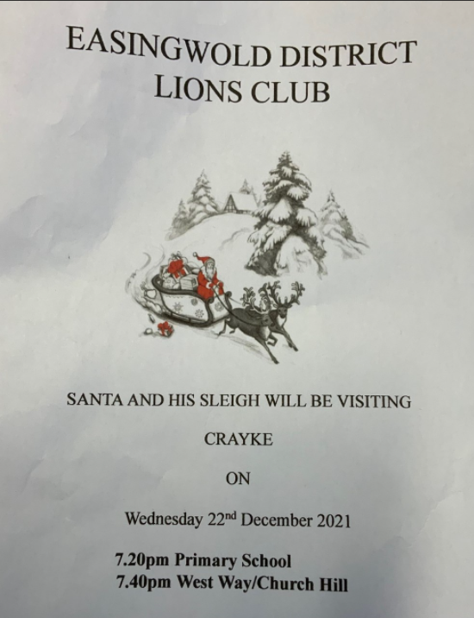

Something exciting is coming to North Yorkshire Libraries this Christmas! We’re challenging children aged 4-11 to read four library books between 20th November and Christmas to win stickers, prizes, a certificate, and a special Christmas gift…. And we haven’t forgotten the little ones, Buzzy Bee has something exciting for them too! Think you can take on the challenge? Pop into your local library, give us a call, or follow us on Facebook for more information.

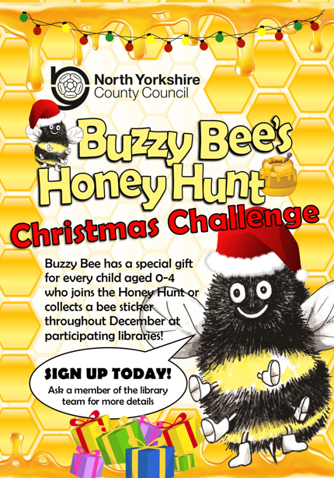

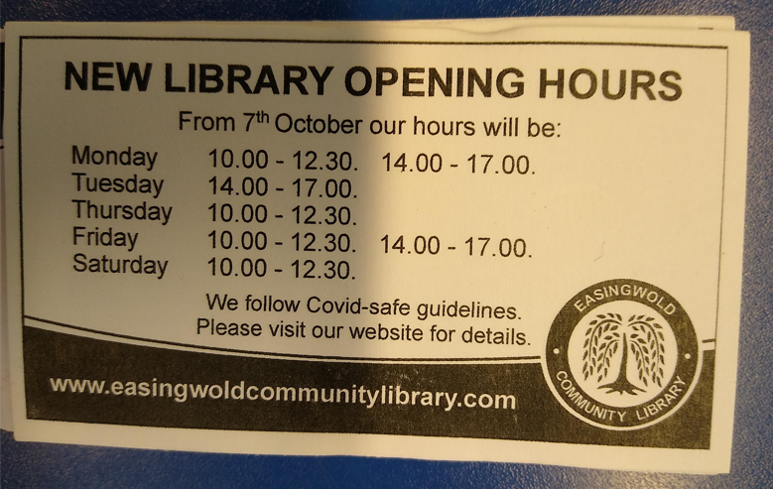

Diary Dates – Autumn Term 2021

Date | Time | Event | Audience
Wed 15 December | 9:30am & 2:15pm | Nativity Performances | Apple & Beech Classes (R/1/2)
Fri 17 December | 2:30pm | School closes | Whole school

Term Dates – Academic Year 2021/2022

Monday 20 December – Monday 3 January 2022 | School Closed – Christmas Holiday
Tuesday 4 January 2022 | School closed to pupils – Training Day
Wednesday 5 January 2022 | School Reopens
Monday 21 February–Friday 25 February 2022 | School Closed – HALF TERM
Monday 28 February 2022 | School Reopens
Monday 11 April – Friday 22 April 2022 | School Closed – Easter Holiday
Monday 25 April 2022 | School closed to pupils – Training Day
Tuesday 26 April 2022 | School Reopens
Monday 2 May 2022 | School closed – May Day Bank Holiday
Monday 30 May – Friday 3 June 2022 | School Closed – HALF TERM
Monday 6 June 2022 | School Reopens
Friday 22 July 2022 | Last day of term for pupils
Monday 25 July 2022 | School closed to pupils – Training Day

Safeguarding concerns
A reminder that if you have any concerns about a child, please do not hesitate to get in contact by emailing headteacher@crayke.n-yorks.sch.uk
Please also be aware that as a school we subscribe to Operation Encompass, whereby we are notified of any incidences of domestic violence where a pupil at our school has been present.

Financial Assistance Free School Meals
If you are encountering financial difficulties at this time and would like a strictly confidential conversation about support that can be provided, please do not hesitate to get in touch.

Judi Jackson
Headteacher
headteacher@crayke.n-yorks.sch.uk

