
Crayke C of E Primary School

FOLLOW YOUR PATHWAY AND WE GROW TOGETHER WITH CONFIDENCE
Respect Friendship Forgiveness Determination

Dear Parents and Carers,

Happy New Year!

We hope that all families have had a restful break and enjoyed some special time together with good food and drink. There was definitely a copious amount of chocolate consumed in my household! Thank you once again from all the staff for the wonderful array of very generous gifts, thoughtful cards and well wishes given before Christmas. We are all very grateful.

It has been fabulous to welcome the children back into school this week and to get cracking with our new topics which are as follows:

Apple – Dinosaurs Rock
Beech – Oh I do like to be beside the seaside!
Holly – Tales from Dragon Mountain
Oak – Journeys

Curriculum newsletters for this term will be posted on the school website shortly.

Reception Admissions 2022

It has been great to show so many prospective families around school over recent months, who have been so complimentary about the children and school in general.
The deadline for applying for a place is fast approaching (15 January 2022) and applications must be made online via: https://www.northyorks.gov.uk/apply-place-primary-or-secondary-school

Farewell to Mrs Hetherington

As you may recall, Mrs Hetherington reduced her hours last term to be able to pursue a career with the Portage service. It is with sadness for us, but happiness for her, that we announce that Mrs Hetherington has now been offered full time hours with the Portage service and will therefore be leaving us. Her last day in school will be next Tuesday, 11 January 2022. Jill has been a wonderful colleague who has worked with children of all ages and supported across all classes and over lunchtimes. Her calm and gentle nature and great sense of humour will be missed by us all. We wish her all the very best and know that the families who she will be supporting in the future are very lucky to have her.

Staffing Update

Mrs Hetherington’s departure has led to some minor changes to staffing across school for this term. The staffing structure has been updated and is as follows:

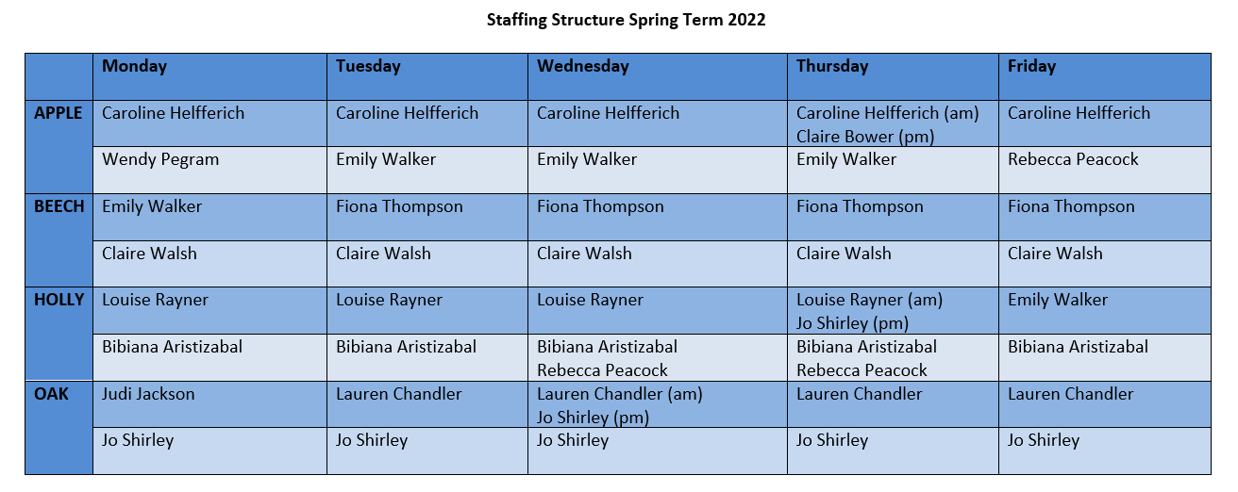

Playtimes

As part of the staff training day earlier this week, we took the opportunity to review our arrangements for playtime. A reminder that children are welcome to bring their skipping ropes into school and they are able to use these on the lower playground at this time of year. I have set the children a challenge to learn a new playground game and teach it to someone else – if you are able to support with this at home it would be very much appreciated in our drive to keep playtimes purposeful, peaceful and positive. So far, “What’s the Time Mr Wolf?” is proving really popular!

PE Kits

PE Kits  w/c 10 Jan | Tuesday | Wednesday | Thursday | Friday
APPLE (CH) |  |  | X | X
BEECH (FT) |  | X |  | X
HOLLY (LR) |  | X |  | X
OAK (LC) | X |  |  | X
Please do ensure that on PE days, the children wear their hoodies, school jumpers or cardigans alongside white or blue t-shirts and black or navy shorts or jogging bottoms.
Children in Apple Class bring their kits to school on a Monday; take them home each Friday.

Drop off and collection arrangements

Please do remember that it is not possible to use the school layby for regular drop off and collections at the beginning and end of the school day. The layby is required for the school bus and deliveries throughout the day and keeping it clear from congestion is also a much safer option for children and families as they travel to and from the school site. The layby is available by pre-arrangement in exceptional circumstances – please contact the office to discuss if this is required for your family. Thank you.
Extra-Curricular Clubs

Clubs will resume w/c 17 January 2022. In recognition of staff wellbeing and the additional pressures at this time in preparing remote learning, there will be no staff-led clubs this half term.
The proposed club schedule at this time is as follows:
Monday  (1st session  17 Jan 2022) | STEM (fee paid direct to provider)  3:30pm – 4:30pm  Years 3 – 6  Discovery-ICE
Tuesday  (1st session  18 Jan 2022) | Multi-sports (fee paid direct to provider)  3:30 – 4:30pm  Year 1-6  Mr Cromack
Friday  (1st session  21 Jan 2022) | GOAL (fee paid direct to provider)  3:30 – 4:30pm  Years 1-6  Simon Carson Sports School
Further information about booking sessions on the above clubs will be shared under separate cover early next week.

Music Lessons
A reminder that music lessons are still available via North Yorkshire Music Hub. Further details are available here: https://www.northyorkshiremusichub.co.uk/

Spelling Lists
Children in Years 2 - 6 will be bringing paper copies home of this half term’s spelling lists. They will also be made available on the school website and on the Google class pages.
Year 2
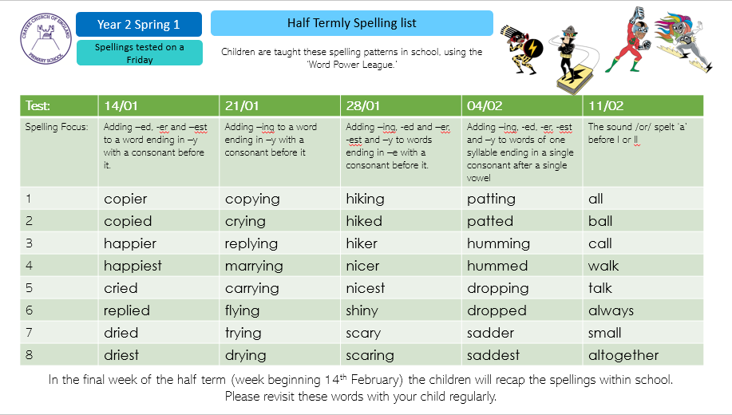

Holly Class Year 3/4
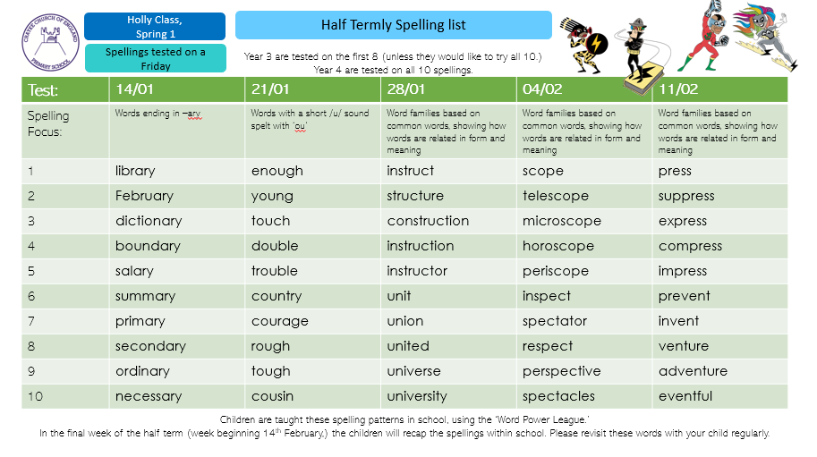

Oak Class Year 5/6
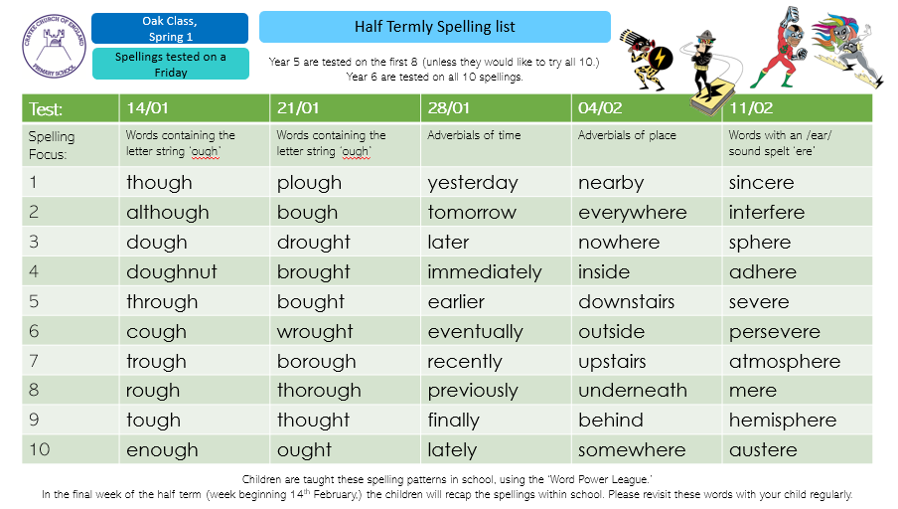

Covid Updates
Ventilation
In line with our risk assessments we continue to follow local and national guidance regarding ensuring adequate ventilation through the building. It does mean that at times it can be quite chilly in school. We strongly recommend that you provide extra layers of clothing for your children if they do feel the cold. This can include thermal tops and tights if needed. We also know that this does not apply to all and that some will continue to wear shorts whatever the weather!

Symptoms
As before the holidays, please do remember that if your child develops any of the main symptoms of Covid-19, they must not come into school.

The main symptoms remain the following:

- a high temperature – this means you feel hot to touch on your chest or back (you do not need to measure your temperature)
- a new, continuous cough – this means coughing a lot for more than an hour, or 3 or more coughing episodes in 24 hours (if you usually have a cough, it may be worse than usual)
- a loss or change to your sense of smell or taste – this means you've noticed you cannot smell or taste anything, or things smell or taste different to normal

If your child has any of these symptoms, they need to get a PCR test (test that is sent to a lab) to check if they have coronavirus. They need to stay at home until the result is known, even if the symptoms are mild. Please note that if your child has symptoms, a lateral flow test is insufficient and a PCR test must be sought.

Self-Isolation
The self-isolation advice for people with coronavirus has changed. It is now possible to end self-isolation after 7 days, following 2 negative LFD tests taken 24 hours apart. The first LFD test should not be taken before the sixth day.

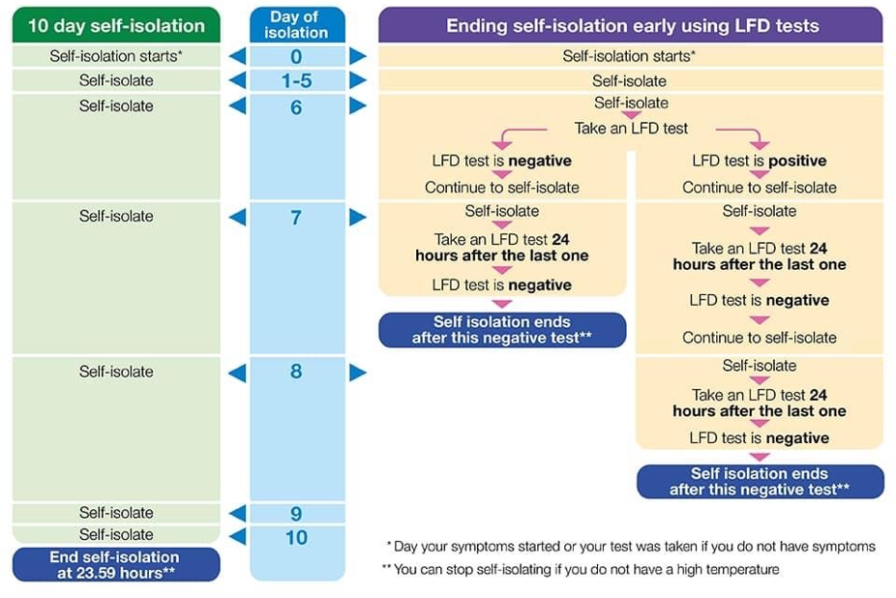

School Lunch Menu

SPRING TERM  2022 | Week 1  w/c 24 Jan, 14 Feb, 14 March, 4 April | Week 2  w/c 10 & 31 Jan, 28 Feb, 21 March | Week 3  w/c 17 Jan, 7 Feb, 7 & 28 March
Monday | Cheese & Tomato Pizza  Diced potatoes  Peas and sweetcorn  Chocolate Crunch  Fresh fruit or yogurt | Pasta Bolognaise  Sweetcorn & green beans  Oat and sultana cookie  Fresh fruit or yogurt | Chicken Korma & Rice  Cauliflower & Green Beans  Chocolate Cornflake pudding  Fresh fruit or yogurt
Tuesday | Chicken & Broccoli  Pasta Bake  Green beans & carrots  Cheese and crackers  Fresh fruit or yogurt | Chicken & Vegetable Pie with baby potatoes  Seasonal medley of veg  Cheese and crackers  Fresh fruit or yogurt | Creamy Mac & cheese  Broccoli & sweetcorn  Fresh fruit salad or yogurt
Wednesday | Savoury Minced Beef & Yorkshire Pudding  Roast potatoes  Medley of vegetables  Fruit Jelly & Ice Cream  Fresh fruit or yogurt | Roast Pork and apple sauce with gravy  Creamy mashed potato  Broccoli and carrots  Creamy Rice Pudding & peaches  Fresh fruit or yogurt | Roast Chicken with Sage & Onion Stuffing & Gravy  Roast potatoes  Spring cabbage and carrots  Banana & Custard  Fresh fruit or yogurt
Thursday | Sausage, Mash &  Onion Gravy  Roast Parsnips and broccoli  Apple Crumble with custard  Fresh fruit or yogurt | Sweet Lentil Curry & Rice  Peas and sweetcorn  Chocolate orange sponge & chocolate sauce  Fresh fruit or yogurt | Nacho Beef Bake  Rice  Sweetcorn & Green Beans  Berry sponge & custard  Fresh fruit or yogurt
Friday | Fish Fingers  Chipped potatoes  Baked beans and peas  Fruity Jam sponge  Fresh fruit or yogurt | Crunchy Breaded (Salmon) Fish  Chipped potatoes  Green Beans and Carrots  Fruity Flapjack  Fresh fruit or yogurt | Harry Ramsdens battered fish  Chipped potatoes  Peas and sweetcorn  Carrot cake  Fresh fruit or yogurt

Term Dates – Academic Year 2021/2022

Monday 21 February–Friday 25 February 2022 | School Closed – HALF TERM
Monday 28 February 2022 | School Reopens
Monday 11 April – Friday 22 April 2022 | School Closed – Easter Holiday
Monday 25 April 2022 | School closed to pupils – Training Day
Tuesday 26 April 2022 | School Reopens
Monday 2 May 2022 | School closed – May Day Bank Holiday
Monday 30 May – Friday 3 June 2022 | School Closed – HALF TERM
Monday 6 June 2022 | School Reopens
Friday 22 July 2022 | Last day of term for pupils
Monday 25 July 2022 | School closed to pupils – Training Day

Safeguarding concerns
A reminder that if you have any concerns about a child, please do not hesitate to get in contact by emailing headteacher@crayke.n-yorks.sch.uk
Please also be aware that as a school we subscribe to Operation Encompass, whereby we are notified of any incidences of domestic violence where a pupil at our school has been present.

Financial Assistance Free School Meals
If you are encountering financial difficulties at this time and would like a strictly confidential conversation about support that can be provided, please do not hesitate to get in touch.

Judi Jackson
Headteacher
headteacher@crayke.n-yorks.sch.uk

