
Crayke C of E Primary School

FOLLOW YOUR PATHWAY AND WE GROW TOGETHER WITH CONFIDENCE
Respect Friendship Forgiveness Determination

Dear Parents and Carers,

Another week over and some gorgeous clear sunny days to enjoy amidst the frost and cold! I am sure I have seen some snowdrops beginning to poke through and the evenings are getting just that little bit lighter for longer so Spring will be here before we know it! It has been another busy week in school and learning is well underway in the new topics.

Covid Update

We have had been informed of Covid cases in each class in school this week. We have informed you by email when your child may have been in close contact with someone who has subsequently tested positive.
Children who are close contacts of someone with COVID-19 are no longer required to isolate unless they develop symptoms. However, they are advised to undertake daily lateral flow testing for 7 days as they are at a higher risk of developing COVID-19 in the days after the contact. Your child should continue to attend school unless they develop symptoms of COVID-19 or are unwell. If they do develop symptoms, please keep your child at home and book a PCR test for them.
The 3 main symptoms of COVID-19 remain a fever (temperature 37.8OC or higher), a new continuous cough, or a change to/loss of taste or smell. However, other commonly reported symptoms of recent variants include headache, sore throat, tiredness, and cold-like symptoms, so please be aware of these as well and stay at home and seek further testing if you are in any doubt.
Self-Isolation – Reminder

Individuals who are self-isolating with COVID-19 will have the option to reduce their isolation period after 5 full days if they test negative with a lateral flow device (LFD) test on both day 5 and day 6 and they do not have a temperature.
It is crucial that people isolating with COVID-19 wait until they have received 2 negative rapid lateral flow tests on 2 consecutive days to reduce the chance of still being infectious. For example, if they test negative on the morning of day 5 and the morning of day 6, they can return to their education or childcare setting immediately on day 6.
The first test must be taken no earlier than day 5 of the self-isolation period, and the second must be taken the following day. All test results should be reported to NHS Test and Trace.
If the result of either of their tests is positive, they should continue to self-isolate until they get negative results from two LFD tests on consecutive days or until they have completed 10 full days of self-isolation, whichever is earliest.
Anyone who is unable to take LFD tests or anyone who continues to have a temperature will need to complete the full 10 day period of self-isolation.

The default self-isolation period continues to be 10 days, and you may only leave self-isolation early if you have taken 2 rapid lateral flow tests and do not have a temperature, in line with guidance.

PCR or LFT?
It can be confusing to know which type of test to source and when. This flow chart summarises it well. If you do need further information or are unsure what to do if your child is unwell, please do contact us for advice.
Thank you for your continued vigilance and support in helping everyone in our school community to stay safe.

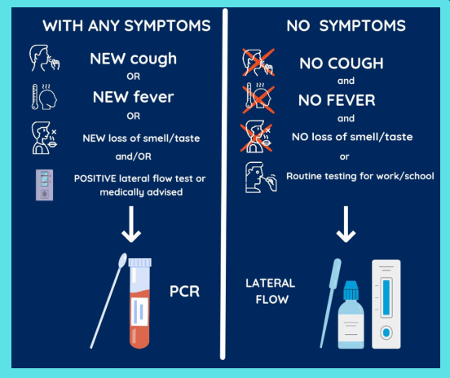

Safer Internet Day – 8 February 2022


Safer Internet Day is celebrated globally in February each year to promote the safe and positive use of digital technology for children and young people, and to inspire a national conversation about using technology responsibly, respectfully, critically, and creatively.
Safer Internet Day 2022 is on 8th February and will be celebrated with the theme ‘All fun and games? Exploring respect and relationships online’.
Next week Mrs Rayner and I will be participating in some CPD related to online safety with STEM learning. STEM is also offering a FREE parent workshop on 15 February 2022 at 4pm, which is available to book via this weblink: https://www.stem.org.uk/cpd/505977/online-safety-parents-workshop

Contacting staff

We have updated staff email contact details. Please use the following with immediate effect if you wish to contact your child’s class teacher.

Class | Teacher | Email address
Apple | Mrs Helfferich | chelfferich@crayke.n-yorks.sch.uk
Beech | Miss Thompson | fthompson@crayke.n-yorks.sch.uk
Holly | Mrs Rayner | lrayner@crayke.n-yorks.sch.uk
Oak | Mrs Chandler | lchandler@crayke.n-yorks.sch.uk

Parent Consultation Evenings – Spring Term

We have provisionally arranged this term’s meetings for Tuesday 8 March and Wednesday 9 March 2022. Further details about the format of this will be shared closer to the event. In the meantime, as always, if you have any concerns about any aspects of your child’s development or wellbeing, please contact your child’s class teacher in the first instance.

Community News

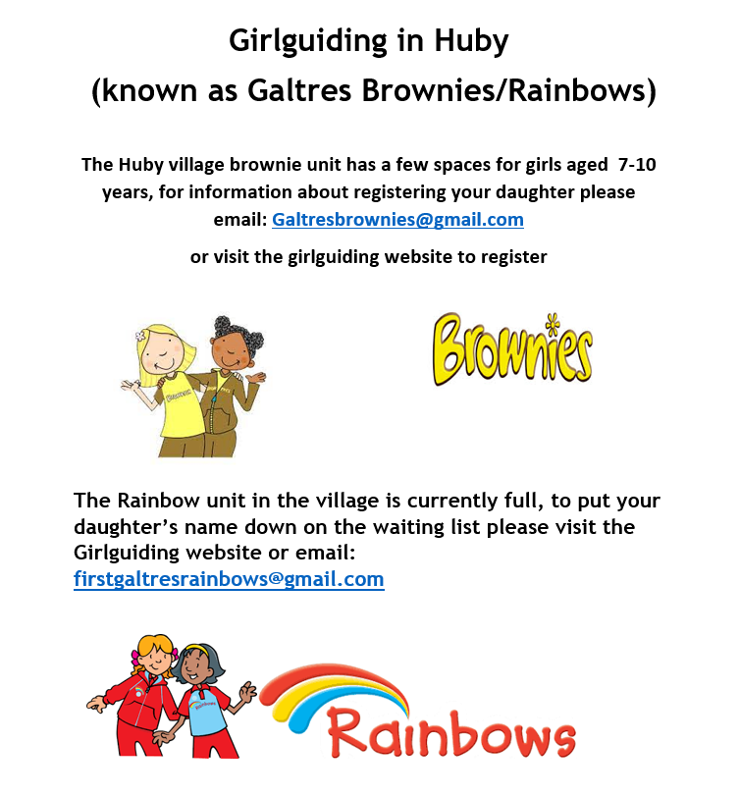

 Stars of the Week

Stars | Class 1 | Class 2 | Class 3 | Class 4
Stars | Tomas Davies | Joshua Jefferson | Toby Seligman | Betty Strong
Stars | Tomas Davies | Carl Keaney | Isla Howland | Annie Swan

Team Points

Green | 849 | Yellow | 683
Blue | 780 | - Red | 853

Attendance and Punctuality
Children will be marked late if they arrive after 9.00am
Please do help us in our mission to ensure that children are in school on time so that valuable learning time is not missed at the start of the day.

This week’s attendance figures: 93.5% School Target: 96%

Apple (CH): 95.5% 2 lates (2 children) | Beech (FT): 92.3% lates (2 children)
Holly (LR): 94% 2 lates (2 children) | Oak (LC): 93.3% 2 lates (2 children)

PE Kits

PE Kits  w/c 24 Jan | Tuesday | Wednesday | Thursday | Friday
APPLE (CH) |  |  | X | X
BEECH (FT) | X |  |  | X
HOLLY (LR) |  | X |  | X
OAK (LC) | X |  |  | X
Please do ensure that on PE days, the children wear their hoodies, school jumpers or cardigans alongside white or blue t-shirts and black or navy shorts or jogging bottoms.
Children in Apple Class bring their kits to school on a Monday; take them home each Friday.

Extra-Curricular Clubs

Clubs have now resumed and will run unless you are notified otherwise.

The club schedule for this half term is as follows:

Monday | STEM (fee paid direct to provider)  3:30pm – 4:30pm  Years 3 – 6  Discovery-ICE
Tuesday | Multi-sports (fee paid direct to provider)  3:30 – 4:30pm  Year 1-6  Mr Cromack
Thursday | SATs Revision Club (no charge)  3:30 – 4:15pm  Year 6  Year 5/6 staff
Friday | GOAL (fee paid direct to provider)  3:30 – 4:30pm  Years 1-6  Simon Carson Sports School

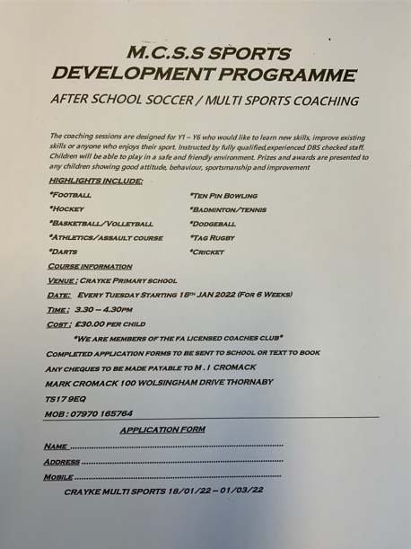

School Lunch Menu

SPRING TERM  2022 | Week 1  w/c 24 Jan, 14 Feb,  14 March, 4 April | Week 2  w/c 31 Jan, 28 Feb,  21 March | Week 3  w/c 7 Feb,  7 & 28 March
Monday | Cheese & Tomato Pizza  Diced potatoes  Peas and sweetcorn  Chocolate Crunch  Fresh fruit or yogurt | Pasta Bolognaise  Sweetcorn & green beans  Oat and sultana cookie  Fresh fruit or yogurt | Chicken Korma & Rice  Cauliflower & Green Beans  Chocolate Cornflake pudding  Fresh fruit or yogurt
Tuesday | Chicken & Broccoli  Pasta Bake  Green beans & carrots  Cheese and crackers  Fresh fruit or yogurt | Chicken & Vegetable Pie with baby potatoes  Seasonal medley of veg  Cheese and crackers  Fresh fruit or yogurt | Creamy Mac & cheese  Broccoli & sweetcorn  Fresh fruit salad or yogurt
Wednesday | Savoury Minced Beef & Yorkshire Pudding  Roast potatoes  Medley of vegetables  Fruit Jelly & Ice Cream  Fresh fruit or yogurt | Roast Pork and apple sauce with gravy  Creamy mashed potato  Broccoli and carrots  Creamy Rice Pudding & peaches  Fresh fruit or yogurt | Roast Chicken with Sage & Onion Stuffing & Gravy  Roast potatoes  Spring cabbage and carrots  Banana & Custard  Fresh fruit or yogurt
Thursday | Sausage, Mash &  Onion Gravy  Roast Parsnips and broccoli  Apple Crumble with custard  Fresh fruit or yogurt | Sweet Lentil Curry & Rice  Peas and sweetcorn  Chocolate orange sponge & chocolate sauce  Fresh fruit or yogurt | Nacho Beef Bake  Rice  Sweetcorn & Green Beans  Berry sponge & custard  Fresh fruit or yogurt
Friday | Fish Fingers  Chipped potatoes  Baked beans and peas  Fruity Jam sponge  Fresh fruit or yogurt | Crunchy Breaded (Salmon) Fish  Chipped potatoes  Green Beans and Carrots  Fruity Flapjack  Fresh fruit or yogurt | Harry Ramsdens battered fish  Chipped potatoes  Peas and sweetcorn  Carrot cake  Fresh fruit or yogurt

Term Dates – Academic Year 2021/2022

Monday 21 February–Friday 25 February 2022 | School Closed – HALF TERM
Monday 28 February 2022 | School Reopens
Monday 11 April – Friday 22 April 2022 | School Closed – Easter Holiday
Monday 25 April 2022 | School closed to pupils – Training Day
Tuesday 26 April 2022 | School Reopens
Monday 2 May 2022 | School closed – May Day Bank Holiday
Monday 30 May – Friday 3 June 2022 | School Closed – HALF TERM
Monday 6 June 2022 | School Reopens
Friday 22 July 2022 | Last day of term for pupils
Monday 25 July 2022 | School closed to pupils – Training Day

Safeguarding concerns
A reminder that if you have any concerns about a child, please do not hesitate to get in contact by emailing headteacher@crayke.n-yorks.sch.uk
Please also be aware that as a school we subscribe to Operation Encompass, whereby we are notified of any incidences of domestic violence where a pupil at our school has been present.

Financial Assistance Free School Meals
If you are encountering financial difficulties at this time and would like a strictly confidential conversation about support that can be provided, please do not hesitate to get in touch.

Judi Jackson
Headteacher
headteacher@crayke.n-yorks.sch.uk

