
Crayke C of E Primary School

FOLLOW YOUR PATHWAY AND WE GROW TOGETHER WITH CONFIDENCE
Respect Friendship Forgiveness Determination

Dear Parents and Carers,

Mrs Jackson continues to be signed off work, but we are hopeful we may see her back in school before half-term (as long as she is well enough).
Should you have any questions about your child's learning or any other aspect of their school life, please contact their class teacher in the first instance.

Class | Teacher | Email address
Apple | Mrs Helfferich | chelfferich@crayke.n-yorks.sch.uk
Beech | Miss Thompson | fthompson@crayke.n-yorks.sch.uk
Holly | Mrs Rayner | lrayner@crayke.n-yorks.sch.uk
Oak | Mrs Chandler | lchandler@crayke.n-yorks.sch.uk

Year 6 SATS Meeting

Mrs Chandler will be holding a Year 6 SATS meeting on Thursday 17 February at 6pm. During the meeting parents/carers will have the opportunity to see examples of test style questions that their children will be presented with during the SATs test week (Monday 9 May – Thursday 12 May 2022) and gain an understanding of how the whole system works, particularly if they are new to it.
Please email Mrs Bacon at admin@crayke.n-yorks.sch.uk to confirm if you are able to attend or not.
For those unable to attend, the Powerpoint will be made available following the meeting.

Holly Class Swimming Lessons

Holly Class will be starting a 6 week course of swimming lessons at Thirsk Pool on a Wednesday after half-term. The first session will be on Wednesday 2 March. As well as their swimming things, children will need a packed lunch, as they will not arrive back at school until approximately 12.30pm.
Information was sent to parents by email yesterday with a request to complete an online consent form by Wednesday 16 February https://forms.office.com/r/HdUawHQ2ne

CHASA

CHASA SMARTIE CHALLENGE!

CHASA would like to give each child a small gift, so watch out in the last week of half term for a tube of Smarties coming home in the book bags. When the children have enjoyed eating the chocolates, please don’t throw the tube away! Instead, we’d like you to fill as much of the tube as you can with loose change and return it to school after the half term holidays.

Thank you for your support!
The CHASA team

World Book Day -3 March 2022



Community News




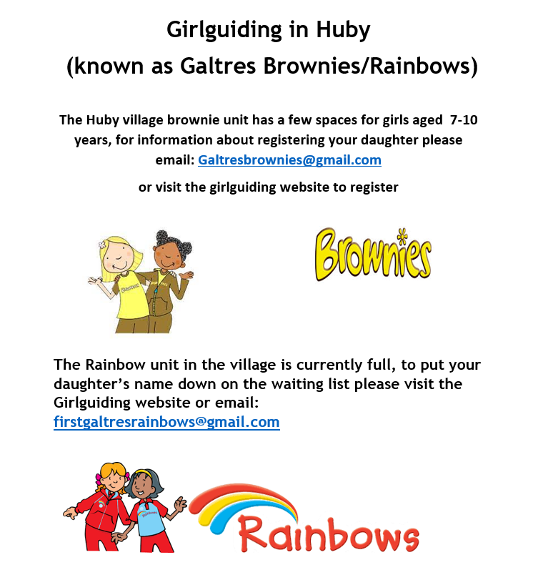

 Stars of the Week

Stars | Class 1 | Class 2 | Class 3 | Class 4
Stars | Joshua Griffin-Miles | India Ward | Arwen Dawson | Ernie Cater
Stars | Joshua Griffin-Miles | Arthur Barrett | Dylan Swiers | Sein Tomkinson

Attendance and Punctuality
Children will be marked late if they arrive after 9.00am
Please do help us in our mission to ensure that children are in school on time so that valuable learning time is not missed at the start of the day.

This week’s attendance figures: School Target: 96% 94.4%

Apple (CH): 90% 3 lates /2 children | Beech (FT) 92% 1 late
Holly (LR): 96.8% 3 lates | Oak (LC): 97% 3 lates

PE Kits

PE Kits  w/c 31 Jan | Monday | Tuesday | Wednesday | Thursday | Friday
APPLE (CH) |  |  |  | X | X
BEECH (FT) |  | X |  |  | X
HOLLY (LR) |  |  | X |  | X
OAK (LC) | X |  |  |  | X
Please do ensure that on PE days, the children wear their hoodies, school jumpers or cardigans alongside white or blue t-shirts and black or navy shorts or jogging bottoms.
Children in Apple Class bring their kits to school on a Monday; take them home each Friday.
PLEASE NOTE CHANGE IN DAY FOR OAK CLASS – MONDAY NOT TUESDAY THIS WEEK

Extra-Curricular Clubs

Clubs have now resumed and will run unless you are notified otherwise.

The club schedule for this half term is as follows:

Monday | STEM (fee paid direct to provider)  3:30pm – 4:30pm  Years 3 – 6  Discovery-ICE
Tuesday | Multi-sports (fee paid direct to provider)  3:30 – 4:30pm  Year 1-6  Mr Cromack
Thursday | SATs Revision Club (no charge)  3:30 – 4:15pm  Year 6  Year 5/6 staff
Friday | GOAL (fee paid direct to provider)  3:30 – 4:30pm  Years 1-6  Simon Carson Sports School

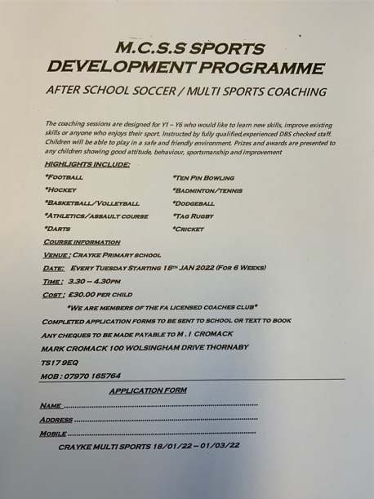

School Lunch Menu

SPRING TERM  2022 | Week 1  w/c 14 Feb,  14 March, 4 April | Week 2  w/c 31 Jan, 28 Feb,  21 March | Week 3  w/c 7 Feb,  7 & 28 March
Monday | Cheese & Tomato Pizza  Diced potatoes  Peas and sweetcorn  Chocolate Crunch  Fresh fruit or yogurt | Pasta Bolognaise  Sweetcorn & green beans  Oat and sultana cookie  Fresh fruit or yogurt | Chicken Korma & Rice  Cauliflower & Green Beans  Chocolate Cornflake pudding  Fresh fruit or yogurt
Tuesday | Chicken & Broccoli  Pasta Bake  Green beans & carrots  Cheese and crackers  Fresh fruit or yogurt | Chicken & Vegetable Pie with baby potatoes  Seasonal medley of veg  Cheese and crackers  Fresh fruit or yogurt | Creamy Mac & cheese  Broccoli & sweetcorn  Fresh fruit salad or yogurt
Wednesday | Savoury Minced Beef & Yorkshire Pudding  Roast potatoes  Medley of vegetables  Fruit Jelly & Ice Cream  Fresh fruit or yogurt | Roast Pork and apple sauce with gravy  Creamy mashed potato  Broccoli and carrots  Creamy Rice Pudding & peaches  Fresh fruit or yogurt | Roast Chicken with Sage & Onion Stuffing & Gravy  Roast potatoes  Spring cabbage and carrots  Banana & Custard  Fresh fruit or yogurt
Thursday | Sausage, Mash &  Onion Gravy  Roast Parsnips and broccoli  Apple Crumble with custard  Fresh fruit or yogurt | Sweet Lentil Curry & Rice  Peas and sweetcorn  Chocolate orange sponge & chocolate sauce  Fresh fruit or yogurt | Nacho Beef Bake  Rice  Sweetcorn & Green Beans  Berry sponge & custard  Fresh fruit or yogurt
Friday | Fish Fingers  Chipped potatoes  Baked beans and peas  Fruity Jam sponge  Fresh fruit or yogurt | Crunchy Breaded (Salmon) Fish  Chipped potatoes  Green Beans and Carrots  Fruity Flapjack  Fresh fruit or yogurt | Harry Ramsdens battered fish  Chipped potatoes  Peas and sweetcorn  Carrot cake  Fresh fruit or yogurt

Term Dates – Academic Year 2021/2022

Monday 21 February–Friday 25 February 2022 | School Closed – HALF TERM
Monday 28 February 2022 | School Reopens
Monday 11 April – Friday 22 April 2022 | School Closed – Easter Holiday
Monday 25 April 2022 | School closed to pupils – Training Day
Tuesday 26 April 2022 | School Reopens
Monday 2 May 2022 | School closed – May Day Bank Holiday
Monday 30 May – Friday 3 June 2022 | School Closed – HALF TERM
Monday 6 June 2022 | School Reopens
Friday 22 July 2022 | Last day of term for pupils
Monday 25 July 2022 | School closed to pupils – Training Day

Safeguarding concerns
A reminder that if you have any concerns about a child, whilst Mrs Jackson is not in school, please do not hesitate to get in contact by emailing one of the Deputy Designated Safeguarding Leads which are Mrs Chandler lchandler@crayke.n-yorks.sch.uk or Mrs Rayner lrayner@crayke.n-yorks.sch.uk.

Financial Assistance Free School Meals
If you are encountering financial difficulties at this time and would like a strictly confidential conversation about support that can be provided, please do not hesitate to get in touch.

Have a lovely weekend.

Helen Bacon
School Administrator
admin@crayke.n-yorks.sch.uk

