
Crayke C of E Primary School

FOLLOW YOUR PATHWAY AND WE GROW TOGETHER WITH CONFIDENCE
Respect Friendship Forgiveness Determination

Dear Parents and Carers,

It’s been a wonderful week in school, with much to be grateful for. It was particularly lovely on Wednesday afternoon, when we were fortunate to have Mr Brown in leading small group booster sessions, Miss Bramwell volunteering in Apple class, Mr Champion visiting in his role as governor and Mr Bird and his team replacing lights in the kitchen. Alongside this, we were able to enjoy the sounds of Keenan, Elliott and Grant as they begin their journey of learning the violin! The sun was shining, spring is definitely in the air and there was a real “buzz” of enthusiasm, enjoyment and normality around school and a sense of community spirit.

Staffing Update

Mrs Bacon currently remains off school sick. We continue to wish her a speedy recovery; in the meantime, please direct any communications to me on headteacher@crayke.n-yorks.sch.uk and I will endeavour to get back to you as soon as possible.

Comic Relief – Friday 18 March

The Comic Relief donations page has now been published for our school and is available here: https://app.parentpay.com/ParentPayShop/Foc/Default.aspx?shopid=6327
To mark this day, we would like to invite everyone to wear red in return for a donation to this worthy charity. Children - you could come dressed head to toe in red or just one item – it’s up to you. However, please remember that you will be doing PE at some point so your outfits should be appropriate for this activity – thank you.

Letters home – reminders to return

Whilst we are trying to move to being as paperless as possible, on some occasions it remains necessary to send letters home for consent. Currently we are awaiting some consent forms to be returned as follows:

Whole school – Easingwold Library letter (deadline 18 March 2022)
Oak Class only – Burger letter (deadline today)

Thanks for your support!

Parent Consultation Evenings – Dates Confirmed

We are delighted to be able to welcome you into school for parent consultation evenings this term. For the first time in two years, you will have the opportunity to look at your children’s books! The dates have been confirmed as Tuesday 29 March and Wednesday 30 March. Both evenings will run between 3:30pm and 6:30pm. We will send a text next week with a link to begin the booking process and appointments will be allocated as soon as possible.

Year 6 Maths Masterclass at St Peters
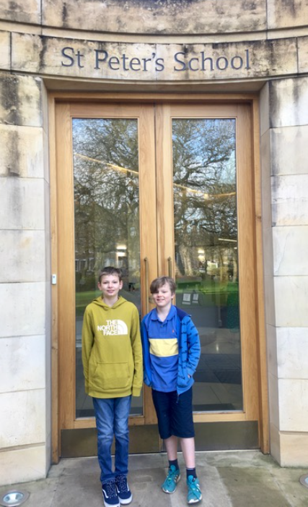

We are very proud of Sein and Ted, who took time out of their own weekend, to represent Crayke at a Maths Masterclass at St Peter's School last Saturday. The focus was on sequences and, as in class, I'm certain they demonstrated their excellent maths skills amongst the group of pupils from varying other schools and ages. I hear that they particularly enjoyed the cake and chocolate biscuits at the end; a well-deserved treat I'm sure you'll agree!

Lauren Chandler

Covid Update

Since 24th February 2022, close contacts are no longer required to undertake daily LFD testing for 7 days (or isolate if an unvaccinated adult). Instead, you are advised to carefully follow the general guidance Coronavirus: how to stay safe and help prevent the spread – GOV.UK (www.gov.uk) to limit the risk of further spread of COVID-19. This includes:
• Getting vaccinated (as appropriate according to age)
• Letting fresh air in if you meet with others indoors, or meeting outside where possible
• Continuing to wear a face covering in crowded and enclosed spaces, especially where you come into contact with people you do not usually meet
• Staying at home if you are unwell
• Taking a test if you have COVID-19 symptoms, and staying at home and avoiding contact with other people if you test positive
• Continuing to use lateral flow tests as a way to manage your personal risk and the risk to those around you. This may be particularly important
before visiting people who are at higher risk of severe illness if they get COVID-19
• Washing your hands regularly and following advice to ‘Catch it, Bin it, Kill it’
There is additional guidance for contacts who live in the same household or who have stayed overnight in the same house as someone who has tested
positive with COVID-19: https://www.gov.uk/government/publications/covid-19-people-with-covid-19-and-their-contacts/covid-19-people-with-covid-19-and-their-contacts
Anyone who develops symptoms of COVID-19 should stay at home and take a PCR test (until 1st April 2022 you can continue to order PCR tests from https://www.gov.uk/get-coronavirus-test). The main symptoms of COVID-19 are a recent onset of any of the following:
• a new continuous cough
• a high temperature
• a loss of, or change in, your normal sense of taste or smell (anosmia)
However, other commonly reported symptoms of recent variants include headache, sore throat, tiredness, and cold-like symptoms, so please be aware of these as well and stay at home and seek further testing if you are in any doubt.
A list of local testing facilities and opening times is available here: https://www.northyorks.gov.uk/coronavirus-covid-19-testing

Church News

The Easter Service in Crayke is on Easter Day - April 17th at 10.30am.
Also, a reminder to follow the church FB page which has details of upcoming services and events - @craykechurchstcuthberts

CHASA News

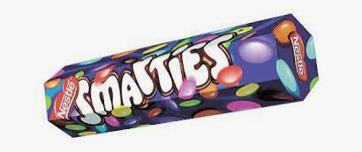
Thank you for your kind donations received so far in the Smartie tubes. The final deadline is Monday, ahead of the monies being counted on Monday afternoon.

CHASA Committee Meeting – Thursday 24 March 2022
All parents and carers are warmly invited to our next committee meeting, which will be held in school for the first time in over two years! The meeting will take place at 3:45pm on Thursday 24 March. If you would like further details please get in touch with Jonathan Dawson, Chair of the committee on chasa@crayke.n-yorks.sch.uk

Community News
We are delighted to support Crayke Open Gardens and, as in previous years, would like to contribute prizes for the tombola. Children are invited to wear non-uniform on Friday 25 March in exchange for a donation to the tombola.

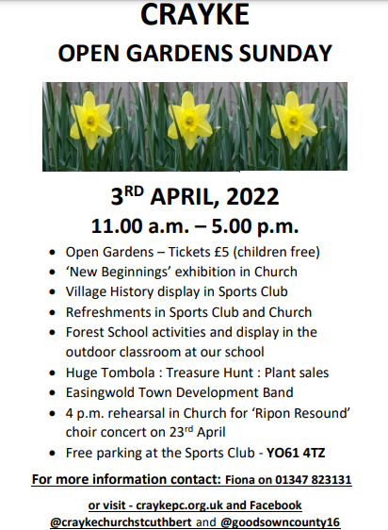

Crayke Open Gardens - We need your help!


The Crayke Open Garden’s Committee, has asked school to provide items for their ‘New Beginnings’ exhibition at the church.
‘New from Old’ can be designed and created by any member of your family; they do not need to attend Crayke School. It could be a spaceship made out of an old bottle, an old boot made into a plant pot, tin cans can be turned into a drum kit or a lampshade that has been given a makeover. Absolutely anything that has been created from something old. Please deliver your creations to Class 1’s (Apple Class) outdoor area by Friday 1st April.

Many thanks
Mrs Helfferich


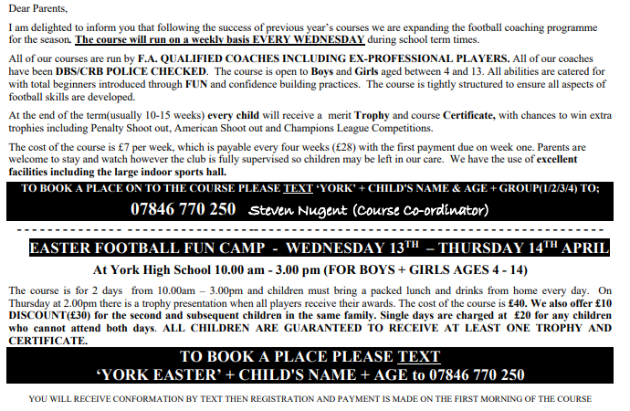
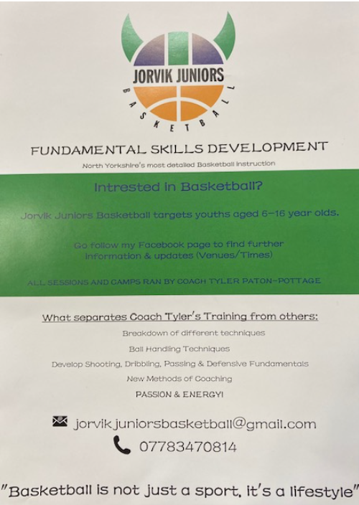



 Stars of the Week

Stars | Class 1 | Class 2 | Class 3 | Class 4
Stars | Reggie Jagger | Wilfred Liddell | Ted Clark | Matilda Beeson
Stars | Reggie Jagger | Eva Copley | Alice Unsworth | Isaac Waite
Headteacher’s Awards | Scarlett Woodhouse |  | Martha Brookes

PE Kits

PE Kits  w/c 14 March | Monday | Tuesday | Wednesday | Thursday | Friday
APPLE (CH) |  |  |  | X | X
BEECH (FT) |  | X |  |  | X
HOLLY (LR) |  |  | X (swim) |  | X
OAK (LC) | X |  |  |  | X
Please do ensure that on PE days, the children wear their hoodies, school jumpers or cardigans alongside white or blue t-shirts and black or navy shorts or jogging bottoms.
Children in Apple Class bring their kits to school on a Monday; take them home each Friday.

Team Points

- Red  | 697 | Yellow | 461
Blue | 490 | Green | 593

Extra-Curricular Clubs

Clubs will run unless you are notified otherwise.

**Please note the addition of Times Tables Club, starting next Wednesday** If you would like to book your child onto this club, please email headteacher@crayke.n-yorks.sch.uk

The club schedule is as follows:

Monday | STEM (fee paid direct to provider)  3:30pm – 4:30pm  Years 3 – 6  Discovery-ICE  Last session 28 March
Tuesday | Multi-sports (fee paid direct to provider)  3:30 – 4:30pm  Years Reception -6  Mr Cromack
Wednesday | **NEW CLUB** Italian Club (no charge)  3:30 – 4:15pm  Years 3 – 6  Mrs Aristizabal  NB: No club on 30 March
Wednesday | **NEW CLUB** Times Tables Club (no charge)  3:30 – 4:15pm  Year 4  Mrs Rayner  NB: No club on 30 March
Thursday | SATs Revision Club (no charge)  3:30 – 4:15pm  Year 6  Year 5/6 staff  NB: No club on 31 March
Friday | GOAL (fee paid direct to provider)  3:30 – 4:30pm  Years 1-6  Simon Carson Sports School  Book via: www.simoncarsonsportsschool.co.uk

Please note that NO CLUBS will run at all during weeks commencing 4 April 2022 or 25 April 2022

School Lunch Menu

SPRING TERM  2022 | Week 1  w/c  14 March, 4 April | Week 2  w/c  21 March | Week 3  w/c  28 March
Monday | Cheese & Tomato Pizza  Diced potatoes  Peas and sweetcorn  Chocolate Crunch  Fresh fruit or yogurt | Pasta Bolognaise  Sweetcorn & green beans  Oat and sultana cookie  Fresh fruit or yogurt | Chicken Korma & Rice  Cauliflower & Green Beans  Chocolate Cornflake pudding  Fresh fruit or yogurt
Tuesday | Chicken & Broccoli  Pasta Bake  Green beans & carrots  Cheese and crackers  Fresh fruit or yogurt | Chicken & Vegetable Pie with baby potatoes  Seasonal medley of veg  Cheese and crackers  Fresh fruit or yogurt | Creamy Mac & cheese  Broccoli & sweetcorn  Fresh fruit salad or yogurt
Wednesday | Savoury Minced Beef & Yorkshire Pudding  Roast potatoes  Medley of vegetables  Fruit Jelly & Ice Cream  Fresh fruit or yogurt | Roast Pork and apple sauce with gravy  Creamy mashed potato  Broccoli and carrots  Creamy Rice Pudding & peaches  Fresh fruit or yogurt | Roast Chicken with Sage & Onion Stuffing & Gravy  Roast potatoes  Spring cabbage and carrots  Banana & Custard  Fresh fruit or yogurt
Thursday | Sausage, Mash &  Onion Gravy  Roast Parsnips and broccoli  Apple Crumble with custard  Fresh fruit or yogurt | Sweet Lentil Curry & Rice  Peas and sweetcorn  Chocolate orange sponge & chocolate sauce  Fresh fruit or yogurt | Nacho Beef Bake  Rice  Sweetcorn & Green Beans  Berry sponge & custard  Fresh fruit or yogurt
Friday | Fish Fingers  Chipped potatoes  Baked beans and peas  Fruity Jam sponge  Fresh fruit or yogurt | Crunchy Breaded (Salmon) Fish  Chipped potatoes  Green Beans and Carrots  Fruity Flapjack  Fresh fruit or yogurt | Harry Ramsdens battered fish  Chipped potatoes  Peas and sweetcorn  Carrot cake  Fresh fruit or yogurt

Dates for your Diary

Friday 18 March 2022 | Comic Relief – wear red
Friday 25 March 2022 | Non-uniform day – tombola donations
Tuesday 29 March 2022 | Box2Bfit - whole school
Tuesday 29 March 2022 | Parent Consultation 3:30pm – 6:30pm
Wednesday 29 March 2022 | Parent Consultation 3:30pm – 6:30pm
Tuesday 5 April 2022 | Chance to Shine Cricket – whole school
Tuesday 5 April 2022 | Easingwold library visit
w/c 9 May 2022 | Year 6 SATs tests
Wednesday 25 – Friday 27 May 2022 | Year 5 residential – Carlton Lodge
Friday 10 – Sunday 12 June 2022 | Year 6 residential - Robinwood

Term Dates – Academic Year 2021/2022

Monday 11 April – Friday 22 April 2022 | School Closed – Easter Holiday
Monday 25 April 2022 | School closed to pupils – Training Day
Tuesday 26 April 2022 | School Reopens
Monday 2 May 2022 | School closed – May Day Bank Holiday
Monday 30 May – Friday 3 June 2022 | School Closed – HALF TERM
Monday 6 June 2022 | School Reopens
Friday 22 July 2022 | Last day of term for pupils
Monday 25 July 2022 | School closed to pupils – Training Day

Safeguarding concerns
A reminder that if you have any concerns about a child, please do not hesitate to get in contact by emailing headteacher@crayke.n-yorks.sch.uk
Please also be aware that as a school we subscribe to Operation Encompass, whereby we are notified of any incidences of domestic violence where a pupil at our school has been present.

Financial Assistance Free School Meals
If you are encountering financial difficulties at this time and would like a strictly confidential conversation about support that can be provided, please do not hesitate to get in touch.

Have a lovely weekend.

Judi Jackson
Headteacher
headteacher@crayke.n-yorks.sch.uk

