
Crayke C of E Primary School

FOLLOW YOUR PATHWAY AND WE GROW TOGETHER WITH CONFIDENCE
Respect Friendship Forgiveness Determination

Dear Parents and Carers,

It seems unbelievable that it is already April and that we are rapidly approaching the end of another term. I think Gem summed up the mood perfectly yesterday morning by questioning why was it snowing in Spring!

Please note that next week, we break up on Friday 8 April 2022, at the earlier time of 2:30pm.

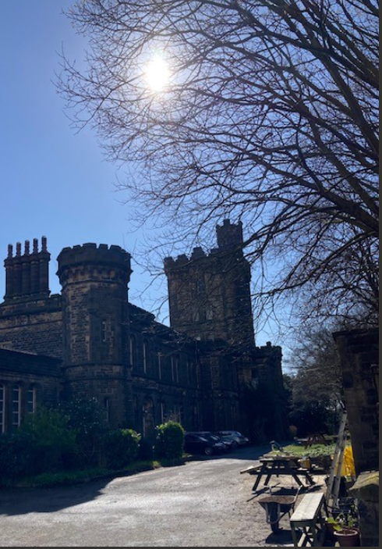
Year 6 Residential

Yesterday I had the pleasure of visiting Dobroyd Castle which is the base for the Robinwood Activity Centre in Todmorden where we will be visiting with Year 6 pupils in mid-June.

As you can see, it’s an incredibly impressive building and I am really looking forward to sharing further details with parents and carers about the visit on Tuesday 5 April at 3:45pm.

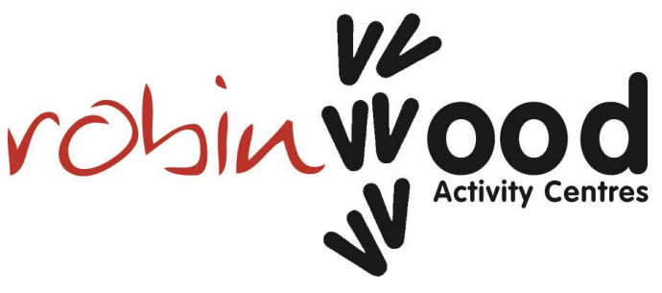

Parent Consultation Evenings
It was so absolutely brilliant to be able to welcome so many of you into school earlier this week. 96% of families have either already attended or made separate arrangements to do so before the end of term. That’s a mark of your commitment to supporting your children’s learning and we are hugely grateful. The feedback received from so many on both of the evenings was so positive and it was lovely to be able to talk to lots of you.

After School Clubs
Please note that there are NO clubs at all next week, with it being the last week of term. Neither will there be any clubs during the first week back (week commencing 25 April 2022)
Details regarding clubs, including booking arrangements, for next term will follow in due course.

Box 2B Fit
We were really disappointed that Dave wasn’t able to be in school as planned this week due to illness. Hopefully he will be able to fit us in again at some point before we break up for the summer holidays, otherwise, we will see him again in the Autumn Term.

Covid Update

On Tuesday 29 March, the Secretary of State for Health and Social Care, Sajid Javid, set out the next steps for living with COVID-19 in England from Friday 1 April.

Free COVID-19 tests will continue to be available for specific groups, including eligible patients and NHS staff, once the universal testing offer ends on Friday 1 April.

Updated guidance will advise:

- adults with the symptoms of a respiratory infection, and who have a high temperature or feel unwell, should try to stay at home and avoid contact with other people until they feel well enough to resume normal activities and they no longer have a high temperature
- children and young people who are unwell and have a high temperature should stay at home and avoid contact with other people. They can go back to school, college or childcare when they no longer have a high temperature, and they are well enough to attend
- adults with a positive COVID-19 test result should try to stay at home and avoid contact with other people for 5 days, which is when they are most infectious. For children and young people aged 18 and under, the advice will be 3 days

Chance to Shine – Cricket
Next Tuesday 5 April, Tom Bates will return to school for another day with pupils, where they will all have an opportunity to participate in a cricket taster session. Therefore, please can all pupils come into school on Tuesday dressed in PE kits. This is in addition to the usual PE sessions.

Swimming Lessons – Beech Class
It has been fabulous to see the growth in confidence of children in Holly Class over the past few weeks. They have one swimming session remaining, next Wednesday.

Next term, Beech Class will be going swimming for a block of 6 sessions at Thirsk pool, each Thursday, on the following dates:
Thursday 28 April 2022
Thursday 5 May 2022
Thursday 12 May 2022
Thursday 19 May 2022
Thursday 26 May 2022
Thursday 9 June 2022

As we have managed to secure an earlier time slot for this group, they will be back in time for lunch at school and will not require a packed lunch.

Crayke Open Gardens – This Weekend!

Thank you all so much for your very generous tombola prizes. Jane Sidders, who runs the tombola, couldn't believe the quality of the prizes and the sheer generosity.
Apple class have been busy getting the garden and outdoor classroom ready for our visitors. Hopefully it will be a sunny Sunday rather than a snowy one!
Many thanks
Mrs Helfferich

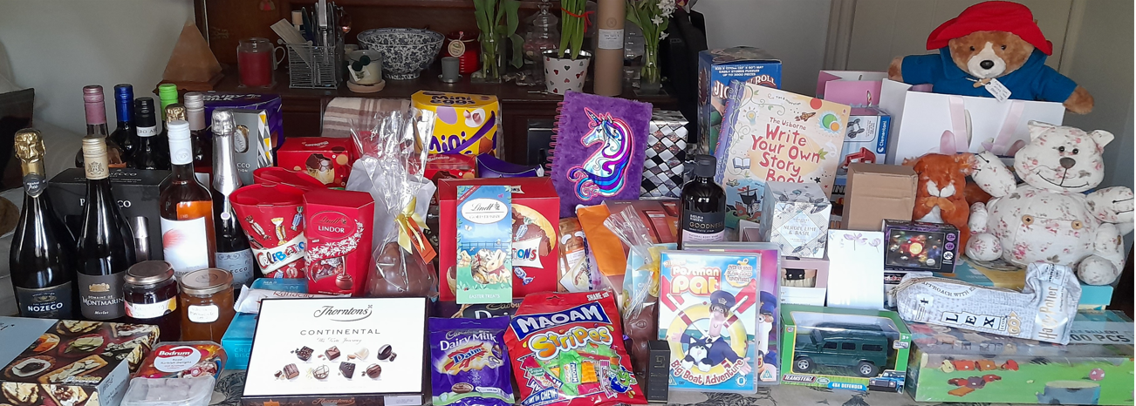

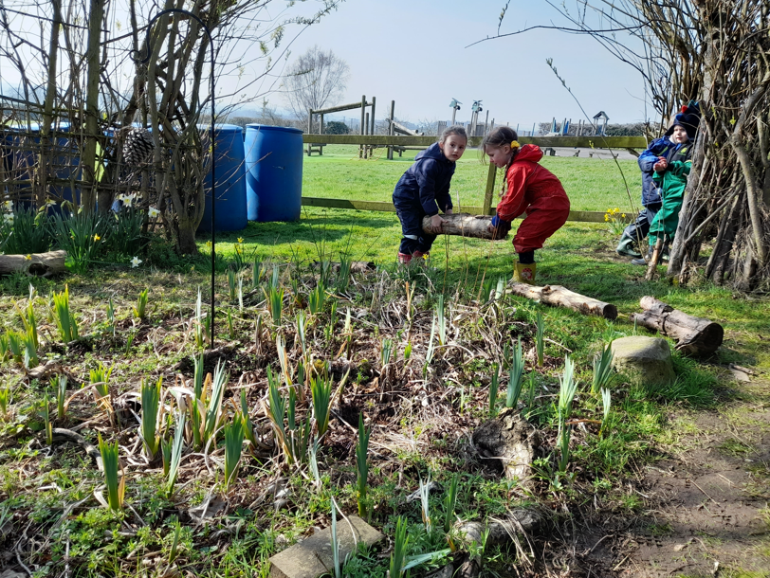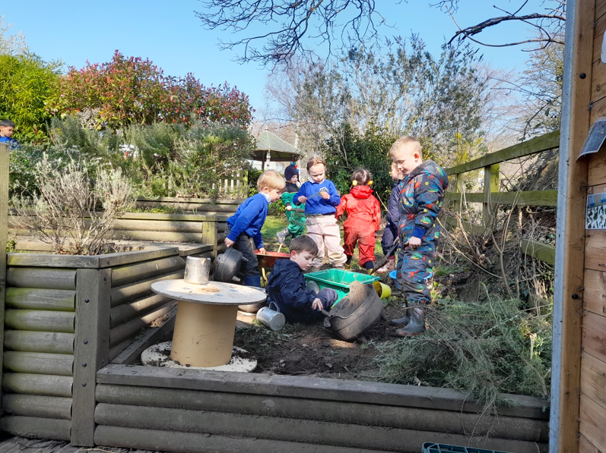

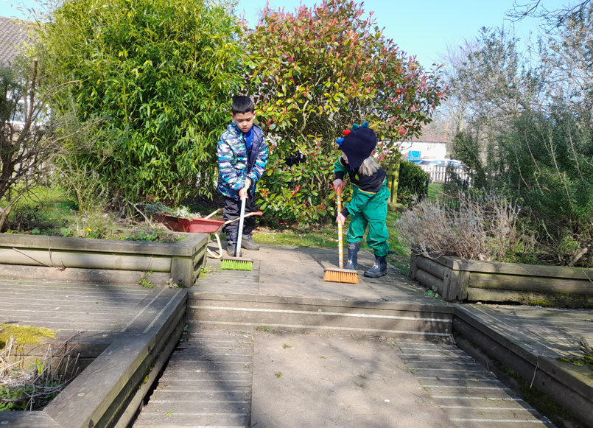

CHASA News

Calling All Pre-Loved Uniform!

CHASA will be running a regular stall selling pre-loved school uniform. The first stall will be outside school next Thursday 7th April at school pick up time. We would like to ask for parents help with uniform donations for the stall - please bring any unwanted school uniform (anything from uniform and PE kit to shoes and jackets) to school on Monday 4th April and leave in the box outside reception. All proceeds raised will be benefited by Crayke School Pupils, and pre-loved uniform will find a new home instead of going to Landfill. Going forward CHASA kindly ask you to keep hold of any unwanted uniform, as we will be doing regular collections. Thank you for your support and we look forward to seeing you at the stall on Thursday!
The CHASA team

Some dates for your diaries (more details to follow…)

Friday 8 April 2022 – Break the Rules day
Thursday 28 April 2022 – CHASA Committee Meeting
From Friday 29 April 2022 – Ice Cream Fridays
Friday 13 May 2022 – Film night
Saturday 18 June 2022 – Summer Fair

Plea from CHASA - We need your help!

The successful running of events depends on help from parents and carers of all children. If you are able to help with any of the above events, please contact:

Jonathan Dawson (Chairperson) on chasa@crayke.n-yorks.sch.uk or
Rebecca Stubbins (Secretary) on chasasecretary@crayke.n-yorks.sch.uk

In addition, we would be really grateful for Year Reps for Year 4 and Year 5 for the remainder of this academic year. If you would like any further information, or an informal chat about what the role entails, please contact either of the above.

CHASA News (Cont.)
EASTER BREAK THE RULES DAY
Friday 8th April 2022 
Dear Rule Breakers!
It’s here again…the best day ever…when you are allowed to break some of the strictest school rules! Yes!
For every rule broken the suggested donation is 50p to the school CHASA (Crayke Home and School Association) fund, however all and any donations are gratefully received. There are 10 rules that can be broken, and we have provided some guidance below on how you may break the rule.
Easter theme or Easter colours welcomed!
Also, when you are in school for the day on Friday 8th April, you are not allowed to break any further rules as they are there to help everyone have a positive and safe time in school; this is really important!
Please bring your money with you to school on the day and there will be collection buckets to put your donation in as you enter school and when you leave school.
Enjoy the fun and Happy Easter!
CHASA
School Rule | How to break it
- Have neat hair | You could gel up your hair in a funky way, wear a big hair accessory or spray your hair a different colour
- No temporary tattoos | You can wear a temporary tattoo
- No nail varnish | Paint your fingernails in a brightly coloured polish
- No non uniform tops or bottoms | You can wear any top and bottoms or dress/onesie
- Wear school shoes only | You could wear your favourite pair of trainers, suitable for a school day.  Please no heels or open toed shoes – you must still be in shoes that are safe for a school day
- Fill your water bottle with water only | You can bring squash or juice in your bottle (no fizzy drinks though please)
- Only wear white, black or grey socks | You can wear odd socks or brightly coloured socks/tights
- No caps or hats | You can wear your favourite hat / cap / EASTER EARS OR BONNET!
- No makeup to be worn | You can wear ONE item of makeup
- Stud earrings only | You may wear dangly earrings

Community News

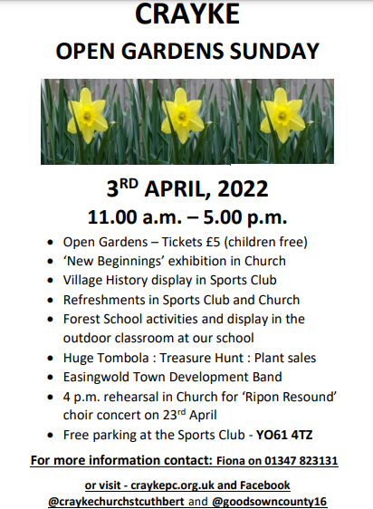

Design a Post to Inspire Sustainable Travel

Audience: all schools

The North Yorkshire County Council Sustainable Travel Team would like to invite everybody to create a piece of bespoke artwork to encourage and inspire others to use Active Travel modes. You may use any material (new or recycled) and any process, for example; drawing, painting, printmaking, textiles, collage or montage

We will select two winners who will each receive a £50.00 shopping voucher. The two winning entries will be enlarged and used in marketing campaigns across the county.

Artists have until Saturday 30th April to submit their artwork. Please see attached Use it Sketch it Share it poster.

Community News (cont.)

Easingwold Community Library are delighted to be hosting a comic book workshop. We will invite children to discover how to create their very own comics with artist Wendi New. Wendi runs “Scribble Zone”, an art club for young people at Northallerton Library. She created the illustrations for “Buzzy Bee’s Honey Hunt”, which can be seen in libraries across North Yorkshire.
The workshop is aimed at children aged 7-11, and we have limited places so any one who is interested will need to book. It is on the 20th of April (during the Easter holiday) from 10-11:30am.




 Stars of the Week

Stars | Class 1 | Class 2 | Class 3 | Class 4
Stars | Tabi Copley | Mabel Dawson | Brooke Smith | Annie Swan
Stars | Tabi Copley | Elijah Brown | Percy Ollive | Martha Brookes
Headteacher’s Awards | Isla Fenton |  | Brooke Smith

PE Kits

PE Kits  w/c 4 April | Monday | Tuesday | Wednesday | Thursday | Friday
APPLE (CH) |  | X |  | X | X
BEECH (FT) |  | X |  |  | X
HOLLY (LR) |  | X | X (last swim) |  | X
OAK (LC) | X | X |  |  | X
Please do ensure that on PE days, the children wear their hoodies, school jumpers or cardigans alongside white or blue t-shirts and black or navy shorts or jogging bottoms.
Children in Apple Class bring their kits to school on a Monday; take them home each Friday.

Attendance and Punctuality
Children will be marked late if they arrive after 9.00am
Please do help us in our mission to ensure that children are in school on time so that valuable learning time is not missed at the start of the day.

This week’s attendance figures: 85.7% School Target: 96%
Apple (CH): 85.4% 1 late | Beech (FT): 78.5%
Holly (LR): 92.6% | Oak (LC): 87% 1 late

School Lunch Menu

SPRING TERM  2022 | Week 1  w/c  4 April
Monday | Cheese & Tomato Pizza  Diced potatoes  Peas and sweetcorn  Chocolate Crunch  Fresh fruit or yogurt
Tuesday | Chicken & Broccoli  Pasta Bake  Green beans & carrots  Cheese and crackers  Fresh fruit or yogurt
Wednesday | Savoury Minced Beef & Yorkshire Pudding  Roast potatoes  Medley of vegetables  Fruit Jelly & Ice Cream  Fresh fruit or yogurt
Thursday | Sausage, Mash &  Onion Gravy  Roast Parsnips and broccoli  Apple Crumble with custard  Fresh fruit or yogurt
Friday | Fish Fingers  Chipped potatoes  Baked beans and peas  Fruity Jam sponge  Fresh fruit or yogurt

School Lunch Menu
SUMMER TERM | Week 1  w/c 25 April, 16 May,  13 June, 4 July | Week 2  w/c 2 & 23 May, 20 June, 11 July | Week 3  w/c 9 May, 6 & 27 June, 18 July
Monday | Creamy Cheese &Tomato Pasta Bake  Carrots & Broccoli  Crusty Bread  Orange Shortbread  Fresh Fruit or Fruit Yoghurt | Pasta Bolognaise Sweetcorn &  Green Beans  Garlic Bread  Marbled Sponge and Chocolate Sauce | Beef Burger in a Bun Chipped Potatoes  Grated Carrot & Sweetcorn  Cheese & Crackers  Fresh Fruit or Fruit Yoghurt
Tuesday | Chicken Wrap  Summer Veg Sticks  Fiesta Rice  Fruit Jelly with Ice-cream Fresh Fruit or Fruit Yoghurt | Margherita Pizza Homemade Potato Wedges  Peas & Sweetcorn  Chocolate & Vanilla Cookie with Orange Slice  Fresh Fruit or Fruit Yoghurt | Macaroni Cheese  Peas and Sweetcorn  Naan Bread  Chocolate Banana Brownie  Fresh Fruit or Fruit Yoghurt
Wednesday | Savoury Minced Beef & Vegetable Pie  Creamy Mashed Potato  Gravy  Medley of Summer Veg Sliced Wholemeal Bread  Cheese & Crackers  Fresh Fruit or Fruit Yoghurt | Roast Pork & Apple Sauce Gravy  Baby New Potatoes Broccoli & Carrots  HM 50/50 Bread  Raspberry & Apple Doughnut Muffin  Fresh Fruit or Fruit Yoghurt | Roast Chicken with Sage and Onion Stuffing  & Gravy  Creamy Mashed Potato Carrots & Summer Cabbage  Sliced Wholemeal Bread  Custard Cookie with Apple Wedge
Thursday | Sausage in a homemade bun with Tomato Ketchup Diced Potatoes  Mixed Summer Salad Coleslaw  Summer Mousse  Fresh Fruit or Fruit Yoghurt | Chicken Korma & Rice  Peas & Cauliflower  Naan Bread  Cheese & Crackers  Fresh Fruit or Fruit Yoghurt | HM Pork Sausage Roll  Baked Baby Potatoes Baked Beans  Sunflower Seed Bread  Summer Berry Crumble & Custard  Fresh Fruit or Fruit Yoghurt
Friday | Harry Ramsdens  Battered Fish  Chipped Potatoes  Baked Beans  Peas  Tomato Bread  Fresh Summer Fruit Platter Fruit Yoghurt | Fish Fingers  Chipped Potatoes  Mixed Summer Salad  Grated Carrot  Herbie Bread  Iced Lemon & Sultana Finger  Fresh Fruit or Fruit Yoghurt | Crunchy Fish Bites (Salmon)  HM Potato Wedges  Broccoli & Carrots  Tomato Ketchup  Crusty Bread  Summer Drizzle Cake Fresh Fruit or Fruit Yoghurt

Dates for your Diary

Monday 4 April 2022 | Parent meeting Year 5 residential Carlton Lodge 3:45pm
Tuesday 5 April 2022 | Chance to Shine Cricket – whole school
Tuesday 5 April 2022 | Easingwold library visit
Tuesday 5 April 2022 | Parent meeting Year 5 residential Robinwood 3:45pm
Friday 8 April 2022 | CHASA Break the Rules Day
w/c 9 May 2022 | Year 6 SATs tests
Friday 13 May 2022 | CHASA Film Night
w/c 16 May 2022 | Bikeability
Wed 25 – Friday 27 May 2022 | Year 5 residential – Carlton Lodge
Friday 10 – Sunday 12 June 2022 | Year 6 residential - Robinwood
Saturday 18 June 2022 | CHASA Summer Fair

Term Dates – Academic Year 2021/2022

Monday 11 April – Friday 22 April 2022 | School Closed – Easter Holiday
Monday 25 April 2022 | School closed to pupils – Training Day
Tuesday 26 April 2022 | School Reopens
Monday 2 May 2022 | School closed – May Day Bank Holiday
Monday 30 May – Friday 3 June 2022 | School Closed – HALF TERM
Monday 6 June 2022 | School Reopens
Friday 22 July 2022 | Last day of term for pupils
Monday 25 July 2022 | School closed to pupils – Training Day

Safeguarding concerns
A reminder that if you have any concerns about a child, please do not hesitate to get in contact by emailing headteacher@crayke.n-yorks.sch.uk
Please also be aware that as a school we subscribe to Operation Encompass, whereby we are notified of any incidences of domestic violence where a pupil at our school has been present.

Financial Assistance Free School Meals
If you are encountering financial difficulties at this time and would like a strictly confidential conversation about support that can be provided, please do not hesitate to get in touch.

Have a lovely weekend.

Judi Jackson
Headteacher
headteacher@crayke.n-yorks.sch.uk

