
Crayke C of E Primary School

FOLLOW YOUR PATHWAY AND WE GROW TOGETHER WITH CONFIDENCE
Respect Friendship Forgiveness Determination

Dear Parents and Carers,
Welcome back to Summer 2 – could someone please tell the weather that it’s June?!
It was a fabulous end to last half term being able to come together to celebrate our Jubilee Afternoon Tea. Watch out for photographs in the next edition of the Easingwold Advertiser! We hope that you enjoyed Jubilee celebrations last weekend with your loved ones. Discussions in school have continued this week to reflect upon the inspirational leadership and service demonstrated by Queen Elizabeth and the incredible achievements during her 70-year reign.

Robinwood Residential
Mrs Shirley and I are really looking forward to spending the weekend with the Year 6 pupils at Dobroyd Castle, Todmorden. It is sure to be a weekend of challenging but fun activities!
We will endeavour to keep you updated with photographs and texts but I am not sure how good the signal will be, so please don’t be alarmed if you do not hear from us. We are aiming to be back at school for 4pm on Sunday. We will send a text en-route to update you about our ETA.

Swimming
A reminder that next week (Thursday 16 June) is the final swim session for Beech class. Unfortunately, we have been unable to secure further swimming sessions for the remainder of the academic year due to high demand but we look forward to taking children again next academic year.

Jubilee Afternoon Tea – Unclaimed Item
We have taken possession of an item which was left behind after the afternoon tea. If you think it may be yours, please contact Mrs Bacon.

Leavers’ Service
I am delighted to confirm that we will be able to hold the Year 6 Leavers’ Service at St Cuthbert’s Church for the first time since 2019. In order to enable Rev. Katie Franks to join us this will be at the slightly later time of 11am. We do hope that you will be able to join us – all welcome.

Drop Off Arrangements – Information for all
With effect from Monday, the gate near the front door of school will be locked prior to 8:50am so all parents/carers dropping children off will need to exit via the staff car park.
In order to prepare for transition to Year 1, we would like Reception children to be dropped at the gate just like the older children and for them to come straight into school via their usual entrance.

Apple Class – A Day at the Seaside
On Wednesday June 15th, Apple Class will be spending a day at the ‘seaside’. Invitations with all the details were handed to the parents yesterday. We look forward to sharing the outcomes of this in next week’s newsletter!
Early collections from school
We have seen a recent increase in the number of parents wanting to collect children early for various after school activities. We understand that many important extra-curricular opportunities have been missed over time due to the pandemic. However, it is now becoming unmanageable and disruptive to the last teaching session. Therefore, please accept this as advance notice that, from the beginning of the next academic year (September 2022), we will no longer be able to allow children to leave before the end of the school day at 3:30pm for any after school activities. We hope that providing this much notice will enable alternative arrangements to be made in advance. Thank you for your support with this.

Spelling Lists – Summer 2

Please find below the spelling lists for the forthcoming half term. As always these are also available on the school website and your child will be bringing home paper copies this week.

Year 2
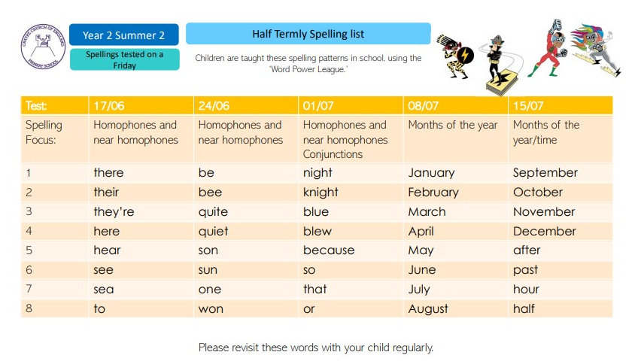

Year 3/4
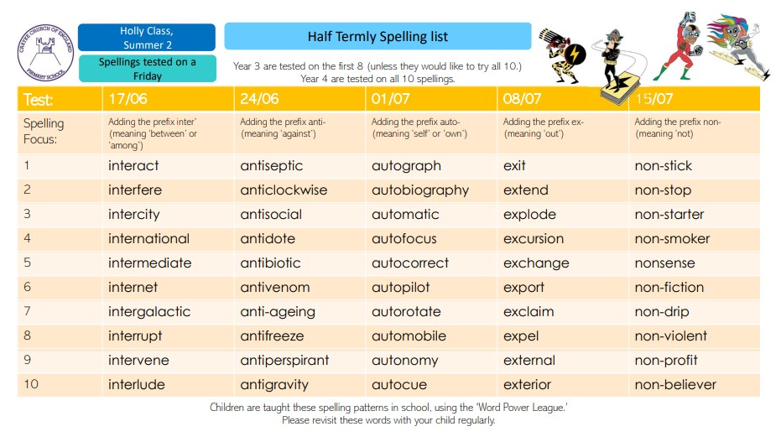

Year 5/6

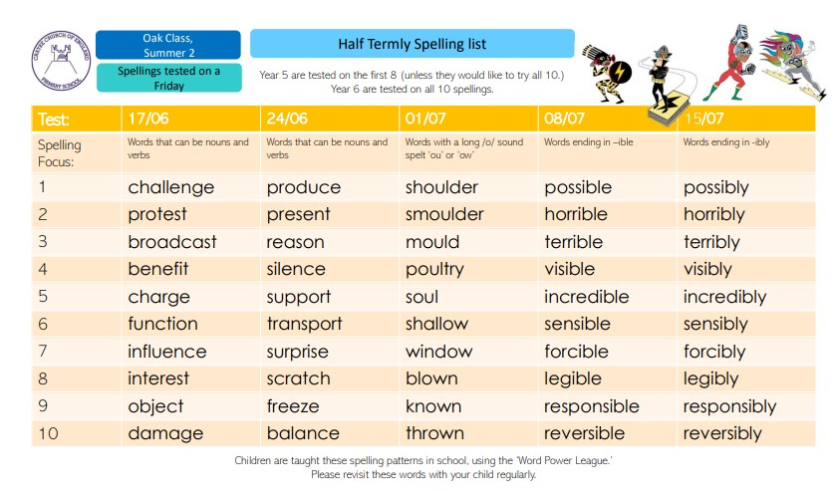
Extra-Curricular Clubs – Summer Term 2022
We are delighted to be able to offer a wide range of clubs for our children. Some clubs have limited capacity and places will be allocated on a first come first served basis. In the event of a club being fully booked, your child’s name will be added to a waiting list and you will be advised if a place becomes available. Booking is not required for lunchtime clubs. For after school clubs run by school staff (in blue type; denoted with *) please email Mrs Bacon on admin@crayke.n-yorks.sch.uk to book a place.
Before School Clubs
Club | Leader | Day and Time | Group
Run a Mile | Mrs Jackson | Tuesday and Thursday  8:30am | All welcome

Lunchtime Clubs
Club | Leader | Day | Group
Skipping | Mrs Helfferich | Monday | All
Reading Ambassadors | Mrs Rayner | Monday | Successful candidates
School Council | Miss Walker | Tuesday | Successful candidates
Girls Football | Mr Montgomery | Friday | Y4/5/6

After School Clubs

We respectfully ask you to check the collection time below carefully and to collect your children promptly at the end of clubs. Clubs will run unless you are notified otherwise.
Monday | STEM (fee paid direct to provider; email discovery-ice@outlook.com)  3:30pm – 4:30pm  Years 3 – 6  Discovery-ICE |  | British Sign Language* (no charge)  3:30pm – 4:15pm  Year 1 – 6  Mrs Aristizabal | Recorders* - NO CLUB 13/6  3:30pm – 4:00pm  Years 1 and 2  Mrs Shirley
Tuesday | Multi-sports (Fee paid direct)  3:30 – 4:30pm  Year R-6  Mr Cromack
Wednesday | Forest Schools* (no charge)  3:30pm – 4:15pm  Year 1 – 6  Mrs Helfferich | Times Tables* (no charge)  3:30pm – 4:15pm  Year 3/4  Mrs Rayner
Thursday | Homework  Year 5/6  Mrs Chandler | Football (fee paid direct) SESSIONS BOOKABLE FOR NEW AGE GROUP  3:30pm – 4:30pm  Years 3 – 6  York City Football Club  https://officialsoccerschools.co.uk/yorkcity/key-stage-2-crayke-primary-school-1.html
Friday | Unique Sports (fee paid direct to provider) NEW BLOCK OF SESSIONS BOOKABLE Booking Link: https://simoncarsonsportsschool.co.uk/shop/after-school-clubs/crayke-summer-2/  3:30 – 4:30pm  Years R-6  Simon Carson Sports School



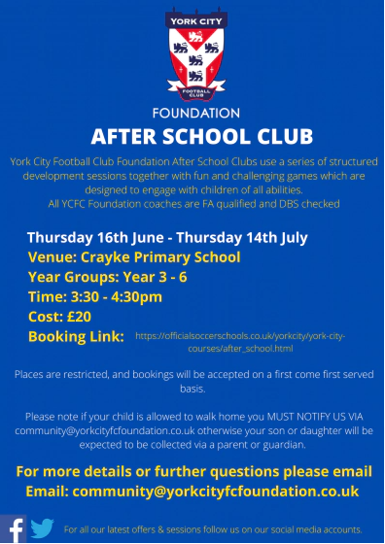



CHASA News
We were overwhelmed with your generosity yesterday – thank you so much for all the fantastic donations of raffle prizes, books, pre-loved uniform, teddies and jam jars. We are still able to take further donations next week so please do bring any other items into school via the office. Thank you.
HELP NEEDED!
In order to make the fair as successful as possible, we really could do with some additional volunteers to run stalls on the day. Even if you are able to give one hour on the day it would be so very much appreciated. Please contact Rebecca Stubbins CHASA Secretary on: chasasecretary@crayke.n-yorks.sch.uk if you are able to help. Thank you!

Cake Stall Donations
We kindly ask that cake donations for the Summer fair be brought into school on Friday 17th June or at the latest by 11.30am on the morning of Saturday 18th June. Cakes with fresh cream/ cheesecake / cream cheese toppings unfortunately cannot be refrigerated overnight so please bring them on the day. Many thanks for your support.




 Stars of the Week

Stars | Class 1 | Class 2 | Class 3 | Class 4
Stars | Tabi Copley | Year 1 | Isla Howland | William Piercy
Stars | Tabi Copley | Isla Grant | Aiden Simpson | Seb Hindley
Headteacher’s Awards | Carl Keaney |  | Penelope Ritchie

PE Kits

PE Kits  w/c 13 June | Monday | Tuesday | Wednesday | Thursday | Friday
APPLE (CH) |  |  |  | X | X
BEECH (LD) |  |  |  | X (final swim) | X
HOLLY (LR) |  |  |  | X | X
OAK (LC) |  | X |  |  | X
Please do ensure that on PE days, the children wear their hoodies, school jumpers or cardigans alongside white or blue t-shirts and black or navy shorts or jogging bottoms.

Attendance and Punctuality
Children will be marked late if they arrive after 9.00am
Please do help us in our mission to ensure that children are in school on time so that valuable learning time is not missed at the start of the day.

This week’s attendance figures: 93.5% School Target: 96%
Apple (CH): 99.2% 3 lates (1 child) | Beech (LD): 91.3% 0 lates
Holly (LR): 93% 1 late | Oak (LC): 93.7% 2 lates (1 child)

Team Points

Red | 247 | Yellow | 214
Blue | 198 | - Green  | 288

School Lunch Menu
SUMMER TERM | Week 1  w/c 13 June,  4 July | Week 2  w/c 20 June,  11 July | Week 3  w/c 27 June,  18 July
Monday | Creamy Cheese &Tomato Pasta Bake  Carrots & Broccoli  Crusty Bread  Orange Shortbread  Fresh Fruit or Fruit Yoghurt | Pasta Bolognaise Sweetcorn &  Green Beans  Garlic Bread  Marbled Sponge and Chocolate Sauce | Beef Burger in a Bun Chipped Potatoes  Grated Carrot & Sweetcorn  Cheese & Crackers  Fresh Fruit or Fruit Yoghurt
Tuesday | Chicken Wrap  Summer Veg Sticks  Fiesta Rice  Fruit Jelly with Ice-cream Fresh Fruit or Fruit Yoghurt | Margherita Pizza Homemade Potato Wedges  Peas & Sweetcorn  Chocolate & Vanilla Cookie with Orange Slice  Fresh Fruit or Fruit Yoghurt | Macaroni Cheese  Peas and Sweetcorn  Naan Bread  Chocolate Banana Brownie  Fresh Fruit or Fruit Yoghurt
Wednesday | Savoury Minced Beef & Vegetable Pie  Creamy Mashed Potato  Gravy  Medley of Summer Veg Sliced Wholemeal Bread  Cheese & Crackers  Fresh Fruit or Fruit Yoghurt | Roast Pork & Apple Sauce Gravy  Baby New Potatoes Broccoli & Carrots  HM 50/50 Bread  Raspberry & Apple Doughnut Muffin  Fresh Fruit or Fruit Yoghurt | Roast Chicken with Sage and Onion Stuffing  & Gravy  Creamy Mashed Potato Carrots & Summer Cabbage  Sliced Wholemeal Bread  Custard Cookie with Apple Wedge
Thursday | Sausage in a homemade bun with Tomato Ketchup Diced Potatoes  Mixed Summer Salad Coleslaw  Summer Mousse  Fresh Fruit or Fruit Yoghurt | Chicken Korma & Rice  Peas & Cauliflower  Naan Bread  Cheese & Crackers  Fresh Fruit or Fruit Yoghurt | HM Pork Sausage Roll  Baked Baby Potatoes Baked Beans  Sunflower Seed Bread  Summer Berry Crumble & Custard  Fresh Fruit or Fruit Yoghurt
Friday | Harry Ramsdens  Battered Fish  Chipped Potatoes  Baked Beans  Peas  Tomato Bread  Fresh Summer Fruit Platter Fruit Yoghurt | Fish Fingers  Chipped Potatoes  Mixed Summer Salad  Grated Carrot  Herbie Bread  Iced Lemon & Sultana Finger  Fresh Fruit or Fruit Yoghurt | Crunchy Fish Bites (Salmon)  HM Potato Wedges  Broccoli & Carrots  Tomato Ketchup  Crusty Bread  Summer Drizzle Cake Fresh Fruit or Fruit Yoghurt

Crayke Church of England Primary School

Dates for your Diary – Summer Term 2022

In order to help you plan ahead and book time off work where necessary, we have mapped out as many dates as possible for this term.
Please note that additional sporting events and other dates will be added; please always read the weekly newsletter for updates.

Day | Date | Event | Who | Where
Fridays | All term  (Not 17/6) | CHASA Ice Cream Fridays | Whole school | Gazebo
Friday - Sunday | 10 – 12 June | Residential | Year 6 | Dobroyd Castle Todmorden
Monday | 13 June | Multiplication Tables Check this week | Year 4 | School
Tuesday | 14 June | Ancient Egypt Virtual Visit – British Museum | Year 3/4 | Holly Classroom
Thursday | 16 June | Final swimming session | Year 1/2 | Thirsk
Thursday | 16 June | Create and Pray - After School* | All welcome – book by email | School hall
Saturday | 18 June | CHASA Summer Fair | All welcome | School
Friday | 24 June | Sports Day – picnic and afternoon  Parents and carers welcome | Whole school | Outside
Monday | 27 June | Diocese Leavers’ Service | Year 6 | Northallerton
Tuesday | 28 June | First Aid Training | Year 4/5 | Hall
Friday | 1 July | Whole School Photograph | Whole school | Outside
Friday | 1 July | Reserve date - Sports Day  Parents and carers welcome | Whole school | Outside
Tuesday | 5 July | Celebration Afternoon – Open School 2:15pm  Parents and carers welcome | Whole school | Classrooms
Thursday | 7 July | Educational visit to The Yorkshire Arboretum – further details to follow* | Beech Class | Castle Howard Arboretum

w/c 18 July |  | Reports to parents | Whole school | Reports home
Monday | 18 July | KS2 Production Dress Rehearsal | KS2 | Hall
Tuesday | 19 July | KS2 Production – Afternoon performance [2pm] | KS2 | Hall
Wednesday | 20 July | Box2Bfit – parents welcome to join – further details to follow* | Whole school | Outside
Wednesday | 20 July | KS2 Production – Evening performance [6pm] | KS2 | Hall
Thursday | 21 July | Colour Run | Whole school | Outside
Friday | 22 July | Leavers’ Service 11am**  Parents and carers welcome | Whole school | Church
Friday | 22 July | School closes to pupils 2:30pm | All children | School

Tuesday | 6 Sept | School opens for new academic year | All children | School

*New date added this week

** New time
Term Dates – Academic Year 2021/2022

Monday 30 May – Friday 3 June 2022 | School Closed – HALF TERM
Monday 6 June 2022 | School Reopens
Friday 22 July 2022 | Last day of term for pupils
Monday 25 July 2022 | School closed to pupils – Training Day
Academic Year 2022/2023
Autumn Term Tuesday 6th September to Friday 16th December, 2022
Half Term Monday 24th October to return on Monday 31st October
Spring Term Wednesday 4th January to Friday 31st March 2023
Half Term Monday 13th February to return on Monday 20th February
Summer Term Tuesday 18th April to Friday 21st July 2023
May Day Monday 1st May 2023
Half Term Monday 29th May to return on Monday 5th June
INSET Days (School Closed to pupils) –
Monday 5th September 2022
Tuesday 3rd January 2023
Monday 17th April 2023
Monday 24th July 2023
Tuesday 25th July 2023

Safeguarding concerns
A reminder that if you have any concerns about a child, please do not hesitate to get in contact by emailing headteacher@crayke.n-yorks.sch.uk
Please also be aware that as a school we subscribe to Operation Encompass, whereby we are notified of any incidences of domestic violence where a pupil at our school has been present.

Financial Assistance Free School Meals
If you are encountering financial difficulties at this time and would like a strictly confidential conversation about support that can be provided, please do not hesitate to get in touch.

Judi Jackson
Headteacher headteacher@crayke.n-yorks.sch.uk

