
Crayke Church of England Primary School
FOLLOW YOUR PATHWAY AND WE GROW TOGETHER WITH CONFIDENCE
You did not choose me, I chose you that you might go and bear fruit, fruit that will last so that whatever you ask in my name the Father will give you. John 15:16
Respect Friendship Forgiveness Determination

Dear Parents and Carers,
Sports Day Success!
We are still all absolutely buzzing about how brilliant Sports Day was last Friday and we are all so appreciative of your lovely feedback and positive comments about how well it went and how lovely it was to be able to watch Sports Day – for many parents, it was the first opportunity to do so.
Message from Mrs Helfferich, PE Subject Leader:
Congratulations to all the children who took part in last week’s Sports Day. Your impeccable behaviour, kindness, determination and working as part of a team has been commended by staff, governors and spectators. Well done.
We all know that the most important part of these events is the taking part and trying your best but we also know that you were awarded points for each activity. These have been added up by Mrs Shirley (Thank you Mrs Shirley) and we can announce that the following teams were our top three scoring teams:
 | Team | Points
1st | Yellow 3 | 932
2nd | Red 2 | 788
3rd | Blue 3 | 740

Thank you to all the staff for their help, the children for their super attitudes and effort and to all the parents/carers who attended… and participated!

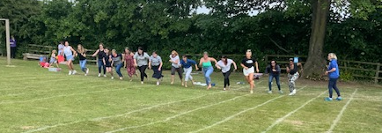

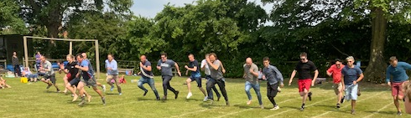
Welcome to our New Starters!
What an absolutely fabulous little bunch of Reception new starters we welcomed into school on Wednesday morning. They are delightful! We can’t wait for them to come back again next Wednesday afternoon (6 July) and the following Wednesday for the morning and lunch (13 July).

Year 6 Leavers’ Service – Northallerton
On Monday our Year 6 children had the opportunity to visit All Saints’ Church in Northallerton along with several other local schools, organised by the Diocese of York. They thoroughly enjoyed the experience!

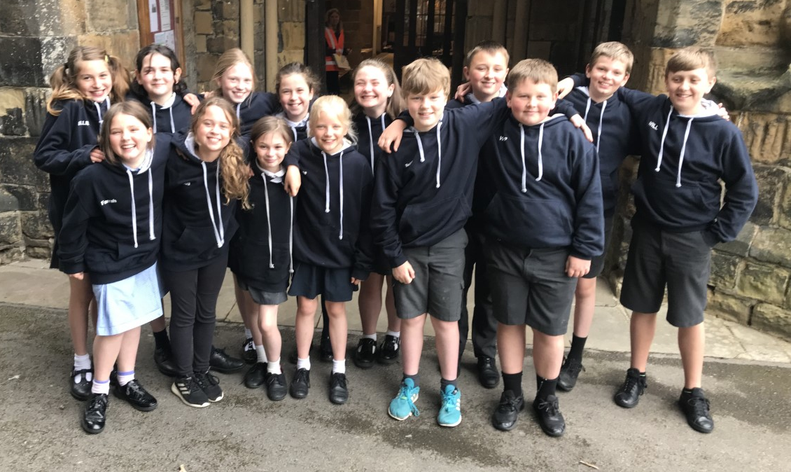

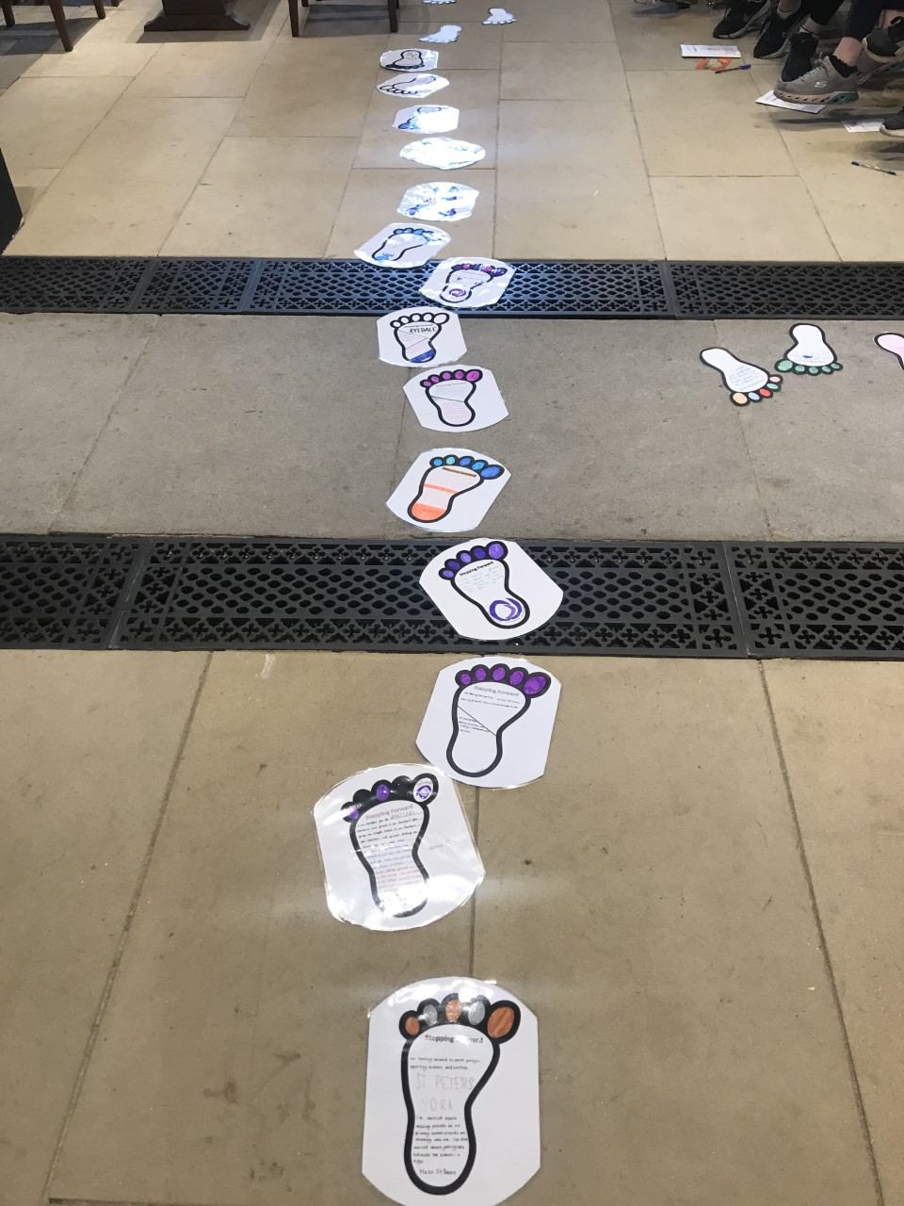

Celebration Afternoon – Tuesday 5 July

Join us in school from 2:15pm on Tuesday 5 July for an opportunity to visit your child’s class, experience a flavour of their school day and learn about some of the topics your child has covered this year.
In addition, there will be singing performances by each class at the following times:
Oak – 2:40pm
Holly – 2:50pm
Beech - 3:00pm
Apple - 3:10pm
So far, we have received 30 responses to our survey. Please do let us know if you will be joining us by completing this short form: https://forms.office.com/r/tzS3xYSn5v before the end of today. Thank you!

Please note that photographs and videos are not permitted during this event. In addition, this will not be an opportunity to speak to your child’s class teacher on an individual basis but, as always, please do make an appointment to discuss any concerns you may have about any aspect of your child’s wellbeing or development.
Annual written school reports will be sent home by pupil post during the final week of this term.

Educational Visits – Apple and Beech Classes
We are really pleased to confirm that children in Apple and Beech classes are both getting an opportunity to go on an educational visit next week. Beech will be visiting the Yorkshire Arboretum on Thursday and Apple will be going to the Elvington Air Museum on Friday. The cost of both trips has been subsidised by CHASA, for which we are really grateful. I have no doubt that both classes will have brilliant days out which will be memorable experiences to enhance the learning of their current topics.

First Aid “Mini Medics” Sessions – Year 4 and Year 5
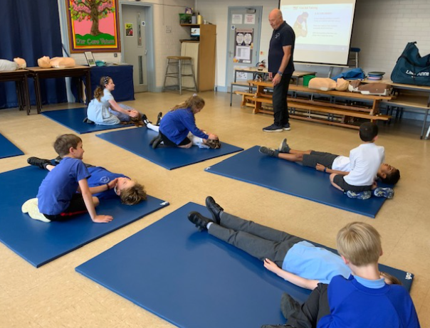
Kevin from Quantum First Aid worked with pupils in Years 4 and 5 this week and seems to have quite the impact.

I have since heard that children are now asking for first aid kits for their birthdays and have witnessed children practising their newly acquired skills on each other during playtimes!

Kevin was delighted to have had the opportunity to deliver sessions in a “thriving local school” and we hope to be able to work with him again in the future.
Whole School Photograph
It was fabulous to have everyone together this morning for the first whole school photograph since 2019! The proof should be available by the middle of next week for you to be able to view to purchase if you would like to do so.

School Meal Price
Due to the increase in national insurance and the cost of food, our catering provider has increased their fixed meal cost. From September 2022, the cost of a school meal for pupils In Year 3 and above (who are not in receipt of a free school meal) will be £2.90.
All pupils from Reception to Year 2 are entitled to a Universal Free School Meal but school receives funding for your child if you are eligible and complete the free school meal application form.
We understand that many families are under pressure and the cost of living continues to increase. We strongly encourage all of our families (regardless of their year group) to complete a free school meal application form available here: https://craykeschool.org/school-lunches/ if you think you may be entitled.

Our Safeguarding Team
At Crayke, we have three members of staff and a governor who make up our Safeguarding Leadership Team. I am the Designated Safeguarding Lead, which means that I am the lead person responsible for child protection and safeguarding issues. Mrs Rayner and Mrs Chandler are our Deputy Designated Safeguarding Leads (Deputy DSLs); a deputy DSL supports the DSL in their role of safeguarding and child protection. Mr Hugh Porter is our Safeguarding Link Governor. The role of the Safeguarding Governor is to support the DSL as well as to regularly review, ask questions and make suggestions about our safeguarding policies and procedures and to report back to the governing body.
All staff at Crayke know that safeguarding is EVERYONE’S responsibility. Find out more on our dedicated website Safeguarding page: https://craykeschool.org/safeguarding/
You can also report any safeguarding concerns to our DSL email: dsl@crayke.n-yorks.sch.uk
Please also be aware that as a school we subscribe to Operation Encompass, whereby we are notified of any incidences of domestic violence where a pupil at our school has been present.

Extra-Curricular Clubs
Please note that there will be NO CLUBS AT ALL during the last week of this term. Therefore, the final clubs will be run during week commencing 11 July. We do try our best to only cancel clubs in exceptional circumstances, but please do keep an eye on your text messages from the Teacher2Parents app in case we unavoidably do have to cancel a session for any reason.
Clubs will resume in September and we would be grateful for any ideas of clubs you might like to see on our schedule for next year.

Extra-Curricular Clubs – Summer Term 2022
We are delighted to be able to offer a wide range of clubs for our children. Some clubs have limited capacity and places will be allocated on a first come first served basis. In the event of a club being fully booked, your child’s name will be added to a waiting list and you will be advised if a place becomes available. Booking is not required for lunchtime clubs. For after school clubs run by school staff (in red type; denoted with *) please email Mrs Bacon on admin@crayke.n-yorks.sch.uk to book a place.
Before School Clubs
Club | Leader | Day and Time | Group
Run a Mile | Mrs Jackson | Tuesday and Thursday  8:30am | All welcome

Lunchtime Clubs
Club | Leader | Day | Group
Skipping | Mrs Helfferich | Monday | All
Reading Ambassadors | Mrs Rayner | Monday | Successful candidates
School Council | Miss Walker | Tuesday | Successful candidates
Girls Football | Mr Montgomery | Friday | Y4/5/6

After School Clubs

We respectfully ask you to check the collection time below carefully and to collect your children promptly at the end of clubs. Clubs will run unless you are notified otherwise.
Monday | STEM  3:30pm – 4:30pm  Years 3 – 6  Discovery-ICE |  | British Sign Language* (no charge)  3:30pm – 4:15pm  Year 1 – 6  Mrs Aristizabal | Recorders*  3:30pm – 4:00pm  Years 1 and 2  Mrs Shirley
Tuesday | Multi-sports (Fee paid direct)  3:30 – 4:30pm  Year R-6  Mr Cromack
Wednesday | Forest Schools* (no charge)  3:30pm – 4:15pm  Year 1 – 6  Mrs Helfferich | Times Tables* (no charge)  3:30pm – 4:15pm  Year 3/4  Mrs Rayner
Thursday | Homework*  3:30pm – 4:15pm  Year 5/6  Mrs Chandler | Football (fee paid direct)  3:30pm – 4:30pm  Years 3 – 6  York City Football Club
Friday | Unique Sports (fee paid direct to provider)  3:30 – 4:30pm  Years R-6  Simon Carson Sports School

CHASA News
Please support CHASA for free!!

By clicking this link:
https://smile.amazon.co.uk/ch/1119662-0



You will need to turn on Amazon Smile in the settings section of the app.



 Stars of the Week

Stars | Class 1 | Class 2 | Class 3 | Class 4
Stars | Sophy Triffitt | Arthur Barrett | Oskar Braidwood | Nat Fenton
Stars | Sophy Triffitt | Wynter Brierley | Florence Hindley | Odin Dawson
Headteacher’s Awards | George Ritchie |  | Riley Hunsdale

PE Kits

PE Kits  w/c 4 July | Monday | Tuesday | Wednesday | Thursday | Friday
APPLE (CH) |  |  |  | X | X
BEECH (LD) |  |  |  | X | X
HOLLY (LR) |  |  |  | X | X
OAK (LC) |  | X |  |  | X
Please do ensure that on PE days, the children wear their hoodies, school jumpers or cardigans alongside white or blue t-shirts and black or navy shorts or jogging bottoms.

Attendance and Punctuality
Children will be marked late if they arrive after 9.00am
Please do help us in our mission to ensure that children are in school on time so that valuable learning time is not missed at the start of the day.

This week’s attendance figures: 95.5% School Target: 96%
Apple (CH): 97% 3 lates (1 child) | Beech (LD): 94.9% 7 lates (3 children)
Holly (LR): 95.4% 3 lates (3 children) | Oak (LC): 96.7% 3 lates (1child)

Team Points

Red | 329 | Yellow | 229
Blue | 270 | Green | 297

School Lunch Menu
SUMMER TERM | Week 1  w/c 4 July | Week 2  w/c 11 July | Week 3  w/c 18 July
Monday | Creamy Cheese &Tomato Pasta Bake  Carrots & Broccoli  Crusty Bread  Orange Shortbread  Fresh Fruit or Fruit Yoghurt | Pasta Bolognaise Sweetcorn &  Green Beans  Garlic Bread  Marbled Sponge and Chocolate Sauce | Beef Burger in a Bun Chipped Potatoes  Grated Carrot & Sweetcorn  Cheese & Crackers  Fresh Fruit or Fruit Yoghurt
Tuesday | Chicken Wrap  Summer Veg Sticks  Fiesta Rice  Fruit Jelly with Ice-cream Fresh Fruit or Fruit Yoghurt | Chicken Korma & Rice  Peas & Cauliflower  Naan Bread  Cheese & Crackers  Fresh Fruit or Fruit Yoghurt | Macaroni Cheese  Peas and Sweetcorn  Naan Bread  Chocolate Banana Brownie  Fresh Fruit or Fruit Yoghurt
Wednesday | Savoury Minced Beef & Vegetable Pie  Creamy Mashed Potato  Gravy  Medley of Summer Veg Sliced Wholemeal Bread  Cheese & Crackers  Fresh Fruit or Fruit Yoghurt | Margherita Pizza Homemade Potato Wedges  Peas & Sweetcorn  Chocolate & Vanilla Cookie with Orange Slice  Fresh Fruit or Fruit Yoghurt | Roast Chicken with Sage and Onion Stuffing  & Gravy  Creamy Mashed Potato Carrots & Summer Cabbage  Sliced Wholemeal Bread  Custard Cookie with Apple Wedge
Thursday | Sausage in a homemade bun with Tomato Ketchup Diced Potatoes  Mixed Summer Salad Coleslaw  Summer Mousse  Fresh Fruit or Fruit Yoghurt | Roast Pork & Apple Sauce Gravy  Baby New Potatoes Broccoli & Carrots  HM 50/50 Bread  Raspberry & Apple Doughnut Muffin  Fresh Fruit or Fruit Yoghurt | YEAR 6 LEAVERS’ CHOICE:  Pizza  Apple crumble
Friday | Harry Ramsdens  Battered Fish  Chipped Potatoes  Baked Beans  Peas  Tomato Bread  Fresh Summer Fruit Platter Fruit Yoghurt | Fish Fingers  Chipped Potatoes  Mixed Summer Salad  Grated Carrot  Herbie Bread  Iced Lemon & Sultana Finger  Fresh Fruit or Fruit Yoghurt | Whole School Picnic Lunch  including:  Selection of sandwiches  Vegetable sticks  Cake

Crayke Church of England Primary School
Dates for your Diary – Summer Term 2022

In order to help you plan ahead and book time off work where necessary, we have mapped out as many dates as possible for this term.
Please note that additional sporting events and other dates will be added; please always read the weekly newsletter for updates.
Day |  | Date | Event | Who | Where
Fridays |  | All term | CHASA Ice Cream Fridays | Whole school | Gazebo
Tuesday |  | 5 July | Celebration Afternoon – Open School 2:15pm  Parents and carers welcome | Whole school | Classrooms
Thursday |  | 7 July | Educational visit to The Yorkshire Arboretum | Beech Class | Castle Howard Arboretum
Friday |  | 8 July | Educational visit to Elvington Air Museum** | Apple Class | Elvington
Monday |  | 11 July | Languages Morning | Year 5 | Outwood Academy
w/c 18 July |  |  | Reports to parents | Whole school | Reports home
Monday | 18 July |  | KS2 Production Dress Rehearsal | KS2 | Hall
Tuesday | 19 July |  | KS2 Production – Afternoon performance [2pm] | KS2 | Hall
Wednesday | 20 July |  | Box2Bfit  Parents welcome to join | Whole school | Outside
Wednesday | 20 July |  | KS2 Production – Evening performance [6pm] | KS2 | Hall
Thursday | 21 July |  | Colour Run | Whole school | Outside
Friday | 22 July |  | Leavers’ Service 11am  Parents and carers welcome | Whole school | Church
Friday | 22 July |  | School closes to pupils 2:30pm | All children | School

Tuesday | 6 Sept | School opens for new academic year | All children | School

**New date added this week
Term Dates – Academic Year 2021/2022

Friday 22 July 2022 | Last day of term for pupils
Monday 25 July 2022 | School closed to pupils – Training Day
Academic Year 2022/2023
Autumn Term Tuesday 6th September to Friday 16th December, 2022
Half Term Monday 24th October to return on Monday 31st October
Spring Term Wednesday 4th January to Friday 31st March 2023
Half Term Monday 13th February to return on Monday 20th February
Summer Term Tuesday 18th April to Friday 21st July 2023
May Day Monday 1st May 2023
Half Term Monday 29th May to return on Monday 5th June
INSET Days (School Closed to pupils) –
Monday 5th September 2022
Tuesday 3rd January 2023
Monday 17th April 2023
Monday 24th July 2023
Tuesday 25th July 2023

Judi Jackson
Headteacher headteacher@crayke.n-yorks.sch.uk

