
Crayke Church of England Primary School
FOLLOW YOUR PATHWAY AND WE GROW TOGETHER WITH CONFIDENCE
You did not choose me, I chose you that you might go and bear fruit, fruit that will last so that whatever you ask in my name the Father will give you. John 15:16
Respect Friendship Forgiveness Determination

Dear Parents and Carers,

What. A. Week!
We seem to have crammed so very much in to the final few days in school and it has been just amazing! It seems hard to believe that only a few days ago the children were performing in the end of year show and that we were all sweltering in extreme temperatures! The KS2 production of Splash was incredible, the colour run was fantastic, Box2BFit was brilliant and the Leavers’ Service was both emotional and memorable. We now send our leavers on their way with our love and very best wishes for a bright and glittering future. For everyone else, we can’t wait to see you back at school on Tuesday 6 September 2022; the gates will be open at 8:50am!

End of Year Review
The end of the academic year is always a bittersweet time, where we both bid farewell to our wonderful Year 6 pupils and begin preparations for the new starters. It’s also a time to reflect on the year which has gone before us. Whilst this has been the first academic year since 2019 where the children haven’t been subject to school closures, there have still been significant disruptions to attendance due to times of isolation and illness. We can only hope that next year will be smoother and with less disruptions.

The end of the academic year also marks the opportunity to say a heartfelt thank you to our amazing wider staff team, who are absolutely incredible. Thanks to you all as parents and carers, to the governors and to CHASA, all of whom have worked tirelessly to ensure the best outcomes for our pupils. Most importantly, thanks to the children – we are lucky to have the very best in the land and they are the jewels in our crown!

On behalf of all the staff, thank you for ALL the cards, gifts and well-wishes we have received this week – we really do appreciate it.

As many hands that build a house, so many hearts make a school.

Year 6 Leavers’ Gift
A huge thank you to the Year 6 parents and carers who contributed to the leavers’ gift of a table top oven, as an upgraded replacement for the one which broke recently. This will allow us to cook, bake and use in science teaching activities. We are so grateful - thank you!

Farewell Year 6!

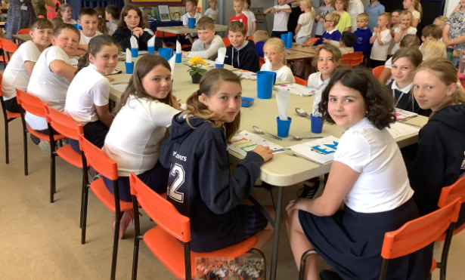

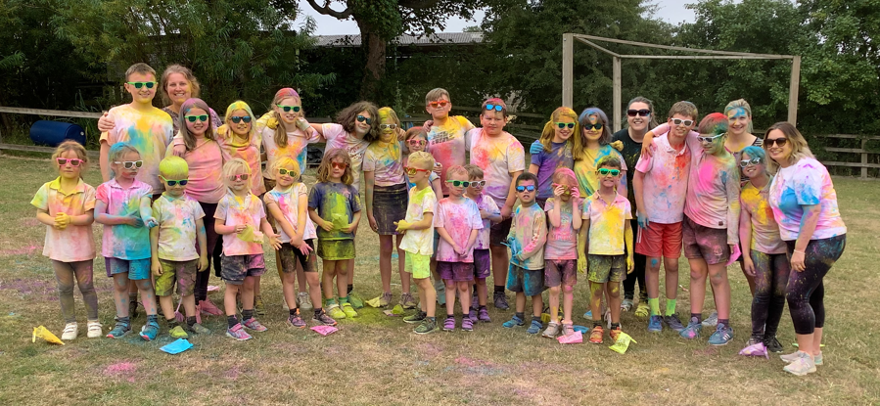

Year 6 - What a super group you have been! It’s been a week of high emotion all round but we hope that we have given you a send-off to remember. Keep Crayke in your hearts, wherever you may end up and we hope that you will remember your primary school days as being filled with fun, laughter and enjoyment. We look forward to hearing of your future successes and achievements!

Harry Hall Cup Winners
In conjunction with Mr Montgomery and Mrs Shirley, I am delighted to have awarded the Harry Hall Cup for 2022 today to Penelope and Ted.

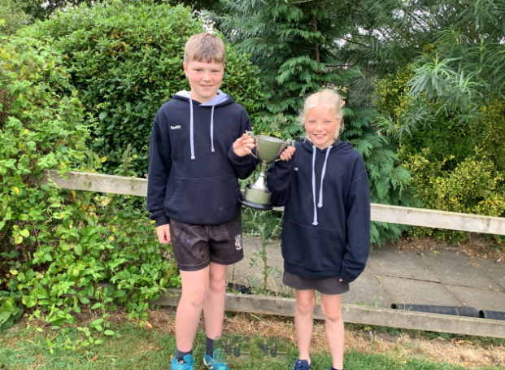

The Harry Hall Cup is awarded for ‘All round sporting ability’ and no better two pupils embody this statement than Pepe and Ted.

Here is what Mr M has to say about our two award winners:
Pepe-when I first came to Crayke, Pepe was the first child who caught my eye with her enthusiasm towards PE. She always enjoyed every topic and performed at a good standard. She always encourages classmates to fulfil their potential and sets a good standard for everyone else to follow. She consistently did well at individual competitions during Covid. Pepe will definitely thrive when she moves to Ryedale and I hope she maintains her enthusiasm for sport!

Ted- He always set a great example to the other children with his enthusiasm and his maturity towards PE. He always puts 100% into challenges and has always been healthily competitive. Ted is someone who is a great leader and other children look up to him. Just like his sister, who also always enjoyed PE, I am sure that he will thrive when he takes his next step in education.

Ultimately, Pepe and Ted consistently demonstrate the values of 'Being a Crayke Sportsperson' through their determination, respect, friendship and forgiveness - we are very proud of them. I’m sure you’ll join me in congratulating them on their achievement. I’m certain they will continue to enjoy and excel at sport at secondary school.

Three cheers for Pepe and Ted! Hip-Hip-Hooray, Hip-Hip-Hooray, Hip-Hip-Hooray.

Mrs Chandler

Annual Reports
Reports were sent home earlier this week. Should you wish to provide any feedback, please do so using this weblink: https://forms.office.com/r/sdJ9CKQPrQ

Parent Survey
In total, 38 parents/carers completed our survey. The responses were overwhelmingly positive. Thank you for your lovely comments and constructive feedback. Importantly, 100% of you would recommend Crayke school to another parent/carer – thank you!
A full analysis of the outcomes and our response to your suggestions will follow early in the Autumn Term.

Work Experience Students
Over the past four weeks we have been fortunate to have had 5 work experience students from 4 different settings as follows:

Zizi and Lottie – Ryedale School
Will – Thirsk School and Sixth Form College
Abi – Outwood Academy Easingwold
Alfie – The Joseph Rowntree School

The students have all been fantastic, experiencing working alongside children of all ages, being outside at playtime and lunchtime. Will even taught a German lesson or two to the older children and Abi joined Apple class on their educational visit last week. It has been fantastic to work in partnership with a range of secondary schools and we look forward to being able to do so again next year.

Staffing
Today we say a fond farewell to Mrs Peacock who is going on maternity leave ahead of her baby who is due to be born in September.

The Big Picture Project
We were thrilled to be able to share the finished project with the children in Achievement Assembly yesterday. The children were proud to be able to see the art and drama outcomes of their work as well as to hear the audio recordings of their poetry. They also enjoyed the opportunity to see what other children from local schools contributed to the project.
 Termly Values Awards

 | Friendship | Forgiveness | Respect | Determination
Apple | Amber Brown | Fenton Ward | Sophy Triffitt | Joshua Griffin-Miles
Beech | Alfie Burnett-Armstrong | Elijah Brown | India Ward | Riley Hunsdale
Holly | Beatrice Ritchie | Asa Champion | Ted Clark | Alice Unsworth
Oak | Annie Swan | Seb Hindley | Emma Swiers | William Piercy
Headteacher | Betty Strong | Arthur Barrett | Sienna Jagger | Cyrus Saeedi

Attendance and Punctuality
Children will be marked late if they arrive after 9.00am
Please do help us in our mission to ensure that children are in school on time so that valuable learning time is not missed at the start of the day.

This week’s attendance figures: 89.8% School Target: 96%
Apple (CH): 92.3% 4 lates (3 children) | Beech (LD): 81.9% 2 lates (2 children)
Holly (LR): 89.2% 1 late | Oak (LC): 98.8% 2 lates (2 children)

CHASA News
Parents and carers of Reception new starters are warmly welcomed to join us at 7pm on Thursday 22 September 2022 at the Durham Ox. This will be a great opportunity for you to meet each other and also to learn more about the role CHASA plays within our school community.

All parents and carers are invited to join the CHASA AGM meeting on Thursday 6 October at 3:45pm in school.
Community News
EXTENDED DEADLINE: NHSE are looking for feedback about the School Age Immunisation Service from children, parents, carers, schools, and education partners.

We would be grateful if you can distribute the survey via all available communication mechanisms and network streams. The survey will be accessible via the following link or QR code below and will close on Tuesday 2nd August 2022.

SURVEY LINK: School Aged Immunisation Survey for Children, Parents & Carers, and School & Education Stakeholders

Summer Holiday Activity Ideas

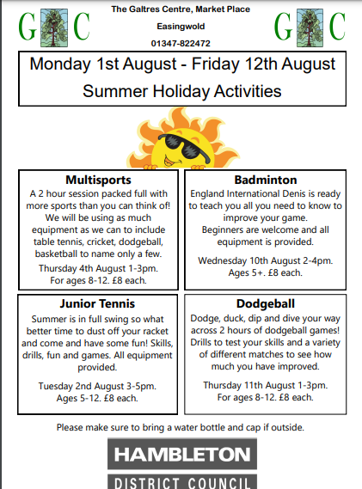

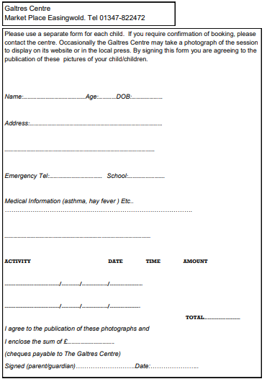
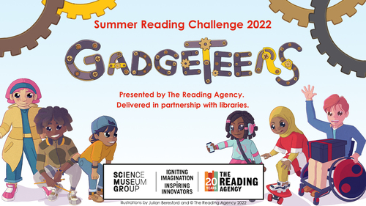
Get inventive with the Summer Reading Challenge 2022!
Children can once again sign up for the Summer Reading Challenge at their local library during the holidays. This year the theme is Gadgeteers and is all about getting creative with science and inventions.
The challenge for children is to read 6 library books of their choice and collect special stickers and other prizes along the way – everyone who finishes will receive a limited edition Gadgeteers medal and a certificate. Any child aged 4 to 11 can join in and the challenge runs from Sat 16th July until Sat 10th Sept.
There will also be a fantastic programme of activities in libraries all summer, many of them free, to go with the challenge – flyers with more details will be sent to school for children to bring home.

M.C.S.S SPORTS DEVELOPMENT PROGRAMME

CRAYKE MULTI SPORTS HOLIDAY CAMP 2022

The coaching sessions are designed for REC – Y6 who would like to learn new skills, improve existing skills or anyone who enjoys their sport. Instructed by fully qualified, experienced DBS checked staff. Children will be able to play in a safe and friendly environment. Prizes and awards are presented to any children showing good attitude, behaviour, sportsmanship and improvement

HIGHLIGHTS INCLUDE:
*Football *Ten Pin Bowling
*Hockey *Badminton/tennis
*Basketball/Volleyball *Dodgeball
*Athletics/assault course *Tag Rugby
*Darts / STREET DANCE *Cricket

Course information
Venue : CRAYKE PRIMARY SCHOOL
Date: MONDAY 15TH – WEDNESDAY 17TH AUGUST 2022
Time : 9.30AM – 3.00PM
Cost : £ 50.00 FULLCOURSE OR £20 PER DAY
*We are members of the fa licensed coaches club*

Completed application forms to be sent ADDRESS BELOW OR TEXT TO BOOK

Any cheques to be made payable to M . I CROMACK

MARK CROMACK 100 WOLSINGHAM DRIVE THORNABY TS17 9EQ
MOB : 07970 165764

APPLICATION FORM

Name …………………………………………………………………………………
Address …………………………………………………………………………….
Mobile ………………………………………………………………………………

CRAYKE SCHOOL SUMMER HOLIDAY MULTI SPORTS 15/08/22 – 17/08/22

Term Dates – Academic Year 2022/2023

Autumn Term Tuesday 6th September to Friday 16th December, 2022
Half Term Monday 24th October to return on Monday 31st October
Spring Term Wednesday 4th January to Friday 31st March 2023
Half Term Monday 13th February to return on Monday 20th February
Summer Term Tuesday 18th April to Friday 21st July 2023
May Day Monday 1st May 2023
Half Term Monday 29th May to return on Monday 5th June
INSET Days (School Closed to pupils) –
Monday 5th September 2022
Tuesday 3rd January 2023
Monday 17th April 2023
Monday 24th July 2023
Tuesday 25th July 2023

Safeguarding Concerns
Should you have any concerns about a child, you can report these via our dedicated DSL email: dsl@crayke.n-yorks.sch.uk
Please also be aware that as a school we subscribe to Operation Encompass, whereby we are notified of any incidences of domestic violence where a pupil at our school has been present.

And finally…

We wish you a wonderful summer!

Judi Jackson
Headteacher
headteacher@crayke.n-yorks.sch.uk

