
Crayke Church of England Primary School
FOLLOW YOUR PATHWAY AND WE GROW TOGETHER WITH CONFIDENCE
You did not choose me, I chose you that you might go and bear fruit, fruit that will last so that whatever you ask in my name the Father will give you. John 15:16
Respect Friendship Forgiveness Determination

Dear Parents and Carers,
***NEWS THIS WEEK***

Collection Arrangements at the end of the day – Beech Class
The car park can get quite congested at the end of the day and it can be tricky to see parents in the crowd sometimes. We have reviewed this process and would like to improve it by requesting that parents of children in Beech Class (Year 1/2) come to the front of the area, near the big green gates to the playground, which will help ensure that children can be handed over swiftly at the end of the day. Thank you for your support.

School Councillors
This year’s councillors have now been elected and Miss Walker is looking forward to meeting them as a group in the very near future. Last year’s councillors worked to develop our anti-bullying policy and to communicate this in practice by sharing the messages around school in a variety of ways. This year, the team’s first project is to design and organise an event which gives pupils an opportunity to make a positive contribution to our school community. I can’t wait to see what they come up with!

Reception representatives | Emma and Cyrus
Year 1 | Martha and Thomas
Year 2 | Arthur and Keenan
Year 3 | Scarlett and Rosie
Year 4 | Ted and Percy
Year 5 | Alice and Oskar
Year 6 | Maisy and Tom

Big Tidy Up – Big Thank You!
Many hands make light work… this was certainly the case last Saturday and we are so grateful to the small army of volunteers who were able to join us and who got so willingly stuck in to help weed, prune and chop. The forest school area and garden are looking so much better and the children will certainly benefit from it – thank you! Also, thanks to Mr and Mrs Porter who came well prepared with tools and waste bags and took a car full to dispose at the tip. There was a brilliant community vibe and the rain stayed (mostly!) away so it was a real win!

Football Goals
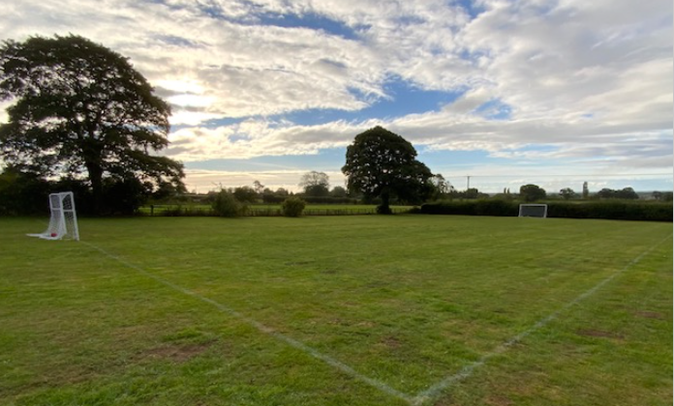
We are absolutely thrilled that the fixed football goals have finally been able to be installed and football playing can now commence, without needing to use tree trunks and/or jumpers as goal posts!

They have definitely been worth the wait – they were funded by the class of 2021 Year 6 leavers and we are really grateful!

Macmillan Coffee Morning – WOW!

What an amazing event we enjoyed this morning! We hope to have made over £300 for this very worthy cause – exact total to be confirmed next week. The cake donations were overwhelming and there was such a fabulous feeling of community spirit. Cups and saucers and an urn were provided by the Sports Club and another urn was lent to us by the Church. It was so lovely to welcome so many local residents and members of the community including Rev. Katie and representatives form our Open the Book team.

Many members of staff participated in a “Cake Off” with the children voting for their favourite and the cakes being auctioned off during the event. We have unearthed yet more hidden talent amongst our workforce!
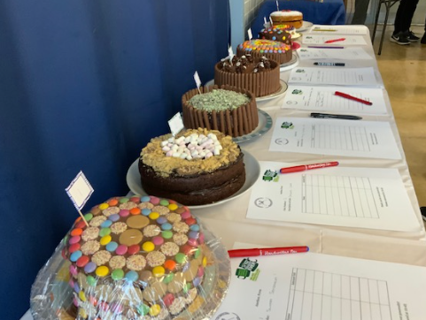
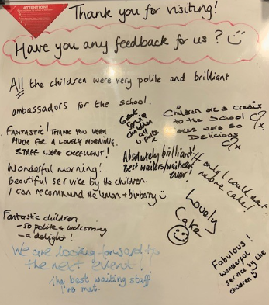
The children did an astounding job of greeting customers, serving, organising games, cleaning and washing up – many of them doing some of these things for the very first time. So many visitors commented on their confidence, attentiveness and high level of customer service, as also shown in this feedback we received!

A huge thank you to Mrs Bacon, Miss Ford, Mrs Aristizabal, Amy Helfferich and Miss Ayre for their “behind the scenes” help and to Miss Walker who organised and led the event – what a triumph!

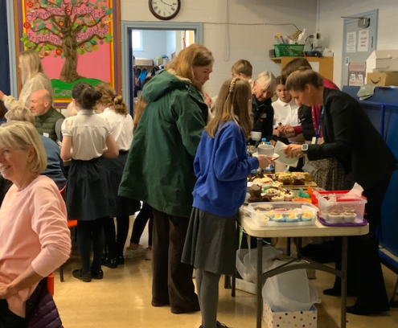

Murton Park – Oak Class Visit
Oak Class look to have had an amazing fun-filled and action-packed visit to Murton Park earlier this week as part of their topic this term on World War 2; these photographs are certainly testament to that. Tom’s eyes lit up when I asked him how the visit had gone, saying “It was just so interesting! I love history especially finding out about the World Wars and so it was brilliant.”

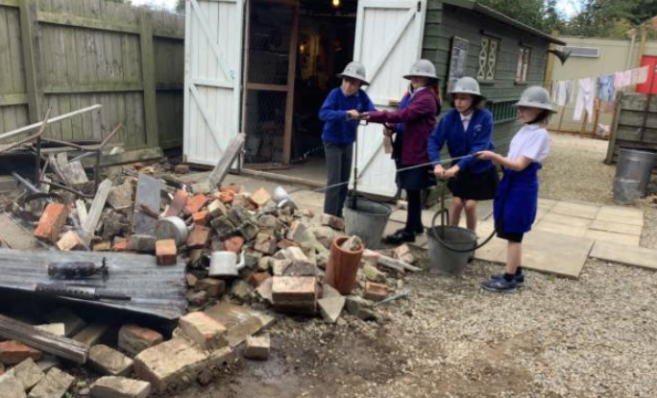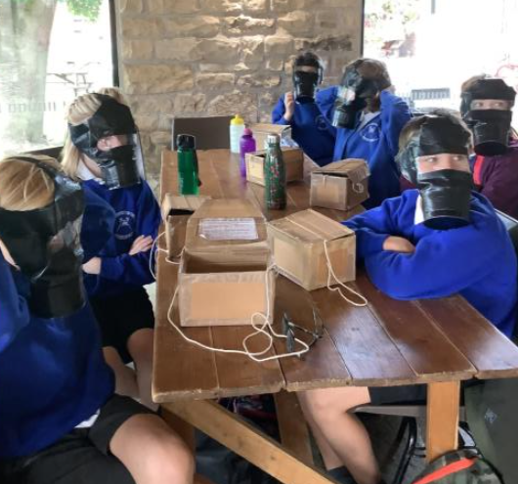

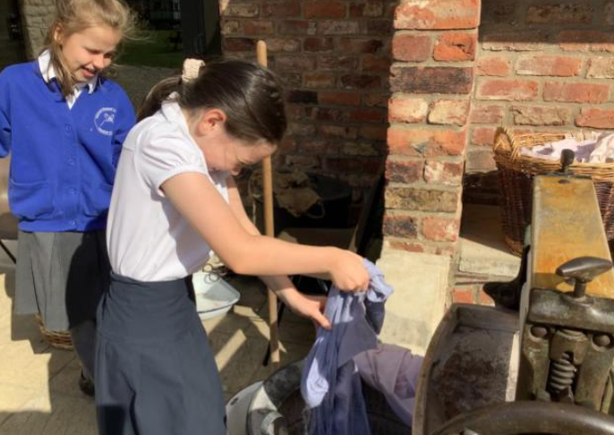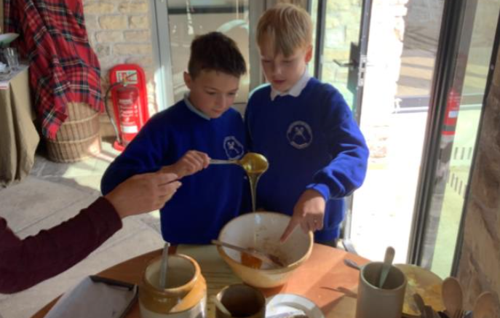

***UPCOMING EVENTS***

Fun Run – Tuesday 4 October
We are really looking forward to taking children in Apple and Beech class over to Husthwaite Primary next Tuesday afternoon. Parents/carers have received a letter with details about the visit and your consent is required in order to allow them to participate. If you have not yet done so, please complete this online form: https://forms.office.com/r/5KWTWh63vy

Harvest Festival and Harvest Lunch - Wednesday 4 October
Parents and carers are warmly welcomed to join us at St Cuthbert’s Church on Wednesday morning at 11am for our Harvest Festival. The service will be led by Oak Class, on the theme of “fruit”, linking to our Biblical verse of “Go and bear fruit, fruit that will last.”
After the service, the children will be treated to a special Harvest Lunch of pizza and chips, followed by jelly and ice cream.
In recognition of the difficulties faced by all in the light of rising food and energy costs, we are not asking specifically for contributions this year. However, should you wish to make a donation there are various ways to do this including via this weblink: https://www.trusselltrust.org/get-involved/ways-to-give/ or by adding item(s) to Food Bank collections for example in the Co-op on Long Street.

Stay and Play Sessions – Apple Class &
Phonics Taster Sessions – Beech Class
Parents of children in Apple Class are being given an opportunity to learn a little about life in Reception Class by attending one of the available sessions on Wednesdays on 5 and 12 October. Sessions will run from 9:05am until 9:45am.
Parents of children in Year 1 (and Year 2, by invitation) will have the opportunity to see phonics in action by attending one of the available sessions on Thursdays on 6 and 13 October. Sessions will run from 9:05am until 9:30am.
We can accommodate a maximum of 5 parents or carers on each of these sessions. Regrettably it is not possible for younger siblings to attend on these occasions. Places can be booked by emailing Mrs Bacon on admin@

Swimming – Oak Class starting 11 October
Children in Year 5/6 will once again be going swimming this term, for a block of 8 sessions starting on Tuesday 11 October. Further details and consent forms will be sent by email next week.

Football v Alne
I am delighted that we have been able to secure football fixtures for Key Stage 2 pupils in the forthcoming weeks. Matches will take place against Alne for boys and girls in Year 3/4 on the afternoon of Monday 17 October and for boys and girls in Year 5/6 on the afternoon of Monday 31 October. In order to keep costs down, I would be grateful if parents/carers may be able to help with transport to and from the event. If you are able to do so, please email admin@ and further details will be communicated in due course. Thank you.

Year 5 Residential – June 2023
In order to help with your forward planning, we would like to give you advance notice that the Year 5 residential will be taking place next summer term, from Monday 5- Wednesday 7 June 2023. This will be at Carlton Lodge as in previous years. The cost will be approximately £200 per pupil. If you would like to begin paying in instalments please contact Mrs Bacon.

Year 4 residential – School Camp Out – June 2023
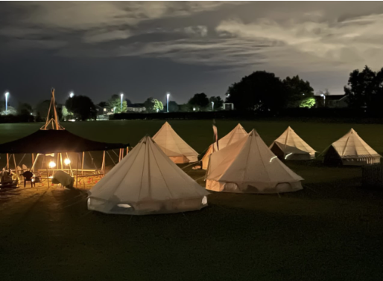
We are super excited to offer a brand-new residential opportunity to Year 4 pupils for the first time this summer. We have provisionally booked Wilderness Outdoor Education to host a camp for children overnight on Friday 30 June. The price is likely to be around £60 per child to include all the equipment they will need, evening meal, hot chocolate, evening activities and breakfast. Further details will follow. If you would like any further information in the meantime, please do not hesitate to contact me.

Reception New Starters 2023
We have already started to welcome prospective parents for new starters in Autumn 2023 which is fabulous! Applications for school places are made via NYCC Admissions.
The application window opens on 12 October 2022 and completed applications must be submitted no later than 15 January 2023. Further details about the process are available here: https://www.northyorks.gov.uk/apply-place-primary-or-secondary-school

Open Morning – 2 November 2022
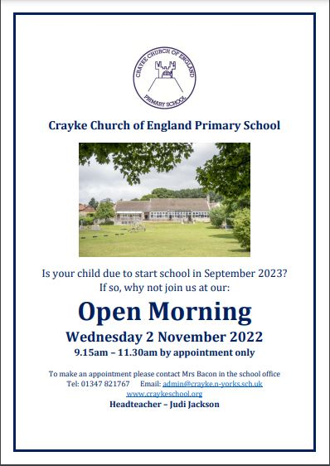

Church News
Message from Fiona Warriner, Church Warden:
This Sunday, 2nd October, at 10.30am we are having our usual Family service but with a bit of a change. It is going to be the village Harvest Festival and also a family communion service. Rev. Katie is leading the service, with the support of the family service team. As always, everyone is welcome. Please note, refreshments will be served after the service rather than before.

CHASA News
THANK YOU for your generosity, as always, during last week’s Open Morning raffle. We raised… £110!
Parents and carers are warmly welcomed to join us for the AGM in the school hall on Thursday 6 October at 3:45pm.

***CLUB NEWS***
See also – Club Schedule on Page 12
Gymnastics Club – Mondays
We are pleased to confirm that the club has recruited sufficient additional children to be able to continue!
Multi-Sports Club – Tuesday 4 October
Due to a prior commitment Mr Cromack is unable to deliver Tuesday’s session so the club is cancelled next week and will resume the following Tuesday, 11 October. Apologies for any inconvenience caused.

Dance After School Club – Thursdays after half term Years 1-6

Kelly from Curve Dance will be coming into school after half term to deliver sessions to children in Beech and Holly classes. I have enquired to see whether she would be available to run an after- school club too. She is happy to, but needs a guaranteed number of a minimum of 10 children. Therefore, if you would be interested in signing your child up for after-school dance club sessions, please email Mrs Bacon on admin@ to reserve your space. The sessions will take place on a Thursday starting on 10 November, from 3:30pm – 4:30pm at a cost of £20 for 5 weeks. If we have not received sufficient interest by Friday 14 October, unfortunately we will not be in a position to offer the club opportunity.

Advanced notice – no staff led clubs w/c 17 October
Please be aware that, due to Parent Consultation Evenings the week commencing 17 October, some of the staff led clubs will NOT be on that week, specifically:
Book Club (Monday 17 October) – Mrs Rayner
Forest School Club (Wednesday 19 October) – Mrs Helfferich
Sewing Club (Thursday 20 October) – Mrs Dobson

Forest School Activity– DO try this at home!
Message from Mrs Helfferich
This week, we decided to try tie dye using blackberries. To say we are excited about our success, is an understatement!
If you would like to try this at home;
- Ask your parent/carer for a piece of white cotton material.
- Collect blackberries in a bowl then mush them up.
- Add a cup of cold water, carefully mix it together.
- Use elastic bands or string to tie your material. Make sure it is tight.
- Put your bundle into the blackberry water.
- Leave to soak for at least 30mins.
- Remove from the bowl, squeeze the excess liquid from the bundle.
- Very carefully remove the bands/string.
- Hang the material up to dry.
We would love to see your creations! chelfferich@crayke.n-yorks.sch.uk
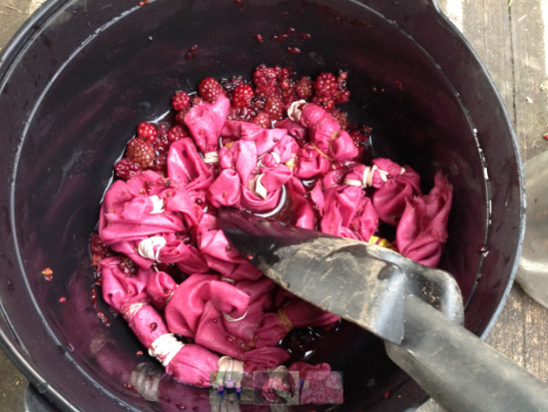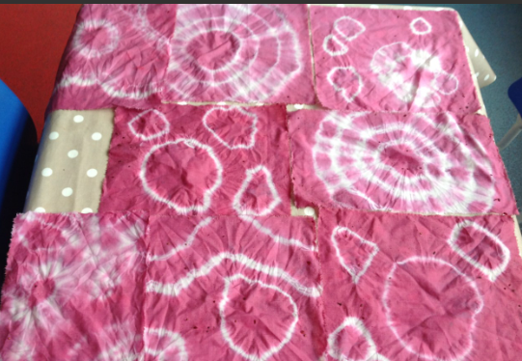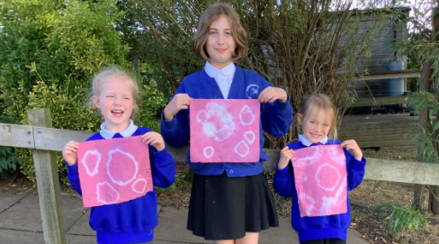

Cost of Living Crisis
We are very aware that costs continue to rise and look set to do so for some time. If you are encountering financial difficulties, we may be able to signpost support. Please get in touch.
If your circumstances have changed and you think your child may be eligible for free school meals, it has never been easier to apply. There is no stigma attached to this, it is not highlighted to the children in any way, and the school gets valuable funding too. If you would like a confidential conversation about whether you may be eligible for free school meals, please do not hesitate to speak to me. To apply directly please use this weblink: https://www.northyorks.gov.uk/free-school-meals
Attendance and Punctuality
We strive for high levels of attendance at school. Please try, wherever possible, to book holidays out of term time. The impact of even one day’s absence on your child’s learning is huge. Also, please try to book medical appointments out of school hours if possible as this also minimises the time missed. If your child is very unwell and unable to attend school, please inform the office by phoning 01347 821767 no later than 9:15am. Thank you for your support with this important matter.
Online Safety
We recognise the importance of online safety and also understand that it is a fast paced, ever changing online world where parents can struggle to keep up with the technical knowledge and understanding demonstrated by their children. The National Online Safety organisation produce regular guides for parents – this week they have produced a leaflet entitled “Parents Guide to Loot Boxes”. Please see the attached leaflet which is also available on the Online Safety section of our website. Should you wish to access any of the other online safety parent guides available on a whole range of topics including what parents need to know about Amazon Fire Tablets, Google Chromebooks, and ways to champion equality online, please have a look at this weblink: https://nationalonlinesafety.com/guides
Should you wish to access more information about how to support your child/ren with online safety at home, this course is available which explains in detail the risks they might be exposed to and what you can do to support them. https://info.nationalonlinesafety.com/myleene-uk

Our Safeguarding Team
At Crayke, we have three members of staff and a governor who make up our Safeguarding Leadership Team. I am the Designated Safeguarding Lead, which means that I am the lead person responsible for child protection and safeguarding issues. Mrs Rayner and Mrs Chandler are our Deputy Designated Safeguarding Leads (Deputy DSLs); a deputy DSL supports the DSL in their role of safeguarding and child protection. Mr Hugh Porter is our Safeguarding Link Governor. The role of the Safeguarding Governor is to support the DSL as well as to regularly review, ask questions and make suggestions about our safeguarding policies and procedures and to report back to the governing body. All staff at Crayke know that safeguarding is EVERYONE’S responsibility. Find out more on our dedicated website Safeguarding page: https://craykeschool.org/safeguarding/
You can also report any safeguarding concerns to our DSL email: dsl@crayke.n-yorks.sch.uk
Please also be aware that as a school we subscribe to Operation Encompass, whereby we are notified of any incidences of domestic violence where a pupil at our school has been present.

Lunch Menu
AUTUMN TERM | Week 1  w/c 17 Oct,  14 Nov, 5 Dec | Week 2  w/c 3 Oct, 31 Oct,  21 Nov, 12 Dec | Week 3  w/c 10 Oct,  7 Nov, 28 Nov
Monday | Creamy Macaroni Cheese Broccoli & Sweetcorn  Homemade Garlic Bread  Banana Mousse  Fresh Fruit or Fruit Yoghurt | Cheese & Tomato Pasta with Seeded Bread  Grated Carrot &  Cucumber Sticks  Oatie Cookie  Fresh Fruit or Fruit Yoghurt | Cheese & Onion Roll  Baked Potato Wedges  Ketchup  Grated Carrot & Cucumber  Sticks  Herby Bread  Fruit Jam Sandwich & Custard  Fresh Fruit or Fruit Yoghurt
Tuesday | Chicken Burger in a Bun  Diced Potatoes  Winter Slaw & Mixed Salad  Apple Crumble & Custard Fresh Fruit or Yoghurt | Tortilla Boats  Vegetable Rice  Carrots & Broccoli  Jelly & Ice-cream  Fresh Fruit or Fruit Yoghurt | All Day Breakfast  Homemade 50/50 Bread  Chocolate Crispie  Fresh Fruit or Fruit Yoghurt
Wednesday | Roast Gammon  Gravy  Baked Baby Potatoes  Carrots & Savoy Cabbage Crusty Bread  Fruity Flapjack  Fresh Fruit or Fruit Yoghurt | 5 October: Harvest Lunch  Roast Pork & Apple Sauce Gravy  Creamy Mashed Potato  Roasted Parsnips &  Green Beans  Homemade Wholemeal Bread  Cheese & Crackers  Fresh Fruit or Fruit Yoghurt | Roast Chicken & Yorkshire Pudding, Gravy  Creamy Mashed Potato  Autumnal Medley of Veg  Sliced Wholemeal Bread  Rice Pudding & Peaches  Fresh Fruit or Fruit Yoghurt
Thursday | Chicken Korma & Rice  Peas & Sweetcorn  Naan Bread  Cheese & Biscuits  Fresh Fruit or Fruit Yoghurt | Meatballs & Pasta  Green Beans & Cauliflower  Homemade Garlic Bread  Fruit Muffin  Fresh Fruit or Fruit Yoghurt | Spaghetti Bolognese  Peas & Sweetcorn  Homemade Garlic Bread  Chocolate Berry Brownie  Fresh Fruit or Fruit Yoghurt
Friday | Fish Fingers  Ketchup  Chips  Veggie Sticks  Homemade 50/50 Bread  Winter Berry Bake & Custard  Fresh Fruit or Fruit Yoghurt | Battered Fish  Ketchup  Chips  Peas & Sweetcorn  Homemade 50/50 Bread  Chocolate Orange Sponge & Chocolate Sauce  Fresh Fruit or Fruit Yoghurt | Crispy Fish Taco/Wrap  Chips  Winter Slaw  Lemon Shortcake  Fresh Fruit or Fruit Yoghurt

PE Kits
PE Kits  w/c 3 Oct | Monday | Tuesday | Wednesday | Thursday | Friday
BEECH (LD) |  |  |  | X | X
HOLLY (LC) |  |  |  | X | X
OAK (LR) |  | X |  |  | X
Please do ensure that on PE days, the children wear their hoodies, school jumpers or cardigans alongside white or blue t-shirts and black or navy shorts or jogging bottoms.
Children in Apple Class need to bring their Forest School kit in each Monday and bring their PE kit in on Wednesday. They will be learning how to get changed in school during their PE sessions on Thursdays and Fridays and will come home wearing their kits home each Friday.
PLEASE NOTE HOLLY CLASS HAVE CHANGED PE DAY FROM TUESDAY TO THURSDAY – THANKS.

Attendance and Punctuality
Children will be marked late if they arrive after 9.00am
Please do help us in our mission to ensure that children are in school on time so that valuable learning time is not missed at the start of the day.

This week’s attendance figures: 94.9% School Target: 96%
Apple (CH): 100% (0 lates) | Beech (LD): 94.1% 2 lates (2 children)
Holly (LC): 95.9% (0 lates) | Oak (LR): 91.4% 2 lates (2 children)
WOW – well done again Apple Class!

Team Points

Red | 630 | Yellow | 623
- Blue | 1014 | Green | 762

Extra-Curricular Clubs – Autumn Term
Some clubs have limited capacity and places will be allocated on a first come first served basis. In the event of a club being fully booked, your child’s name will be added to a waiting list and you will be advised if a place becomes available. Booking is not required for before school or lunchtime clubs. For after school clubs run by school staff (in red type; denoted with *) please email Mrs Bacon on admin@crayke.n-yorks.sch.uk to book a place.
Before School Clubs
Club | Leader | Day and Time | Group
Run a Mile | Mrs Jackson | Monday, Tuesday Thursday & Friday  8:30am | All welcome – parents and carers included!

Lunchtime Clubs
Club | Leader | Day | Group
Skipping | Mrs Helfferich | Monday | All
School Council | Miss Walker | Tuesday | Successful candidates
Fitness | Mr Montgomery | Friday | Y4/5/6

After School Clubs

We respectfully ask you to check the collection time below carefully and to collect your children promptly at the end of clubs. Clubs will run unless you are notified otherwise.
Monday | Gymnastics (Fee paid direct)  3:30 – 4:30pm  Year 3 – 6* NB: opened to wider age range  Simon Carson Sports School  BOOKING LINK: https://simoncarsonsportsschool.co.uk/shop/after-school-clubs/crayke-gymnastics/ |  | Craft (£10 pay via ParentPay)  3:30 – 4:15pm  Years 1 – 6  Mrs Seligman and Miss Sherry |  | Book Club* (no charge)  3:30pm – 4:15pm  Year 4-6  Mrs Rayner
Tuesday | Multi-sports (Fee paid direct)  3:30 – 4:30pm  Year 1-6  Mr Cromack
Wednesday | Forest Schools* (no charge)  3:30pm – 4:15pm  Year 1-6  Mrs Helfferich | Computing* (no charge)  3:30pm – 4:15pm  Year 3/4  Mr Brown
Thursday | Sewing* (no charge)  3:30pm – 4:15pm  Year 3/4  Mrs Dobson | Rounders* (no charge)  3:30pm – 4:15pm  Year 3-6  Mrs Aristizabal |  | Christmas Cards* (no charge)  3:30pm – 4:15pm  Year 3-6  Mrs Bower
Friday | Football (fee paid direct)  3:30 – 4:30pm  Years 3-6  Simon Carson Sports School  BOOKING LINK: https://simoncarsonsportsschool.co.uk/shop/after-school-clubs/crayke-ms-autumn-1/
Crayke Church of England Primary School
Dates for your Diary – Autumn Term 2022

** New date added this week

Day | Date | Event | Who | Where
Tuesday | 4 Oct | NSPCC Workshop | Year 5/6 | Oak Class
Tuesday | 4 Oct | Cluster Sports - Fun Run Event pm | Reception and KS1 | Husthwaite Primary
Wednesday | 5 Oct | Harvest Festival 11am  Parents and carers welcome | Whole school | Church
Wednesday | 5/12 Oct | Stay and Play 9:05am | Reception parents/carers | Apple Class
Thursday | 6/13 Oct | Phonics Taster Sessions 9:05am | Year 1 parents  Year 2 by invite | Beech Class
Thursday | 6 Oct | CHASA AGM 3:45pm | All welcome | Hall
Tuesdays | 11/18 Oct  1/8/15/22/29 Nov  6 Dec | Swimming am | Year 5/6 | Thirsk Pool
Thursday | 13 Oct | Stone Age Workshop | Year 3/4 | Field
Monday | 17 Oct | Football match pm | Year 3/4 | Alne Primary
Tuesday | 18 Oct | Parent Consultation Evening 3:30 – 6pm | Whole School | Classrooms
Wednesday | 19 Oct | Parent Consultation Evening 3:30 – 6pm | Whole School | Classrooms
HALF TERM 24 – 28 October 2022

Day | Date | Event | Who | Where
Monday | 31 Oct | Football match | Year 5/6 | Alne Primary
Wednesday | 2 Nov | Open Morning – Reception New Starters September 2023 | Prospective parents | Whole school
Monday | 7 Nov | Flu vaccinations | Whole school | Meeting Room
Friday | 2 Dec | Pantomime | Whole school | Sports Club
Wednesday | 7 Dec | Nativity Performance 9:30am  Parents and carers welcome | Apple and Beech Classes | Hall
Wednesday | 7 Dec | Nativity Performance 2:15pm  Parents and carers welcome | Apple and Beech Classes | Hall
Thursday | 8 Dec | Skip2BFit | Whole School | Hall/Sports Club TBC
Tuesday | 13 Dec | Christmas Lunch | Whole School | Hall
Wednesday | 14 Dec | Christmas Parties | Whole School | Hall
Friday | 16 Dec | Christmas Jumper Day | Everyone | Whole school
Friday | 16 Dec | Christmas Carol Service  Parents and carers welcome | Whole school | Hall/Church TBC

Term Dates – Academic Year 2022/2023
Autumn Term Tuesday 6th September to Friday 16th December, 2022
Half Term Monday 24th October to return on Monday 31st October
Spring Term Wednesday 4th January to Friday 31st March 2023
Half Term Monday 13th February to return on Monday 20th February
Summer Term Tuesday 18th April to Friday 21st July 2023
May Day Monday 1st May 2023
Half Term Monday 29th May to return on Monday 5th June
INSET Days (School Closed to pupils) –
Tuesday 3rd January 2023
Monday 17th April 2023
Monday 24th July 2023
Tuesday 25th July 2023

Judi Jackson
Headteacher
headteacher@crayke.n-yorks.sch.uk

FOLLOW YOUR PATHWAY AND WE GROW TOGETHER WITH CONFIDENCE
You did not choose me, I chose you that you might go and bear fruit, fruit that will last so that whatever you ask in my name the Father will give you. John 15:16
Respect Friendship Forgiveness Determination

