
Crayke Church of England Primary School
FOLLOW YOUR PATHWAY AND WE GROW TOGETHER WITH CONFIDENCE
You did not choose me, I chose you that you might go and bear fruit, fruit that will last so that whatever you ask in my name the Father will give you. John 15:16
Respect Friendship Forgiveness Determination

Dear Parents and Carers,

***NEWS FROM SCHOOL THIS WEEK***

Open Morning
We welcomed several families throughout the morning. All prospective families had a full tour of the school led by myself and Y6 pupils. They were also given the opportunity to speak to children from across school and then at the end of the tour met with some current parents to discuss what life is like as a parent of Crayke School. The Year 6 children were excellent ambassadors for our school. Huge thanks to Elly Dawson, Rebecca Stubbins and Jonathan Dawson who were fantastic parent representatives for us.

Football Match v Alne – Oak Class
Well done for great games and congratulations to our goal scorers Isabelle and Ethan H!

Wow Walk to School Challenge
Message from Mrs Helfferich

Well done everyone!
Results for this week:
Holly and Beech Class have successfully achieved a Bronze award.
Apple Class are the winners, they have achieved Gold.
Come on Oak class, let’s see what you can achieve; more walking is needed. In the country we are ranked 544th and we are currently 2nd in the Local Authority! Please park at the Sports Club, attend running club or use your playtime to get active.

Keeping the ‘Apples’ hydrated

This week in Apple Class we have been learning the importance of drinking water during the school day.
This Photo by Unknown Author is licensed under CC BY-NC
It is good for our body – keeping our joints, bones and teeth healthy. When we are well hydrated it improves our mood, memory and attention. We have set up a hydration recording station within the classroom. In true Apple style, we have been encouraging and supporting each other as well as celebrating individual achievements. Isabelle is our ‘star drinker’ this week.

Thanks to our community!
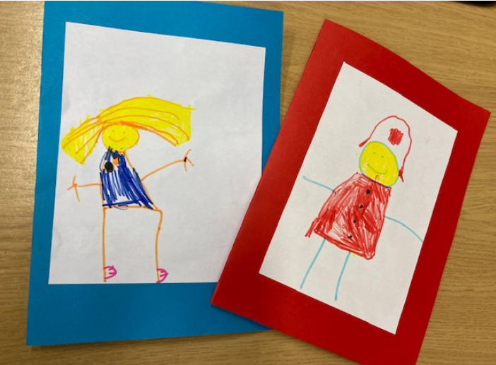
Apple Class have sent some wonderful, personalised cards to members of our local community, thanking them for the help that they provide. Cards have been sent to, amongst others the police, fire service and library. We received this lovely response from Easingwold Police Station: Please pass on our thanks to Apple class for the card received at Easingwold Police Station this morning. It’s always nice to get some appreciation from the community and was a very welcome surprise. The card has pride of place in the office at the police station and has been admired by us all here.
Best wishes, PC Jan Powell and all the staff at Easingwold

We Will Rock You – Stone Age Style
Holly Class really rocked school yesterday afternoon with a musical and dance rendition of We Will Rock You with personalised Stone Age lyrics. It was wonderful!

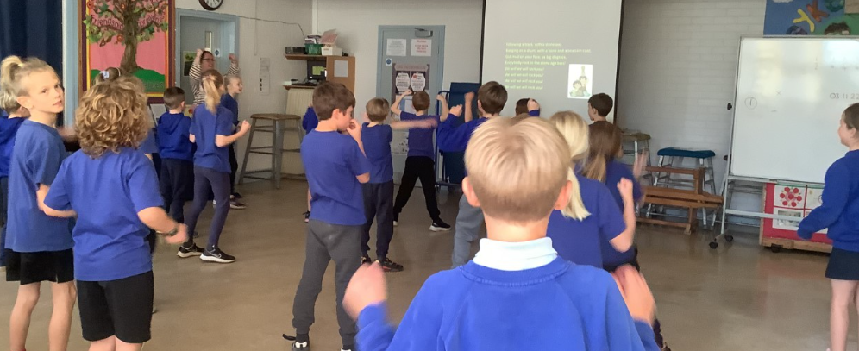

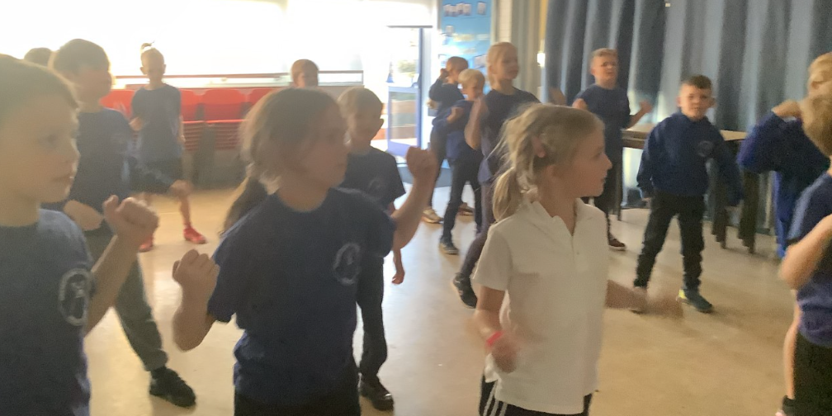

***UPCOMING EVENTS***


Children in Need “Be Spotacular!”– Friday 18 November
The theme for this year is “Be Spotacular” Children can wear one or more spotty items of clothing for the day. Please do remember that outfits should be appropriate for PE too. We will not be collecting cash donations on the day; parents wishing to make a contribution can do so via this link. Many thanks in advance for your support. https://app.parentpay.com/ParentPayShop/Foc/Default.aspx?shopid=8174

Reception New Starters 2023
We have already started to welcome prospective parents for new starters in Autumn 2023 which is fabulous! Applications for school places are made via NYCC Admissions.
The application window is now open and completed applications must be submitted no later than 15 January 2023. Further details about the process are available here: https://www.northyorks.gov.uk/apply-place-primary-or-secondary-school

***CLUB NEWS***
See also – Club Schedule on Page 10

Curve Dance


Join Curve Dance after school club at Crayke School with Kelly on Thursdays 3.30-4.30pm.
We will be getting creative with movement, learning new exciting skills and dance routines. In addition, we will be dancing we lots of props and expanding our knowledge different dance styles.

Dates; 17th November, 24th November, 1st December and 8th December.
Cost: £16.00
There are limited spaces so please Pay direct to - Curve Dance, 04 00 04, 55651674
(Please put your child's name as the reference so we can add to them to our register)

Rounders

Please note that there will be no rounders club on 17 November. We apologise for any inconvenience that this may cause.

***STANDING ITEMS***
Tesco Thirsk Fundraiser
If you happen to be passing by Tesco in Thirsk between now and the middle of January, please do take a moment to drop a blue token or two into the middle section of the fundraising box…funds raised will go directly towards our running track. In the words of Tesco… Every Little Helps!
Please spread the word! Thank you.
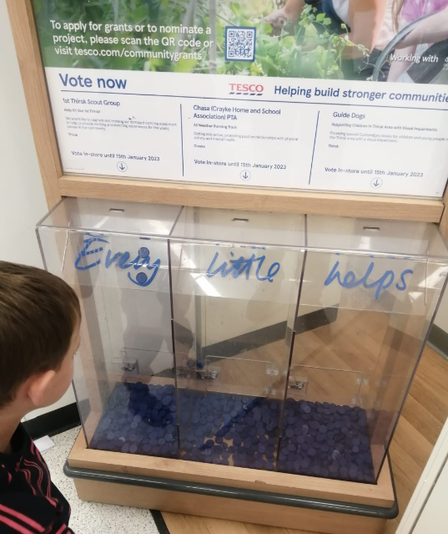

Cost of Living Crisis
We are very aware that costs continue to rise and look set to do so for some time. If you are encountering financial difficulties, we may be able to signpost support. Please get in touch.
If your circumstances have changed and you think your child may be eligible for free school meals, it has never been easier to apply. There is no stigma attached to this, it is not highlighted to the children in any way, and the school gets valuable funding too. If you would like a confidential conversation about whether you may be eligible for free school meals, please do not hesitate to speak to me. To apply directly please use this weblink: https://www.northyorks.gov.uk/free-school-meals
Attendance and Punctuality
We strive for high levels of attendance at school. Please try, wherever possible, to book holidays out of term time. The impact of even one day’s absence on your child’s learning is huge. Also, please try to book medical appointments out of school hours if possible as this also minimises the time missed. If your child is very unwell and unable to attend school, please inform the office by phoning 01347 821767 no later than 9:15am. Thank you for your support with this important matter.

Online Safety
We recognise the importance of online safety and also understand that it is a fast paced, ever changing online world where parents can struggle to keep up with the technical knowledge and understanding demonstrated by their children. The National Online Safety organisation produce regular guides for parents – this week they have produced a leaflet entitled “Parents Guide to Amigo”. Please see the attached leaflet which is also available on the Online Safety section of our website. Should you wish to access any of the other online safety parent guides available on a whole range of topics including what parents need to know about Amazon Fire Tablets, Google Chromebooks, and ways to champion equality online, please have a look at this weblink: https://nationalonlinesafety.com/guides
Should you wish to access more information about how to support your child/ren with online safety at home, this course is available which explains in detail the risks they might be exposed to and what you can do to support them. https://info.nationalonlinesafety.com/myleene-uk

Our Safeguarding Team
At Crayke, we have three members of staff and a governor who make up our Safeguarding Leadership Team. I am the Designated Safeguarding Lead, which means that I am the lead person responsible for child protection and safeguarding issues. Mrs Rayner and Mrs Chandler are our Deputy Designated Safeguarding Leads (Deputy DSLs); a deputy DSL supports the DSL in their role of safeguarding and child protection. Mr Hugh Porter is our Safeguarding Link Governor. The role of the Safeguarding Governor is to support the DSL as well as to regularly review, ask questions and make suggestions about our safeguarding policies and procedures and to report back to the governing body. All staff at Crayke know that safeguarding is EVERYONE’S responsibility. Find out more on our dedicated website Safeguarding page: https://craykeschool.org/safeguarding/
You can also report any safeguarding concerns to our DSL email: dsl@crayke.n-yorks.sch.uk
Please also be aware that as a school we subscribe to Operation Encompass, whereby we are notified of any incidences of domestic violence where a pupil at our school has been present.

Church News
Message from the Family Service Team
It's the November Family Service on Sunday at 10.30am. Lucy Willshaw will be with us and we would love to see you. Refreshments will be available from 10:15am as usual.

Also, an early reminder that the December Service will be on 4th December and we will be starting off the Advent Posada of the knitted Mary & Joseph on their travels - we haven't been able to do this for the last 2 Christmases so it will be very exciting!

CHASA News
Many thanks for the donations received this morning and throughout the day for tomorrow night’s Bonfire Night stall. Any final donations can be brought at the end of the school day and we would be very grateful. We look forward to seeing you tomorrow night if you are joining the Crayke Bonfire event!

Community News

North Yorkshire Sportshall Athletics Event / Trials
For Under 11’s (School Year 5 and 6), Under 13's (Years 7 & 8) and Under 15's (Years 9 & 10)
Ages are on 31 August 2022
North Yorkshire events will take place

Sunday 20 November, Richmond School, Richmond DL10 7BQ 10.15am to 1pm, All Ages.
Hosted by Allerton Junior AC

Saturday 26 November, Ashville College, Harrogate Under 11 10.15 to 12.30. Under 13 and 15, 12.45 to 3pm. Hosted by Harrogate Harriers

Sunday Dec / Jan to be decided, York University (track site), Under 11 10.15 to 12.30, Under 13 & 15 12.45 to 3. Under 11 initially restricted to Year 6, if spaces 9 days in advance, will offer to Year 5
Hosted by City of York AC

Places will be limited, must book in advance. Cost £6, £10 for 2 from family, pay cash at venue.
Strong, known Under 13 / 15s do not need to go to first trial, can go to Final Trial. Discuss with organiser

Final Trial / Team Practice, by invitation after the above events.
Sunday 29 January, Fulford School York (near University). Under 11 at 10.00, Under 13 / 15 12.30 to 3pm
We will then select a North Yorkshire Team for the Regional event, currently Sat 4 March.
Then if we win that, U13 and U15 have National Final on Sat 1 April.

To book a place, please email nyorkshiresportshall@hotmail.co.uk from the email address you wish us to use.
Give name, AND VENUE, boy / girl, date of birth, age group, phone number, club or school
All these could fill up.
General enquiries to Dave Paver 01937 581165 Emergency contact (on the day only) 07778 950200

Many may have done Sportshall athletics before – but the event will be suitable for those who have not.
Events will be fully explained.

Running events use Reversaboards. If athletes have not used them before, they will be fine as they will
soon get used to them.
_______________________________________________________________________________________
Events available for Under 13 and Under 15
Track - 2 lap , 4 lap , 6 lap (Under 13 only) - Variety of Relays
(2 lap takes about 25 secs, 4 lap about 55 secs, 6 lap about 85 secs, very tough)
Field - Speed Bounce , Standing Long Jump , Standing Triple Jump , Vertical Jump
U13 and U15 Shot will not be available at these trials, but will be needed for Regional event
_______________________________________________________________________________________
Events available for Under 11
Various running events, all Sprint based (ie not Endurance)
Field events – Standing Long, Standing Triple, Vertical Jump, High Stepper, Speed Bounce,
Chest Push, Soft Javelin,
_______________________________________________________________________________________


Lunch Menu
AUTUMN TERM | Week 1  w/c  14 Nov, 5 Dec | Week 2  w/c  21 Nov, 12 Dec | Week 3  w/c  7 Nov, 28 Nov
Monday | Creamy Macaroni Cheese Broccoli & Sweetcorn  Homemade Garlic Bread  Banana Mousse  Fresh Fruit or Fruit Yoghurt | Cheese & Tomato Pasta with Seeded Bread  Grated Carrot &  Cucumber Sticks  Oatie Cookie  Fresh Fruit or Fruit Yoghurt | Cheese & Onion Roll  Baked Potato Wedges  Ketchup  Grated Carrot & Cucumber  Sticks  Herby Bread  Fruit Jam Sandwich & Custard  Fresh Fruit or Fruit Yoghurt
Tuesday | Chicken Burger in a Bun  Diced Potatoes  Winter Slaw & Mixed Salad  Apple Crumble & Custard Fresh Fruit or Yoghurt | Tortilla Boats  Vegetable Rice  Carrots & Broccoli  Jelly & Ice-cream  Fresh Fruit or Fruit Yoghurt | All Day Breakfast  Homemade 50/50 Bread  Chocolate Crispie  Fresh Fruit or Fruit Yoghurt
Wednesday | Roast Gammon  Gravy  Baked Baby Potatoes  Carrots & Savoy Cabbage Crusty Bread  Fruity Flapjack  Fresh Fruit or Fruit Yoghurt | Roast Pork & Apple Sauce Gravy  Creamy Mashed Potato  Roasted Parsnips &  Green Beans  Homemade Wholemeal Bread  Cheese & Crackers  Fresh Fruit or Fruit Yoghurt | Roast Chicken & Yorkshire Pudding, Gravy  Creamy Mashed Potato  Autumnal Medley of Veg  Sliced Wholemeal Bread  Rice Pudding & Peaches  Fresh Fruit or Fruit Yoghurt
Thursday | Chicken Korma & Rice  Peas & Sweetcorn  Naan Bread  Cheese & Biscuits  Fresh Fruit or Fruit Yoghurt | Meatballs & Pasta  Green Beans & Cauliflower  Homemade Garlic Bread  Fruit Muffin  Fresh Fruit or Fruit Yoghurt | Spaghetti Bolognese  Peas & Sweetcorn  Homemade Garlic Bread  Chocolate Berry Brownie  Fresh Fruit or Fruit Yoghurt
Friday | Fish Fingers  Ketchup  Chips  Veggie Sticks  Homemade 50/50 Bread  Winter Berry Bake & Custard  Fresh Fruit or Fruit Yoghurt | Battered Fish  Ketchup  Chips  Peas & Sweetcorn  Homemade 50/50 Bread  Chocolate Orange Sponge & Chocolate Sauce  Fresh Fruit or Fruit Yoghurt | Crispy Fish Taco/Wrap  Chips  Winter Slaw  Lemon Shortcake  Fresh Fruit or Fruit Yoghurt

PE Kits
PE Kits  w/c 7/11 | Monday | Tuesday | Wednesday | Thursday | Friday
BEECH (LD) |  |  |  | X | X
HOLLY (LC) |  |  |  | X | X
OAK (LR) |  | X (swim) |  |  | X
Please do ensure that on PE days, the children wear their hoodies, school jumpers or cardigans alongside white or blue t-shirts and black or navy shorts or jogging bottoms.
Children in Apple Class need to bring their Forest School kit in each Monday and bring their PE kit in on Wednesday. They will be learning how to get changed in school during their PE sessions on Thursdays and Fridays and will come home wearing their kits home each Friday.

Attendance and Punctuality
Children will be marked late if they arrive after 9.00am
Please do help us in our mission to ensure that children are in school on time so that valuable learning time is not missed at the start of the day.

This week’s attendance figures: 94.4% School Target: 96%
Apple (CH): 96.3% 1 late | Beech (LD): 95.2% 1 late
Holly (LC): 95.5% 1 late | Oak (LR): 90.9% 3 lates/3 children

Team Points

Red | 613 | - Yellow  | 792
Blue | 688 | Green | 622

 Stars of the Week

Stars | Apple | Beech | Holly | Oak
Stars | Isabelle Kay | Lucia Grant | Joshua Jefferson | Ethan Jackson
Stars | Isabelle Kay | Riley-Mae Simpson | Joah Brown | Isabelle Sargent
Gold Awards for Sport | Pippa Dawson | Martha Seligman | Leo Bunker-Barnes | Tom Ward

Extra-Curricular Clubs – Autumn Term
Some clubs have limited capacity and places will be allocated on a first come first served basis. In the event of a club being fully booked, your child’s name will be added to a waiting list and you will be advised if a place becomes available. Booking is not required for before school or lunchtime clubs. For after school clubs run by school staff (in red type; denoted with *) please email Mrs Bacon on admin@crayke.n-yorks.sch.uk to book a place.
Before School Clubs
Club | Leader | Day and Time | Group
Run a Mile | Mrs Jackson | Monday, Tuesday Thursday & Friday  8:30am | All welcome – parents and carers included!

Lunchtime Clubs
Club | Leader | Day | Group
Skipping | Mrs Helfferich | Monday | All
School Council | Miss Walker | Tuesday | Successful candidates
Fitness | Mr Montgomery | Friday | Y4/5/6

After School Clubs

We respectfully ask you to check the collection time below carefully and to collect your children promptly at the end of clubs. Clubs will run unless you are notified otherwise.
Monday | Craft (£10 pay via ParentPay)  3:30 – 4:15pm  Years 1 – 6  Mrs Seligman and Miss Sherry |  | Book Club* (no charge)  3:30pm – 4:15pm  Year 4-6  Mrs Rayner
Tuesday | Multi-sports (Fee paid direct) NB: LAST SESSION THIS TERM WILL BE ON 8 NOVEMBER AND THE NEXT BLOCK WILL START IN THE NEW YEAR  3:30 – 4:30pm  Year 1-6  Mr Cromack
Wednesday | Forest Schools* (no charge)  3:30pm – 4:15pm  Year 1-6  Mrs Helfferich |  | Computing* (no charge)  3:30pm – 4:15pm  Year 3/4  Mr Brown
Thursday | Sewing* (no charge)  3:30pm – 4:15pm  Year 3/4  Mrs Dobson | Rounders* (no charge) **NB No club 17/11**  3:30pm – 4:15pm  Year 3-6  Mrs Aristizabal |  | Dance (Fee paid direct by bank transfer - £16.00 for 4 weeks)  17 & 24 Nov 1 & 8 Dec  3:30 – 4:30pm  Year 1-6  Kelly Jane Goodwin
Friday | Football (fee paid direct)  3:30 – 4:30pm  Years 3-6  Simon Carson Sports School  BOOKING LINK: https://simoncarsonsportsschool.co.uk/shop/after-school-clubs/crayke-ms-autumn-1/
Crayke Church of England Primary School
Dates for your Diary – Autumn Term 2022

** New date added this week

Day | Date | Event | Who | Where
Monday | 7 Nov | Flu vaccinations | Whole school | Meeting Room
Tuesdays | 8/15/22/29 Nov  6 Dec | Swimming | Oak Class | Thirsk Swimming Pool
Thursday | 10 Nov | CHASA meeting | All welcome | Hall
Friday | 18 Nov | Children in Need – Be Spotacular! | Everyone | Whole School
Monday | 21 Nov | Crucial Crew | Year 6 | Carlton Lodge
Friday | 2 Dec | Pantomime | Whole school | Sports Club
Wednesday | 7 Dec | Nativity Performance 9:30am  Parents and carers welcome | Apple and Beech Classes | Hall
Wednesday | 7 Dec | Nativity Performance 2:15pm  Parents and carers welcome | Apple and Beech Classes | Hall
Thursday | 8 Dec | Skip2BFit | Whole School | Hall/Sports Club TBC
Friday | 9 Dec | CHASA Christmas Film Night | Whole School | Hall
Tuesday | 13 Dec | Christmas Lunch | Whole School | Hall
Wednesday | 14 Dec | Christmas Parties | Whole School | Hall
Thursday | 15 Dec | Reindeer Rush | Whole School | Field
Friday | 16 Dec | Christmas Jumper Day | Everyone | Whole school
Friday | 16 Dec | Christmas Carol Service  Parents and carers welcome | Whole school | Hall/Church TBC

Term Dates – Academic Year 2022/2023
Autumn Term Tuesday 6th September to Friday 16th December, 2022
Spring Term Wednesday 4th January to Friday 31st March 2023
Half Term Monday 13th February to return on Monday 20th February
Summer Term Tuesday 18th April to Friday 21st July 2023
May Day Monday 1st May 2023
Half Term Monday 29th May to return on Monday 5th June
INSET Days (School Closed to pupils) –
Tuesday 3rd January 2023
Monday 17th April 2023
Monday 24th July 2023
Tuesday 25th July 2023

Judi Jackson
Headteacher
headteacher@crayke.n-yorks.sch.uk

FOLLOW YOUR PATHWAY AND WE GROW TOGETHER WITH CONFIDENCE
You did not choose me, I chose you that you might go and bear fruit, fruit that will last so that whatever you ask in my name the Father will give you. John 15:16
Respect Friendship Forgiveness Determination

