
Crayke Church of England Primary School
FOLLOW YOUR PATHWAY AND WE GROW TOGETHER WITH CONFIDENCE
You did not choose me, I chose you that you might go and bear fruit, fruit that will last so that whatever you ask in my name the Father will give you. John 15:16
Respect Friendship Forgiveness Determination

Dear Parents and Carers,
Christmas Tree Delivery - Newburgh Christmas Trees
We were thrilled to receive our Christmas tree delivery this week and the children had a wonderful time adding their lovely decorations to it during a special carol service event yesterday.
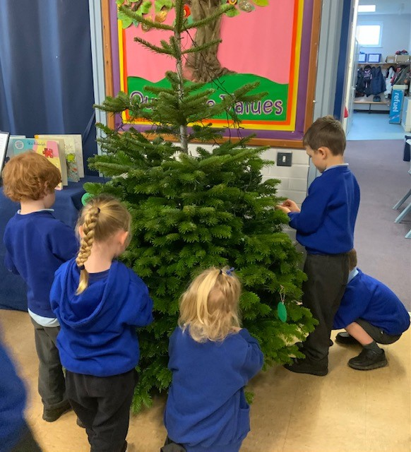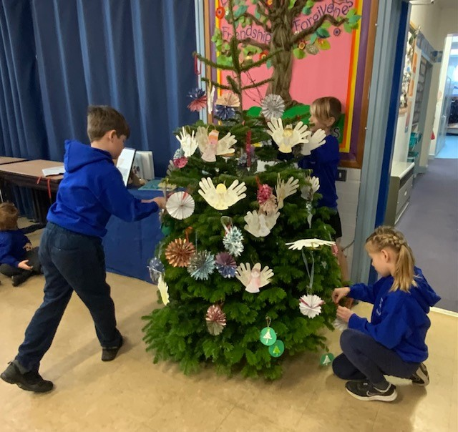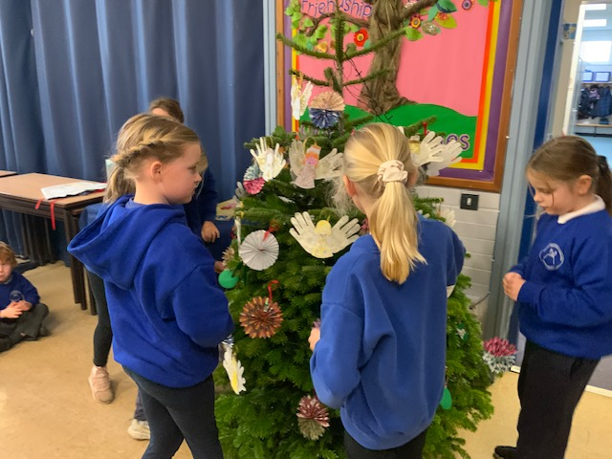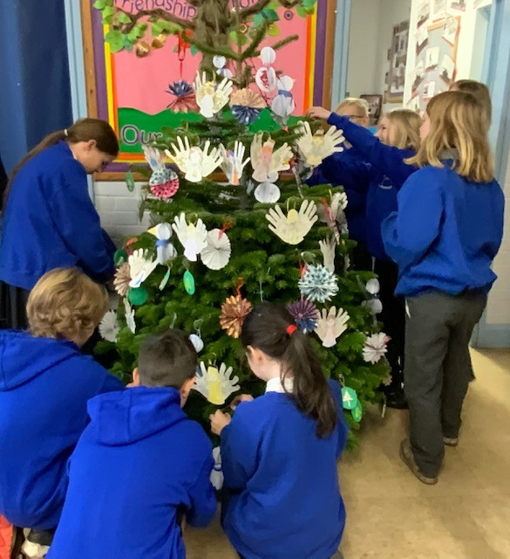

In Crayke tradition, the oldest boy and girl then completed the decorating spectacular by adding the star on top of the tree and then came the big switch on, to a spontaneous round of applause from the children!

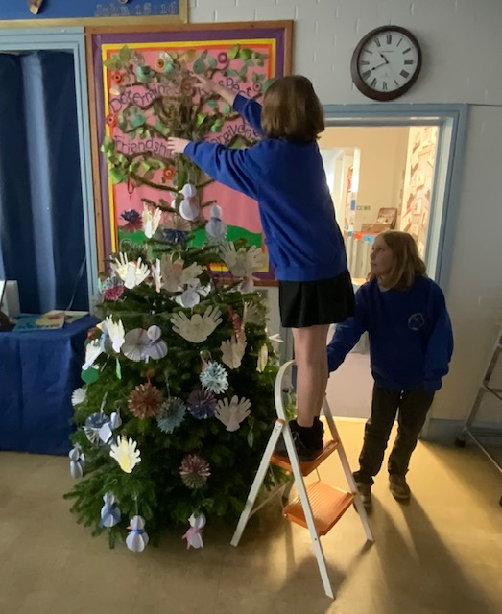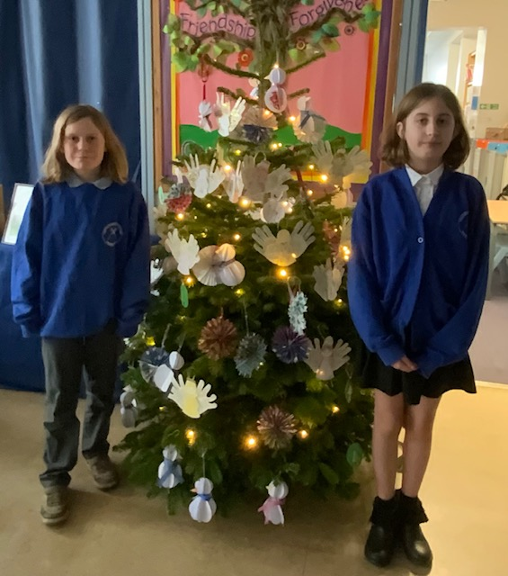

Pantomime – Sports Hall
At the time of going to press, the children are busily getting very excited about their visit to the Sports Hall this afternoon for a special whole school performance of Aladdin. Oh, yes they are!
We are really grateful to the Sports Club for the use of the venue, a big thanks to Mrs Bacon for sourcing and organising the event and we really appreciate that CHASA have kindly funded this event entirely so it comes at no cost to parents.

Nativity Performances – Please book your tickets!
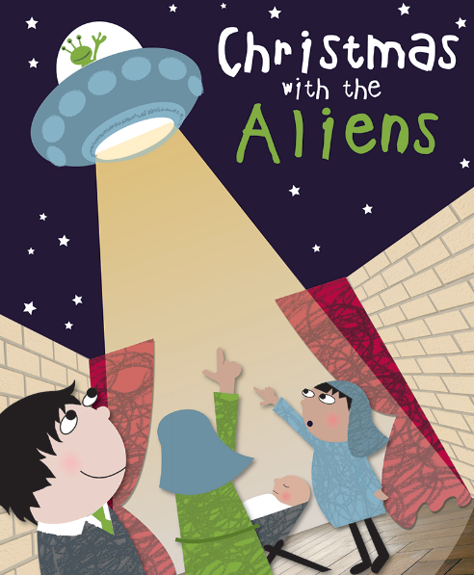
As per communication earlier this week, Apple and Beech class will be performing 'Christmas with the Aliens' on Wednesday 7 December at 9.30am and again at 2.15pm.
Each child in KS1 will be allocated 2 tickets for either the morning or afternoon performance or these can be split into 1 ticket for the morning and 1 ticket for the afternoon.
We expect that there will be some additional tickets available and these will be allocated on a first come first served basis up to a maximum of 2 additional tickets. We will not be able to confirm this until Monday 5 December.
Please complete the following online form by Monday 5 December to confirm your ticket requirements. https://forms.office.com/e/g859s4gNBa
CHASA reps have kindly offered to run a raffle before each performance, so please do bring some loose change and buy your tickets on the way in! There are some great prizes to be won!
Swimming – Oak Class – CHANGE OF DATE
In order to allow Oak class the opportunity to watch the dress rehearsal of the nativity performance, we have changed the date of the final swimming session for Year 5/6. This means that they will NOT swim on Tuesday 6 December, but WILL swim on Tuesday 13 December. We apologise for any inconvenience caused.

Carol Service – Whole School – CHANGE OF TIME
Due to circumstances beyond our control, we unfortunately need to change the time of the Carol Service at St Cuthbert’s Church on Friday 16 December. It will now be held at 1:15pm. We do hope that you are able to join us for this service which will be led by Year 6.
Please note that all children will be brought back to school after the service and it will not be possible to collect from directly from the church after the service. This is both for safeguarding reasons and to ensure that they have the opportunity to collect all their belongings from school before the end of term.

Coronation Bank Holiday – Implication for Year 6 SATs tests

Please see below information from the DfE:
An additional bank holiday in honour of the Coronation of His Majesty King Charles III will take place on Monday 8 May 2023. As this date had previously been announced as the first day of the 2023 key stage 2 (KS2) test week in England, a change to the KS2 test schedule next year will be necessary.
Ministers have considered the situation carefully and have decided that KS2 tests will take place in the same week with tests following the usual order but each taking place one day later than originally planned. As such, the new schedule will be:
- Tuesday 9 May: English grammar, punctuation and spelling (GPS) papers 1 (questions) and 2 (spelling)
- Wednesday 10 May: English reading paper
- Thursday 11 May: mathematics papers 1 (arithmetic) and 2 (reasoning)
- Friday 12 May: mathematics paper 3 (reasoning)
The KS2 timetable variation (TTV) window for each assessment will also move back one day, in accordance with this change.
There will be no changes to arrangements for our other assessments, including KS2 teacher assessments, key stage 1 tests and teacher assessments, the phonics screening check and the multiplication tables check. Dates and deadlines for these assessments remain as previously announced.
In making their decision, ministers have considered the views of schools and stakeholders including trade unions and have sought to minimise disruption to schools arising from the change in plans.

Blue House Bookshop Competition Window
Message from Karen:
You were all very creative, so I had the hardest job to choose just one winner from all these brilliant entries. I liked something in every one of them and in the end found I just couldn’t choose between them – so – I decided to make up one window from all my favourite parts of your designs! The window has been a team effort, so I hope you all like it! 😊

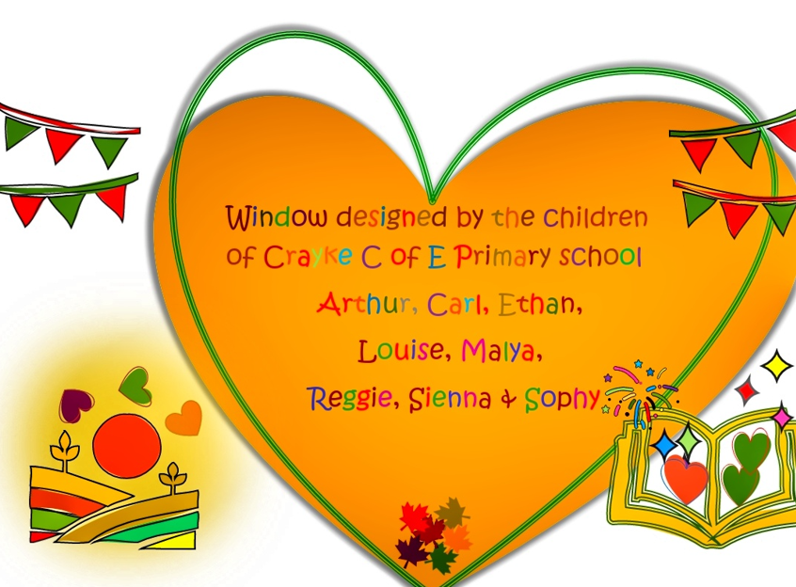

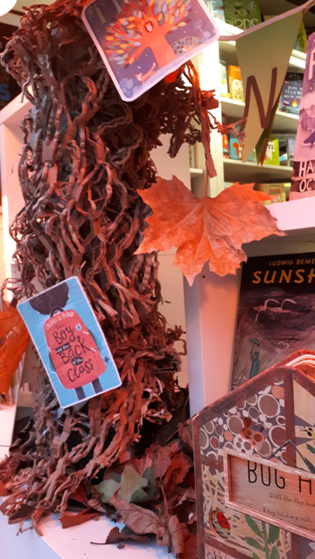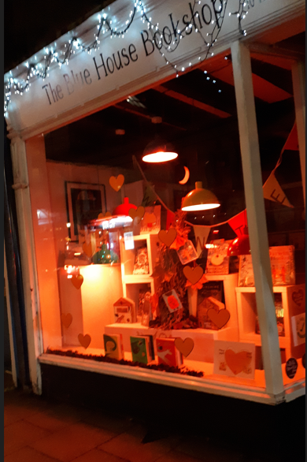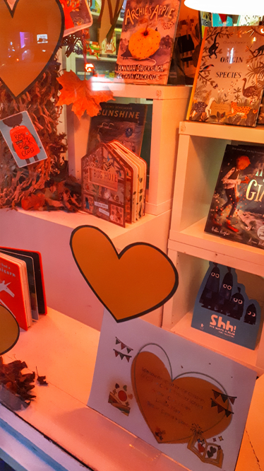

Wow Walk to School Challenge Weekly Update
Message from Mrs Helfferich



This week’s WOW challenge results are as follows:

This Photo by Unknown Author is licensed under CC BY-NC
Apple Beech and Holly Oak

Well done to everyone who gained their Hieroglyph badge during November. In December, we are walking to achieve the ‘Roman Centurion’ badge. A centurion was the principal professional officer in the armies of ancient Rome and its empire. They got their name because they commanded 100 men.


If you are interested in finding out more information, please click on the following link: Walk to School | Living Streets

Reindeer Rush Event - Thursday 15 December 2022

Message from Mrs Helfferich
Thank you to everyone who has donated to the Reindeer Rush. So far, we have raised nearly £200 for St Leonard’s Hospice which is incredible. It isn’t too late to donate www.stleonardshospice.org.uk/fundraising/crayke-church-of-england-primary-schools-reindeer-rush/
York Mix radio are looking forward to getting the children warmed up before their run. They will all be given a pair of antlers. I personally feel that ‘Father Christmas’ should follow the reindeer but apparently it’s more fun for the children to chase ‘Father Christmas’. This ‘Father Christmas’ is hoping that a magic sleigh will fall from the sky to pick her up.

YorkMix Toy Appeal
Thanks to Mrs Bacon for masterminding this initiative and for offering to take the donations we receive to the drop off point.
It will be a difficult Christmas for many families this year and to reflect our Christian values we will be supporting the YorkMix Radio Toy Appeal for 2022.
While most of us look forward to Christmas there are some children for whom it is just another day. Every year there are families who through no fault of their own dread the thought of the festive season, people who can’t afford to treat their loved ones and won’t be sharing in the Christmas cheer.
This year will be the toughest in living memory for many of us as the cost of living crisis continues to bite and household bills rise.
If you would like to donate a new & unwrapped toy to the YorkMix Toy Appeal, please can you drop this off in school by Friday 9 December. You don’t need to wrap your gifts, the YorkMix elves will do everything for you!
They will be collecting gifts for children of all ages from babies and pre-schoolers who might receive traditional toys and games from the appeal through to teenagers for whom you might consider donating items such as health and beauty products.
We thank you for your support.

Upcoming Events – Christmas
 INFORMATION REGARDING CHRISTMAS @ CRAYKE 2022 
Here are some important dates for your diaries as we approach the end of term.

Date | Time | Event | What we need from you as parents
Monday 5 December |  | Christmas cards can be brought in from today | Please ensure that Christmas cards are clearly labelled with first name, surname and class to ensure safe delivery to the correct recipient!
Tuesday 6 December | 9:30am | Nativity Dress Rehearsal | All children involved need their costumes ready before today.
Wednesday 7 December | 9:30am  2:15pm | Nativity Performance 1  Nativity Performance | Book your free tickets when the link is shared next week.
Thursday 8 December | All day | Skip2Bfit – workshops at the Sports Hall | ALL children to wear PE kits all day today please
Friday 9 December | 4:30pm – 7pm | CHASA Christmas Film Night – Arthur Christmas | Purchase wristband from your year rep.  Provide consent via https://forms.office.com/r/xpdEyHyHdF
Tuesday 13 December | 12pm | Christmas Lunch | If your child normally has a packed lunch and would like Christmas Lunch please contact Mrs Bacon on admin@
Wednesday 14 December | pm | Christmas Party afternoon | Come to school wearing party outfits.
Thursday 15 December | pm | Reindeer Rush afternoon | Come to school wearing PE kits.  Sponsorship information sent separately.
Friday 16 December |  | Christmas Jumper Day  Christmas Carol Concert  End of term -2:30pm | Children are welcome to wear non-uniform and Christmas jumpers.  Parents and carers are welcome to meet us at church for a service at 11am.

***STANDING ITEMS***
Reception New Starters 2023
We have already started to welcome prospective parents for new starters in Autumn 2023 which is fabulous! Applications for school places are made via NYCC Admissions.
The application window is now open and completed applications must be submitted no later than 15 January 2023. Further details about the process are available here: https://www.northyorks.gov.uk/apply-place-primary-or-secondary-school

Tesco Thirsk Fundraiser
If you happen to be passing by Tesco in Thirsk between now and the middle of January, please do take a moment to drop a blue token or two into the middle section of the fundraising box…funds raised will go directly towards our running track. In the words of Tesco… Every Little Helps!

Please spread the word! Thank you.

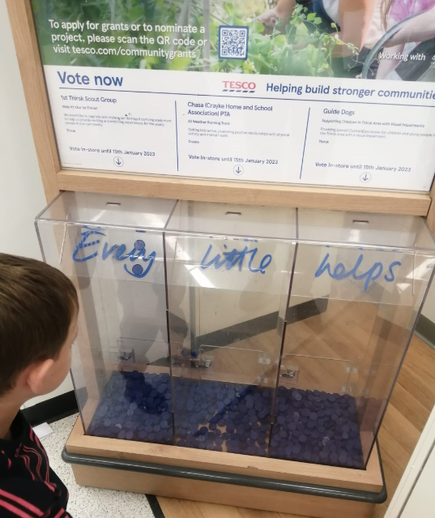
Cost of Living Crisis
We are very aware that costs continue to rise and look set to do so for some time. If you are encountering financial difficulties, we may be able to signpost support. Please get in touch.
If your circumstances have changed and you think your child may be eligible for free school meals, it has never been easier to apply. There is no stigma attached to this, it is not highlighted to the children in any way, and the school gets valuable funding too. If you would like a confidential conversation about whether you may be eligible for free school meals, please do not hesitate to speak to me. To apply directly please use this weblink: https://www.northyorks.gov.uk/free-school-meals

Online Safety
We recognise the importance of online safety and also understand that it is a fast paced, ever changing online world where parents can struggle to keep up with the technical knowledge and understanding demonstrated by their children. The National Online Safety organisation produce regular guides for parents – this week they have produced a leaflet entitled “Parent’s Guide to Social Media and Mental Health”. Please see the attached leaflet which is also available on the Online Safety section of our website. Should you wish to access any of the other online safety parent guides available on a whole range of topics including what parents need to know about Amazon Fire Tablets, Google Chromebooks, and ways to champion equality online, please have a look at this weblink: https://nationalonlinesafety.com/guides
Should you wish to access more information about how to support your child/ren with online safety at home, this course is available which explains in detail the risks they might be exposed to and what you can do to support them. https://info.nationalonlinesafety.com/myleene-uk

Attendance and Punctuality
We strive for high levels of attendance at school. Please try, wherever possible, to book holidays out of term time. The impact of even one day’s absence on your child’s learning is huge. Also, please try to book medical appointments out of school hours if possible as this also minimises the time missed. If your child is very unwell and unable to attend school, please inform the office by phoning 01347 821767 no later than 9:15am. Thank you for your support with this important matter.

Why is it important for children not to miss school?
All parents want the best for their children and for them to get on well in life. Having a good education is important to ensure that they have the best opportunities in their adult life. They only get one chance at school, and your child’s future may be affected by not attending school or alternative provision regularly.

If children do not attend school regularly they may:
• Struggle to keep up with school work. In a busy school day, it can be difficult for schools to find the extra time to help a child catch up.
• Miss out on the social side of school life. Poor attendance can affect children’s ability to make and keep friendships; a vital part of growing up.

Setting good attendance patterns from an early age, from nursery through primary school will also help your child later on in their life. Children who have a poor school attendance record may have less chance of securing a job when they are adults. Being on time is also vital. Arriving late at school can be very disruptive for your child, their teacher and the other children in the class. Some parents may be finding it difficult to ensure that their child attends school regularly. If this is the case please speak to Mrs Jackson as soon as possible so that the situation can be addressed.

The world is run by those who turn up.

Attending school every day = 100% attendance
Attending 4½ days a week = 90% attendance = 4 weeks missed per year
Attending 4 days a week = 80% attendance = more than half a term missed per year.
Attending 3½ days each week = 70% attendance = more than a quarter of the school year missed. An average attendance of 80% or less across a child’s school career adds up to missing a whole 2 years from school.

Being late for school reduces learning time.
If your child is 5 minutes late every day they will miss three days of learning each year.
If your child is 15 minutes late every day they will miss 2 weeks of learning each year.

Make every minute count!

Our Safeguarding Team
At Crayke, we have three members of staff and a governor who make up our Safeguarding Leadership Team. I am the Designated Safeguarding Lead, which means that I am the lead person responsible for child protection and safeguarding issues. Mrs Rayner and Mrs Chandler are our Deputy Designated Safeguarding Leads (Deputy DSLs); a deputy DSL supports the DSL in their role of safeguarding and child protection. Mr Hugh Porter is our Safeguarding Link Governor. The role of the Safeguarding Governor is to support the DSL as well as to regularly review, ask questions and make suggestions about our safeguarding policies and procedures and to report back to the governing body. All staff at Crayke know that safeguarding is EVERYONE’S responsibility. Find out more on our dedicated website Safeguarding page: https://craykeschool.org/safeguarding/
You can also report any safeguarding concerns to our DSL email: dsl@crayke.n-yorks.sch.uk
Please also be aware that as a school we subscribe to Operation Encompass, whereby we are notified of any incidences of domestic violence where a pupil at our school has been present.

Church News

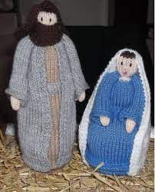
Message from the Family Service Team

Our final Family Service of 2022 will be our Advent celebration on Sunday December 4th at 10.30am. Do come if you can as we turn our thoughts to preparing for Christmas and what that really means. Refreshments from 10.15 as usual.

We will have our Posada of Mary & Joseph to set off on their journey - which we haven't been able to do for 2 years! They will return to church on Thursday Dec 22nd at 6pm for our Carol Service - so do join us then too for lots of carols followed by mulled wine (or juice!) and mince pies.

The other services to highlight for families across the Benefice are the Crib Service on Christmas Eve at 4pm in Coxwold church and the Christingle service on Dec 11th at 4pm in Carlton Husthwaite church.
If you haven't been to those churches before, do give it a try - you will be most welcome. If you have any questions about where the churches are etc, do ask us.

All services are also listed on the website www.bylandchurches.net

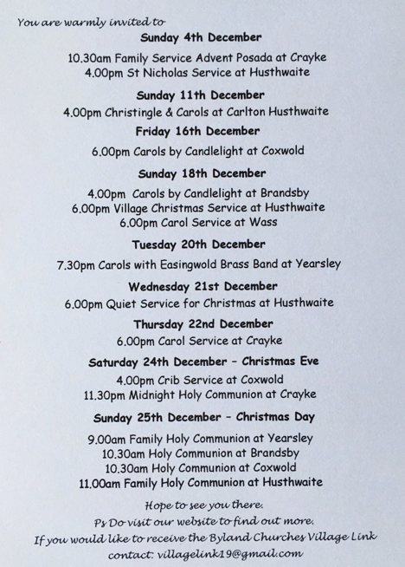

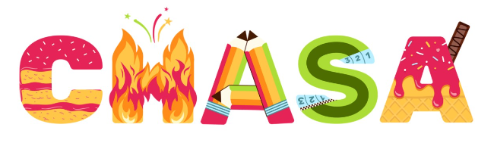
We’d like your feedback!
CHASA have prepared a survey for you to complete; we would really value your feedback about events which have already happened and about how you may be able to provide support in different ways for upcoming events. The survey will remain open until the end of term and we would be really grateful if you could take a few minutes to share your thoughts. Thank you!
https://forms.office.com/r/aW0ct9aFSt

Christmas Film Night



**Please complete the consent form here to register your child for the event. This is needed in addition to purchasing the wristband.**
https://forms.office.com/r/xpdEyHyHdF

Amazon Smile


Easyfundraising

Thank you so much to all the families who have so far supported us with this.
Please remember to use easyfundraising EVERY time you shop online. Over 7,000 brands will donate to Crayke CE School, Crayke for FREE when you use easyfundraising to shop with them, so you can support us no matter what you’re buying! If you haven’t signed up yet, it’s easy and completely FREE.
Visit:
https://www.easyfundraising.org.uk/causes/craykeceschoolcrayke/?utm_campaign=raise-more&utm_source=social&utm_medium=whatsapp&utm_content=rm-wa-2
 | Crayke CE School, Crayke Fundraising | Easyfundraising  Raise free funds for Crayke CE School, Crayke today by shopping online via Easyfundraising. Click now to shop at no extra cost and raise free donations.  www.easyfundraising.org.uk

Community News
Christmas Library Reading Challenge

Something exciting is coming to North Yorkshire Libraries this Christmas! We’re challenging children aged 0-11 to read four library books between 26th November and Christmas to win stickers, prizes, a certificate, and a special Christmas gift…. Think you can take on the challenge? Pop into your local library, give us a call, or follow us on Facebook for more information.



Lunch Menu
AUTUMN TERM | Week 1  w/c  5 Dec | Week 2  w/c  12 Dec
Monday | Creamy Macaroni Cheese Broccoli & Sweetcorn  Homemade Garlic Bread  Banana Mousse  Fresh Fruit or Fruit Yoghurt | Cheese & Tomato Pasta with Seeded Bread  Grated Carrot &  Cucumber Sticks  Oatie Cookie  Fresh Fruit or Fruit Yoghurt
Tuesday | Chicken Burger in a Bun  Diced Potatoes  Winter Slaw & Mixed Salad  Apple Crumble & Custard Fresh Fruit or Yoghurt | CHRISTMAS LUNCH!  
Wednesday | Roast Gammon  Gravy  Baked Baby Potatoes  Carrots & Savoy Cabbage Crusty Bread  Fruity Flapjack  Fresh Fruit or Fruit Yoghurt | Roast Pork & Apple Sauce Gravy  Creamy Mashed Potato  Roasted Parsnips &  Green Beans  Homemade Wholemeal Bread  Cheese & Crackers  Fresh Fruit or Fruit Yoghurt
Thursday | Chicken Korma & Rice  Peas & Sweetcorn  Naan Bread  Cheese & Biscuits  Fresh Fruit or Fruit Yoghurt | Meatballs & Pasta  Green Beans & Cauliflower  Homemade Garlic Bread  Fruit Muffin  Fresh Fruit or Fruit Yoghurt
Friday | Fish Fingers  Ketchup  Chips  Veggie Sticks  Homemade 50/50 Bread  Winter Berry Bake & Custard  Fresh Fruit or Fruit Yoghurt | Battered Fish  Ketchup  Chips  Peas & Sweetcorn  Homemade 50/50 Bread  Chocolate Orange Sponge & Chocolate Sauce  Fresh Fruit or Fruit Yoghurt

PE Kits
PE Kits  w/c 5/12 | Monday | Tuesday | Wednesday | Thursday  Skip2BFit | Friday
BEECH (LD) |  |  |  | X | X
HOLLY (LC) |  |  |  | X | X
OAK (LR) |  |  |  | X | X
Please do ensure that on PE days, the children wear their hoodies, school jumpers or cardigans alongside white or blue t-shirts and black or navy shorts or jogging bottoms.
Children in Apple Class need to bring their Forest School kit in each Monday and bring their PE kit in on Wednesday. They will be learning how to get changed in school during their PE sessions on Thursdays and Fridays and will come home wearing their kits home each Friday.

Attendance and Punctuality
Children will be marked late if they arrive after 9.00am
Please do help us in our mission to ensure that children are in school on time so that valuable learning time is not missed at the start of the day.

This week’s attendance figures: School Target: 92.1% 96%
Apple (CH): 95.7% 1 late | Beech (LD): 91.7% 5 lates / 4 children
Holly (LC): 90.3% 3 lates/ 2 children | Oak (LR): 92.7% 2 lates / 2 children

Team Points

Red | 415 | - Yellow  | 537
Blue | 428 | Green | 509

 Stars of the Week

Stars | Apple | Beech | Holly | Oak
Stars | Zephie Brown | Sophy Triffitt | Sam Stubbins | Maiya Rosa-Keyter
Stars | Zephie Brown | Martha Seligman | Scarlett Woodhouse | Sienna Jagger
Gold Awards for Sport | Letty Wilkinson | Grant Colman | Joah Brown | Isabelle Sargent

Extra-Curricular Clubs – Autumn Term
***PLEASE NOTE THERE WILL BE NO CLUBS W/C 12 DECEMBER***
Some clubs have limited capacity and places will be allocated on a first come first served basis. In the event of a club being fully booked, your child’s name will be added to a waiting list and you will be advised if a place becomes available. Booking is not required for before school or lunchtime clubs. For after school clubs run by school staff (in red type; denoted with *) please email Mrs Bacon on admin@crayke.n-yorks.sch.uk to book a place.
Before School Clubs
Club | Leader | Day and Time | Group
Run a Mile | Mrs Jackson | Monday, Tuesday Thursday & Friday  8:30am | All welcome – parents and carers included!

Lunchtime Clubs
Club | Leader | Day | Group
Skipping | Mrs Helfferich | Monday | All
School Council | Miss Walker | Tuesday | Successful candidates
Fitness | Mr Montgomery | Friday | Y4/5/6

After School Clubs

We respectfully ask you to check the collection time below carefully and to collect your children promptly at the end of clubs. Clubs will run unless you are notified otherwise.
Monday | Craft (£10 pay via ParentPay)  3:30 – 4:15pm  Years 1 – 6  Mrs Seligman and Miss Sherry |  | Book Club* (no charge)  3:30pm – 4:15pm  Year 4-6  Mrs Rayner
Tuesday | NO CLUBS
Wednesday | Forest Schools* (no charge)  3:30pm – 4:15pm  Year 1-6  Mrs Helfferich |  | Computing* (no charge)  3:30pm – 4:15pm  Year 3/4  Mr Brown
Thursday | Sewing* (no charge)  *NB no club 1/12*  3:30pm – 4:15pm  Year 3/4  Mrs Dobson | Rounders* (no charge)  *Please note earlier finish time*  3:30pm – 4:00pm  Year 3-6  Mrs Aristizabal |  | Dance (Fee paid direct by bank transfer - £16.00 for 4 weeks)  8 Dec  3:30 – 4:30pm  Year 1-6  Kelly Jane Goodwin
Friday | Football (fee paid direct)  3:30 – 4:30pm  Years 3-6  Simon Carson Sports School  BOOKING LINK: https://simoncarsonsportsschool.co.uk/shop/after-school-clubs/crayke-ms-autumn-1/
Crayke Church of England Primary School
Dates for your Diary – Autumn Term 2022

** New date added this week

Day | Date | Event | Who | Where
Wednesday | 7 Dec | Nativity Performance 9:30am  Parents and carers welcome | Apple and Beech Classes | Hall
Wednesday | 7 Dec | Nativity Performance 2:15pm  Parents and carers welcome | Apple and Beech Classes | Hall
Thursday | 8 Dec | Skip2BFit | Whole School | Sports Club
Friday | 9 Dec | CHASA Christmas Film Night | Whole School | Hall
Tuesday | 13 Dec | Swimming | Oak Class | Thirsk Pool
Tuesday | 13 Dec | Christmas Lunch | Whole School | Hall
Wednesday | 14 Dec | Christmas Parties | Whole School | Hall
Thursday | 15 Dec | Reindeer Rush | Whole School | Field
Friday | 16 Dec | Christmas Jumper Day | Everyone | Whole school
Friday | 16 Dec | Christmas Carol Service 1:15pm  Parents and carers welcome | Whole school | Church
Friday | 16 Dec | End of term – school closes at 2:30pm | Whole school

Term Dates – Academic Year 2022/2023
Autumn Term Tuesday 6th September to Friday 16th December, 2022
Spring Term Wednesday 4th January to Friday 31st March 2023
Half Term Monday 13th February to return on Monday 20th February
Summer Term Tuesday 18th April to Friday 21st July 2023
May Day Monday 1st May 2023
Additional Bank Holiday Monday 8th May 2023
Half Term Monday 29th May to return on Monday 5th June
INSET Days (School Closed to pupils) –
Tuesday 3rd January 2023
Monday 17th April 2023
Monday 24th July 2023
Tuesday 25th July 2023

Judi Jackson
Headteacher
headteacher@crayke.n-yorks.sch.uk

FOLLOW YOUR PATHWAY AND WE GROW TOGETHER WITH CONFIDENCE
You did not choose me, I chose you that you might go and bear fruit, fruit that will last so that whatever you ask in my name the Father will give you. John 15:16
Respect Friendship Forgiveness Determination

