
Crayke Church of England Primary School
FOLLOW YOUR PATHWAY AND WE GROW TOGETHER WITH CONFIDENCE
You did not choose me, I chose you that you might go and bear fruit, fruit that will last so that whatever you ask in my name the Father will give you. John 15:16
Respect Friendship Forgiveness Determination

Dear Parents and Carers,

NEWSFLASH!
WRAP AROUND CARE
We are hugely excited to share with you the news that we are in discussion with a local provider about the possibility of providing wraparound care for Crayke pupils, possibly from as soon as Easter 2023, at the Sports Club in the village. We know that this could make an immense difference to many of our families, both present and future.

In order for the provider to assess the viability of the provision, we would be very grateful if you could complete this short survey as soon as possible, and no later than Friday 10 February 2023. The survey contains much more detail about the proposal including proposed opening times and costs. The survey can be found via this weblink: https://forms.office.com/e/itMfQpsU7K

We will keep you informed of progress. In the meantime, if you have any queries please do not hesitate to contact me.

NEWS FROM SCHOOL THIS WEEK
It has been a really busy time in school and all children have been so lucky to benefit from such a variety of experiences in school and the local area. A huge thanks to the staff who have organised and led these visits and also to the volunteers who have accompanied us in order to make the visits possible.

Holly – York Chocolate Story
Message from Mrs Chandler
Holly class had a wonderful 'stunning start' to our topic at York Chocolate Story. We were fascinated to hear all about the origins of chocolate, and more importantly for us, discovering the stories behind the greatest names in York's chocolate history. We had great fun making chocolate wallpaper in our Charlie and the Chocolate Factory workshop and chocolate lollies on our guided tour. I hope you have enjoyed hearing all about it from the children who were brilliantly behaved, enthusiastic and engaged!
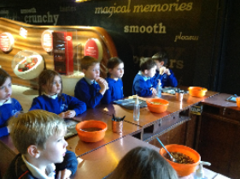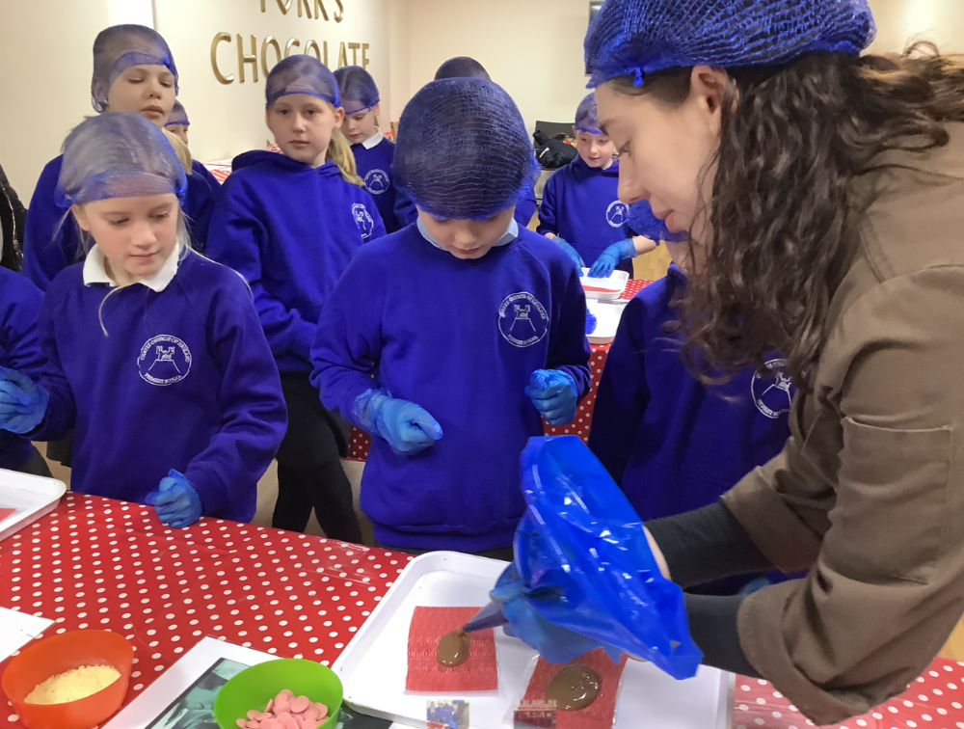
Oak - York Visit
Message from Mrs Rayner
Oak Class had a fantastic day on our 3-in-1 class trip to York on Tuesday! We learnt how to make delicious pizzas at Pizza Express, which we have been writing recipes from back in the classroom. At the Yorkshire Museum, we discovered more about the Romans in York (Eboracum) and got to make links to previous learning. After having our pizzas there, we had a warm welcome at the York Mosque where the Imam taught us about the five pillars of Islam and answered our many questions. All of the children showed enthusiasm and upheld our school value of respect throughout the entire day.
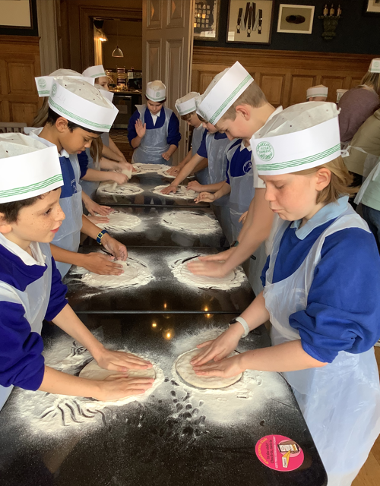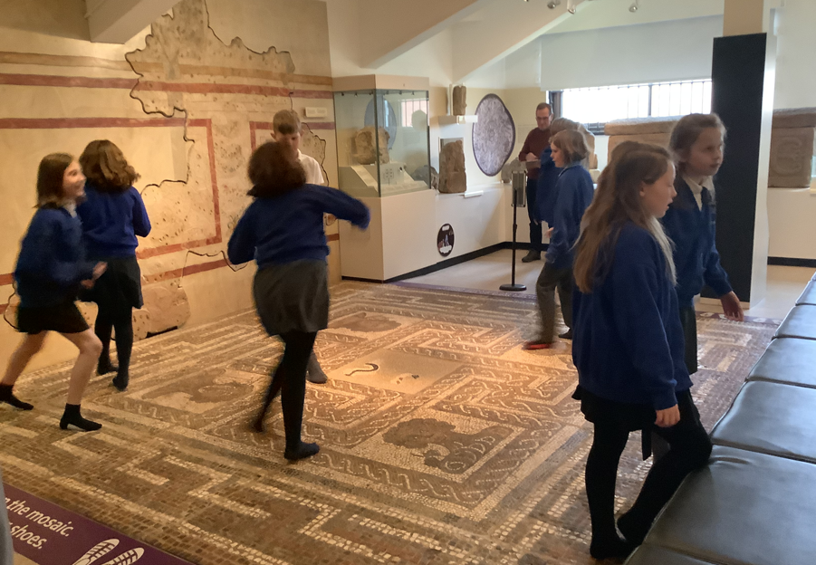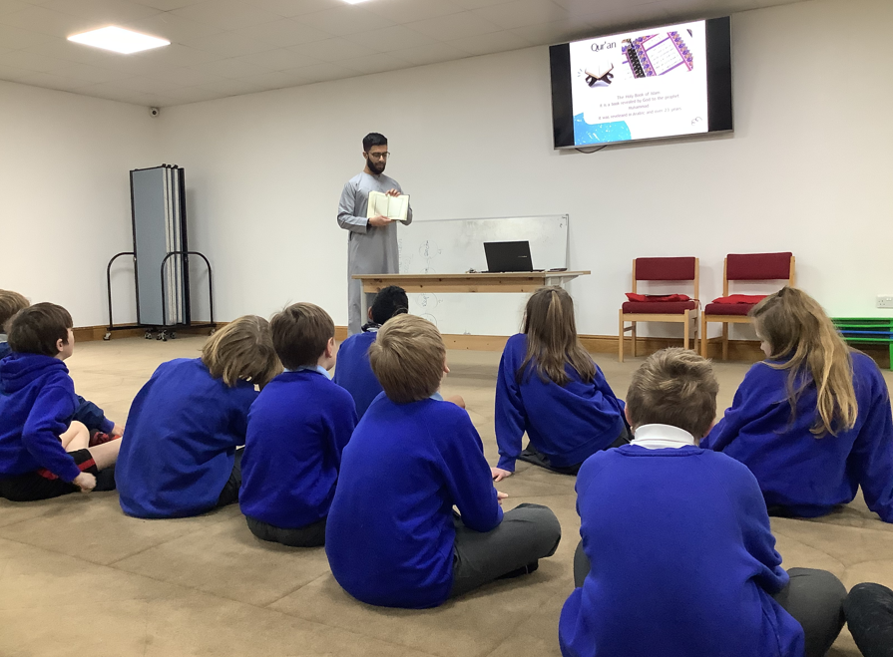

Beech - English Experience Morning “Into the Woods”
Message from Mrs Dobson
Beech Class had a fabulous morning yesterday! We started in the Forest Schools area with a scavenger hunt and then completed a local walk using our senses to spot various sounds, sights and smells. After break we completed a mini beast hunt and a colour hunt. The highlight of the morning was toasting marshmallows and having hot chocolate around the fire. A big thanks to Mrs Helfferich for helping with this.
Beech Class will now use this experience to help write a recount in English.
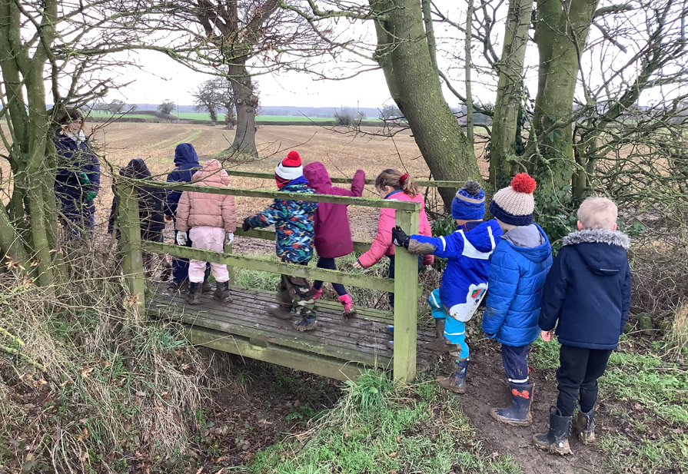
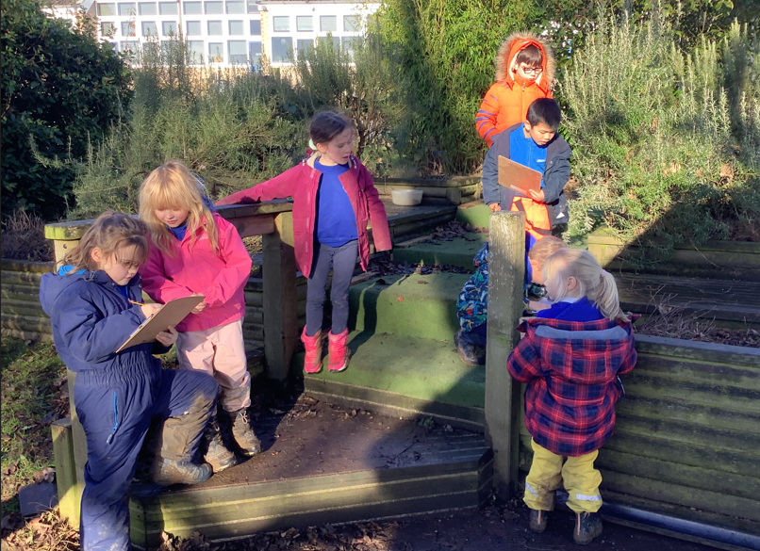
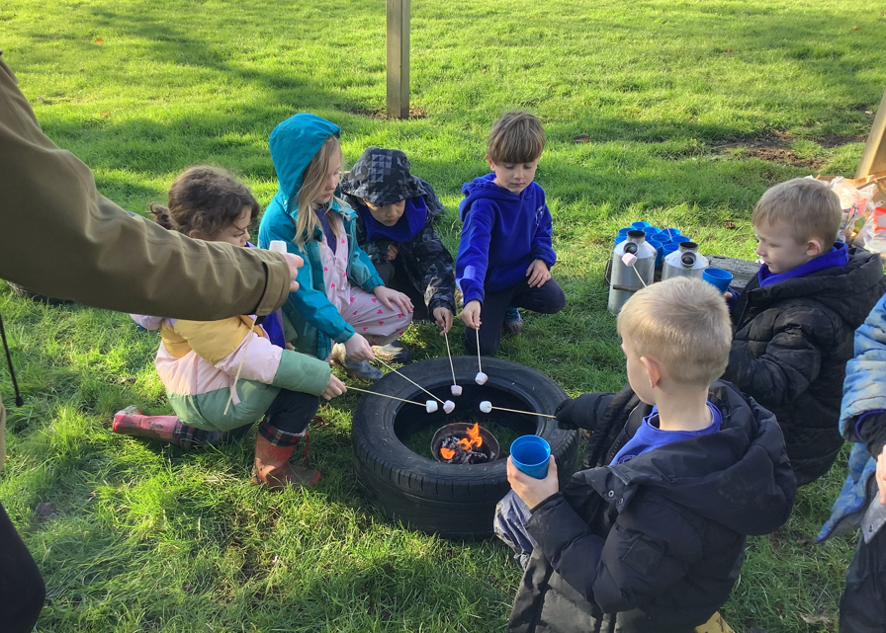

Apple - Update
Message from Mrs Helfferich
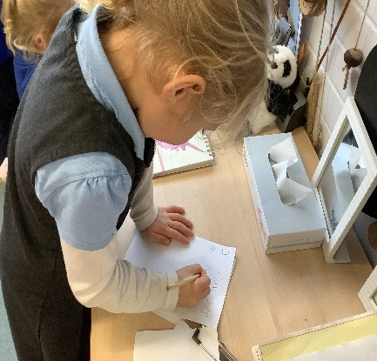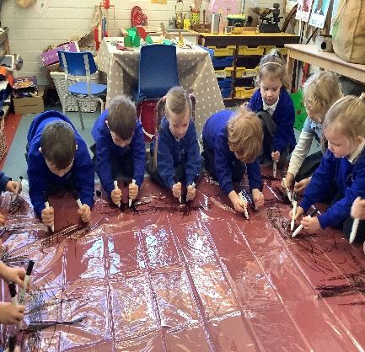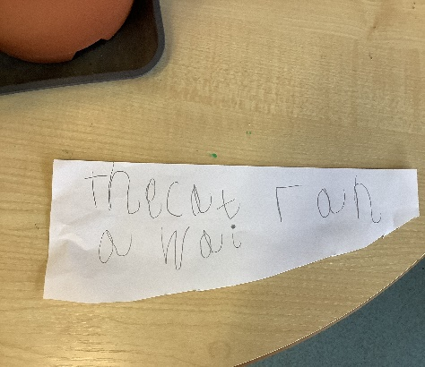
We are so proud of everyones determination and enthusiasm. Our Dough Disco, Squiggle sessions and phonics lessons are definitely paying off. We were going through our tricky words, the children were asked to give a sentence with that word in. Isabelle said a super sentence “The cat ran away”. I set her the challenge of writing it, she was sure that it was just too hard. I reminded her of our daily affirmations. Isabelle and a group of 7 other children rose to the challenge to write their sentences. What an amazing job they all did! It was all independent work, they even picked their own piece of paper to write it on! We are a term and a half into school life and look at what you have achieved. I think we deserve a forest school hot chocolate to celebrate.

Oak – Photography Workshop
Oak Class thoroughly enjoyed the opportunity to learn from an expert last week and we were really grateful to Colin Merritt for his visit. He complimented the group on being “refreshingly attentive and enthusiastic.” We’re looking forward to seeing how they translate the theory into practice this week as they venture out into the village to take their own photographs. Here they are practising framing their views!

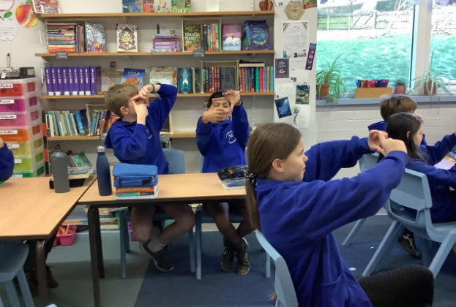

Wow Walk to School Challenge Weekly Update
Message from Mrs Helfferich

We are nearly at the end of January, next week the Viking badge will be handed out.
The Vikings, what do we know about them?
The Vikings were seafaring people from the late 8th to the late 11th century who established a name for themselves as traders, explorers and warriors. They discovered the Americas long before Columbus and could be found as far east as the distant reaches of Russia.
Oak Class Year 6 - we are setting you a challenge, to achieve Bronze status by next Friday. All you need to do is all either walk from the sports club to school, attend running club or do laps of the playground at least once next week. You can do it!

This Photo by Unknown Author is licensed under CC BY-NC
Apple Beech Holly and Year 5

White Rose Maths – One Minute Maths and Maths with Michael

Children in all classes are now using the structure of White Rose Maths in their daily maths lessons. This is an approach used by the majority of schools in North Yorkshire. White Rose Maths have made an app available for children to use to further develop their rapid recall. This is freely available on either the App Store or Google Play by searching for 1 Minute Maths. Please help support your child’s maths fluency by installing this on a device for them – thank you.
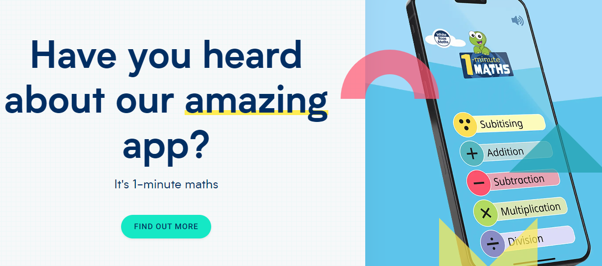


If you would like to find out more about how to help your child with maths and/or about how maths is taught in school, please do have a look at these short videos
https://whiterosemaths.com/maths-with-michael

Industrial Action
As you may have seen in the media this week, one of the teaching unions, the NEU, is intending to call upon its members to take part in industrial action in the forthcoming months. At this stage, we do not anticipate that any of our NEU members will be going out on strike. This therefore means that we do not envisage any closure of classes or school on the published strike dates. If anything changes, we will inform you as soon as possible.

Forest School Club
Message from Mrs Helfferich
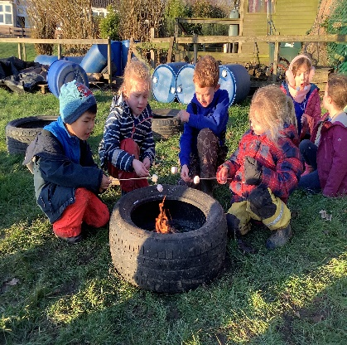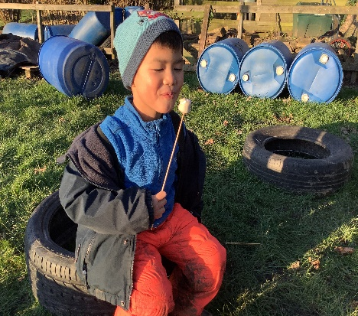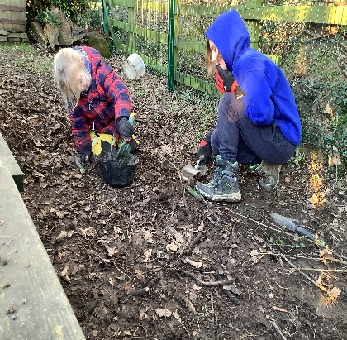
This week at forest school club we reminded ourselves of the fire circle rules, toasted marshmallows, dug for worms, made dens, played hide and seek and balanced along the barrels. The children were very disappointed to find that all too soon it was 4:15pm and time to go home. We have decided that next week we will make hot chocolate using the Kelly Kettle. We will also reinstate our old fire circle and firepit.

**UPCOMING EVENTS**
SPORT
Cross Country – Holly and Oak Tuesday 31 January
Key Stage 2 children have been invited to participate in a cluster event involving local schools. This will be held at Husthwaite Primary School on the afternoon of Tuesday 31 January. Children will be taken by coach after lunch and will be back by the end of the school day. They will require PE kit, a warm coat and a named water bottle. The consent form for this event is available here: https://forms.office.com/e/mS3MZ7G399

Swimming - Holly - Wednesdays until 1 March
Reminder: Due to the timing of the lesson, children are required to bring a packed lunch, which they will eat on return to school. Thank you for your support with this.

Rugby – Beech and Oak – Thursdays until half term
Mark from York City Knights will be teaching rugby to Beech and Oak class on Thursday afternoons until February half term.

**UPCOMING EVENTS**
PARENT WORKSHOPS
We are planning a series of parent workshops over the coming weeks as follows to help provide further information about upcoming events for children across school. Further details will be provided soon but for now please save the dates!

Focus | For parents of children in | Date | Time | Led by
KS1 SATs | Year 2 | Thursday 2 March | 9:10am | Mrs Dobson
KS2 SATs | Year 6 | Thursday 9 March | 9:10am | Mrs Rayner
Multiplication Tables Check | Year 4 | Thursday 16 March | 9:10am | Mrs Chandler
Phonics | Year 1 | Thursday 23 March | 9:10am | Mrs Dobson

**UPCOMING EVENTS**
ENRICHMENT – INCLUDING EDUCATIONAL VISITS AND VISITORS

Candlemas Service – Thursday 2 February
We look forward to welcoming Rev Katie into school on Thursday 2 February to lead a Candlemas Service.
NSPCC Number Day – Whole School - Friday 3 February
Message from Mrs Chandler, Maths Subject Leader

As part of our focus on Maths this year, we are excited to announce that we will be participating in this national event for the first time!
Making maths meaningful
Number Day is a great way to make maths fun and bring about a positive, ‘can-do’ attitude towards it.
We are having a fun day of maths activities and we will be taking part in Dress up for Digits. Pupils are asked to wear an item of clothing with a number on it (football shirt, cap, netball shirt or even a onesie!). Or get even more creative by dressing in a maths or numbers theme.
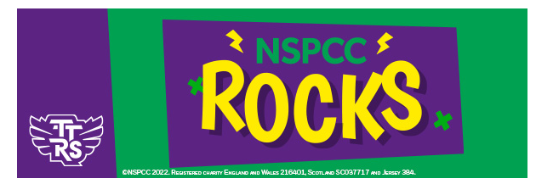
NSPCC Rocks Key Info
- It's free to take part.
- Every correct answer that a pupil gives, in any game type, between the hours of 7:30am to 7:30pm will contribute to their class and school score (To be completed at home please)
- There is a 60-minute limit playtime per player.
- There is a minimum player count of 10 for each class. If fewer than 10 children in the class play in the competition, their total will be divided by 10 regardless.
Heritage Week – w/c 6 February 2023

To commemorate the 50th anniversary of the school opening on its current site, we will be undertaking a whole school local history study entitled “How has our school changed?”
We would be so grateful if anyone has any photographs, news clippings or other resources from their time at Crayke Primary over the years. We would also love to welcome former pupils and parents to speak to the children about what the school was like when they were here.
If you think you can help in any way, or know someone who can, please contact me on headteacher@crayke.n-yorks.sch.uk Thanks in advance!

Safer Internet Day – Tuesday 7 February 2023

For Safer Internet Day 2023, the UK Safer Internet Centre is organising celebrations and learning around the theme “Want to talk about it? Making space for conversations about life online.” They are celebrating by putting children and young people’s voices at the heart of the day and encouraging them to shape the online safety support that they receive.

As a school we will be delivering lessons to pupils around this theme in an age appropriate way. Parents can also find some great resources at the following link: https://www.saferinternetday.org/resources

We are also currently in discussion with North Yorkshire Police about the possibility of one of their Schools Liaison Officers coming into school to deliver a parent workshop and assembly for the children. We will keep you updated when we are able to finalise a date.

Beech - Grass Heads - Tuesday 21 February
Message from Mrs Dobson
After half-term, the children in Beech class will be making 'Grass-heads'. Please could they bring a pair of thin, skin coloured tights or something similar in to school before this date. If anybody has spares these would also be appreciated.

Crayke’s Greatest Show – Tuesday 28 March
Miss Walker and the School Council are formulating plans for a talent show to be held on the afternoon of Tuesday 28 March. Further details to follow!

Easter Service – Wednesday 29 March
Please join us at St Cuthbert’s Church on Wednesday 29 March at 11am for our Easter Service.

Chess Club Match – Thursday 30 March


Message from Mrs Seligman
Crayke School Chess Club would like to invite governors to take part in a chess match on Thursday 30 March, at 3.30pm, at school. All standards welcome!
The idea is to have a team of teachers and governors combined taking on the school team for an end of term tournament. The more the merrier.... The winner might even win a prize!
Please RSVP to mseligman@crayke.n-yorks.sch.uk if you would like to attend.

Extra-Curricular Clubs – Spring Term
Some clubs have limited capacity and places will be allocated on a first come first served basis. In the event of a club being fully booked, your child’s name will be added to a waiting list and you will be advised if a place becomes available. Booking is not required for before school or lunchtime clubs. For after school clubs run by school staff (in red type; denoted with *) please email Mrs Bacon on admin@crayke.n-yorks.sch.uk to book a place.
Before School Clubs
Club | Leader | Day and Time | Group
Run a Mile | Mrs Jackson | Monday, Tuesday Thursday & Friday  8:30am | All welcome – parents and carers included!

Lunchtime Clubs
Club | Leader | Day | Group
Skipping | Mrs Helfferich | Monday | All
School Council | Miss Walker | Tuesday | Successful candidates
Fitness | Mr Montgomery | Friday | Y4/5/6
Games | Miss Clarke | Friday | Max. 20 (list kept in school)

After School Clubs

We respectfully ask you to check the collection time below carefully and to collect your children promptly at the end of clubs. Clubs will run unless you are notified otherwise.
Monday | Craft* (£10 pay via ParentPay)  3:30 – 4:15pm  Years 1 – 6  Mrs Seligman and Miss Sherry | Revision* (no charge) – Starting after Feb half term  3:30pm – 4:15pm  Year 6  Mrs Rayner
Tuesday | Indoor Multi-Sport (fee paid direct)  3:30 – 4:30pm  Years 1 – 6  Mark Cromack
Wednesday  STARTS 1 FEBRUARY | Italian* (no charge)  3:30 – 4:15pm  Years 2 – 6  Mrs Aristizabal
Thursday | Forest Schools* (no charge)  3:30pm – 4:15pm  Year 1-6  Mrs Helfferich | Chess* (no charge)  All abilities; Beginners welcome  3:30pm – 4:15pm  Year 3-6  Mrs Seligman | Rugby (fee paid direct)  3:30pm – 4:30pm  Years 3-6  RLFC
***STANDING ITEMS***
Cost of Living Crisis
We are very aware that costs continue to rise and look set to do so for some time. If you are encountering financial difficulties, we may be able to signpost support. Please get in touch.
If your circumstances have changed and you think your child may be eligible for free school meals, it has never been easier to apply. There is no stigma attached to this, it is not highlighted to the children in any way, and the school gets valuable funding too. If you would like a confidential conversation about whether you may be eligible for free school meals, please do not hesitate to speak to me. To apply directly please use this weblink: https://www.northyorks.gov.uk/free-school-meals

Salt Bin
We have been advised that the Salt Bin on the bank leading to the Sports Hall has been filled up today. If you notice it is running low or empty, please let us know and we can arrange to get it filled.

Reception places available for September 2023
Due to a lower number of sibling than usual, we anticipate that we will have some spaces available in our Reception class in September 2023. Although the deadline has now officially passed for applications of places to North Yorkshire County Council, if you know of any parents who may be interested, please do ask them to contact school.

Online Safety
We recognise the importance of online safety and also understand that it is a fast paced, ever changing online world where parents can struggle to keep up with the technical knowledge and understanding demonstrated by their children. The National Online Safety organisation produce regular guides for parents – this week they have produced a leaflet entitled “Top Tips for Building Cyber Resilience”. Please see the attached leaflet which is also available on the Online Safety section of our website. Should you wish to access any of the other online safety parent guides available on a whole range of topics including what parents need to know about Amazon Fire Tablets, Google Chromebooks, and ways to champion equality online, please have a look at this weblink: https://nationalonlinesafety.com/guides
Should you wish to access more information about how to support your child/ren with online safety at home, this course is available which explains in detail the risks they might be exposed to and what you can do to support them. https://info.nationalonlinesafety.com/myleene-uk

Attendance and Punctuality
We strive for high levels of attendance at school. Please try, wherever possible, to book holidays out of term time. The impact of even one day’s absence on your child’s learning is huge. Also, please try to book medical appointments out of school hours if possible as this also minimises the time missed. If your child is very unwell and unable to attend school, please inform the office by phoning 01347 821767 no later than 9:15am. Thank you for your support with this important matter.

Why is it important for children not to miss school?
All parents want the best for their children and for them to get on well in life. Having a good education is important to ensure that they have the best opportunities in their adult life. They only get one chance at school, and your child’s future may be affected by not attending school or alternative provision regularly.
If children do not attend school regularly they may:
• Struggle to keep up with school work. In a busy school day, it can be difficult for schools to find the extra time to help a child catch up.
• Miss out on the social side of school life. Poor attendance can affect children’s ability to make and keep friendships; a vital part of growing up.
Setting good attendance patterns from an early age, from nursery through primary school will also help your child later on in their life. Children who have a poor school attendance record may have less chance of securing a job when they are adults. Being on time is also vital. Arriving late at school can be very disruptive for your child, their teacher and the other children in the class. Some parents may be finding it difficult to ensure that their child attends school regularly. If this is the case please speak to Mrs Jackson as soon as possible so that the situation can be addressed.

The world is run by those who turn up.

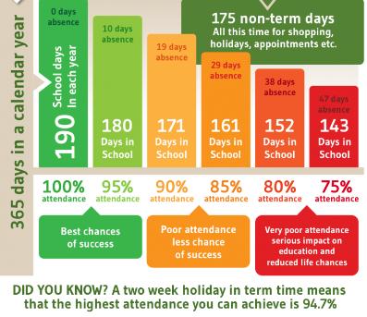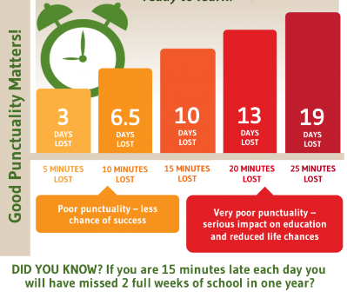

Make every minute count!
Our Safeguarding Team
At Crayke, we have three members of staff and a governor who make up our Safeguarding Leadership Team. I am the Designated Safeguarding Lead, which means that I am the lead person responsible for child protection and safeguarding issues. Mrs Rayner and Mrs Chandler are our Deputy Designated Safeguarding Leads (Deputy DSLs); a deputy DSL supports the DSL in their role of safeguarding and child protection. Mr Hugh Porter is our Safeguarding Link Governor. The role of the Safeguarding Governor is to support the DSL as well as to regularly review, ask questions and make suggestions about our safeguarding policies and procedures and to report back to the governing body. All staff at Crayke know that safeguarding is EVERYONE’S responsibility. Find out more on our dedicated website Safeguarding page: https://craykeschool.org/safeguarding/
You can also report any safeguarding concerns to our DSL email: dsl@crayke.n-yorks.sch.uk Please also be aware that as a school we subscribe to Operation Encompass, whereby we are notified of any incidences of domestic violence where a pupil at our school has been present.

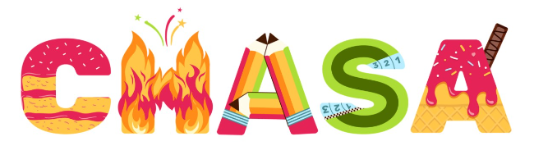
We’d like your feedback!
CHASA have prepared a survey for you to complete; we would really value your feedback about events which have already happened and about how you may be able to provide support in different ways for upcoming events. We have extended the deadline for this and the survey will now remain open until the end of January. We would be really grateful if you could take a few minutes to share your thoughts. Thank you! https://forms.office.com/r/aW0ct9aFSt

Please note that we have have been informed that Amazon Smile will cease to operate with effect from mid February.
Amazon Smile Easyfundraising

Thank you so much to all the families who have so far supported us with this.
Please remember to use easyfundraising EVERY time you shop online. Over 7,000 brands will donate to Crayke CE School, Crayke for FREE when you use easyfundraising to shop with them, so you can support us no matter what you’re buying! If you haven’t signed up yet, it’s easy and completely FREE.
Visit:
https://www.easyfundraising.org.uk/causes/craykeceschoolcrayke/?utm_campaign=raise-more&utm_source=social&utm_medium=whatsapp&utm_content=rm-wa-2

Community News



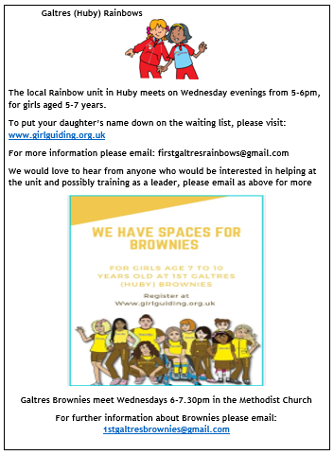
Community News (cont.)


Community Cafe
18th February 11am-1pm
Crayke Sports Club & Village Hall

The theme of the Community Cafe is Habitats. There will be information on making a pond, a bird house, a bug house or a house for a hedgehog!
A local bee keeper will be there and an expert on moths, butterflies and fish!
There will be some flat packs available. Hope some of you can join us with the children for a drink and piece of cake.
THE SUSTAINABLE CRAYKE GROUP

Lunch Menu – Spring Term

SPRING TERM  2023 | Week 1  Served w/c 20th Feb, 13 Mar | Week 2  Served w/c 30th Jan, 27th Feb, 20th Mar | Week 3  Served w/c 6th Feb, 6th Mar, 27th Mar
Monday | Pasta Parcels (Hilcona) in a Homemade Tomato Sauce  Cauliflower & Green Beans  Garlic Bread  Apple Crumble & Custard  Fresh Fruit or Fruit Yoghurt | Pizza  Crusty Bread  Diced Potatoes  Peas & Sweetcorn  Krispie Cereal Bar  Fresh Fruit or Fruit Yoghurt | Farmhouse Mac & Cheese with Garlic Bread  Broccoli & Carrots  Jam Roly Poly & Custard  Fresh Fruit or Fruit Yoghurt
Tuesday | Crispy Chicken Bites  Baked Baby Potatoes  Peas & Sweetcorn  Herby Bread  Orange Shortbread  Fresh Fruit or Fruit Yoghurt | Pasta Bolognese  Cauliflower & Green Beans  Garlic Bread  Chocolate Orange Sponge & Chocolate Sauce  Fresh Fruit or Fruit Yoghurt | Cheese Burger  Baked Potato Wedges  Spring Coleslaw with Cucumber Sticks  Banana Brownie  Fresh Fruit or Fruit Yoghurt
Wednesday | Roast Turkey & Stuffing  Roast Potatoes  Medley of Seasonal Vegetables  Homemade 50/50 Bread  Arctic Roll & Fruit  Fresh Fruit or Fruit Yoghurt | Sausage & Yorkshire Pudding  Mashed Potato  Medley of Seasonal Vegetables  Sliced Wholemeal Bread  Cheese & Crackers  Fresh Fruit or Fruit Yoghurt | Mince Beef & Dumplings with Baked Baby Potatoes  Medley of Seasonal Vegetables  Sliced Wholemeal Bread  Marbled Sponge & Custard  Fresh Fruit or Fruit Yoghurt
Thursday | Chilli Con Carne & Naan Bread  50/50 Rice  Broccoli & Carrots  Cheese & Crackers  Fresh Fruit or Fruit Yoghurt | Chicken Wrap  50/50 Bread  Vegetable Rice  Broccoli & Carrots  Apple Flapjack  Fresh Fruit or Fruit Yoghurt | Chicken Korma & Rice  Cauliflower& Green Beans  Naan Bread  Oatie Biscuit & Cheese  Fresh Fruit Yoghurt
Friday | Fishwich (Salmon)  Chips  Crunchy Vegetable Sticks  Chocolate Berry Mousse Cake  Fresh Fruit or Fruit Yoghurt | Fish Fingers  Chips  Baked Beans & Peas  Crusty Bread  Lemon Drizzle Muffin  Fresh Fruit or Fruit Yoghurt | (Harry Ramsdens) Battered Fish  Chips  Peas & Sweetcorn  Crusty Bread  Lemon & Sultana Iced Finger  Fresh Fruit or Fruit Yoghurt

PE Kits
PE Kits  w/c 30 Jan | Monday | Tuesday | Wednesday | Thursday | Friday
BEECH (LD) |  |  |  | X (rugby) | X
HOLLY (LC) |  |  | X (swim) |  | X
OAK (LR) |  |  |  | X (rugby) | X
Please do ensure that on PE days, the children wear their hoodies, school jumpers or cardigans alongside white or blue t-shirts and black or navy shorts or jogging bottoms.
Children in Apple Class need to bring their Forest School kit in each Monday. Please wear PE kit on Wednesday and bring uniform to change into.

Attendance and Punctuality
Children will be marked late if they arrive after 9.00am
Please do help us in our mission to ensure that children are in school on time so that valuable learning time is not missed at the start of the day.

This week’s attendance figures: 90.3% School Target: 96%
Apple (CH): 97.1% 1 late | Beech (LD): 96.6% 0 lates
Holly (LC): 88% 0 lates | Oak (LR): 80.5% 1 late

 Stars of the Week

Stars | Apple | Beech | Holly | Oak
Stars | Louise Keaney | India Ward | Sam Stubbins | Ethan Hutton
Stars | Louise Keaney | Amber Brown | George Ritchie | Isaac Copley
Gold Awards for Sport | Duke Gains | Wilfred Liddell | Leo Bunker Barnes | Isabelle Sargent

Crayke Church of England Primary School
Dates for your Diary – Spring Term 2023

Day | Date | Event | Who | Where
Wednesdays | 1/8/22 Feb  1 Mar | Swimming | Holly Class | Thirsk Pool
Thursdays | Alternate weeks | Open the Book – collective worship | Whole school | Hall
Tuesday | 31 January | Cross Country – cluster event | Holly and Oak | Husthwaite
Thursday | 2 February | Candlemas Service led by Rev. Katie | Whole school | School hall
Friday | 3 February | NSPCC Number Day | Whole school
w/c 6 February |  | Heritage Week – 50th anniversary celebrations of Crayke Primary | Whole school
Tuesday | 7 February | Play Leader Training | Year 5 | Hall/playground
Tuesday | 7 February | Safer Internet Day – “Want to talk about it?” | Whole school | Classrooms
w/c 13 February – HALF TERM
Thursday | 23 February | Music for Life Percussion focus – concert (morning) and workshop (afternoon) | Whole school  Holly | Hall
Thursday | 2 March | World Book Day | Whole school
Thursday | 2 March | Parent Workshop: KS1 SATs | Y2 parents | Hall
Thursday | 9 March | Parent Workshop: KS2 SATs | Y6 parents | Hall
Tuesday | 14 March | STEM workshop – cluster event | Oak Class | Easingwold Primary
Thursday | 16 March | Parent Workshop: MTC | Y4 parents | Hall
Tuesday | 21 March | Parent Consultation Evening  3:30 – 6:30pm | Whole school | Classrooms
Wednesday | 22 March | Parent Consultation Evening  3:30 – 6:30pm | Whole school | Classrooms
Thursday | 23 March | Parent Workshop: Phonics check | Y1 parents | Hall
Tuesday | 28 March | Crayke’s Greatest Show – A Talent Competition for all | Whole school | Hall
Wednesday | 29 March | Easter Service 11am  Parents and carers welcome | Whole school | St Cuthbert’s Church
Thursday | 30 March | Staff and Governors v Pupils Chess Match | Chess Club | Oak Classroom
Friday | 31 March | Easter Egg Hunt | Whole school | Field

Summer Term Dates for your Diary
Monday - Wednesday | 5-7 June | Residential | Year 5 | Carlton Lodge
Friday | 30 June | Camp Out at School overnight | Year 4 | School field
New date added this week

Term Dates – Academic Year 2022/2023
Spring Term Wednesday 4th January to Friday 31st March 2023
Half Term Monday 13th February to return on Monday 20th February
Summer Term Tuesday 18th April to Friday 21st July 2023
May Day Monday 1st May 2023
Additional Bank Holiday Monday 8th May 2023
Half Term Monday 29th May to return on Monday 5th June
INSET Days (School Closed to pupils) –
Monday 17th April 2023
Monday 24th July 2023
Tuesday 25th July 2023

Judi Jackson
Headteacher
headteacher@crayke.n-yorks.sch.uk

FOLLOW YOUR PATHWAY AND WE GROW TOGETHER WITH CONFIDENCE
You did not choose me, I chose you that you might go and bear fruit, fruit that will last so that whatever you ask in my name the Father will give you. John 15:16

Respect Friendship Forgiveness Determination

