
Crayke Church of England Primary School
FOLLOW YOUR PATHWAY AND WE GROW TOGETHER WITH CONFIDENCE
You did not choose me, I chose you that you might go and bear fruit, fruit that will last so that whatever you ask in my name the Father will give you. John 15:16
Respect Friendship Forgiveness Determination

Dear Parents and Carers,
NEWS FROM SCHOOL THIS WEEK
Happy New Year! Welcome back to the Spring Term, in which we shall be eagerly anticipating signs of spring. It has been lovely to see the children settling straight back into learning and school routines.
Curriculum Trees

This term’s new look Curriculum Trees have been uploaded onto the school website onto the class pages under the “Children” tab. They are also all available on the curriculum intent overview page: https://craykeschool.org/curriculum/overview-intent/ and on each class google page.

We hope that they give you a useful insight into the different aspects of learning your child/ren will be covering this term, including the vocabulary they will be learning in each subject. Should you have any feedback about these curriculum plans, we would be really pleased to hear from you on headteacher@crayke.n-yorks.sch.uk

Club News
See Page 6 for full club offer. There have been a couple of additions to the club offer this week namely:
Italian with Mrs Aristizabal on a Wednesday (starting 1 February due to staff training) – booked via emailing Mrs Bacon on admin@
Rugby with RLFC on a Thursday (starting 19 January) – fee paid direct and booked via https://member.clubforce.com/memberships_cart_m.asp?LL_ID=2220&intMF_ID=11627#Anchor
Please note there is a minimum booking of 8 places on this course and a maximum of 16. Book now to avoid disappointment.

Home School Values
Our special focus this term is on COURAGE and FORGIVENESS. As one of our core values, the children are likely to already be experts on the latter! We shared leaflets via the website which can be used with your child/ren to support discussions around these values. They’re available here: https://craykeschool.org/2023/home-school-values-spring-term-2023/
Online Safety Staff Training
On Tuesday’s training day, staff received valuable online safety training in relation to how we can support children to be as safe as possible in an online world. We focussed on “the 4Cs” namely: Content, Contact, Conduct and Commerce. The main emerging theme for us as educators to share with both parents and pupils is the importance of creating an ethos whereby children will feel comfortable enough to raise concerns and seek help where needed. It was therefore really timely when this week’s National Online Safety update landed with a focus on providing top tips for children about staying safe online. Please take some time to review these with your child/ren. Should you require any further information, or have any questions please contact either me (PSHE Subject Leader) or Mrs Rayner (Computing Subject Leader)



Spelling Lists
This term’s spelling lists are available on each class page on the website, in their individual reading diaries and they are also here for ease of reference. First tests next Friday 13th…!

Year 2
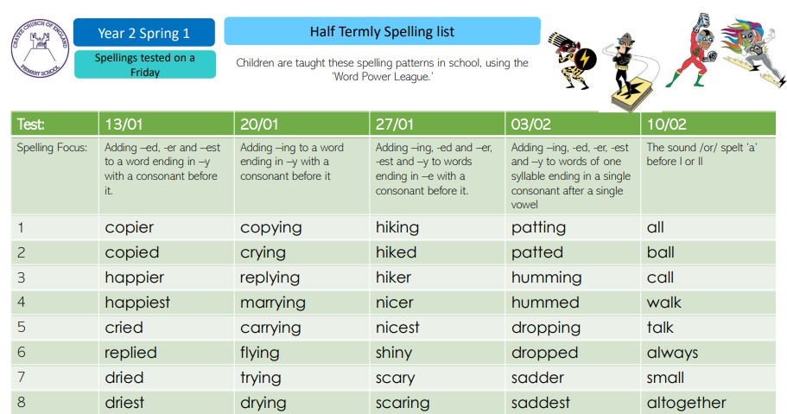

Holly Class
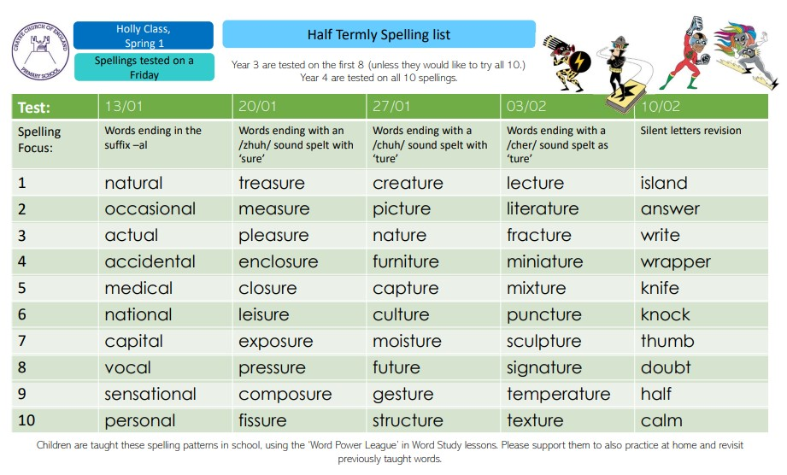

Oak Class
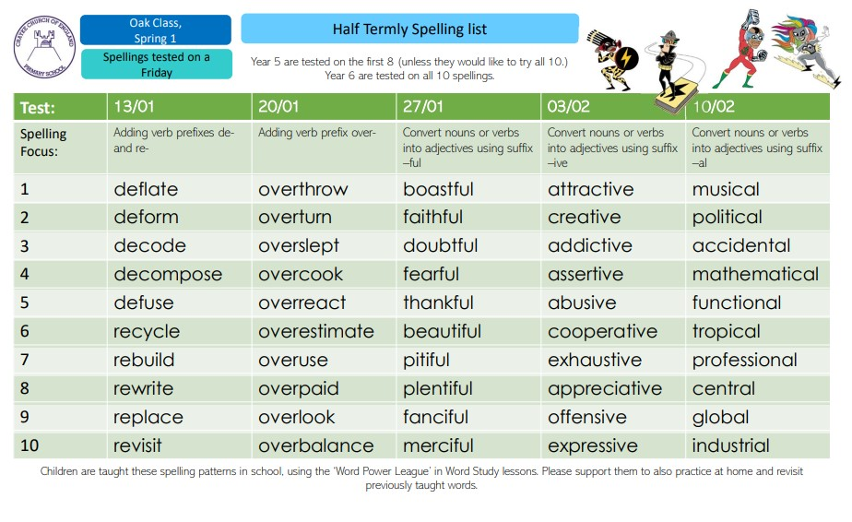
Reindeer Rush

Message from St Leonard’s Hospice:

Thank you all so much for your amazing fundraising, what an incredible amount you raised! We are very thankful for your great support. We hope that the children had lots of fun. Lenny Bear loved cheering the children along on the run.
Best wishes, Jasmine and everyone at St Leonard’s Hospice.
**UPCOMING EVENTS**

Dinosaur Dress up – Apple Class Thursday 12 January

Mrs Helfferich and Miss Walker are inviting children to wear clothes with dinosaurs on or dress up as dinosaurs next Thursday 12th January, as the Stunning Start for their topic “Dinosaurs Rock”.
They will be taking part in lots of dinosaur themed activities and are sure to have a wonderful day!

Senior Citizens’ Lunch – Oak Class Friday 13 January
Oak Class children have been invited to be involved at this fabulous community event next Friday lunchtime by helping to serve the food and then to perform for the audience by singing a couple of songs. The children will be taken to and from the Sports Hall and supervised throughout by myself, Miss Walker and Mrs Aristizabal. They will have their lunch at school as normal and we will be back at school by the end of the school day. If you have any queries about this event, please do not hesitate to contact me.

Swimming - Holly Class starts Wednesday 18 January
Swimming lessons commence for Holly Class on Wednesday 18 January, for a programme of six sessions. As previously, they will travel by coach to the pool in Thirsk. Due to the timing of the lesson, children are required to bring a packed lunch, which they will eat on return to school. Thank you for your support with this.

Heritage Week – w/c 6 February 2023

To commemorate the 50th anniversary of the school opening on its current site, we will be undertaking a whole school local history study entitled “How has our school changed?”
We would be so grateful if anyone has any photographs, news clippings or other resources from their time at Crayke Primary over the years. We would also love to welcome former pupils and parents to speak to the children about what the school was like when they were here.
If you think you can help in any way, or know someone who can, please contact me on headteacher@crayke.n-yorks.sch.uk Thanks in advance!

Extra-Curricular Clubs – Spring Term
Some clubs have limited capacity and places will be allocated on a first come first served basis. In the event of a club being fully booked, your child’s name will be added to a waiting list and you will be advised if a place becomes available. Booking is not required for before school or lunchtime clubs. For after school clubs run by school staff (in red type; denoted with *) please email Mrs Bacon on admin@crayke.n-yorks.sch.uk to book a place.
Before School Clubs
Club | Leader | Day and Time | Group
Run a Mile  STARTS 16 JAN | Mrs Jackson | Monday, Tuesday Thursday & Friday  8:30am | All welcome – parents and carers included!

Lunchtime Clubs
Club | Leader | Day | Group
Skipping | Mrs Helfferich | Monday | All
School Council | Miss Walker | Tuesday | Successful candidates
Fitness | Mr Montgomery | Friday | Y4/5/6
Games | Miss Clarke | Friday | Max. 20 (list kept in school)

After School Clubs

We respectfully ask you to check the collection time below carefully and to collect your children promptly at the end of clubs. Clubs will run unless you are notified otherwise.
Monday  STARTS 16 JANUARY | Craft* (£10 pay via ParentPay)  3:30 – 4:15pm  Years 1 – 6  Mrs Seligman and Miss Sherry | Revision* (no charge) – Starting after Feb half term  3:30pm – 4:15pm  Year 6  Mrs Rayner
Tuesday  STARTS 17 JANUARY | Indoor Multi-Sport (fee paid direct) Fliers to follow  3:30 – 4:30pm  Years 1 – 6  Mark Cromack
Wednesday  STARTS 1 FEBRUARY | Well-Being Club* (£10 pay via ParentPay) – Starting 1 Feb due to staff training  3:30 – 4:15pm  Years 2 – 6  Mrs Jackson |  | Italian* (no charge)  Starting 1 Feb due to staff training  3:30 – 4:15pm  Years 2 – 6  Mrs Aristizabal
Thursday  STARTS 19 JANUARY | Forest Schools* (no charge)  3:30pm – 4:15pm  Year 1-6  Mrs Helfferich | Chess* (no charge)  All abilities; Beginners welcome  3:30pm – 4:15pm  Year 3-6  Mrs Seligman |  | Rugby (fee paid direct)  3:30pm – 4:30pm  Years 3-6  RLFC booking link below
York City Knights Rugby Club booking link: https://member.clubforce.com/memberships_cart_m.asp?LL_ID=2220&intMF_ID=11627#Anchor

***STANDING ITEMS***
Reception New Starters 2023
The deadline is fast approaching and completed applications for children starting school in September 2023 must be submitted no later than 15 January 2023. Further details about the process are available here: https://www.northyorks.gov.uk/apply-place-primary-or-secondary-school
Tesco Thirsk Fundraiser
There’s not long left… if you are passing please take a moment to drop a blue token or two into the middle section of the fundraising box…funds raised will go directly towards our running track. In the words of Tesco… Every Little Helps!

Please spread the word! Thank you.
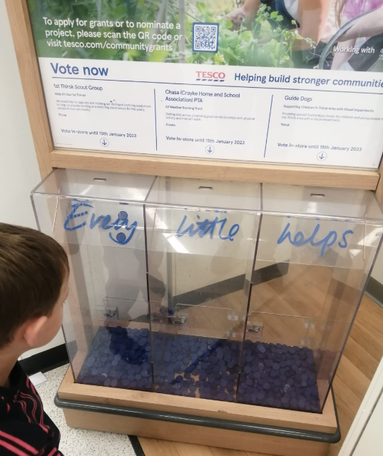

Cost of Living Crisis
We are very aware that costs continue to rise and look set to do so for some time. If you are encountering financial difficulties, we may be able to signpost support. Please get in touch.
If your circumstances have changed and you think your child may be eligible for free school meals, it has never been easier to apply. There is no stigma attached to this, it is not highlighted to the children in any way, and the school gets valuable funding too. If you would like a confidential conversation about whether you may be eligible for free school meals, please do not hesitate to speak to me. To apply directly please use this weblink: https://www.northyorks.gov.uk/free-school-meals
Online Safety
We recognise the importance of online safety and also understand that it is a fast paced, ever changing online world where parents can struggle to keep up with the technical knowledge and understanding demonstrated by their children. The National Online Safety organisation produce regular guides for parents – this week they have produced a leaflet entitled “Staying safe on new devices”. Please see the attached leaflet which is also available on the Online Safety section of our website. Should you wish to access any of the other online safety parent guides available on a whole range of topics including what parents need to know about Amazon Fire Tablets, Google Chromebooks, and ways to champion equality online, please have a look at this weblink: https://nationalonlinesafety.com/guides
Should you wish to access more information about how to support your child/ren with online safety at home, this course is available which explains in detail the risks they might be exposed to and what you can do to support them. https://info.nationalonlinesafety.com/myleene-uk

Attendance and Punctuality
We strive for high levels of attendance at school. Please try, wherever possible, to book holidays out of term time. The impact of even one day’s absence on your child’s learning is huge. Also, please try to book medical appointments out of school hours if possible as this also minimises the time missed. If your child is very unwell and unable to attend school, please inform the office by phoning 01347 821767 no later than 9:15am. Thank you for your support with this important matter.

Why is it important for children not to miss school?
All parents want the best for their children and for them to get on well in life. Having a good education is important to ensure that they have the best opportunities in their adult life. They only get one chance at school, and your child’s future may be affected by not attending school or alternative provision regularly.
If children do not attend school regularly they may:
• Struggle to keep up with school work. In a busy school day, it can be difficult for schools to find the extra time to help a child catch up.
• Miss out on the social side of school life. Poor attendance can affect children’s ability to make and keep friendships; a vital part of growing up.
Setting good attendance patterns from an early age, from nursery through primary school will also help your child later on in their life. Children who have a poor school attendance record may have less chance of securing a job when they are adults. Being on time is also vital. Arriving late at school can be very disruptive for your child, their teacher and the other children in the class. Some parents may be finding it difficult to ensure that their child attends school regularly. If this is the case please speak to Mrs Jackson as soon as possible so that the situation can be addressed.

The world is run by those who turn up.

Attending school every day = 100% attendance
Attending 4½ days a week = 90% attendance = 4 weeks missed per year
Attending 4 days a week = 80% attendance = more than half a term missed per year.
Attending 3½ days each week = 70% attendance = more than a quarter of the school year missed. An average attendance of 80% or less across a child’s school career adds up to missing a whole 2 years from school.

Being late for school reduces learning time.
If your child is 5 minutes late every day they will miss three days of learning each year.
If your child is 15 minutes late every day they will miss 2 weeks of learning each year.
Make every minute count!
Our Safeguarding Team
At Crayke, we have three members of staff and a governor who make up our Safeguarding Leadership Team. I am the Designated Safeguarding Lead, which means that I am the lead person responsible for child protection and safeguarding issues. Mrs Rayner and Mrs Chandler are our Deputy Designated Safeguarding Leads (Deputy DSLs); a deputy DSL supports the DSL in their role of safeguarding and child protection. Mr Hugh Porter is our Safeguarding Link Governor. The role of the Safeguarding Governor is to support the DSL as well as to regularly review, ask questions and make suggestions about our safeguarding policies and procedures and to report back to the governing body. All staff at Crayke know that safeguarding is EVERYONE’S responsibility. Find out more on our dedicated website Safeguarding page: https://craykeschool.org/safeguarding/
You can also report any safeguarding concerns to our DSL email: dsl@crayke.n-yorks.sch.uk
Please also be aware that as a school we subscribe to Operation Encompass, whereby we are notified of any incidences of domestic violence where a pupil at our school has been present.

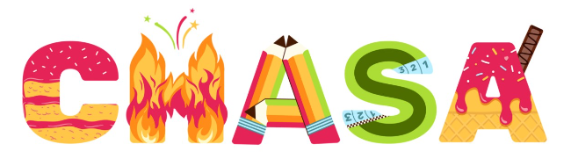
We’d like your feedback!
CHASA have prepared a survey for you to complete; we would really value your feedback about events which have already happened and about how you may be able to provide support in different ways for upcoming events. We have extended the deadline for this and the survey will now remain open until the end of January. We would be really grateful if you could take a few minutes to share your thoughts. Thank you! https://forms.office.com/r/aW0ct9aFSt

Amazon Smile Easyfundraising

Thank you so much to all the families who have so far supported us with this.
Please remember to use easyfundraising EVERY time you shop online. Over 7,000 brands will donate to Crayke CE School, Crayke for FREE when you use easyfundraising to shop with them, so you can support us no matter what you’re buying! If you haven’t signed up yet, it’s easy and completely FREE.
Visit:
https://www.easyfundraising.org.uk/causes/craykeceschoolcrayke/?utm_campaign=raise-more&utm_source=social&utm_medium=whatsapp&utm_content=rm-wa-2

Lunch Menu – Spring Term

SPRING TERM  2023 | Week 1  Served w/c 23rd Jan, 20th Feb, 13 Mar | Week 2  Served w/c 9th Jan, 30th Jan, 27th Feb, 20th Mar | Week 3  Served w/c 16th Jan, 6th Feb, 6th Mar, 27th Mar
Monday | Pasta Parcels (Hilcona) in a Homemade Tomato Sauce  Cauliflower & Green Beans  Garlic Bread  Apple Crumble & Custard  Fresh Fruit or Fruit Yoghurt | Pizza  Crusty Bread  Diced Potatoes  Peas & Sweetcorn  Krispie Cereal Bar  Fresh Fruit or Fruit Yoghurt | Farmhouse Mac & Cheese with Garlic Bread  Broccoli & Carrots  Jam Roly Poly & Custard  Fresh Fruit or Fruit Yoghurt
Tuesday | Crispy Chicken Bites  Baked Baby Potatoes  Peas & Sweetcorn  Herby Bread  Orange Shortbread  Fresh Fruit or Fruit Yoghurt | Pasta Bolognese  Cauliflower & Green Beans  Garlic Bread  Chocolate Orange Sponge & Chocolate Sauce  Fresh Fruit or Fruit Yoghurt | Cheese Burger  Baked Potato Wedges  Spring Coleslaw with Cucumber Sticks  Banana Brownie  Fresh Fruit or Fruit Yoghurt
Wednesday | Roast Turkey & Stuffing  Roast Potatoes  Medley of Seasonal Vegetables  Homemade 50/50 Bread  Arctic Roll & Fruit  Fresh Fruit or Fruit Yoghurt | Sausage & Yorkshire Pudding  Mashed Potato  Medley of Seasonal Vegetables  Sliced Wholemeal Bread  Cheese & Crackers  Fresh Fruit or Fruit Yoghurt | Mince Beef & Dumplings with Baked Baby Potatoes  Medley of Seasonal Vegetables  Sliced Wholemeal Bread  Marbled Sponge & Custard  Fresh Fruit or Fruit Yoghurt
Thursday | Chilli Con Carne & Naan Bread  50/50 Rice  Broccoli & Carrots  Cheese & Crackers  Fresh Fruit or Fruit Yoghurt | Chicken Wrap  50/50 Bread  Vegetable Rice  Broccoli & Carrots  Apple Flapjack  Fresh Fruit or Fruit Yoghurt | Chicken Korma & Rice  Cauliflower& Green Beans  Naan Bread  Oatie Biscuit & Cheese  Fresh Fruit Yoghurt
Friday | Fishwich (Salmon)  Chips  Crunchy Vegetable Sticks  Chocolate Berry Mousse Cake  Fresh Fruit or Fruit Yoghurt | Fish Fingers  Chips  Baked Beans & Peas  Crusty Bread  Lemon Drizzle Muffin  Fresh Fruit or Fruit Yoghurt | (Harry Ramsdens) Battered Fish  Chips  Peas & Sweetcorn  Crusty Bread  Lemon & Sultana Iced Finger  Fresh Fruit or Fruit Yoghurt

PE Kits
PE Kits  w/c 9 Jan | Monday | Tuesday | Wednesday | Thursday | Friday
BEECH (LD) |  |  |  | X | X
HOLLY (LC) |  |  | X |  | X
OAK (LR) |  |  |  | X | X
Please do ensure that on PE days, the children wear their hoodies, school jumpers or cardigans alongside white or blue t-shirts and black or navy shorts or jogging bottoms.
Children in Apple Class need to bring their Forest School kit in each Monday and bring their PE kit in on Wednesday.

Attendance and Punctuality
Children will be marked late if they arrive after 9.00am
Please do help us in our mission to ensure that children are in school on time so that valuable learning time is not missed at the start of the day.

This week’s attendance figures: 94% School Target: 96%
Apple (CH): 100% 2 lates/1 child | Beech (LD): 92% 4 lates / 2 children
Holly (LC): 95.6% no lates | Oak (LR): 90.5% no lates

 Stars of the Week

Stars | Apple | Beech | Holly | Oak
Stars | Constance Cater | Esmond Tsang | Rosie Seligman | Nat Fenton
Stars | Constance Cater | Grant Colman | Dylan Swiers | Sophie Sargent
Gold Awards for Sport | Milo Burnett-Armstrong | Fenton Ward | Arwen Dawson | Asa Champion

Crayke Church of England Primary School
Dates for your Diary – Spring Term 2023

Day | Date | Event | Who | Where
Thursday | 12 January | Dinosaur Dress Up Day – Stunning Start | Apple Class | Classroom
Friday | 13 January | Senior Citizens’ Lunch – serving and singing | Oak Class | Sports Hall
Wednesdays | 18/25 Jan  1/8/22 Feb  1 Mar | Swimming | Holly Class | Thirsk Pool
Thursdays | Alternate weeks | Open the Book – collective worship | Whole school | Hall
Friday | 20 January | Educational Visit | Holly Class | York Chocolate Story
Friday | 20 January | Photography workshop led by Colin Merritt | Oak Class | Classroom
Friday | 27 January | Local visit – landscape photographs | Oak Class | Crayke
Tuesday | 31 January | Cross Country – cluster event | Holly and Oak | Husthwaite
w/c 6 February |  | Heritage Week – 50th anniversary celebrations of Crayke Primary | Whole school
Tuesday | 7 February | Play Leader Training | Year 5 | Hall/playground
w/c 13 February - HALF TERM
Thursday | 2 March | World Book Day | Whole school
Tuesday | 14 March | STEM workshop – cluster event | Oak Class | Easingwold Primary
Tuesday | 21 March | Parent Consultation Evening 3:30 – 6:30pm | Whole school | Classrooms
Wednesday | 22 March | Parent Consultation Evening 3:30 – 6:30pm | Whole school | Classrooms

Term Dates – Academic Year 2022/2023
Spring Term Wednesday 4th January to Friday 31st March 2023
Half Term Monday 13th February to return on Monday 20th February
Summer Term Tuesday 18th April to Friday 21st July 2023
May Day Monday 1st May 2023
Additional Bank Holiday Monday 8th May 2023
Half Term Monday 29th May to return on Monday 5th June
INSET Days (School Closed to pupils) –
Monday 17th April 2023
Monday 24th July 2023
Tuesday 25th July 2023

Judi Jackson
Headteacher
headteacher@crayke.n-yorks.sch.uk

FOLLOW YOUR PATHWAY AND WE GROW TOGETHER WITH CONFIDENCE
You did not choose me, I chose you that you might go and bear fruit, fruit that will last so that whatever you ask in my name the Father will give you. John 15:16

Respect Friendship Forgiveness Determination

