
Crayke Church of England Primary School
FOLLOW YOUR PATHWAY AND WE GROW TOGETHER WITH CONFIDENCE
You did not choose me, I chose you that you might go and bear fruit, fruit that will last so that whatever you ask in my name the Father will give you. John 15:16
Respect Friendship Forgiveness Determination

Dear Parents and Carers,

NEWS FROM SCHOOL THIS WEEK
Heritage Week Special
Thank you to everyone who has contributed in any way to the wonderful week we have had in school learning about the history of our school on its current site. Special thanks go to our Visitors – Annette McEnespie, Stan Featherstone and Helen Hockenhull and to our additional Contributors – Colin Merritt, Hugh Porter, Fiona Warriner, David Knowles, Norman and Gill Jackson, Amanda Goodin, Becky Stubbins, Joanna Braidwood and Louise Beeson. Thank you to you all!

Heritage Week by Beech Class
Message from Mrs Dobson
Beech Class have really enjoyed listening to stories from our visitors this week. Their highlights were the exploding volcano all over the headteacher and the piano rolling down the hill from the old school to the new school!
There was great excitement to open the time capsule and look at the photos and treasures inside! We also had a tour of the school to look at similarities and differences over time. The children were excited to design our new school logo and are eager to find out the winner of the competition!

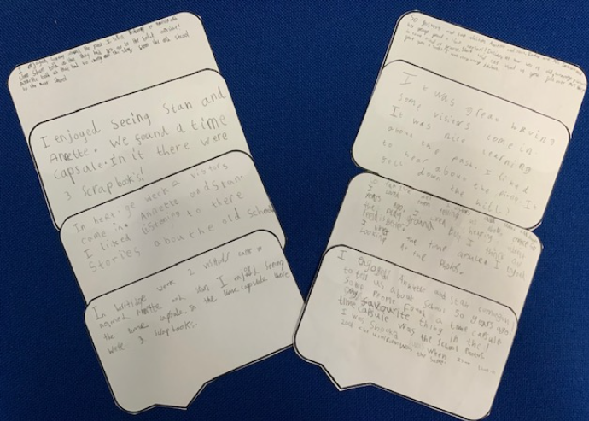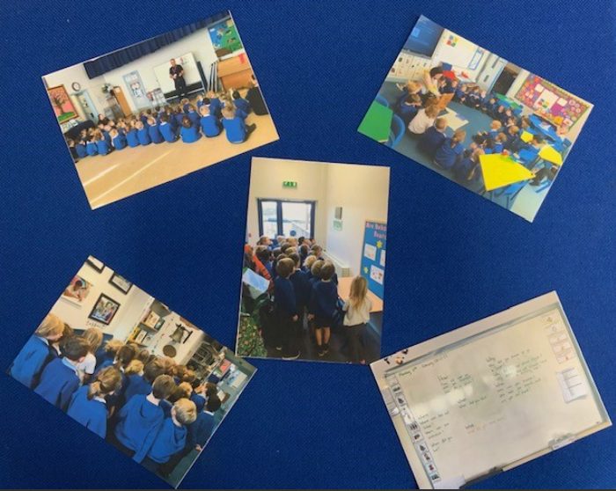

Heritage Week by Holly Class
Holly class have thoroughly enjoyed learning all about how our school has changed over the last 50 years. They have loved listening to our visiting speakers recollecting their memories and I'm sure they could ask them questions for hours on end! They have enjoyed looking around school finding evidence of similarities and differences and did a brilliant 'same/different' activity based on photographs, pupil's work, planning drawings, etc...
They are looking forward to designing a new school logo today. What a great week!

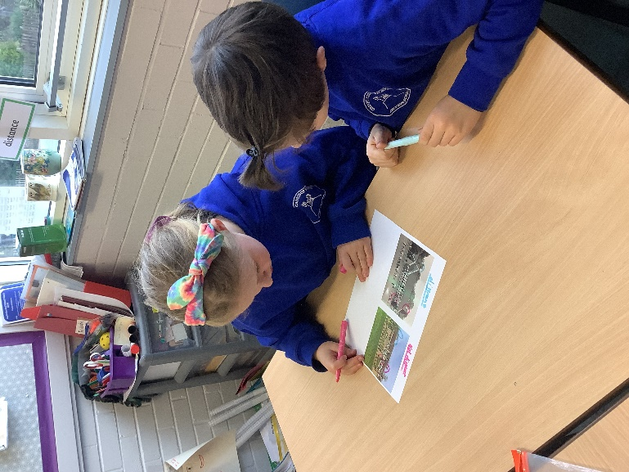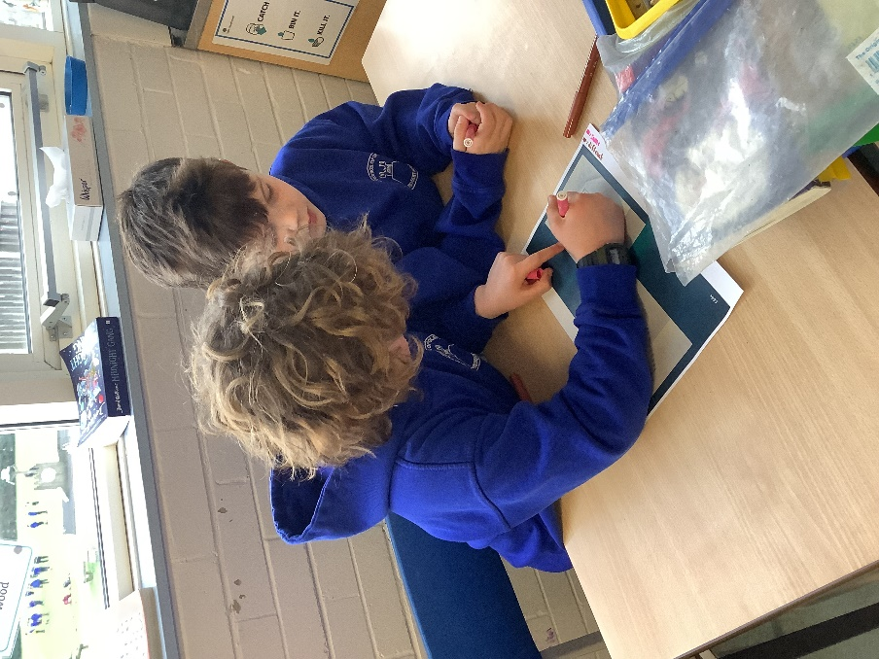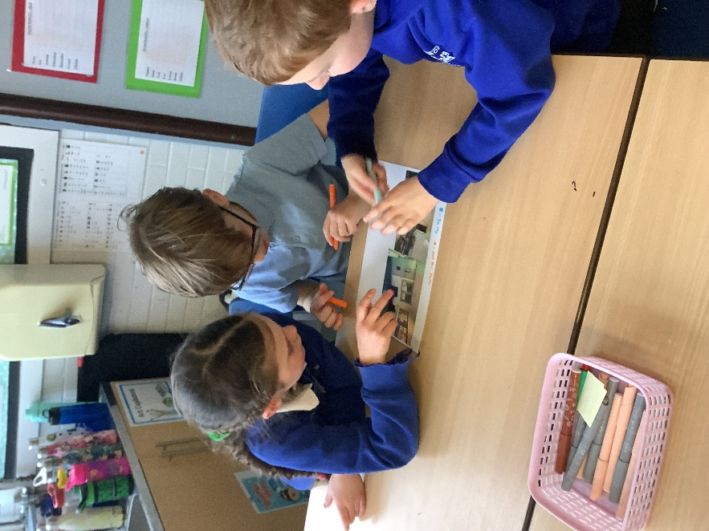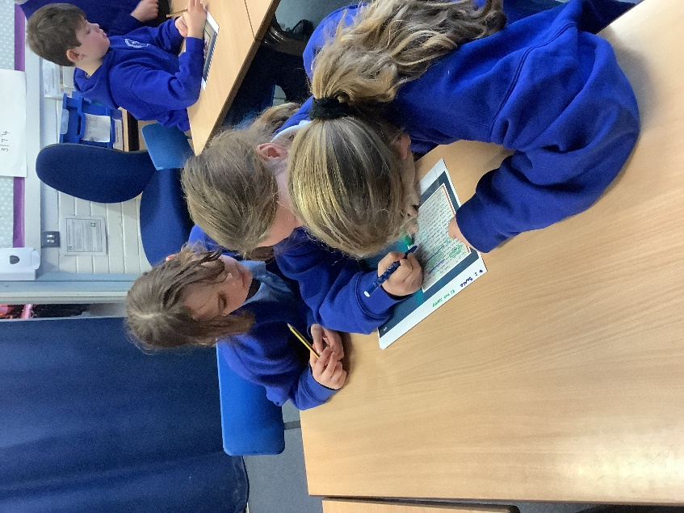
Heritage Week by Oak Class
This week’s Literacy focus combined Heritage Week with newspaper reports. Please see our articles from budding journalists:
Emma Swiers Ethan Jackson
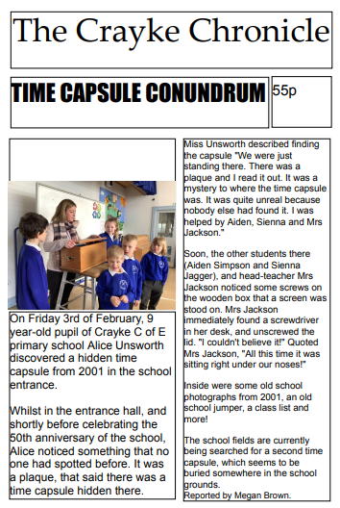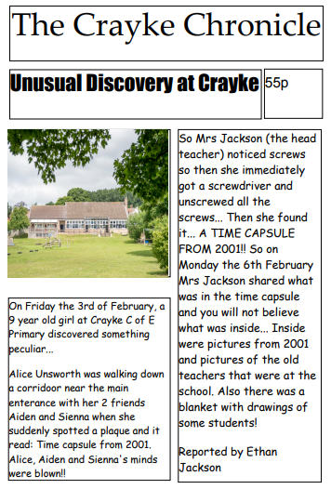
Isabelle Sargent Oskar Braidwood
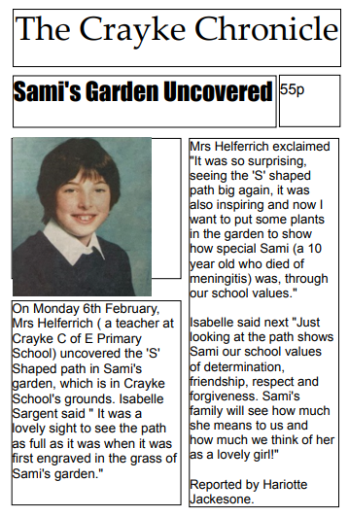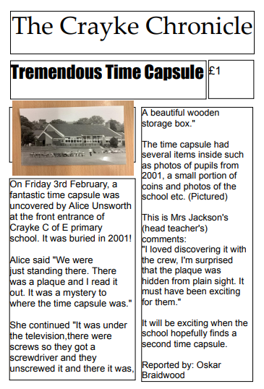

Walking Inspiration

Last weekend Gem and Asa went to the Yorkshire Sculpture Park, they were lucky enough to see all of the Chinese New Year creatures. They saw hundreds of sculptures and walked for miles. Gem’s favourite was a garden statue of Pikachu.
It took Gem and Asa just over an hour to get there. Entry for children was free, adults cost £6. There are no time limits so you can literally spend all day there, you probably still wouldn’t manage to get around all of the sculptures. Thank you boys for the recommendation, we haven’t been there for years. You have definitely earnt the ‘Fox Adventure’ certificate for covering all of those miles.

Wow Walk to School Challenge Weekly Update
Message from Mrs Helfferich

WOW Walk to school
A new month, a new badge;
William Shakespeare was born on 23rd April 1564 in Stratford Upon Avon, England. He was a famous playwright, people still study, read and act out his plays. He made up many English words and expressions. He moved from Stratford to London and became very famous.
This week’s results are as follows:

This Photo by Unknown Author is licensed under CC BY-NC
Apple, Beech & Holly Year 6 Year 5
Well done – some great results this week!

**UPCOMING EVENTS**
SPORT
Swimming - Holly - Wednesdays until 1 March
Reminder: Due to the timing of the lesson, children are required to bring a packed lunch, which they will eat on return to school. Thank you for your support with this.

**UPCOMING EVENTS**
PARENT WORKSHOPS
We are planning a series of parent workshops over the coming weeks as follows to help provide further information about upcoming events for children across school. Further details will be provided soon but for now please save the dates!

Focus | For parents of children in | Date | Time | Led by
KS1 SATs | Year 2 | Thursday 2 March | 9:10am | Mrs Dobson
KS2 SATs | Year 6 | Thursday 9 March | 9:10am | Mrs Rayner
Multiplication Tables Check | Year 4 | Thursday 16 March | 9:10am | Mrs Chandler
Phonics | Year 1 | Thursday 23 March | 9:10am | Mrs Dobson

**UPCOMING EVENTS**
ENRICHMENT – INCLUDING EDUCATIONAL VISITS AND VISITORS

Beech - Grass Heads - Tuesday 21 February
Message from Mrs Dobson
After half-term, the children in Beech class will be making 'Grass-heads'. Please could they bring a pair of thin, skin coloured tights or something similar in to school before this date. If anybody has spares these would also be appreciated.

Crayke’s Greatest Show – Tuesday 28 March
Miss Walker and the School Council are formulating plans for a talent show to be held on the afternoon of Tuesday 28 March. Further details to follow!

Easter Service – Wednesday 29 March
Please join us at St Cuthbert’s Church on Wednesday 29 March at 11am for our Easter Service.

Chess Club Match – Thursday 30 March


Message from Mrs Seligman
Crayke School Chess Club would like to invite governors to take part in a chess match on Thursday 30 March, at 3.30pm, at school. All standards welcome!
The idea is to have a team of teachers and governors combined taking on the school team for an end of term tournament. The more the merrier.... The winner might even win a prize!
Please RSVP to mseligman@crayke.n-yorks.sch.uk if you would like to attend.

Extra-Curricular Clubs – Spring Term
Some clubs have limited capacity and places will be allocated on a first come first served basis. In the event of a club being fully booked, your child’s name will be added to a waiting list and you will be advised if a place becomes available. Booking is not required for before school or lunchtime clubs. For after school clubs run by school staff (in red type; denoted with *) please email Mrs Bacon on admin@crayke.n-yorks.sch.uk to book a place.
Before School Clubs
Club | Leader | Day and Time | Group
Run a Mile | Mrs Jackson | Monday, Tuesday Thursday & Friday  8:30am | All welcome – parents and carers included!

Lunchtime Clubs
Club | Leader | Day | Group
Skipping | Mrs Helfferich | Monday | All
School Council | Miss Walker | Tuesday | Successful candidates
Games | Miss Clarke | Friday | Max. 20 (list kept in school)

After School Clubs

We respectfully ask you to check the collection time below carefully and to collect your children promptly at the end of clubs. Clubs will run unless you are notified otherwise.
Monday | Craft* (£10 pay via ParentPay)  3:30 – 4:15pm  Years 1 – 6  Mrs Seligman and Miss Sherry | SATs Club* (no charge) – Starting after Feb half term  3:30pm – 4:15pm  Year 6  Mrs Rayner
Tuesday | Indoor Multi-Sport (fee paid direct)  3:30 – 4:30pm  Years 1 – 6  Mark Cromack
Wednesday | Italian* (no charge)  3:30 – 4:15pm  Years 2 – 6  Mrs Aristizabal
Thursday | Forest Schools* (no charge)  3:30pm – 4:15pm  Year 1-6  Mrs Helfferich | Chess* (no charge)  All abilities; Beginners welcome  3:30pm – 4:15pm  Year 3-6  Mrs Seligman
***STANDING ITEMS***
Cost of Living Crisis
We are very aware that costs continue to rise and look set to do so for some time. If you are encountering financial difficulties, we may be able to signpost support. Please get in touch.
If your circumstances have changed and you think your child may be eligible for free school meals, it has never been easier to apply. There is no stigma attached to this, it is not highlighted to the children in any way, and the school gets valuable funding too. If you would like a confidential conversation about whether you may be eligible for free school meals, please do not hesitate to speak to me. To apply directly please use this weblink: https://www.northyorks.gov.uk/free-school-meals

Reception places available for September 2023
Due to a lower number of sibling than usual, we anticipate that we will have some spaces available in our Reception class in September 2023. Although the deadline has now officially passed for applications of places to North Yorkshire County Council, if you know of any parents who may be interested, please do ask them to contact school.

Online Safety
We recognise the importance of online safety and also understand that it is a fast paced, ever changing online world where parents can struggle to keep up with the technical knowledge and understanding demonstrated by their children. The National Online Safety organisation produce regular guides for parents – this week they have produced a leaflet entitled “10 ways gaming can support positive outcomes”. Please see the attached leaflet which is also available on the Online Safety section of our website. Should you wish to access any of the other online safety parent guides available on a whole range of topics including what parents need to know about Amazon Fire Tablets, Google Chromebooks, and ways to champion equality online, please have a look at this weblink: https://nationalonlinesafety.com/guides
Should you wish to access more information about how to support your child/ren with online safety at home, this course is available which explains in detail the risks they might be exposed to and what you can do to support them. https://info.nationalonlinesafety.com/myleene-uk

Attendance and Punctuality
This week’s attendance figures: 95.3% School Target: 96%
Apple (CH): 98.6% 0 lates | Beech (LD): 98.3% 9 lates (5 children)
Holly (LC): 91.7% 0 lates | Oak (LR): 94.3% 1 late

We strive for high levels of attendance at school. Please try, wherever possible, to book holidays out of term time. The impact of even one day’s absence on your child’s learning is huge. Also, please try to book medical appointments out of school hours if possible as this also minimises the time missed. If your child is very unwell and unable to attend school, please inform the office by phoning 01347 821767 no later than 9:15am. Thank you for your support with this important matter.

Why is it important for children not to miss school?
All parents want the best for their children and for them to get on well in life. Having a good education is important to ensure that they have the best opportunities in their adult life. They only get one chance at school, and your child’s future may be affected by not attending school or alternative provision regularly.
If children do not attend school regularly they may:
• Struggle to keep up with school work. In a busy school day, it can be difficult for schools to find the extra time to help a child catch up.
• Miss out on the social side of school life. Poor attendance can affect children’s ability to make and keep friendships; a vital part of growing up.
Setting good attendance patterns from an early age, from nursery through primary school will also help your child later on in their life. Children who have a poor school attendance record may have less chance of securing a job when they are adults. Being on time is also vital. Arriving late at school can be very disruptive for your child, their teacher and the other children in the class. Some parents may be finding it difficult to ensure that their child attends school regularly. If this is the case please speak to Mrs Jackson as soon as possible so that the situation can be addressed.

The world is run by those who turn up.

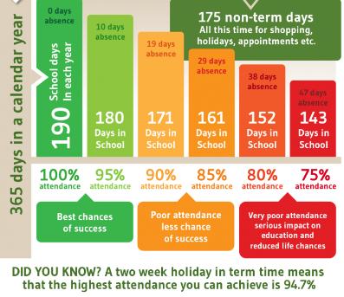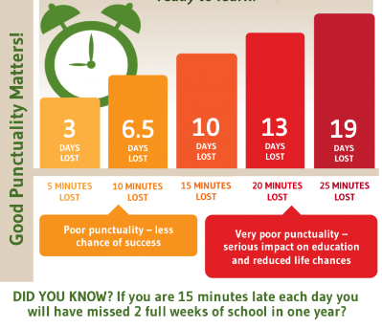

Make every minute count!
Our Safeguarding Team
At Crayke, we have three members of staff and a governor who make up our Safeguarding Leadership Team. I am the Designated Safeguarding Lead, which means that I am the lead person responsible for child protection and safeguarding issues. Mrs Rayner and Mrs Chandler are our Deputy Designated Safeguarding Leads (Deputy DSLs); a deputy DSL supports the DSL in their role of safeguarding and child protection. Mr Hugh Porter is our Safeguarding Link Governor. The role of the Safeguarding Governor is to support the DSL as well as to regularly review, ask questions and make suggestions about our safeguarding policies and procedures and to report back to the governing body. All staff at Crayke know that safeguarding is EVERYONE’S responsibility. Find out more on our dedicated website Safeguarding page: https://craykeschool.org/safeguarding/
You can also report any safeguarding concerns to our DSL email: dsl@crayke.n-yorks.sch.uk Please also be aware that as a school we subscribe to Operation Encompass, whereby we are notified of any incidences of domestic violence where a pupil at our school has been present.



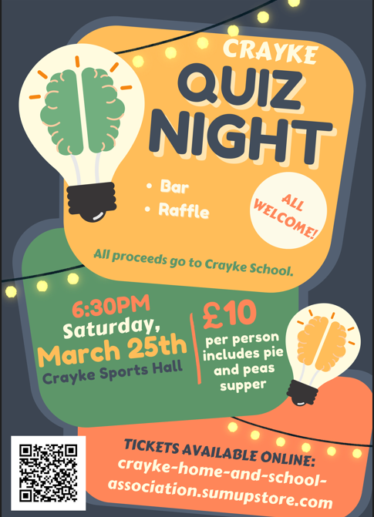
Community News


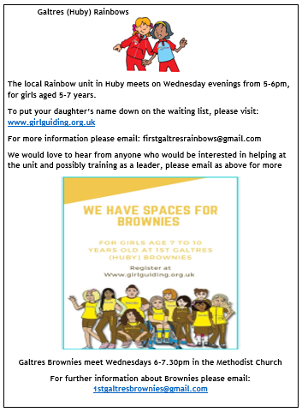

Community News (cont.)
Community Cafe
18th February 11am-1pm
Crayke Sports Club & Village Hall

The theme of the Community Cafe is Habitats. There will be information on making a pond, a bird house, a bug house or a house for a hedgehog!
A local bee keeper will be there and an expert on moths, butterflies and fish!
There will be some flat packs available. Hope some of you can join us with the children for a drink and piece of cake.
THE SUSTAINABLE CRAYKE GROUP

Church News

On Mothering Sunday, March 19th, there will be a Benefice family service at Husthwaite church to which you are all warmly invited.

Our usual 1st Sunday Family Service @ Crayke will take place on March 5th.

Lunch Menu – Spring Term

SPRING TERM  2023 | Week 1  Served w/c 20th Feb, 13 Mar | Week 2  Served w/c 27th Feb, 20th Mar | Week 3  Served w/c 6th Mar, 27th Mar
Monday | Pasta Parcels (Hilcona) in a Homemade Tomato Sauce  Cauliflower & Green Beans  Garlic Bread  Apple Crumble & Custard  Fresh Fruit or Fruit Yoghurt | Pizza  Crusty Bread  Diced Potatoes  Peas & Sweetcorn  Krispie Cereal Bar  Fresh Fruit or Fruit Yoghurt | Farmhouse Mac & Cheese with Garlic Bread  Broccoli & Carrots  Jam Roly Poly & Custard  Fresh Fruit or Fruit Yoghurt
Tuesday | Crispy Chicken Bites  Baked Baby Potatoes  Peas & Sweetcorn  Herby Bread  Orange Shortbread  Fresh Fruit or Fruit Yoghurt | Pasta Bolognese  Cauliflower & Green Beans  Garlic Bread  Chocolate Orange Sponge & Chocolate Sauce  Fresh Fruit or Fruit Yoghurt | Cheese Burger  Baked Potato Wedges  Spring Coleslaw with Cucumber Sticks  Banana Brownie  Fresh Fruit or Fruit Yoghurt
Wednesday | Roast Turkey & Stuffing  Roast Potatoes  Medley of Seasonal Vegetables  Homemade 50/50 Bread  Arctic Roll & Fruit  Fresh Fruit or Fruit Yoghurt | Sausage & Yorkshire Pudding  Mashed Potato  Medley of Seasonal Vegetables  Sliced Wholemeal Bread  Cheese & Crackers  Fresh Fruit or Fruit Yoghurt | Mince Beef & Dumplings with Baked Baby Potatoes  Medley of Seasonal Vegetables  Sliced Wholemeal Bread  Marbled Sponge & Custard  Fresh Fruit or Fruit Yoghurt
Thursday | Chilli Con Carne & Naan Bread  50/50 Rice  Broccoli & Carrots  Cheese & Crackers  Fresh Fruit or Fruit Yoghurt | Chicken Wrap  50/50 Bread  Vegetable Rice  Broccoli & Carrots  Apple Flapjack  Fresh Fruit or Fruit Yoghurt | Chicken Korma & Rice  Cauliflower& Green Beans  Naan Bread  Oatie Biscuit & Cheese  Fresh Fruit Yoghurt
Friday | Fishwich (Salmon)  Chips  Crunchy Vegetable Sticks  Chocolate Berry Mousse Cake  Fresh Fruit or Fruit Yoghurt | Fish Fingers  Chips  Baked Beans & Peas  Crusty Bread  Lemon Drizzle Muffin  Fresh Fruit or Fruit Yoghurt | (Harry Ramsdens) Battered Fish  Chips  Peas & Sweetcorn  Crusty Bread  Lemon & Sultana Iced Finger  Fresh Fruit or Fruit Yoghurt

PE Kits
PE Kits  w/c 20 Feb | Monday | Tuesday | Wednesday | Thursday | Friday
BEECH (LD) |  |  |  | X | X
HOLLY (LC) |  |  | X (swim) |  | X
OAK (LR) |  |  |  | X | X
Please do ensure that on PE days, the children wear their hoodies, school jumpers or cardigans alongside white or blue t-shirts and black or navy shorts or jogging bottoms.
Children in Apple Class need to bring their Forest School kit in each Monday. Please wear PE kit on Wednesday and bring uniform to change into.

 Stars of the Week

Stars | Apple | Beech | Holly | Oak
Stars | Jacob Watson | Arianna Saeedi | Florence Hindley | Isabelle Sargent
Stars | Jacob Watson | Elliott Braidwood | Riley Hunsdale | Isaac Copley
Gold Awards for Sport | Alanna Dawson | Keenan Lee | Percy Ollive | Leonard Liddell

Crayke Church of England Primary School
Dates for your Diary – Spring Term 2023

Day | Date | Event | Who | Where
Wednesdays | 22 Feb  1 Mar | Swimming | Holly Class | Thirsk Pool
Thursdays | Alternate weeks | Open the Book – collective worship | Whole school | Hall
Thursday | 23 February | Music for Life Percussion focus – concert (morning) and workshop (afternoon) | Whole school  Holly | Hall
Thursday | 2 March | World Book Day | Whole school
Thursday | 2 March | Parent Workshop: KS1 SATs | Y2 parents | Hall
Thursday | 9 March | Parent Workshop: KS2 SATs | Y6 parents | Hall
Tuesday | 14 March | STEM workshop – cluster event | Oak Class | Easingwold Primary
Thursday | 16 March | Parent Workshop: MTC | Y4 parents | Hall
Tuesday | 21 March | Parent Consultation Evening  3:30 – 6:30pm | Whole school | Classrooms
Wednesday | 22 March | Parent Consultation Evening  3:30 – 6:30pm | Whole school | Classrooms
Thursday | 23 March | Parent Workshop: Phonics check | Y1 parents | Hall
Saturday | 25 March | CHASA Quiz Night event | Adults only | Sports Club
Tuesday | 28 March | Crayke’s Greatest Show – A Talent Competition for all | Whole school | Hall
Wednesday | 29 March | Easter Service 11am  Parents and carers welcome | Whole school | St Cuthbert’s Church
Thursday | 30 March | Staff and Governors v Pupils Chess Match | Chess Club | Oak Classroom
Friday | 31 March | Easter Egg Hunt | Whole school | Field
Summer Term Dates for your Diary
Monday - Wednesday | 5-7 June | Residential | Year 5 | Carlton Lodge
Friday | 30 June | Camp Out at School overnight | Year 4 | School field

Term Dates – Academic Year 2022/2023
Spring Term Wednesday 4th January to Friday 31st March 2023
Half Term Monday 13th February to return on Monday 20th February
Summer Term Tuesday 18th April to Friday 21st July 2023
May Day Monday 1st May 2023
Additional Bank Holiday Monday 8th May 2023
Half Term Monday 29th May to return on Monday 5th June
INSET Days (School Closed to pupils) –
Monday 17th April 2023
Monday 24th July 2023
Tuesday 25th July 2023

Judi Jackson
Headteacher
headteacher@crayke.n-yorks.sch.uk

FOLLOW YOUR PATHWAY AND WE GROW TOGETHER WITH CONFIDENCE
You did not choose me, I chose you that you might go and bear fruit, fruit that will last so that whatever you ask in my name the Father will give you. John 15:16

Respect Friendship Forgiveness Determination

