
Crayke Church of England Primary School
FOLLOW YOUR PATHWAY AND WE GROW TOGETHER WITH CONFIDENCE
You did not choose me, I chose you that you might go and bear fruit, fruit that will last so that whatever you ask in my name the Father will give you. John 15:16
Respect Friendship Forgiveness Determination

Dear Parents and Carers,

NEWS FROM SCHOOL THIS WEEK

Year 5/6 Online Safety Workshop
North Yorkshire Police visited school to deliver an Online Safety Workshop for children in Oak class this week. The children said:
“It was brilliant because it taught you about online safety.” - Toby
“I learnt how to keep safe online for example to not friend people who you don’t know.” - Ethan H
“I learned not to share your personal information.” - Poppy
“The video we watched was very informative because it helped us to realise how much personal information can be shared online very easily.” – Maisy

World Book Day
A wonderful day was had in school yesterday for our Bedtime Story themed World Book Day celebrations. The children (and staff!) very much enjoyed the opportunity to wear their comfiest clothes and shoes and enjoy reading for pleasure and hearing stories throughout the day. Here’s a flavour of what the children got up to!

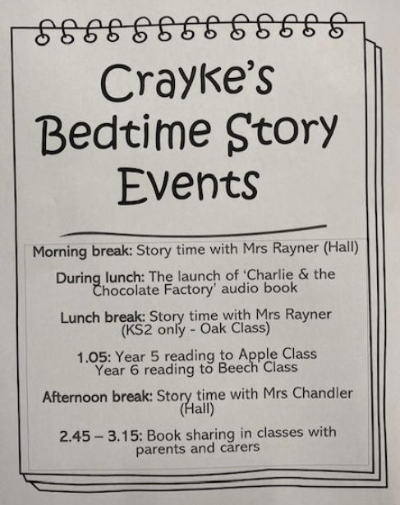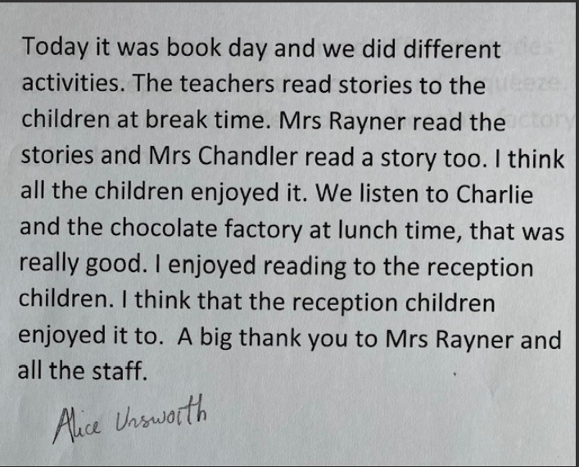
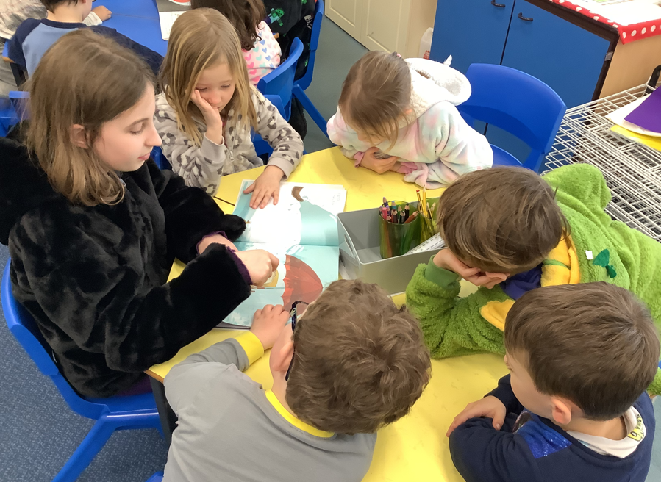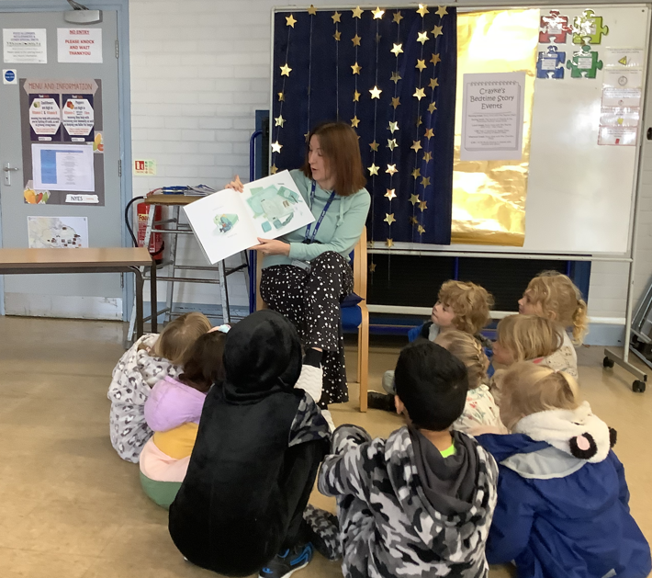

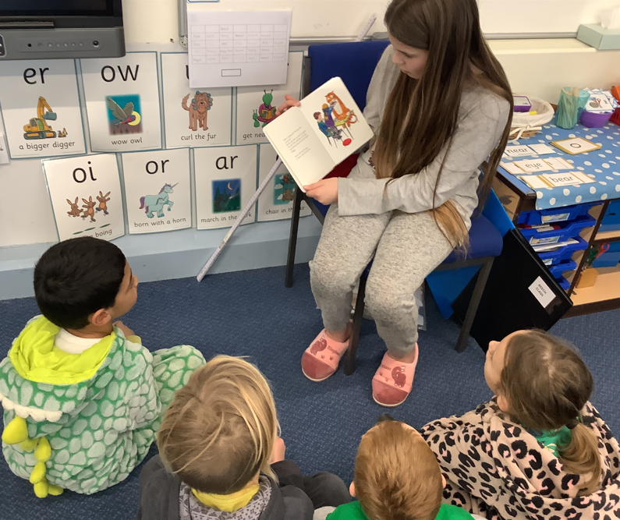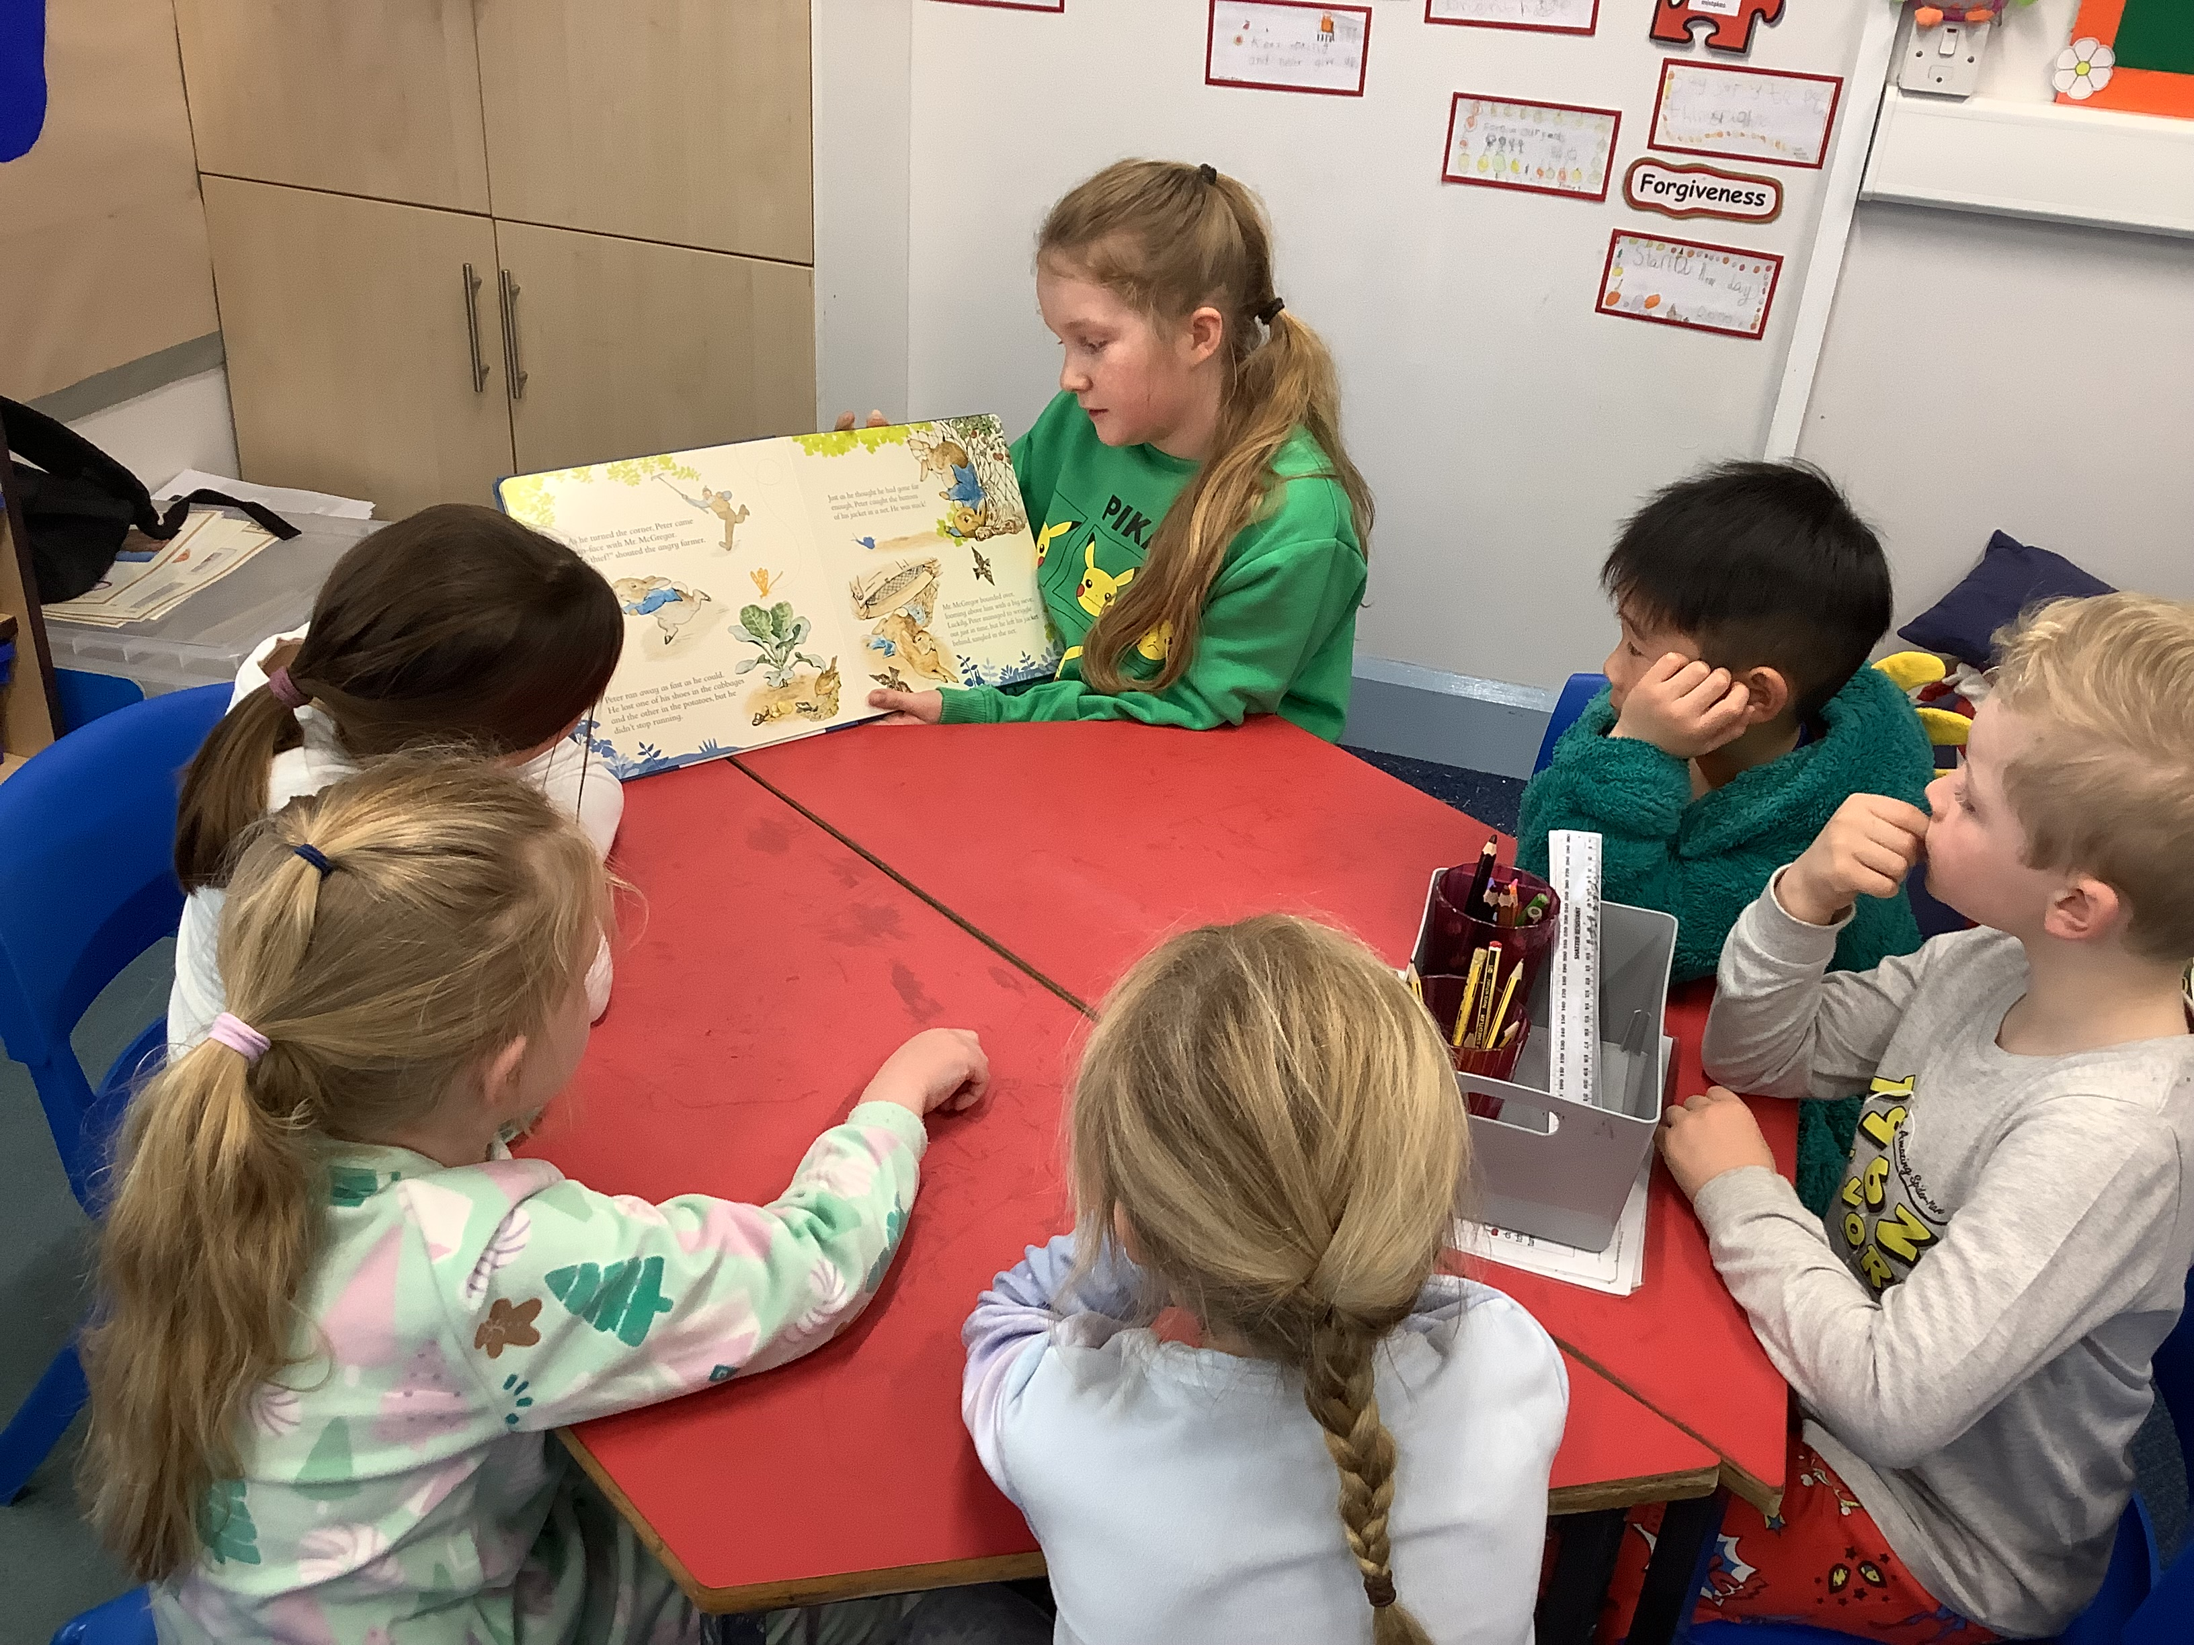

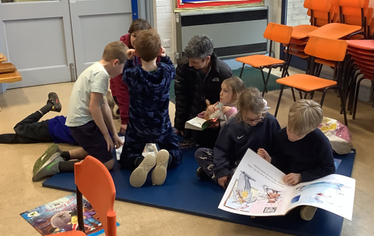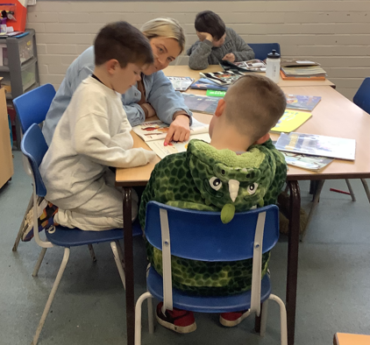

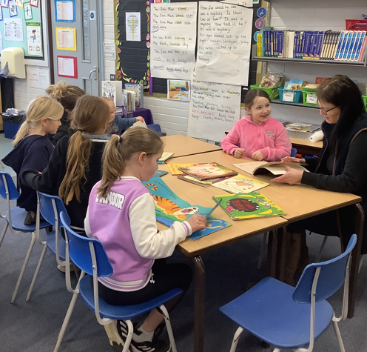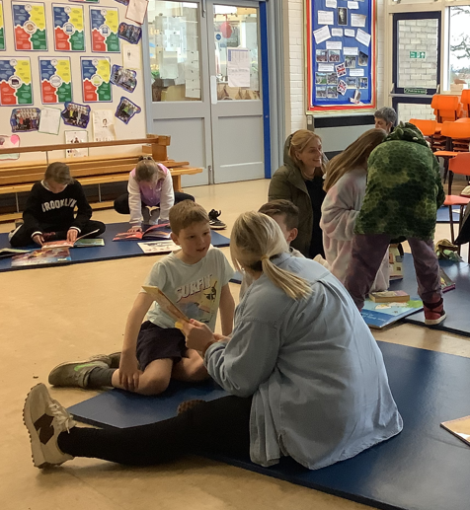

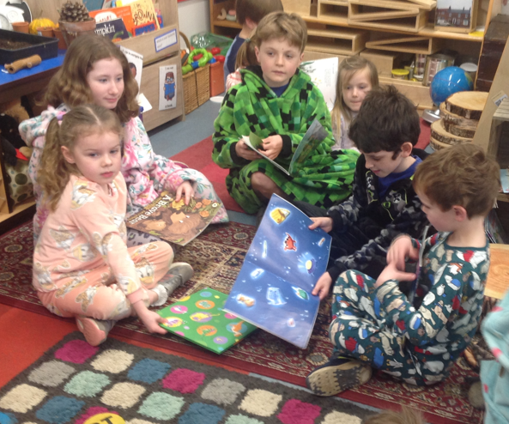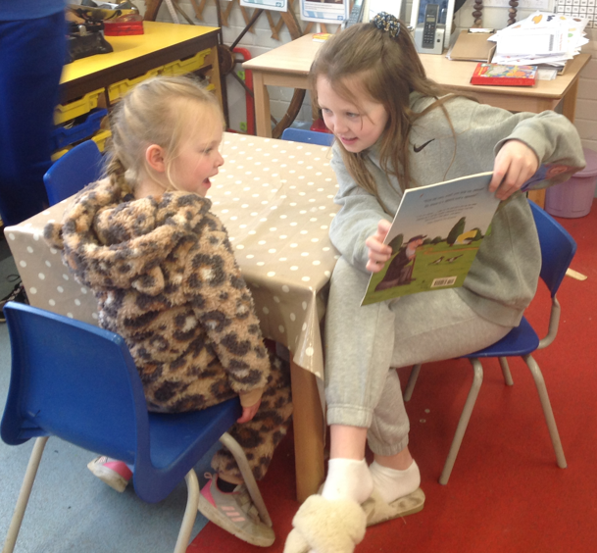

Parent Workshops – Assessment focus
This week was the first in our series of parent workshops and was led by Mrs Dobson for Year 2 parents helping them to understand more about the upcoming SATs assessments they will be taking in the summer. Thank you to Mrs Dobson for delivering this session. The remaining sessions are as follows:

Each session will take place in the hall and will last for approximately 30 minutes.

Focus | For parents of children in | Date | Time | Led by
KS2 SATs | Year 6 | Thursday 9 March | 9:10am | Mrs Rayner
Multiplication Tables Check | Year 4 | Thursday 16 March | 9:10am | Mrs Chandler
Phonics | Year 1 | Thursday 23 March | 9:10am | Mrs Dobson
Wow Walk to School Challenge Weekly Update
Message from Mrs Helfferich

WOW Walk to school

The badge for March is the bicycle. The history of the bike:
A German baron named Karl von Drais made the first major development when he created a steerable, two-wheeled contraption in 1817. Known by many names, including the “velocipede,” “hobby-horse,” “draisine” and “running machine,” this early invention has made Drais widely acknowledged as the father of the bicycle. But the bicycle as we know it today evolved in the 19th century.
In hopes of adding stability, inventors such as Eugène Meyer and James Starley later introduced new models that sported an oversized front wheel. Dubbed “penny-farthings” or “ordinaries,” these oddly shaped machines became all the rage during the 1870s and 1880s, and helped give rise to the first bicycle clubs and competitive races. Beginning in 1884, an Englishman named Thomas Stevens famously rode a high-wheeler bike on a journey around the globe.

This week’s results are as follows:

This Photo by Unknown Author is licensed under CC BY-NC
Apple Beech & Holly Oak Class: Get active!!
Well done – some great results this week!

Walking Inspiration
Well done Olive for taking part in the mile run raising money for the Anthony Nolan charity. Anthony Nolan is a pioneering charity that saves the lives of people with blood cancer and blood disorders. We are very proud of you.

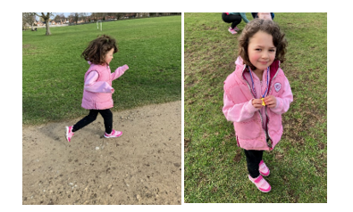

**UPCOMING EVENTS**
ENRICHMENT – INCLUDING EDUCATIONAL VISITS AND VISITORS

**New** – Red Nose Day Friday 17 March
Children are welcome to wear an item (or more!) of red clothing on this day. Donations can be made via this link: https://app.parentpay.com/ParentPayShop/Foc/Default.aspx?shopid=9797

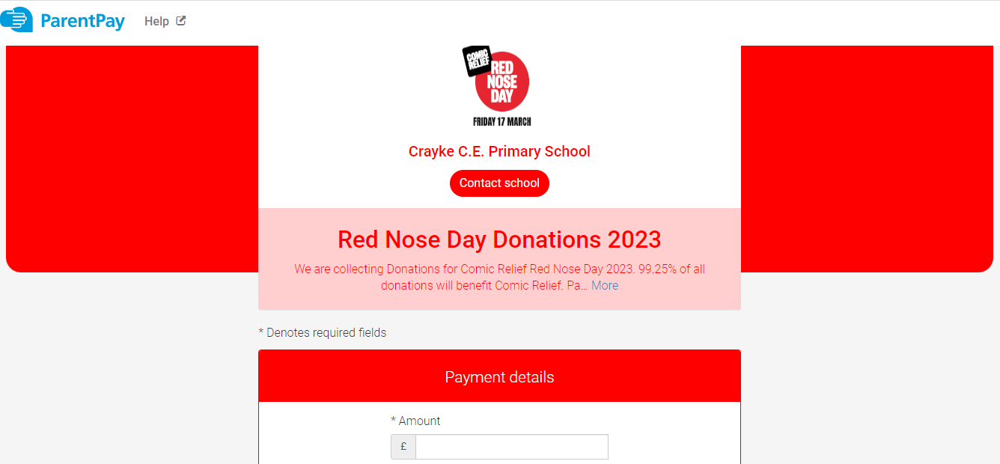

**New** School Camp Out Residential including Parent Meeting - Monday 27 March at 6:00pm

Parents were sent details about what this experience involves earlier this week and we would be grateful if parents of children in Year 4 could please complete this short survey before the end of the day on Monday in order for us to be able to confirm the visit is financially viable. https://forms.office.com/e/3j5r59pmAD

Should the visit be able to go ahead, parents and carers of children in Year 4 are invited to a parent meeting on Monday 27 March to learn more about the upcoming residential visit in June. This will be held virtually with a link to follow. We hope you can make it!

**Updated** Crayke’s Greatest Show Audition News –
Tuesday 28 March

Message from Miss Walker and School Council

On Tuesday 28th March we will be putting on a spectacular talent show! This is an opportunity to celebrate our unique talents and showcase what makes the children so amazing.

In preparation, there will be auditions held in classrooms. Children can perform individually or team up with others in their class to create their own act. This could be any talent the children would like to showcase e.g. dancing, singing, performing or playing instruments.

Each class will then choose 4 acts (2 acts for Apple class) to represent their class in the talent show.
Auditions will be as follows:
Apple Class: Tuesday 14th March
Beech Class: Monday 13th March
Holly Class: Thursday 16th March
Oak Class: Friday 17th March

Easter Service – Wednesday 29 March
Please join us at St Cuthbert’s Church on Wednesday 29 March at 11am for our Easter Service.

**New** Carlton Lodge Residential – Parent Meeting - Wednesday 29 March at 3:40pm
Parents and carers of children in Year 5 are invited to a parent meeting to learn more about the upcoming residential visit in June. This will be held in Oak class on Wednesday 29 March at 3:40pm. We hope you can make it!


Chess Club Match – Thursday 30 March

Message from Mrs Seligman
Crayke School Chess Club have invited governors to take part in a chess match on Thursday 30 March, at 3.30pm, at school. We look forward to hearing who is victorious!



Uniform Sale – Thursday 9 March 3:30pm


CHASA will be holding a pre-loved uniform sale next Thursday 9 March at 3.30pm
Donations welcome!

CHASA Meeting – Thursday 9 March 3:45pm
The next CHASA meeting will take place in the hall immediately after the uniform sale, on Thursday 9 March at 3:45pm, in order to plan the upcoming Summer Fair. All welcome!

Tuck Shop


Quiz Night – Saturday 25 March



PLEASE USE THE LINK BELOW TO BOOK TICKETS FOR THE QUIZ NIGHT
https://crayke-home-and-school-association.sumupstore.com

Extra-Curricular Clubs – Spring Term
Some clubs have limited capacity and places will be allocated on a first come first served basis. In the event of a club being fully booked, your child’s name will be added to a waiting list and you will be advised if a place becomes available. Booking is not required for before school or lunchtime clubs. For after school clubs run by school staff (in red type; denoted with *) please email Mrs Bacon on admin@crayke.n-yorks.sch.uk to book a place.
Before School Clubs
Club | Leader | Day and Time | Group
Run a Mile  LAST SESSION 17 MARCH | Mrs Jackson | Monday, Tuesday Thursday & Friday  8:30am | All welcome – parents and carers included!

Lunchtime Clubs
Club | Leader | Day | Group
Skipping | Mrs Helfferich | Monday | All
School Council | Miss Walker | Tuesday | Successful candidates
Games | Miss Clarke | Friday | Max. 20 (list kept in school)

After School Clubs

We respectfully ask you to check the collection time below carefully and to collect your children promptly at the end of clubs. Clubs will run unless you are notified otherwise.
Monday | Craft* (£10 pay via ParentPay)  LAST SESSION 13 MARCH  3:30 – 4:15pm  Years 1 – 6  Mrs Seligman and Miss Sherry | SATs Club* (no charge)  3:30pm – 4:15pm  Year 6  Mrs Rayner
Tuesday | Indoor Multi-Sport (fee paid direct) NEW BLOCK OF SESSIONS START 7 MARCH – 25 APRIL  3:30 – 4:30pm  Years 1 – 6  Mark Cromack
Wednesday | Italian* (no charge)  LAST SESSION 15 MARCH  3:30 – 4:15pm  Years 2 – 6  Mrs Aristizabal
Thursday | Forest Schools* (no charge)  LAST SESSION 16 MARCH  3:30pm – 4:15pm  Year 1-6  Mrs Helfferich | Chess* (no charge)  All abilities; Beginners welcome  3:30pm – 4:15pm  Year 3-6  Mrs Seligman
***STANDING ITEMS***
Cost of Living Crisis
We are very aware that costs continue to rise and look set to do so for some time. If you are encountering financial difficulties, we may be able to signpost support. Please get in touch.
If your circumstances have changed and you think your child may be eligible for free school meals, it has never been easier to apply. There is no stigma attached to this, it is not highlighted to the children in any way, and the school gets valuable funding too. If you would like a confidential conversation about whether you may be eligible for free school meals, please do not hesitate to speak to me. To apply directly please use this weblink: https://www.northyorks.gov.uk/free-school-meals

Reception places available for September 2023
Due to a lower number of sibling than usual, we anticipate that we will have some spaces available in our Reception class in September 2023. Although the deadline has now officially passed for applications of places to North Yorkshire County Council, if you know of any parents who may be interested, please do ask them to contact school.

Online Safety
We recognise the importance of online safety and also understand that it is a fast paced, ever changing online world where parents can struggle to keep up with the technical knowledge and understanding demonstrated by their children. The National Online Safety organisation produce regular guides for parents – this week they have produced a leaflet entitled “NGL”. Please see the attached leaflet which is also available on the Online Safety section of our website. Should you wish to access any of the other online safety parent guides available on a whole range of topics including what parents need to know about Amazon Fire Tablets, Google Chromebooks, and ways to champion equality online, please have a look at this weblink: https://nationalonlinesafety.com/guides
Should you wish to access more information about how to support your child/ren with online safety at home, this course is available which explains in detail the risks they might be exposed to and what you can do to support them. https://info.nationalonlinesafety.com/myleene-uk

Our Safeguarding Team
At Crayke, we have three members of staff and a governor who make up our Safeguarding Leadership Team. I am the Designated Safeguarding Lead, which means that I am the lead person responsible for child protection and safeguarding issues. Mrs Rayner and Mrs Chandler are our Deputy Designated Safeguarding Leads (Deputy DSLs); a deputy DSL supports the DSL in their role of safeguarding and child protection. Mr Hugh Porter is our Safeguarding Link Governor. The role of the Safeguarding Governor is to support the DSL as well as to regularly review, ask questions and make suggestions about our safeguarding policies and procedures and to report back to the governing body. All staff at Crayke know that safeguarding is EVERYONE’S responsibility. Find out more on our dedicated website Safeguarding page: https://craykeschool.org/safeguarding/
You can also report any safeguarding concerns to our DSL email: dsl@crayke.n-yorks.sch.uk Please also be aware that as a school we subscribe to Operation Encompass, whereby we are notified of any incidences of domestic violence where a pupil at our school has been present.
Attendance and Punctuality
This week’s attendance figures: 96.5% School Target: 96%
Apple (CH): 96.4% 1 late | Beech (LD): 97.9% 6 lates (4 children)
Holly (LC): 97.1% 0 lates | Oak (LR): 93.6% 1 late

We strive for high levels of attendance at school. Please try, wherever possible, to book holidays out of term time. The impact of even one day’s absence on your child’s learning is huge. Also, please try to book medical appointments out of school hours if possible as this also minimises the time missed. If your child is very unwell and unable to attend school, please inform the office by phoning 01347 821767 no later than 9:15am. Thank you for your support with this important matter.

Why is it important for children not to miss school?
All parents want the best for their children and for them to get on well in life. Having a good education is important to ensure that they have the best opportunities in their adult life. They only get one chance at school, and your child’s future may be affected by not attending school or alternative provision regularly.
If children do not attend school regularly they may:
• Struggle to keep up with school work. In a busy school day, it can be difficult for schools to find the extra time to help a child catch up.
• Miss out on the social side of school life. Poor attendance can affect children’s ability to make and keep friendships; a vital part of growing up.
Setting good attendance patterns from an early age, from nursery through primary school will also help your child later on in their life. Children who have a poor school attendance record may have less chance of securing a job when they are adults. Being on time is also vital. Arriving late at school can be very disruptive for your child, their teacher and the other children in the class. Some parents may be finding it difficult to ensure that their child attends school regularly. If this is the case please speak to Mrs Jackson as soon as possible so that the situation can be addressed.

The world is run by those who turn up.

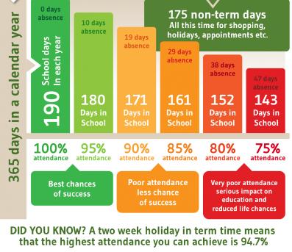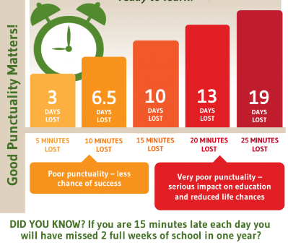

Make every minute count!
Lunch Menu – Spring Term

SPRING TERM  2023 | Week 1  Served w/c 13 Mar | Week 2  Served w/c 20th Mar | Week 3  Served w/c 6th Mar, 27th Mar
Monday | Pasta Parcels (Hilcona) in a Homemade Tomato Sauce  Cauliflower & Green Beans  Garlic Bread  Apple Crumble & Custard  Fresh Fruit or Fruit Yoghurt | Pizza  Crusty Bread  Diced Potatoes  Peas & Sweetcorn  Krispie Cereal Bar  Fresh Fruit or Fruit Yoghurt | Farmhouse Mac & Cheese with Garlic Bread  Broccoli & Carrots  Jam Roly Poly & Custard  Fresh Fruit or Fruit Yoghurt
Tuesday | Crispy Chicken Bites  Baked Baby Potatoes  Peas & Sweetcorn  Herby Bread  Orange Shortbread  Fresh Fruit or Fruit Yoghurt | Pasta Bolognese  Cauliflower & Green Beans  Garlic Bread  Chocolate Orange Sponge & Chocolate Sauce  Fresh Fruit or Fruit Yoghurt | Cheese Burger  Baked Potato Wedges  Spring Coleslaw with Cucumber Sticks  Banana Brownie  Fresh Fruit or Fruit Yoghurt
Wednesday | Roast Turkey & Stuffing  Roast Potatoes  Medley of Seasonal Vegetables  Homemade 50/50 Bread  Arctic Roll & Fruit  Fresh Fruit or Fruit Yoghurt | Sausage & Yorkshire Pudding  Mashed Potato  Medley of Seasonal Vegetables  Sliced Wholemeal Bread  Cheese & Crackers  Fresh Fruit or Fruit Yoghurt | Mince Beef & Dumplings with Baked Baby Potatoes  Medley of Seasonal Vegetables  Sliced Wholemeal Bread  Marbled Sponge & Custard  Fresh Fruit or Fruit Yoghurt
Thursday | Chilli Con Carne & Naan Bread  50/50 Rice  Broccoli & Carrots  Cheese & Crackers  Fresh Fruit or Fruit Yoghurt | Chicken Wrap  50/50 Bread  Vegetable Rice  Broccoli & Carrots  Apple Flapjack  Fresh Fruit or Fruit Yoghurt | Chicken Korma & Rice  Cauliflower& Green Beans  Naan Bread  Oatie Biscuit & Cheese  Fresh Fruit Yoghurt
Friday | Fishwich (Salmon)  Chips  Crunchy Vegetable Sticks  Chocolate Berry Mousse Cake  Fresh Fruit or Fruit Yoghurt | Fish Fingers  Chips  Baked Beans & Peas  Crusty Bread  Lemon Drizzle Muffin  Fresh Fruit or Fruit Yoghurt | (Harry Ramsdens) Battered Fish  Chips  Peas & Sweetcorn  Crusty Bread  Lemon & Sultana Iced Finger  Fresh Fruit or Fruit Yoghurt

PE Kits
PE Kits  w/c 6 March | Monday | Tuesday | Wednesday | Thursday | Friday
BEECH (LD) |  |  |  | X | X
HOLLY (LC) |  |  | X |  | X
OAK (LR) |  |  |  | X | X
Please do ensure that on PE days, the children wear their hoodies, school jumpers or cardigans alongside white or blue t-shirts and black or navy shorts or jogging bottoms.
Children in Apple Class need to bring their Forest School kit in each Monday. Please wear PE kit on Wednesday and bring uniform to change into.

 Stars of the Week

Stars | Apple | Beech | Holly | Oak
Stars | William Wardle | Riley-Mae Simpson | Dexter Bird | Tom Ward
Stars | William Wardle | Isla Fenton | Nancy Barrett | Maisy Emsley
Gold Awards for Sport | Isabelle Kay | Elijah Brown | Aidan Brown | Tom Ward

Crayke Church of England Primary School
Dates for your Diary – Spring Term 2023

Day | Date | Event | Who | Where
Thursdays | Alternate weeks | Open the Book – collective worship | Whole school | Hall
Thursday | 9 March | Parent Workshop: KS2 SATs | Y6 parents | Hall
Thursday | 9 March | CHASA Pre-loved uniform sale 3:30pm | All | Playground/hall
Thursday | 9 March | CHASA Meeting 3:45pm | All | Playground/hall
Tuesday | 14 March | STEM workshop – cluster event | Oak Class | Easingwold Primary
Thursday | 16 March | Parent Workshop: MTC | Y4 parents | Hall
Tuesday | 21 March | Parent Consultation Evening  3:30 – 6:30pm | Whole school | Classrooms
Wednesday | 22 March | Cluster skipping event | Selected Y5 | Galtres Centre
Wednesday | 22 March | Parent Consultation Evening  3:30 – 6:30pm | Whole school | Classrooms
Thursday | 23 March | Parent Workshop: Phonics check | Y1 parents | Hall
Saturday | 25 March | CHASA Quiz Night event | Adults only | Sports Club
Monday | 27 March | Residential meeting for parents  6pm | Year 4 | Virtual – link to follow
Tuesday | 28 March | Crayke’s Greatest Show – A Talent Competition for all | Whole school | Hall
Wednesday | 29 March | Easter Service 11am  Parents and carers welcome | Whole school | St Cuthbert’s Church
Wednesday | 29 March | Residential meeting for parents 3:40pm | Year 5 | Oak class
Thursday | 30 March | Staff and Governors v Pupils Chess Match | Chess Club | Oak Classroom
Friday | 31 March | Easter Egg Hunt | Whole school | Field
Friday | 31 March | Break the Rules Day – CHASA fundraiser | Whole school

Crayke Church of England Primary School
Dates for your Diary – Summer Term 2023

We have tried to give you as much notice as possible about upcoming events, and will try wherever possible not to have to amend them.

Day | Date | Event | Who | Where
Tuesday | 25 April | Cluster Spelling Bee tbc | TBC | Linton Primary
Thursday | 4 May | Box2BFit | All | Playground
w/c 8 May (Tue – Fri) |  | Key Stage 2 SATs tests | Year 6 | Oak class
w/c 15 May |  | Bikeability | Year 5/6 | Playground and local area
Tuesday | 16 May | Class photo day | All | Outside
Friday | 19 May | Roman topic educational visit | Holly | Murton Park
Monday - Wednesday | 5-7 June | Residential | Year 5 | Carlton Lodge
Thursdays | 8/15/22/29 Jun; 6/13 Jul | Swimming | Apple  Beech | Thirsk Pool
Wednesday | 14 June | New starter parent meeting 17:30 | Reception new starter parents | Hall
Saturday | 24 June | CHASA Summer Fair | All welcome | School grounds
Friday | 30 June | Camp Out at School overnight | Year 4 | School field
Tuesday | 4 July | Sports Day | All | Outside
Friday | 7 July | Reserve Sports Day | All | Outside
Monday | 10 July | KS2 performance dress rehearsal | KS2 | Hall
Tuesday | 11 July | KS2 performance 2:00pm | KS2 | Hall
Wednesday | 12 July | KS2 performance 6:00pm | KS2 | Hall
Friday | 21 July | Leavers service (time tbc) | All | St Cuthbert’s Church

Term Dates – Academic Year 2022/2023
Spring Term Wednesday 4th January to Friday 31st March 2023
Summer Term Tuesday 18th April to Friday 21st July 2023
May Day Monday 1st May 2023
Additional Bank Holiday Monday 8th May 2023
Half Term Monday 29th May to return on Monday 5th June
INSET Days (School Closed to pupils) –
Monday 17th April 2023
Monday 24th July 2023
Tuesday 25th July 2023

Judi Jackson
Headteacher
headteacher@crayke.n-yorks.sch.uk

FOLLOW YOUR PATHWAY AND WE GROW TOGETHER WITH CONFIDENCE
You did not choose me, I chose you that you might go and bear fruit, fruit that will last so that whatever you ask in my name the Father will give you. John 15:16

Respect Friendship Forgiveness Determination
Church News

Message from the Family Service Team
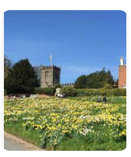

It’s time for our next Family Service – this Sunday March 5th at 10.30am, refreshments from 10.15 as usual. We hope to welcome you.

Dates for your diaries:

On Mothering Sunday, March 19th, there are two family services in the Benefice – 9am in Brandsby and 10.30am in Husthwaite churches.

On Easter Sunday (April 9th), we are having a Family Holy Communion @ Crayke – please note it is at 10am and will be followed by refreshments.

After that our regular Family Services @ Crayke continue on the 1st Sunday of the month as usual.

Looking forward to seeing you!

The Family Service team
Community News



Community News (cont.)



