
Crayke Church of England Primary School
FOLLOW YOUR PATHWAY AND WE GROW TOGETHER WITH CONFIDENCE
You did not choose me, I chose you that you might go and bear fruit, fruit that will last so that whatever you ask in my name the Father will give you. John 15:16
Respect Friendship Forgiveness Determination

Dear Parents and Carers,

NEWS FROM SCHOOL THIS WEEK
What a difference a week makes! From snow last Friday, to beautiful sunshine today. We’ve got, amongst many other things, some important safeguarding updates to share in this week’s newsletter and an exciting update about wraparound care! Have a lovely weekend and I hope that all you mums get well and truly spoilt on Mothering Sunday!

Red Nose Day


Everyone looks fabulous in their item(s) of red clothing! Thanks for the donations received so far. The page is still live and donations can still be made via this link: https://app.parentpay.com/ParentPayShop/Foc/Default.aspx?shopid=9797

So far, we have raised £132 from 19 donations. We are very grateful to all those who have donated to this valuable cause.

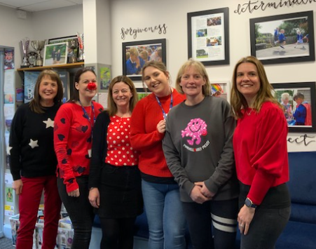
Photo credit: Cyrus Saeedi!

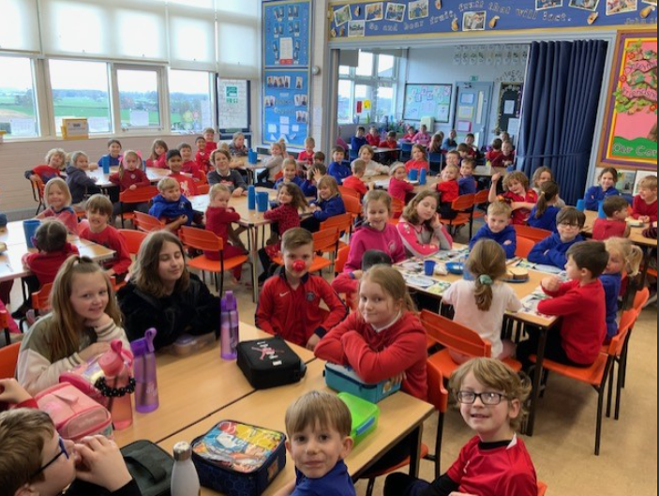

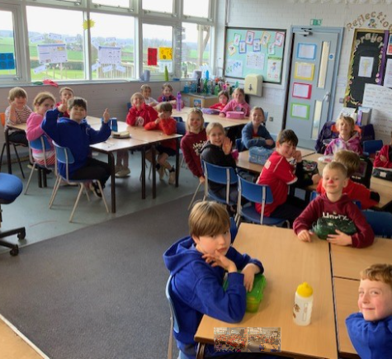

Wraparound Care – Update

I am delighted to confirm that we have signed a license agreement this week and am now in a position to confirm that the Ofsted Outstanding Tiddlywinks Private Day Nursery will be providing wraparound care to children from Crayke Primary, on our school site. They are currently in the process of seeking Ofsted registration and, since this can take up to 10 weeks, we have taken the decision to commence the club from early June. Tiddlywinks are also in the process of advertising for staff – please see the advert below and pass the word on to anyone who may be interested in applying.


Do you love talking to children and helping them extend their knowledge and experiences, do you enjoy using your imagination, getting messy, creating new inventions and being physically active? If so then this is the job for you!

Tiddlywinks is super excited to be advertising for a play worker to work in our brand new Out of School club based in the beautiful countryside at Crayke Primary School. The role would come with supported professional development opportunities, generous benefits and a true competitive salary.
The working hours will be from 7:30-9am and 3:30-6:00pmor a mix depending on the applicants.

If you wish to join our Outstanding, friendly and inspirational team then please apply by emailing your CV and covering letter to tiddleywinks@btopenworld.com or alternatively calling our nursery in Easingwold directly on 01347 824123 for an application form.

Successful candidates will be short listed and invited to interview subject to references.
You will be required to provide a clear DBS check in addition to two suitable references.
We look forward to receiving your application soon.
Tracey & Rowena
Further details will follow in due course around the registration process for places.

Safeguarding Update
Invacuation - Last week we talked to the children about how to keep safe if something unusual were to happen, for example a dog on the playground. The children were very sensible and followed all the instructions really carefully. We will continue to work with the children to help ensure that they feel comfortable and safe if something out of routine happens during the school day.

Tuck Shop – we also spoke to the children this week about slightly revised procedures at the end of day, to enable the tuck shop to proceed with minimal disruption and to ensure that everyone has the opportunity to participate, regardless of their collection arrangements. With this in mind, the following amendments will take effect from this afternoon:
Bus/LiveWires children – will get the opportunity to visit Mrs Bacon’s pop-up Tuck Shop at afternoon playtime and place their order, for collection at the end day. They will need to bring cash.
All other children – the tuck shop will now be sited on the staff car park. Children have been told that they are not to leave the playground until they see their parent/carer, as normal. Children have also been told that they need to wait with their parents if they are queueing for the tuck shop and that they are not to return onto the school site or to leave the staff car park until their parents do. This is to ensure the safety and well-being of all children. Thank you for your support with this matter.

Village Link Magazine – Easter designs
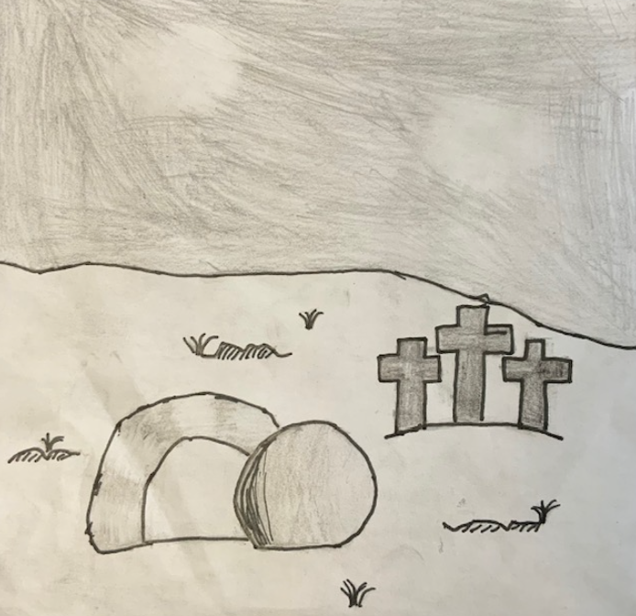
Thank you to Holly Class for submitting designs for the local magazine, which will be included in their next edition. There was a competition to provide the front cover design; I am delighted to announce that Joah won this with this superb illustration:

Joah will be awarded with a prize in Collective Worship this afternoon and the other children will also receive a small chocolate treat to thank them for their entries. Thank you to the magazine team for organising this!

Parent Workshops – presentations available
Mrs Rayner’s Year 6 SATs video and presentation is available via this weblink: https://sites.google.com/crayke.n-yorks.sch.uk/class4homelearning

Mrs Chandler’s Year 4 Multiplication Tables Check presentation is available via this weblink:
https://sites.google.com/crayke.n-yorks.sch.uk/class3homelearning

Please note: access to both weblinks requires use of your child’s Google log in details.

Club News
Please note the after-school club timetable for the remaining two weeks of this term. Please do check it carefully as there are some changes due to parent consultation evenings. If the club is not listed below (e.g. Craft Club) this means it is not running for the next fortnight.

Monday  20 | SATs Club (no charge)  3:30pm – 4:15pm  Year 6  Mrs Rayner | Monday  27 | SATs Club (no charge)  3:30pm – 4:15pm  Year 6  Mrs Rayner
Tuesday  21 | Multi-Sports (fee paid direct)  3:30 – 4:30pm  Years 1 – 6  Mark Cromack | Tuesday  28 | Multi-Sports (fee paid direct)  3:30 – 4:30pm  Years 1 – 6  Mark Cromack
Wednesday  22 |  | Wednesday  29 | Italian (no charge)  3:30pm – 4:15pm  Year 2-6  Mrs Aristizabal
Thursday  23 | Chess (no charge)  3:30pm – 4:15pm  Year 3-6  Mrs Seligman | Thursday  30 | Chess (no charge)  3:30pm – 4:15pm  Year 3-6  Mrs Seligman

Run a Mile Club – please note that this will NOT be on for the next fortnight and will resume after Easter.

Auditions
I was privileged to be able to see some of the auditions for Crayke’s Greatest Show earlier this week and was so impressed to see such a range of talents amongst our children. We’ve had many different acts including: singers, dancers, gymnasts, musicians, comedians and fact tellers. The finalists will be revealed in collective worship this afternoon, giving each act time to prepare ahead of the Grand Finale on 28 March. We can’t wait!

STEM Workshop for Oak Class
The children had a great opportunity to meet other children of the same age this week, from across the cluster, hosted by Easingwold Primary School. It sounds like they had great fun in mixed groups attempting a challenge involving dried spaghetti and marshmallows. Maybe one to be repeated at home over Easter…?!

Tennis Sessions at Crayke Sports Club
Oak Class have had the opportunity to play tennis at the Club today and will return next week. Thanks to the Sports Club for allowing the children to take advantage of this brilliant experience.

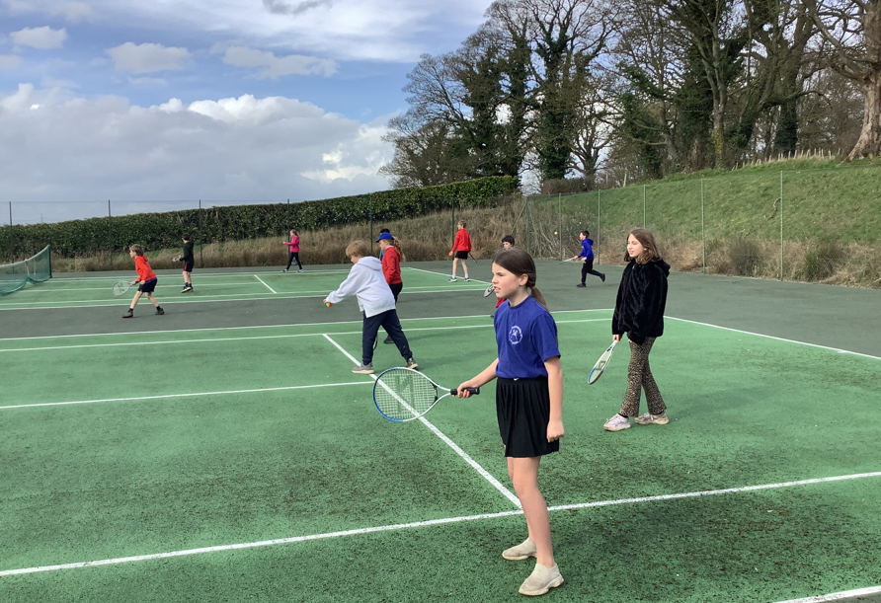

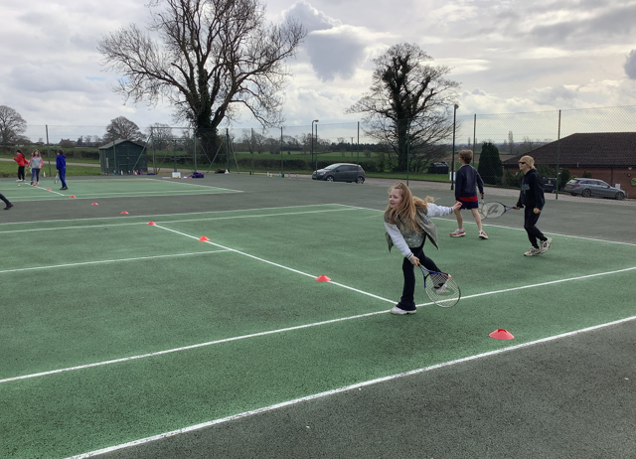

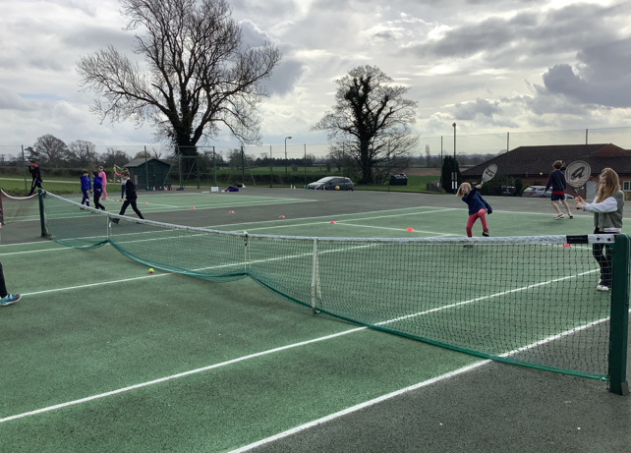
Healthy Lifestyle Focus – Sleep and Rest
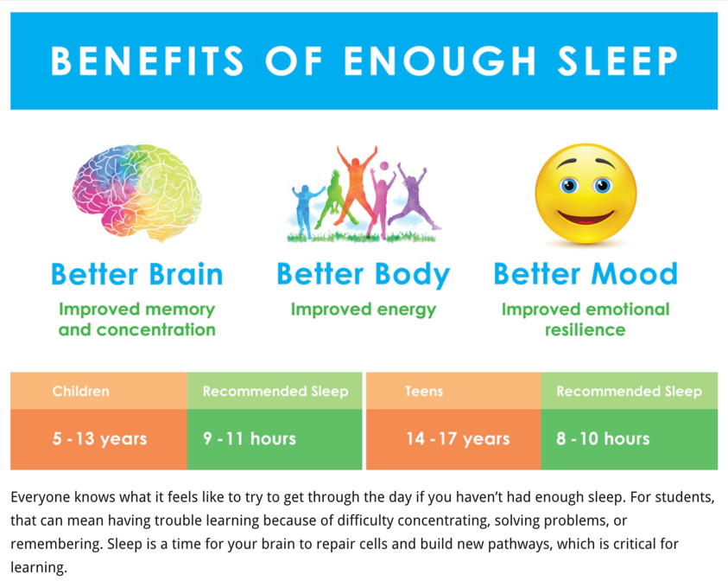

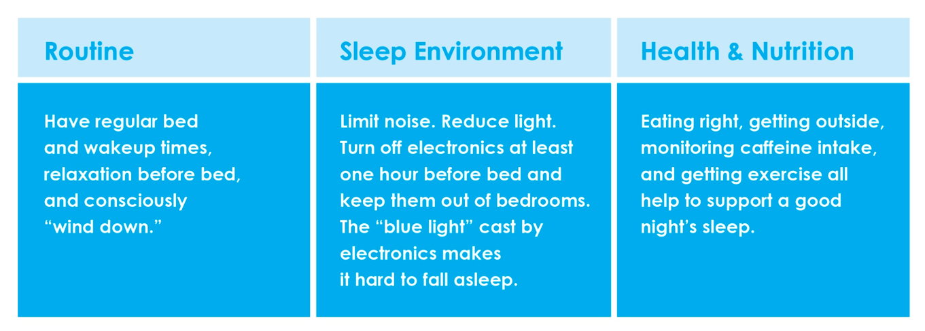

Wow Walk to School Challenge Weekly Update
Message from Mrs Helfferich

WOW Walk to school
It has been great to see the year 5 girls doing laps of the playground during breaktime, keep it up girls and the bike badge will be coming your way.

This week’s results are as follows:

This Photo by Unknown Author is licensed under CC BY-NC
Apple, Beech & Holly Year 6
Well done – some great results this week!

Walking Inspiration
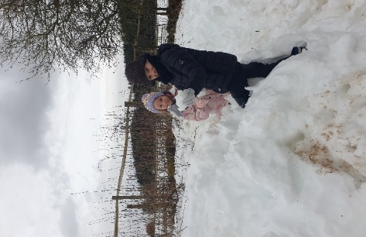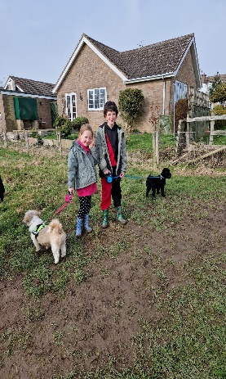
‘This was a very snowy walk at Garbutt Wood Nature Reserve up at Sutton Bank. Aidan and Amber loved playing in the heaps of snow but did get very cold, wet feet!’.
This looks like the place to visit after a snowfall. I will definitely be adding it to my places to visit.
Aiden and Riley-Mae had a very muddy dog walk around Sheriff Hutton. Well done, keep up the great walking.
Mrs Helfferich
**UPCOMING EVENTS**
ENRICHMENT – INCLUDING EDUCATIONAL VISITS AND VISITORS

Parent Consultation Evenings – 21 and 22 March
Parents and carers should have received a text regarding booking arrangements for the upcoming Parent Consultation Evenings. We look forward to welcoming you into school and giving you the opportunity to see your child/ren’s books.

**NEW** - The Blue House Bookshop – Pop Up Stall

As previously, we are delighted to welcome The Blue House Bookshop into school next week during Parent Consultation Evenings. They will be running a pop up stall on both evenings so why not treat your child to a new book following a successful meeting with their teacher?! They can take card and cash and will be giving a percentage of their sales back to the school to spend on books.

**NEW** - Skipping Competition – Year 5 – Wednesday 22 March
Children in Year 5 have been invited to participate in a cluster event at the Galtres Centre, Easingwold next Wednesday morning 22 March. They will be accompanied by Mrs Helfferich, Mrs Aristizabal and Miss Ayre.
The Skiptbfit challenge offers a great opportunity for pupils to take part in a fun activity and also learn the importance of a healthy lifestyle. They will be transported by coach at 9.30am and will be back at school by 12.30pm. They will be required to come to school in their PE kit and need to bring a named water bottle and warm coat. As they won't arrive back at school in time for lunch, please can all children bring a packed lunch with them, which they will eat on their return to school.
The event will be attended by local media, so pictures will be taken throughout the event and used. Please confirm on the consent form that you give permission for this to happen.
If you have not already done so, please complete a consent form via this link by Monday 20 March latest: https://forms.office.com/e/d5RbiU3ruU

Parent Workshops – Assessment focus
Thanks to Mrs Chandler for her workshop yesterday. The details of the final workshop is as follows:
Focus | For parents of children in | Date | Time | Led by
Phonics | Year 1 | Thursday 23 March | 9:10am | Mrs Dobson
Each session will take place in the hall and will last for approximately 30 minutes.

**NEW** National Skipping Day – Friday 24 March
Message from Mrs Helfferich, PE Subject Leader
To celebrate National Skipping Day, music will be played during Friday playtimes. Bring your skip2Bfit ropes and see how many skips you can achieve. Apple Class, skipping ropes will be provided.

Crayke’s Greatest Show Audition News – Tuesday 28 March
Message from Miss Walker and School Council

On Tuesday 28th March we will be putting on a spectacular talent show! This is an opportunity to celebrate our unique talents and showcase what makes the children so amazing.

Easter Service – Wednesday 29 March
Please join us at St Cuthbert’s Church on Wednesday 29 March at 11am for our Easter Service.

Carlton Lodge Residential – Parent Meeting Wed 29 March@3:40pm
Parents and carers of children in Year 5 are invited to a parent meeting to learn more about the upcoming residential visit in June. This will be held in Oak class on Wednesday 29 March at 3:40pm. We hope you can make it!


Chess Club Match – Thursday 30 March

Message from Mrs Seligman
Crayke School Chess Club have invited governors to take part in a chess match on Thursday 30 March, at 3.30pm, at school. We look forward to hearing who is victorious!

**NEW** - SATs Club – Dates
Mrs Rayner is keen for the children not to miss any SATs club sessions in the run up to the tests. She is also determined to overcome the hurdle of the number of Mondays which school is not open to pupils before then and therefore the SATs club will be running on the following dates for Year 6 pupils:
Monday 20 March
Monday 27 March
Wednesday 19 April
Monday 24 April
Wednesday 3 May

Mrs Rayner has also found the following news article which highlights the importance of a healthy breakfast, which is an interesting read:
https://www.bbc.co.uk/food/articles/food_exam_performance#:~:text=Add%20a%20protein%20food%2C%20such,to%20have%20brain%2Dboosting%20properties.



Quiz Night – Saturday 25 March


Advance Notice – Summer Fair Saturday 24 June
Plans are underway for this year’s Summer Fair! Please start collecting clean teddies and empty, clean jam jars to be able to make these popular stalls bigger than ever! Thank you!
***STANDING ITEMS***
Cost of Living Crisis
We are very aware that costs continue to rise and look set to do so for some time. If you are encountering financial difficulties, we may be able to signpost support. Please get in touch.
If your circumstances have changed and you think your child may be eligible for free school meals, it has never been easier to apply. There is no stigma attached to this, it is not highlighted to the children in any way, and the school gets valuable funding too. If you would like a confidential conversation about whether you may be eligible for free school meals, please do not hesitate to speak to me. To apply directly please use this weblink: https://www.northyorks.gov.uk/free-school-meals

Reception places available for September 2023
Due to a lower number of sibling than usual, we anticipate that we will have some spaces available in our Reception class in September 2023. Although the deadline has now officially passed for applications of places to North Yorkshire County Council, if you know of any parents who may be interested, please do ask them to contact school.

Online Safety
We recognise the importance of online safety and also understand that it is a fast paced, ever changing online world where parents can struggle to keep up with the technical knowledge and understanding demonstrated by their children. The National Online Safety organisation produce regular guides for parents – this week they have produced a leaflet entitled “Top Tips for adopting safe and healthy online habits”. Please see the attached leaflet which is also available on the Online Safety section of our website. Should you wish to access any of the other online safety parent guides available on a whole range of topics including what parents need to know about Amazon Fire Tablets, Google Chromebooks, and ways to champion equality online, please have a look at this weblink: https://nationalonlinesafety.com/guides
Should you wish to access more information about how to support your child/ren with online safety at home, this course is available which explains in detail the risks they might be exposed to and what you can do to support them. https://info.nationalonlinesafety.com/myleene-uk

Our Safeguarding Team
At Crayke, we have three members of staff and a governor who make up our Safeguarding Leadership Team. I am the Designated Safeguarding Lead, which means that I am the lead person responsible for child protection and safeguarding issues. Mrs Rayner and Mrs Chandler are our Deputy Designated Safeguarding Leads (Deputy DSLs); a deputy DSL supports the DSL in their role of safeguarding and child protection. Mr Hugh Porter is our Safeguarding Link Governor. The role of the Safeguarding Governor is to support the DSL as well as to regularly review, ask questions and make suggestions about our safeguarding policies and procedures and to report back to the governing body. All staff at Crayke know that safeguarding is EVERYONE’S responsibility. Find out more on our dedicated website Safeguarding page: https://craykeschool.org/safeguarding/
You can also report any safeguarding concerns to our DSL email: dsl@crayke.n-yorks.sch.uk Please also be aware that as a school we subscribe to Operation Encompass, whereby we are notified of any incidences of domestic violence where a pupil at our school has been present.
Attendance and Punctuality
This week’s attendance figures: 96.9% School Target: 96%
Apple (CH): 99.3% 3 lates (2 children) | Beech (LD): 100% 4 lates (2 children)
Holly (LC): 92.3% 1 late | Oak (LR): 97.7% 2 lates (1 child)

We strive for high levels of attendance at school. Please try, wherever possible, to book holidays out of term time. The impact of even one day’s absence on your child’s learning is huge. Also, please try to book medical appointments out of school hours if possible as this also minimises the time missed. If your child is very unwell and unable to attend school, please inform the office by phoning 01347 821767 no later than 9:15am. Thank you for your support with this important matter.

Why is it important for children not to miss school?
All parents want the best for their children and for them to get on well in life. Having a good education is important to ensure that they have the best opportunities in their adult life. They only get one chance at school, and your child’s future may be affected by not attending school or alternative provision regularly.
If children do not attend school regularly they may:
• Struggle to keep up with school work. In a busy school day, it can be difficult for schools to find the extra time to help a child catch up.
• Miss out on the social side of school life. Poor attendance can affect children’s ability to make and keep friendships; a vital part of growing up.
Setting good attendance patterns from an early age, from nursery through primary school will also help your child later on in their life. Children who have a poor school attendance record may have less chance of securing a job when they are adults. Being on time is also vital. Arriving late at school can be very disruptive for your child, their teacher and the other children in the class. Some parents may be finding it difficult to ensure that their child attends school regularly. If this is the case please speak to Mrs Jackson as soon as possible so that the situation can be addressed.

The world is run by those who turn up.

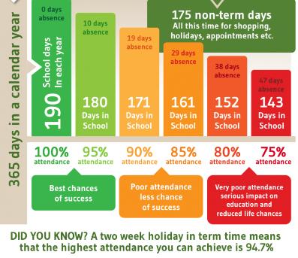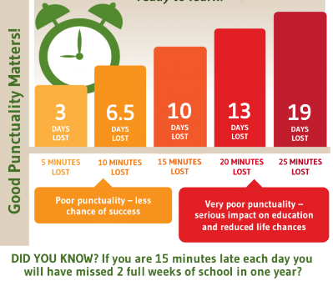

Make every minute count!
Lunch Menu – Spring Term

SPRING TERM  2023 | Week 2  Served w/c 20th Mar | Week 3  Served w/c 27th Mar
Monday | Pizza  Crusty Bread  Diced Potatoes  Peas & Sweetcorn  Krispie Cereal Bar  Fresh Fruit or Fruit Yoghurt | Farmhouse Mac & Cheese with Garlic Bread  Broccoli & Carrots  Jam Roly Poly & Custard  Fresh Fruit or Fruit Yoghurt
Tuesday | Pasta Bolognese  Cauliflower & Green Beans  Garlic Bread  Chocolate Orange Sponge & Chocolate Sauce  Fresh Fruit or Fruit Yoghurt | Cheese Burger  Baked Potato Wedges  Spring Coleslaw with Cucumber Sticks  Banana Brownie  Fresh Fruit or Fruit Yoghurt
Wednesday | Sausage & Yorkshire Pudding  Mashed Potato  Medley of Seasonal Vegetables  Sliced Wholemeal Bread  Cheese & Crackers  Fresh Fruit or Fruit Yoghurt | Mince Beef & Dumplings with Baked Baby Potatoes  Medley of Seasonal Vegetables  Sliced Wholemeal Bread  Marbled Sponge & Custard  Fresh Fruit or Fruit Yoghurt
Thursday | Chicken Wrap  50/50 Bread  Vegetable Rice  Broccoli & Carrots  Apple Flapjack  Fresh Fruit or Fruit Yoghurt | Chicken Korma & Rice  Cauliflower& Green Beans  Naan Bread  Oatie Biscuit & Cheese  Fresh Fruit Yoghurt
Friday | Fish Fingers  Chips  Baked Beans & Peas  Crusty Bread  Lemon Drizzle Muffin  Fresh Fruit or Fruit Yoghurt | (Harry Ramsdens) Battered Fish  Chips  Peas & Sweetcorn  Crusty Bread  Lemon & Sultana Iced Finger  Fresh Fruit or Fruit Yoghurt

PE Kits
PE Kits  w/c 20 March | Monday | Tuesday | Wednesday | Thursday | Friday
BEECH (LD) |  |  |  | X | X
HOLLY (LC) |  |  | X |  | X
OAK (LR) |  |  | X Y5 skip | X | X
Please do ensure that on PE days, the children wear their hoodies, school jumpers or cardigans alongside white or blue t-shirts and black or navy shorts or jogging bottoms.
Children in Apple Class need to bring their Forest School kit in each Monday. Please wear PE kit on Wednesday and bring uniform to change into.

 Stars of the Week

Stars | Apple | Beech | Holly | Oak
Stars | Milo Burnett-Armstrong | Gem Champion | Ted Clark | Ethan Hutton
Stars | Milo Burnett-Armstrong | Grant Colman | Felicity Ritchie | Nat Fenton
Gold Awards for Sport | Duke Gains | Fenton Ward | Elise Fenton | Maisy Emsley

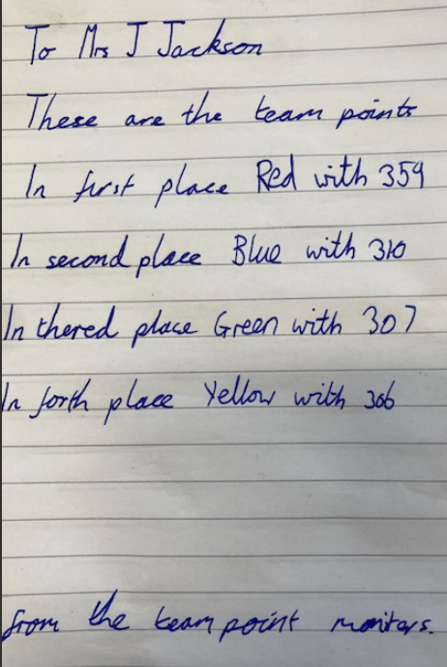
Team Points

I was delighted to receive this letter on my desk yesterday afternoon with this week’s team points! Well done to Isabelle for presenting it so beautifully and well done to Red team for winning this week!

Crayke Church of England Primary School
Dates for your Diary – Spring Term 2023

Day | Date | Event | Who | Where
Thursdays | Alternate weeks | Open the Book – collective worship | Whole school | Hall
Tuesday | 21 March | Parent Consultation Evening  3:30 – 6:30pm | Whole school | Classrooms
Wednesday | 22 March | Cluster skipping event | Selected Y5 | Galtres Centre
Wednesday | 22 March | Parent Consultation Evening  3:30 – 6:30pm | Whole school | Classrooms
Thursday | 23 March | Parent Workshop: Phonics check | Y1 parents | Hall
Friday | 24 March | Tennis | Oak Class | Sports Hall
Friday | 24 March | National Skipping Day – please bring ropes | All | Playground
Saturday | 25 March | CHASA Quiz Night event | Adults only | Sports Club
Tuesday | 28 March | Crayke’s Greatest Show – A Talent Competition for all | Whole school | Hall
Wednesday | 29 March | Easter Service 11am  Parents and carers welcome | Whole school | St Cuthbert’s Church
Wednesday | 29 March | Residential meeting for parents 3:40pm | Year 5 | Oak class
Thursday | 30 March | Staff and Governors v Pupils Chess Match | Chess Club | Oak Classroom
Friday | 31 March | Easter Egg Hunt | Whole school | Field
Friday | 31 March | Break the Rules Day – CHASA fundraiser | Whole school

Crayke Church of England Primary School
Dates for your Diary – Summer Term 2023

We have tried to give you as much notice as possible about upcoming events, and will try wherever possible not to have to amend them.

Day | Date | Event | Who | Where
Tuesday | 25 April | Cluster Spelling Bee tbc | TBC | Linton Primary
Thursday | 4 May | Box2BFit | All | Playground
w/c 8 May (Tue – Fri) |  | Key Stage 2 SATs tests | Year 6 | Oak class
w/c 15 May |  | Bikeability | Year 5/6 | Playground and local area
Tuesday | 16 May | Class photo day | All | Outside
Friday | 19 May | Roman topic educational visit | Holly | Murton Park
Monday - Wednesday | 5-7 June | Residential | Year 5 | Carlton Lodge
Thursdays | 8/15/22/29 Jun; 6/13 Jul | Swimming | Apple  Beech | Thirsk Pool
Monday | 12 June | Launch of Wrapround Care | Open to all | School site
Wednesday | 14 June | New starter parent meeting 17:30 | Reception new starter parents | Hall
Saturday | 24 June | CHASA Summer Fair | All welcome | School grounds
Friday | 30 June | Camp Out at School overnight | Year 4 | School field
Tuesday | 4 July | Sports Day | All | Outside
Friday | 7 July | Reserve Sports Day | All | Outside
Monday | 10 July | KS2 performance dress rehearsal | KS2 | Hall
Tuesday | 11 July | KS2 performance 2:00pm | KS2 | Hall
Wednesday | 12 July | KS2 performance 6:00pm | KS2 | Hall
Friday | 21 July | Leavers service (time tbc) | All | St Cuthbert’s Church

Term Dates – Academic Year 2022/2023
Spring Term Wednesday 4th January to Friday 31st March 2023
Summer Term Tuesday 18th April to Friday 21st July 2023
May Day Monday 1st May 2023
Additional Bank Holiday Monday 8th May 2023
Half Term Monday 29th May to return on Monday 5th June
INSET Days (School Closed to pupils) –
Monday 17th April 2023
Monday 24th July 2023
Tuesday 25th July 2023

Judi Jackson
Headteacher
headteacher@crayke.n-yorks.sch.uk

FOLLOW YOUR PATHWAY AND WE GROW TOGETHER WITH CONFIDENCE
You did not choose me, I chose you that you might go and bear fruit, fruit that will last so that whatever you ask in my name the Father will give you. John 15:16

Respect Friendship Forgiveness Determination
Church News

Message from the Family Service Team


Dates for your diaries:

On Mothering Sunday, March 19th, there are two family services in the Benefice – 9am in Brandsby and 10.30am in Husthwaite churches.

On Easter Sunday (April 9th), we are having a Family Holy Communion @ Crayke – please note it is at 10am and will be followed by refreshments.

After that our regular Family Services @ Crayke continue on the 1st Sunday of the month as usual.

Looking forward to seeing you!

The Family Service team
Community News



Community News (cont.)



Community News (cont.)



Community News (cont.)



Community News (cont.)



Community News (cont.)



Community News (cont.)




Community News (cont.)




