
Crayke Church of England Primary School
FOLLOW YOUR PATHWAY AND WE GROW TOGETHER WITH CONFIDENCE
You did not choose me, I chose you that you might go and bear fruit, fruit that will last so that whatever you ask in my name the Father will give you. John 15:16
Respect Friendship Forgiveness Determination

Dear Parents and Carers,

NEWS FROM SCHOOL THIS WEEK
Well done Year 6!
Year 6 children have been quite remarkable this week and we are so, so impressed with each and every one of them. They have ALL given every test their absolute best effort and should feel really proud of how well they have concentrated, focussed and persevered. Every single child maintained a positive attitude throughout each test. We could not be any prouder of you all. Also, an enormous thank you and well done to the wonderful team who have supported the children this year – Mrs Rayner, Mrs Aristizabal and Miss Ayre.

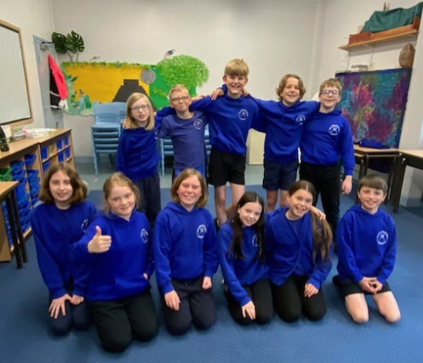

The children have loved their special SATs breakfasts – thank you so, so much to the parents who donated items for this.

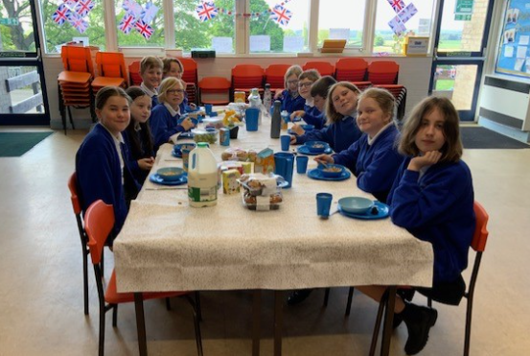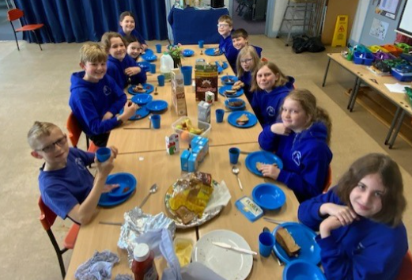

The children celebrated the end of their tests with a party, although I am not quite sure who enjoyed it the most… my vote is Mrs Rayner!

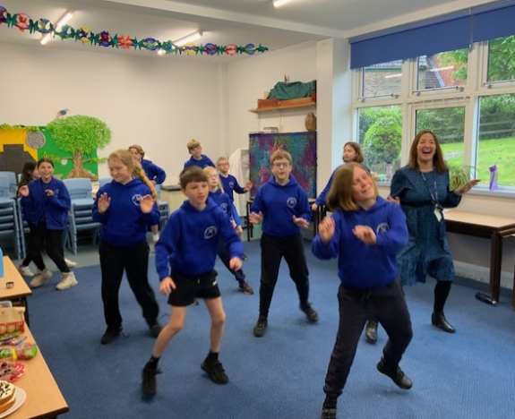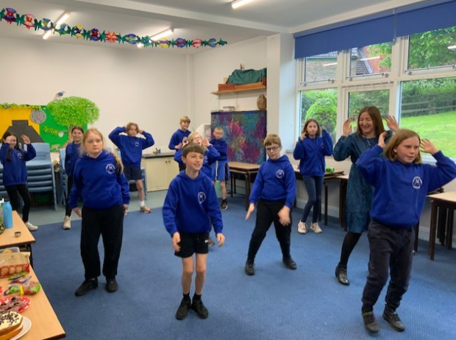
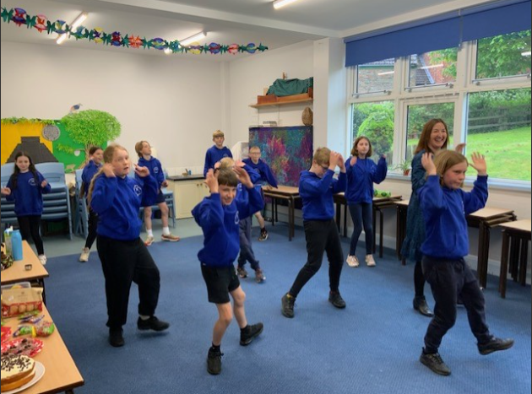

Message from Mrs Helfferich
The weather must have got the memo that we needed it to brighten up in time for last Friday’s event! Luckily the weather stayed mostly dry apart from the odd drop of rain. Well done to all the children/staff/parents who took part in the ‘Mini Marathon’ last Friday,
We will let you know if we are successful in our attempt to break a Guinness World Record. My Fitbit recorded 2.32km, so I am confident that all children completed a mile.

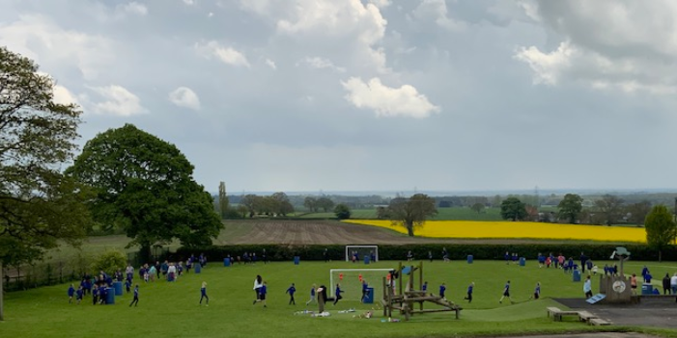

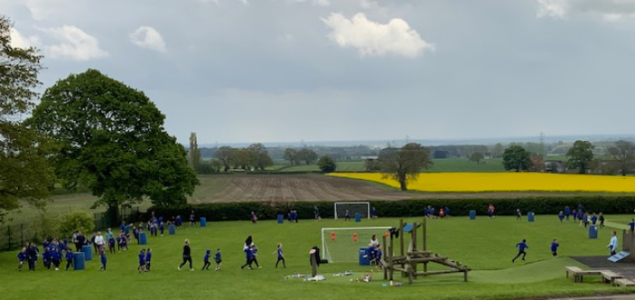
Apple Class Update
Message from Mrs Helfferich
This week we have been learning about Florence Nightingale, it would have been her birthday today. Today, is International Nurses Day, we made cards for the nurses at St Monica’s, Millfield and Stillington Surgery. They were delighted to receive them.
The children are all very aware and concerned about the impact that litter has on animals and the environment. We are going to walk around the school grounds to collect any rubbish to ensure that all the animals on our school field are safe. We were really pleased to see that a hedgehog had stayed a night or two in our hedgehog home.
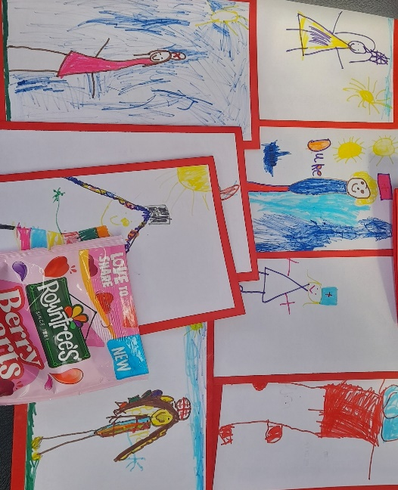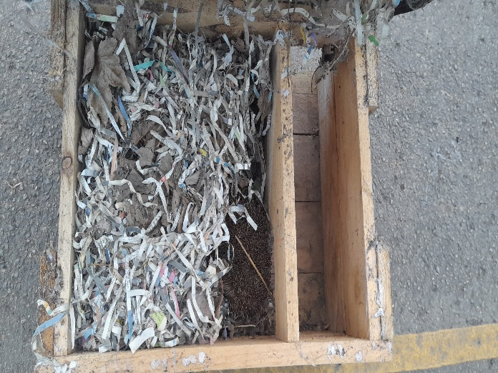

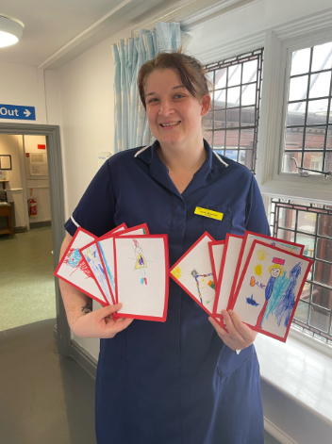
Response from the nurses at St Monica’s
I would like to just send a heartfelt thank you to Mrs Helfferich and Apple class for thinking of us nurses at St Monica’s on this International Nurses Day.
You had the nurses close to tears with the lovely pictures and messages, so thank you.
We have put the cards up proudly around our hospital for everybody to see!
And we really enjoyed the sweets!
From Jade

UPCOMING EVENTS

Walk to School week – next week
We are encouraging children to be more active during Walk to School Week 2023. The 5-day challenge takes place from the 16th to the 20th of May and is designed to help children reach their minimum 60 minutes of exercise per day.
What are the benefits of Walk to School Week?
Being active and getting some exercise in the morning before arriving at school will help set kids up for a positive day; improving focus and concentration, and instilling a sense of physical and mental wellbeing.
Walk to School Week is also designed to extend beyond the week itself, by encouraging healthy habits for life with a focus on exercise, diet and wellbeing.
There are many health benefits to walking:
- Exercise helps develop strong bones and increase muscle strength. It also tones the whole body.
- Walking gets the heart pumping, which can help improve cognitive function for lessons throughout the school day.
- Walking helps to improve mood. Getting outdoors and making the most of natural daylight makes for a positive start to the day.
- When walking to school, children can relax and let off steam before they head into the classroom to learn.
Forest School sessions – Reception and Year 1
As part of transition from EYFS to Key Stage 1, and to enable to Year 2 children to do their SATs tests, Mrs Helfferich will be running some Forest School sessions for children in Reception and Year 1 on the following mornings:
Thursday 18 May
Friday 19 May
Tuesday 23 May
Wednesday 24 May
Thursday 25 May
Please can ALL children in Apple Class and Year 1 have their Forest School kits in school for the above days – thank you.

New starter survey – Reception 2023
Parents of new starters in Reception were emailed this week with information about the information evening and new starter visits. In the meantime, to support our planning of the visits to feeder settings, please can parents of Reception new starters please complete this survey as soon as possible and no later than Friday 26 May: https://forms.office.com/e/5zWxfmDxFk Thank you to those parents who have already completed this.

Holly Class Visit – Murton Park – 19 May 2023
A reminder to parents/carers of children in Holly Class to complete the consent form no later than Monday 15 May: https://forms.office.com/e/Mv3qzNdX1h Thank you.
Pentecost Event at St Cuthbert’s Church – Monday 22 May
We are delighted to have been invited to a Pentecost themed event at church on the afternoon of 22 May. Children in Holly and Oak class will be attending and will experience a variety of different activities led by a local team of volunteers. As we will be back in time for the end of the school day and the visits falls within our local area, specific consent is not required for this event. Given the unpredictability of the current weather, please ensure your child has a coat in school this day. Should anyone wish to contact me to discuss further please do not hesitate to do so.

Whole School Photograph – 21 June 2023
We have been advised that we need to reach a minimum of 25 group photograph orders in order for it to be cost effective for Tempest Photography to transport the rigging and stage to school for our whole school photograph on 21 June. If they come to school and we do not reach the minimum order, school will have to make up the difference and we do not have the funds to do this.
Please can you therefore indicate on the MS Form - link below - if you are likely to purchase a group photograph. Prices start from £20.00 (we need a minimum order of 25 x £20.00 - £500 in total). The form will literally take seconds to complete, but we will need all responses by Friday 12 May. If we don't receive enough interest, we will have no alternative but to cancel the shoot.
https://forms.office.com/e/QMseS2NhVQ

IMPORTANT: Robinwood Residential Autumn 2023
As per previous communication, we are aiming to take Year 5/6 children (current Year 4/5) to Robinwood for a residential visit on the weekend of 6-8 October 2023. To ensure that the visit is viable, please can parents of children in current Year 4 and 5 complete this survey as soon as possible and no later than Friday 26 May https://forms.office.com/e/27QdFqvcZ4
A parent meeting will be held in due course to provide further information about the visit. However, should you wish to find out more in the meantime please visit: https://www.robinwood.co.uk/activity-centres/dobroyd-castle/
Also, please see this typical programme outline to give you a flavour of what to expect:
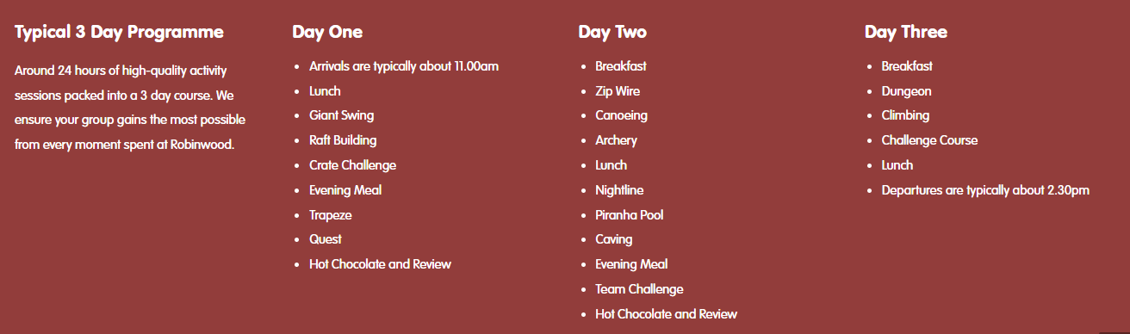

Walking Inspiration
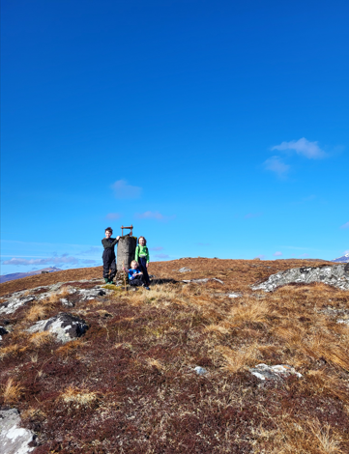
Toby, Rosie and Martha went on a great big hill walk in the Highlands during the Easter Holidays. Yet again more lovely Scottish scenery. Well done.

Wow Walk to School Challenge Weekly Update
Message from Mrs Helfferich

WOW Walk to school

The Suffragettes Badge – May Facts:
- The suffragettes campaigned for equal opportunities for women in the early 20th century.
- Their campaign led 8.4 million women being granted the right to vote for the first time in 1918.
- It took another 10 years for all women to be allowed to vote with the same rights as men.
This week’s results are as follows:

This Photo by Unknown Author is licensed under CC BY-NC
Apple, Beech & Year 4 Year 3
Oak class - we know you have been busy with SATs; we look forward to seeing you back at running club/walking to school next week.

Upcoming Meetings

Meetings to plan the Summer Fair have been arranged for the following dates. Each meeting will be at 3:45pm in the School Hall.
18 May
8 June
22 June
Everyone is welcome.

Summer Fair Saturday 24 June


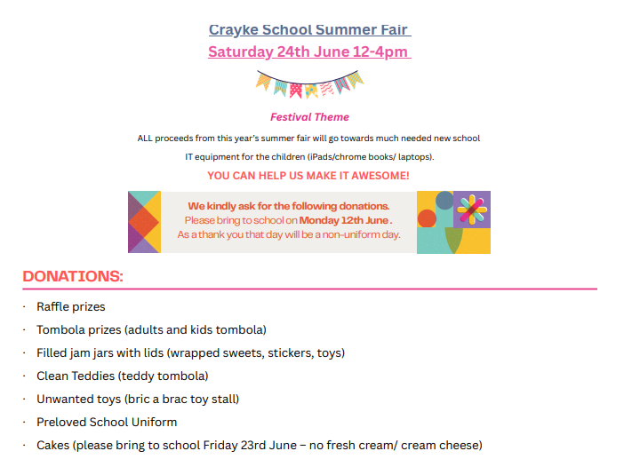

***STANDING ITEMS***
Cost of Living Crisis
We are very aware that costs continue to rise and look set to do so for some time. If you are encountering financial difficulties, we may be able to signpost support. Please get in touch.
If your circumstances have changed and you think your child may be eligible for free school meals, it has never been easier to apply. There is no stigma attached to this, it is not highlighted to the children in any way, and the school gets valuable funding too. If you would like a confidential conversation about whether you may be eligible for free school meals, please do not hesitate to speak to me. To apply directly please use this weblink: https://www.northyorks.gov.uk/free-school-meals

Reception places available for September 2023
Due to a lower number of sibling than usual, we anticipate that we will have some spaces available in our Reception class in September 2023. Although the deadline has now officially passed for applications of places to North Yorkshire County Council, if you know of any parents who may be interested, please do ask them to contact school.

Online Safety
We recognise the importance of online safety and also understand that it is a fast paced, ever changing online world where parents can struggle to keep up with the technical knowledge and understanding demonstrated by their children. The National Online Safety organisation produce regular guides for parents – this week they have produced a leaflet entitled “Guide to Telegram”. Please see the attached leaflet which is also available on the Online Safety section of our website. Should you wish to access any of the other online safety parent guides available on a whole range of topics including what parents need to know about Amazon Fire Tablets, Google Chromebooks, and ways to champion equality online, please have a look at this weblink: https://nationalonlinesafety.com/guides
Should you wish to access more information about how to support your child/ren with online safety at home, this course is available which explains in detail the risks they might be exposed to and what you can do to support them. https://info.nationalonlinesafety.com/myleene-uk
Our Safeguarding Team
At Crayke, we have three members of staff and a governor who make up our Safeguarding Leadership Team. I am the Designated Safeguarding Lead, which means that I am the lead person responsible for child protection and safeguarding issues. Mrs Rayner and Mrs Helfferich (in Mrs Chandler’s absence) are our Deputy Designated Safeguarding Leads (Deputy DSLs); a deputy DSL supports the DSL in their role of safeguarding and child protection. Mr Hugh Porter is our Safeguarding Link Governor. The role of the Safeguarding Governor is to support the DSL as well as to regularly review, ask questions and make suggestions about our safeguarding policies and procedures and to report back to the governing body. All staff at Crayke know that safeguarding is EVERYONE’S responsibility. Find out more on our dedicated website Safeguarding page: https://craykeschool.org/safeguarding/
You can also report any safeguarding concerns to our DSL email: dsl@crayke.n-yorks.sch.uk Please also be aware that as a school we subscribe to Operation Encompass, whereby we are notified of any incidences of domestic violence where a pupil at our school has been present.

PE Kits
PE Kits  w/c 15 May | Monday | Tuesday | Wednesday | Thursday | Friday
APPLE (CH) |  |  | X | Forest School | Forest School  X
BEECH (LD) |  |  |  | Y1 Forest School  X | Y1 Forest School  X
HOLLY (EW) |  | X |  |  | X
OAK (LR) |  |  |  | X | X
Please do ensure that on PE days, the children wear their hoodies, school jumpers or cardigans alongside white or blue t-shirts and black or navy shorts or jogging bottoms.

 Stars of the Week

Stars | Apple | Beech | Holly | Oak
Stars | Duke Gains | Tomas Davies | Lucas Stubbins | Year 6
Stars | Duke Gains | Elijah Brown | Felicity Ritchie | Year 5
Gold Awards for Sport | Oliver Warriner | Lucia Grant | Ted Clark | Ethan Jackson

Attendance and Punctuality
This week’s attendance figures: 95.6% School Target: 96%
Apple (CH): 92% | Beech (LD): 98.7% 4 lates (3 children)
Holly (LC): 95.2% | Oak (LR): 94.3% 2 lates (1 child)

Attendance
We strive for high levels of attendance at school. Please try, wherever possible, to book holidays out of term time. The impact of even one day’s absence on your child’s learning is huge. Also, please try to book medical appointments out of school hours if possible as this also minimises the time missed. If your child is very unwell and unable to attend school, please inform the office by phoning 01347 821767 no later than 9:15am. Thank you for your support with this important matter.
Punctuality
It is very important that the children arrive to school on time so that:
1. They take part in all of the learning opportunities for the day with complete focus and without interruption from late arrivals.
2. Teachers can teach the best possible lessons without complete focus and without interruption from late arrivals.

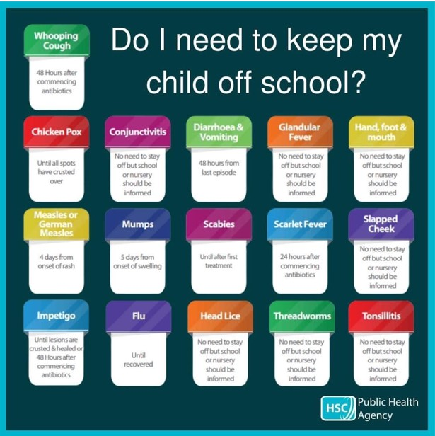
Extra-Curricular Clubs – Summer Term
Some clubs have limited capacity and places will be allocated on a first come first served basis. In the event of a club being fully booked, your child’s name will be added to a waiting list and you will be advised if a place becomes available. Booking is not required for before school or lunchtime clubs. For after school clubs run by school staff (in red type; denoted with *) please email Mrs Bacon on admin@crayke.n-yorks.sch.uk to book a place.
Before School Clubs
Club | Leader | Day and Time | Group
Run a Mile | Mrs Jackson | Monday, Tuesday Thursday & Friday  8:30am | All welcome – parents and carers included!

Lunchtime Clubs
Club | Leader | Day | Group
Skipping | Mrs Helfferich | Monday | All
School Council | Miss Walker | Tuesday | Successful candidates
Games | Miss Clarke | Friday | Max. 20 (list kept in school)

After School Clubs

We respectfully ask you to check the collection time below carefully and to collect your children promptly at the end of clubs. Clubs will run unless you are notified otherwise.
Monday | Craft* (£10 pay via ParentPay)  3:30 – 4:15pm  Years 1 – 6  Mrs Seligman and Miss Sherry
Tuesday | Indoor Multi-Sport (fee paid direct)  3:30 – 4:30pm  Years 1 – 6  Mark Cromack
Wednesday | Spanish* (no charge)  3:30 – 4:15pm  Years 2 – 6  Mrs Aristizabal |  | COMING SOON (fee paid direct)  Athletics Club  3:30 – 4:30pm  TBC
Thursday | Forest Schools* (no charge)  3:30pm – 4:15pm  Year 1-6  Mrs Helfferich | Chess* (no charge)  All abilities; Beginners welcome  3:30pm – 4:15pm  Year 1-6  Mrs Seligman | Phonics Drop In (no charge)  3:30pm – 4:15pm  Year 1 (and Year 2 by invitation)  Mrs Dobson and Miss Ford  Children must be accompanied by a parent/carer

PLEASE NOTE – DUE TO THE POPULARITY OF CRAFT CLUB & FOREST SCHOOLS, PRIORITY WILL BE GIVEN TO CHILDREN WHO HAVEN’T ALREADY ACCESSED THESE CLUBS IN THE CURRENT ACADEMIC YEAR
Lunch Menu

SUMMER TERM 23 | Week 1  Served w/c 5th Jun, 26th Jun, 17th July | Week 2  Served w/c 15th May, 12th Jun, 3rd Jul | Week 3  Served w/c 22nd May, 19th Jun, 10th Jul
Monday | Cheese & Tomato Pasta  Medley of Summer Vegetables  Garlic Flatbread  Raspberry & Apple  Doughnut Muffin  Fresh Fruit or Fruit Yoghurt | Nuggets and Ketchup  Potato Wedges  Sweetcorn & Peas  Homebaked Bread  Berry Sponge  Fresh Fruit or Fruit Yoghurt | Pizza  Potato Wedges  Coleslaw & Peas  Summer Drizzle Cake  Fresh Fruit or Fruit Yoghurt
Tuesday | Hotdog and Ketchup  Diced Potatoes  Cucumber Sticks & Grated Carrot  Summer Mousse & Shortbread Bite  Fresh Fruit or Fruit Yoghurt | BBQ Chicken Wrap with Vegetable Rice  Veggie Sticks  Tortilla Wrap  Oat Biscuit & Cheese  Fresh Fruit or Fruit Yoghurt | Beef Enchiladas with Rice  Broccoli & Sweetcorn  Crusty Bread  Cheese & Biscuit  Fresh Fruit or Fruit Yoghurt
Wednesday | Cottage Pie  Broccoli & Carrots  Crusty Bread  Cheese & Crackers  Fresh Fruit or Fruit Yoghurt | Roast Gammon  Baby Potatoes  Gravy  Medley of Summer Vegetables  Sliced Wholemeal Bread  Summer Crumble & Custard  Fresh Fruit or Fruit Yoghurt | Roast Chicken, Yorkshire Pudding & Gravy  Mashed Potato  Summer Cabbage & Carrots  Homebaked Bread  Waffle Finger & Ice-cream  Fresh Fruit or Fruit Yoghurt
Thursday | Chicken Korma  Rice  Cauliflower & Green Beans  Naan Bread  Chocolate Orange Sponge & Chocolate Sauce  Fresh Fruit or Fruit Yoghurt | Spaghetti Bolognese  Garlic Bread  Carrots & Peas  Chocolate & Vanilla Swirl Muffin  Fresh Fruit or Fruit Yoghurt | Meatballs & Pasta  Cauliflower & Green Beans  Pitta Bread  Cornflake Crispie  Fresh Fruit Yoghurt or Fruit Yoghurt
Friday | Fish Fingers  Chips  Baked Beans & Peas  Wholemeal Bread  Fruity Flapjack  Fresh Fruit or Fruit Yoghurt | Crispy Fish & Chips  Mixed Summer Salad  Sunflower Seed Bread  Jelly & Ice-Cream  Fresh Fruit or Fruit Yoghurt | Battered Fish & Chips  Ketchup  Peas & Sweetcorn  Sliced Wholemeal Bread  Custard Cookie with Apple  Fresh Fruit or Fruit Yoghurt

Crayke Church of England Primary School
Dates for your Diary – Summer Term 2023

We have tried to give you as much notice as possible about upcoming events, and will try wherever possible not to have to amend them.

Day | Date | Event | Who | Where
w/c 15 May |  | Bikeability (Group 1 – Monday; Group 2 – Wednesday) | Year 6 | Playground and local area
Tuesday | 16 May | Class photo day | All | Outside
Thursday | 18 May | CHASA meeting 3:45pm | All welcome | Hall
Friday | 19 May | Roman topic educational visit | Holly | Murton Park
Monday | 22 May | Pentecost event (afternoon) | Holly and Oak | St Cuthbert’s Church
Wednesday | 24 May | Visit to Ampleforth’s Production of Skellig | Oak | Ampleforth College
HALF TERM
Monday - Wednesday | 5-7 June | Residential | Year 5 | Carlton Lodge
Thursdays | 8/15/22/29 Jun; 6/13 Jul | Swimming | Apple  Beech | Thirsk Pool
Thursday | 8 June | CHASA meeting 3:45pm | All welcome | Hall
Monday | 12 June | Launch of Wrapround Care – Tiddlywinks@Crayke | Open to all | School site
Wednesday | 14 June | New starter parent meeting 17:30 | Reception ‘23 parents | Hall
Wednesday | 21 June | Whole School photograph | All | Field
Thursday | 22 June | CHASA meeting 3:45pm | All welcome | Hall
Friday | 23 June | Football match v Alne | Year 5/6 | Field
Saturday | 24 June | CHASA Summer Fair | All welcome | School grounds
Wednesday | 28 June | New starter visit 1 of 3  9:30 – 11:30 | Rec new starters | Apple Class
Friday | 30 June | Rounders Festival Competition | Cluster schools Y5/6 | Field
Monday | 3 July | Transition Visits | Year 6 | Outwood
Tuesday | 4 July | Transition Visits | Year 6 | Outwood
Tuesday | 4 July | Visit to Askham Bryan Wildlife & Conservation Park | Beech Class | Askham Bryan, York
Wednesday | 5 July | New starter visit 2 of 3  13:15 – 15:15 | Rec new starters | Apple Class
Friday | 7 July | Sports Day – First choice | All | Outside
Monday | 10 July | KS2 performance dress rehearsal | KS2 | Hall
Tuesday | 11 July | KS2 performance 2:00pm | KS2 | Hall
Wednesday | 12 July | New starter visit 3 of 3  9:30 – 12:30 (incl. lunch) | Rec new starters | Apple Class
Wednesday | 12 July | KS2 performance 6:00pm | KS2 | Hall
Friday | 14 July | Reserve Sports Day | All | Outside
Friday | 21 July | Leavers service (time tbc) | All | Church
Autumn Term – Friday 6 – Sunday 8 October – Year 5 and 6 Residential Visit to Robinwood

Term Dates – Academic Year 2022/2023
Summer Term Tuesday 18th April to Friday 21st July 2023
Half Term Monday 29th May to return on Monday 5th June
INSET Days (School Closed to pupils) –
Monday 24th July 2023
Tuesday 25th July 2023

Judi Jackson
Headteacher
headteacher@crayke.n-yorks.sch.uk

FOLLOW YOUR PATHWAY AND WE GROW TOGETHER WITH CONFIDENCE
You did not choose me, I chose you that you might go and bear fruit, fruit that will last so that whatever you ask in my name the Father will give you. John 15:16

Respect Friendship Forgiveness Determination
Church News

Message from the Family Service Team
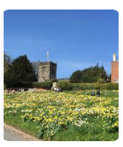

Family Service @ Crayke
In June and July, we will be back to Family Service as usual on the first Sunday of the month.

Looking forward to seeing you!

The Family Service team
Community News




Community News (cont.)
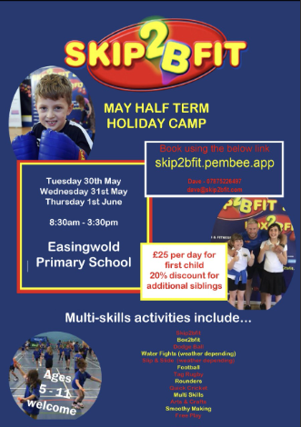



The Diocese of York has launched a new discipleship programme for young people. GROW: Youth Discipleship Ambassadors invests in young people as disciples through an academic year, exploring themes such as community, love, generosity, worship and sharing faith, shaped around our diocesan Rhythm of Life.
Young people taking part in the programme will meet in small groups for input days spread over the year facilitated by GROW Leaders, and with the support of a mentor and their church, will complete a set of tasks and challenges – all deeply rooted in how we Live Christ’s Story.
At the end of each programme, young people will be commissioned in a special service as Youth Discipleship Ambassadors.
For more information see: https://dioceseofyork.org.uk/news-events/news/diocese-launches-grow-youth-discipleship-ambassadors-programme/?fbclid=IwAR2xRxTbaZc1ap1lS0QnI-46ZGpWQqt2e_QvSJ94NXjgSzUolMmRFjrTB6c

Community News (cont.)
Youth Church @ Ampleforth meets from 6:30pm to 8:00pm on a Sunday evening, alternating between the village hall and St. Benedict's RC parish hall. We aim to explore faith through fun, fellowship and food and the group is for those who are aged 11+. This term we are particularly inviting Year 6s to come and join us to try out a session or two. Please do get in touch with Lucy for further information: lucy.willshaw@outlook.com.

Youth Church@Ampleforth for young people in the Valley and beyond…
Summer 2023

Sundays in term time 6.30 - 8.00pm
Meals with Jesus
14th May | The Big Picnic | Ampleforth Village Hall
21st May | Tea with Zaccheus | St Ben’s Church Hall
27th May & 4th June | Half Term - no meetings
11th June | Lunch with Levi | St Ben’s Church Hall
18th June | Supper with Simon | St Ben’s Church Hall
25th June | Meal with Mary and Martha | Ampleforth Village Hall
2nd July | The Great Banquet | St Ben’s Church Hall
9th July | End of term | Start at St Ben’s & end at Ampleforth Village Hall
During the summer term we may go out to play games at the park, but we will always start and finish at the hall shown.

