
Crayke Church of England Primary School
FOLLOW YOUR PATHWAY AND WE GROW TOGETHER WITH CONFIDENCE
You did not choose me, I chose you that you might go and bear fruit, fruit that will last so that whatever you ask in my name the Father will give you. John 15:16
Respect Friendship Forgiveness Determination

Dear Parents and Carers,

NEWS FROM SCHOOL THIS WEEK
It’s hard to believe this is the final week of this half term and that there only a few short (but busy!) weeks remaining in this academic year. We know there’s a lot of communication coming out from school at the moment about the exciting and interesting things we have planned for the children. Please do try to respond to surveys and provide consent as soon as possible in order to reduce pressure on the increasingly busy school office. Thank you. School closes today at the usual time of 3:30pm and reopens on Monday 5 June at 8:50am. Have a wonderful half term break!

Murton Park Visit – Holly
Message from Miss Walker and Mrs Shirley
We had such an amazing experience at Murton Park! From the second we arrived we were immersed in the Roman world. The children adored creating traditional clay oil lamps and writing in Latin. They were (of course) incredibly interested in the toilets and sponges on sticks as toilet paper! The highlight of the day was using the swords to attack our enemies (a smelly Celt) and throwing battle spears.
The children were impeccably behaved all day. They have made us incredibly proud with their politeness, how well they referred to the knowledge they've gained so far and their eagerness to learn more. Well done Holly Class!
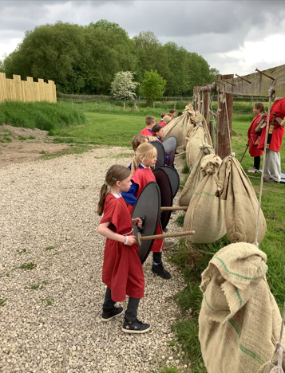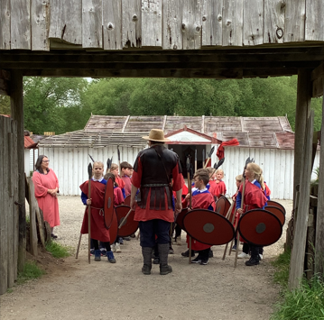
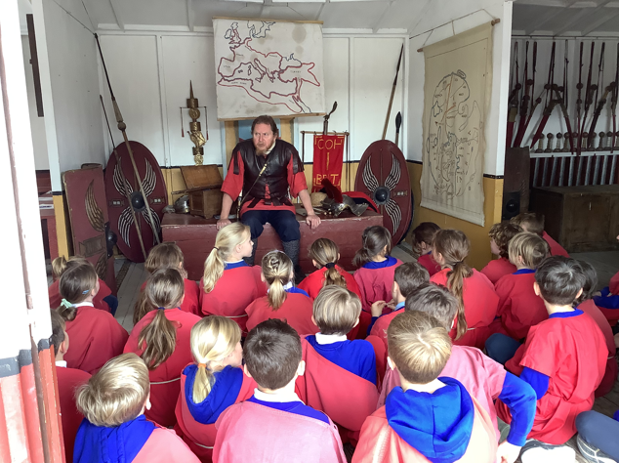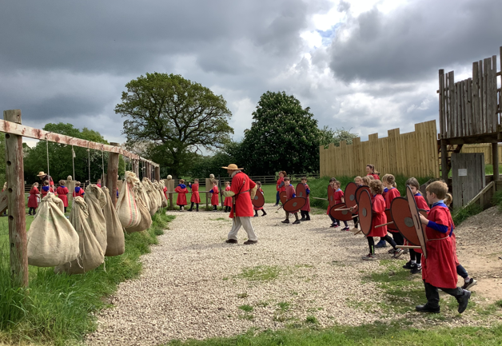

Pentecost Event at St Cuthbert’s Church – Holly and Oak
The children all thoroughly enjoyed the opportunity to visit church on Monday to take part in a range of activities linked to Pentecost. They came back to school excitedly talking about what they had done and showed off some of the things they had created. We then received this wonderful feedback from Fiona Warriner: “The children were all very well behaved and enthusiastic about everything they did. Many people commented on how knowledgeable they were, especially at recalling the school values and vision and linking that knowledge into the activities they were doing.” It’s lovely to hear such great things about the children – well done to everyone involved!

Author Visit – Elizabeth Green
Message from Mrs Helfferich
On Tuesday morning we had an inspiring visit from Elizabeth Green. She wrote her first book when she was 14 years old after receiving a typewriter for Christmas ‘The Adventures of Detective Dopeyworth’. Forty years later, she found the forgotten story and has published it. She talked to the older children about her journey. She read to the younger children her soon to be released book ‘The Owl who could only Growl’. The children enjoyed joining in with the story growling until Clarence got his twit twoo back. We learnt the importance of expressing our feelings. She also read another story, which hasn’t been illustrated yet, about Bertie the bee.
I heard Sienna walking into the hall after her session with Elizabeth, saying “She has inspired me to write a story.” I look forward to seeing it.
If anyone would like to pre-order a signed copy of ‘The Owl who could only Growl’ or a copy of ‘Detective Dopeyworth’. Please let me know at chelfferich@crayke.n-yorks.sch.uk
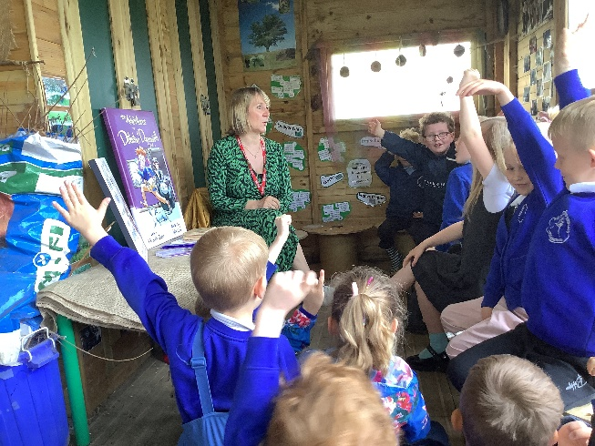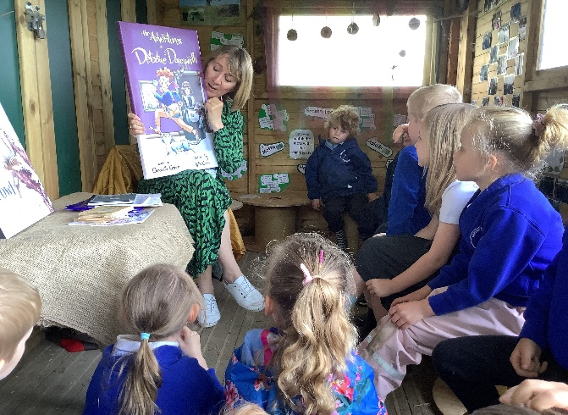

Skellig Performance – Oak
Message from Mrs Rayner
Oak Class were treated to a stunning performance by drama students at Ampleforth College on Thursday afternoon. We were blown away by the student's confidence, expression and clever ways in which they told the story of Skellig. Everyone in Oak Class was inspired to take some of what they had seen and put it into our own performance of 'Hagbane's Doom' that we will be performing later in the summer term. They were a wonderful audience and a credit to our school. Well done, Oak Class!

We have a new School Shed!
Message from CHASA
What a fantastic school and community project our new school shed has been! The shed was funded by your CHASA donations and the whole community came together to make it happen.
Thank you to everyone involved for their kindness, hard work, and immense generosity. It really has been a huge team effort.
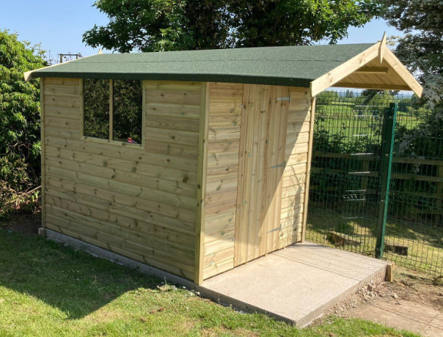
Special thanks go out to the following people and businesses:
· Becky along with the CHASA committee – Sourced shed and managed project.
· Tim Clad (York Timber) – Supplied discounted shed, delivered, and fitted.
· Mrs Helfferich – Sorted and cleared shed contents.
· James Jefferson – Removed shed rubbish/debris.
· Sam Jagger – Old shed removal.
· GH Brooks – Donated shed base materials.
· Stan Featherstone – Donated timber for shed base.
· John Bird and Birds Electrical team, Stan Featherstone, Rob Dawson and Jonathan Dawson – Laid the shed base.
· Mark Stubbins – Chopped down surrounding plant debris.
· Oakcraft, Easingwold – Donated the shed paint.
· John Howland – Will paint the shed.

Handwriting Update

This week Mrs Rayner led a staff meeting revisiting the importance of correctly formed letters and accurate joins. Children are taught handwriting explicitly in weekly sessions within school using the Penpals for Handwriting scheme. We thought it would be useful for you to see the expectations of handwriting so that you can support with this at home. Please see attached leaflet for more information.

Inclusion, Diversity and Equality Update
Oak Class have been learning about this topic as part of our PSHE topic this term. This image was shared with them as part of the teaching which I thought would be a useful discussion point with families over half term and beyond. It certainly is thought provoking.


Reading Diaries – We need your feedback!
Message from Mrs Rayner
This academic year, we have trialled a fully bespoke reading diary for children across the whole school. Overall, it has been a great success and we will be looking to get further Crayke reading diaries printed for September with the kind support of CHASA. However, we would really appreciate constructive feedback from parents and carers to make improvements so that the reading diaries are even better for next year! Please could you let me know what you have liked about the format of the reading diaries and any suggestions of what to change, remove or add. Please email lrayner@crayke.n-yorks.sch.uk with your thoughts (including which year group your child is currently in) as soon as possible, as I will be working on these over the half term. Thank you for your ongoing support.

Tiddlywinks@Crayke Update
Everything is in place for a 12 June start for the wraparound club…apart from the confirmation of the Ofsted registration. Tiddlywinks are continuing to pursue this as a matter of urgency. We hope to have more news for you as soon as possible. Thank you for your patience.

Apple Class Update
Last week, we learnt all there is to know about bees. On Saturday, it was National Bee Day. We created a bee walk for children and village residents to enjoy. I have been asked by members of the community to leave them up a bit longer for people to enjoy.
We have added turtle paintings and facts as it was National Turtle Day on Tuesday. We love learning facts about different things and it makes us very happy and proud of our work when people send us thank you cards and messages.
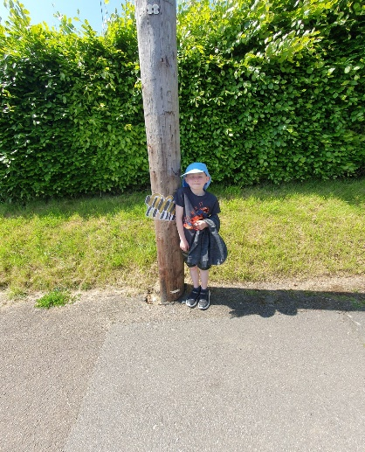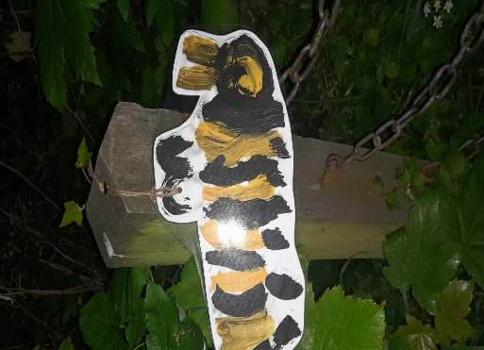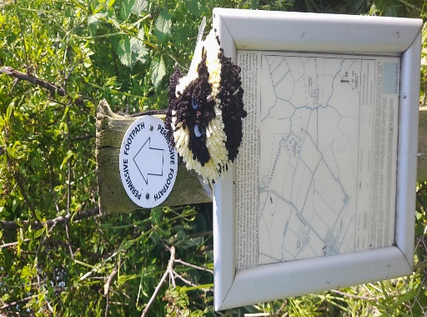

Wow Walk to School Challenge Weekly Update
Message from Mrs Helfferich
Walk to School Week 15th -19th May
Well done to everyone who parked at the Sports Club and walked up to school last week. Also, well done to those children who either took part in running club or used their playtime to run laps of the track or walk around the playground.
The children who walked/ran the greatest number of times were:
Apple Class – Jacob and Oliver
Beech Class – Amber
Holly Class – Aidan and Jonah
Oak Class – Oskar, Poppy and Harry

Walking Inspiration
Last weekend Ethan walked part of the Cleveland Way from Scarborough to Filey.

In total Ethan walked 15.87 miles and this totalled to 36533 steps. That’s a lot of steps Ethan, well done.
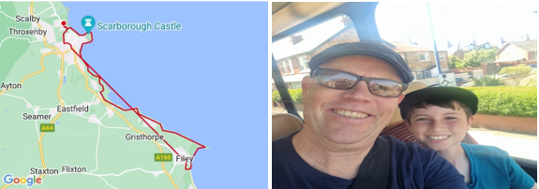

UPCOMING EVENTS – New this week

Carlton Lodge Year 5 Residential – Final reminders
Monday 5 June – Wednesday 7 June
We know that the children are really looking forward to the visit after half term. Some final reminders as follows:
- Children need to arrive at school at normal time on Monday morning with their luggage.
- They do not need to wear school uniform on Monday but do need to wear clothes appropriate for the activities – jogging bottom/leggings are ideal.
- On arrival at Carlton Lodge, the first activities for all the children will be water based, so it may be an idea to pack their swim wear (required for showering purposes only) and a towel in a separate bag within their luggage.
- Please try to pack with your child so they know what is in their case and where their belongings have been packed.
- The Year 5 children will have a packed lunch before departure. This will be provided by school if they normally have a school meal.
- They will be setting off from school at approximately 12:15pm on Monday.
- They will return at approximately 1:30pm on Wednesday and can be collected at the usual time of 3:30pm.

Times Table Rockstars Day – Holly - Wednesday 7 June
Holly Class will be taking part in a Times Table Rockstars Day in preparation for the Year 4's Multiplication Check on Thursday 8 June. We will be taking part in lots of different times-tables themed activities throughout the day to practise our skills. Children can come to school dressed as a 'Rockstar'. I can't wait to see them all!

Artbytes Competition invitation to watch – Wednesday 7 June
The ceremony is being live-streamed from Leeds Art Gallery on Wednesday 7 June from 3pm until 4pm. I am proposing that we show this on the screen in Oak class. If any children in Oak would like to stay at school to watch the awards being presented, they are welcome to stay until 4pm. Survey link here: https://forms.office.com/e/Jg7yyYGXtG If we do not hear from you, we will assume that you do not wish your child to attend.

Tennis session at Sports Club courts - Holly – Friday 9 June
We are grateful to Crayke Sports Club committee for allowing Holly Class to use the tennis courts on Friday 9 June for their PE lesson, which will be a brilliant opportunity for them. Children will be taken down to the courts by Mr Shimwell, Miss Walker and Mrs Shirley.

Summer Sports Sessions – Mark Cromack Multi-Sports July
We wanted to give you advance notice that Mark Cromack will be providing a multi-sports summer camp on Wednesday 26, Thursday 27 and Friday 28 July. This will be from 9am until 3pm each day - £20 per day or £50 for the three days. Mark will provide further details of how to book a place in due course.

UPCOMING EVENTS – Reminders

New starter survey – Reception 2023
Parents of new starters in Reception have been emailed with details about the information evening and new starter visits. In the meantime, to support our planning of the visits to feeder settings, please can parents of Reception new starters please complete this survey as soon as possible and no later than Friday 26 May: https://forms.office.com/e/5zWxfmDxFk Thank you to those parents who have already completed this.

Swimming – Apple and Beech Class
Children in both Apple and Beech class will start their swimming lessons on Thursday 8 June for a 6 week period at Thirsk Pool. The half hour session will run between 10.45am and 11.15am and we will be using money from our Sports Grant to fund the lessons and also the cost of coach transport to and from Thirsk. The bus will leave school at 10.00am and arrive back at approximately 12.00 noon in time for lunch.
Please can you provide your child with a suitable snack for eating on the bus whilst travelling to Thirsk i.e. a small packet of dried fruit, cereal bar, etc (not fresh fruit, as it is not easy to dispose of apple cores, banana skins, etc on the bus).
​As it is only a short journey, children will not be permitted to take any additional items on the coach i.e. games, cards, etc.
If your child has long hair, please send them with their hair tied back for the session.

Sports Week – w/c 19 June
Mrs Helfferich is busy planning a variety of activities for the children during Sports Week – further information to follow.

Football Match - Wednesday 28 June
Save the Date: Children in Year 5/6 are invited to take part in a football match after school on Wednesday 28 June vs Ralph Butterfield Primary. Further information to follow.

Careers Week – Oak w/c 17 July
As part of our PSHE topic on the world of work this term, I would like to give children in Oak class the opportunity to learn more about different jobs. If any parents/carers would be willing to support with this by coming in during the week to share information about their job, we would love to hear from you. Survey to follow.

IMPORTANT: Robinwood Residential Autumn 2023
As per previous communication, we are aiming to take Year 5/6 children (current Year 4/5) to Robinwood for a residential visit on the weekend of 6-8 October 2023. To ensure that the visit is viable, please can parents of children in current Year 4 and 5 complete this survey as soon as possible and no later than Friday 26 May https://forms.office.com/e/27QdFqvcZ4

A parent meeting will be held in due course to provide further information about the visit. However, should you wish to find out more in the meantime please visit: https://www.robinwood.co.uk/activity-centres/dobroyd-castle/
Also, please see this typical programme outline to give you a flavour of what to expect:
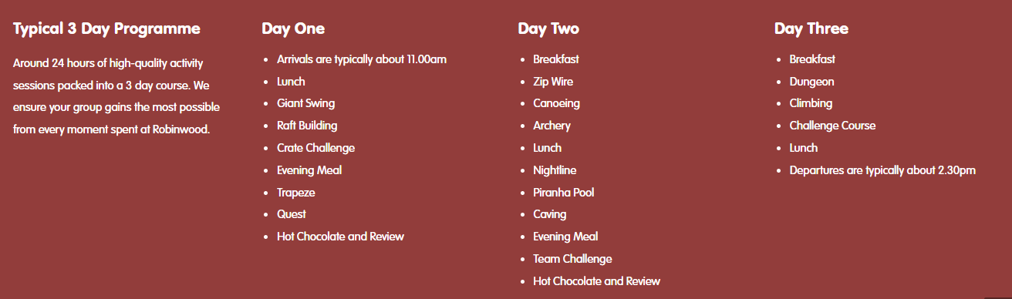



Non Uniform Day – Monday 12 June
Children are invited to wear non-uniform on Monday 12 June. We would be ever so grateful for raffle/tombola donations in lieu of this. Thank you!

Upcoming Meetings

Plans for the fair are well underway! Further meetings to finalise the Summer Fair have been arranged for the following dates. Each meeting will be at 3:45pm in the School Hall.
8 June
22 June
Everyone is welcome.

Summer Fair Saturday 24 June




***STANDING ITEMS***
Cost of Living Crisis
We are very aware that costs continue to rise and look set to do so for some time. If you are encountering financial difficulties, we may be able to signpost support. Please get in touch.
If your circumstances have changed and you think your child may be eligible for free school meals, it has never been easier to apply. There is no stigma attached to this, it is not highlighted to the children in any way, and the school gets valuable funding too. If you would like a confidential conversation about whether you may be eligible for free school meals, please do not hesitate to speak to me. To apply directly please use this weblink: https://www.northyorks.gov.uk/free-school-meals

Reception places available for September 2023
Due to a lower number of sibling than usual, we anticipate that we will have some spaces available in our Reception class in September 2023. Although the deadline has now officially passed for applications of places to North Yorkshire County Council, if you know of any parents who may be interested, please do ask them to contact school.

Online Safety
We recognise the importance of online safety and also understand that it is a fast paced, ever changing online world where parents can struggle to keep up with the technical knowledge and understanding demonstrated by their children. The National Online Safety organisation produce regular guides for parents – this week they have produced a leaflet entitled “Guide to Influencers”. Please see the attached leaflet which is also available on the Online Safety section of our website. Should you wish to access any of the other online safety parent guides available on a whole range of topics including what parents need to know about Amazon Fire Tablets, Google Chromebooks, and ways to champion equality online, please have a look at this weblink: https://nationalonlinesafety.com/guides
Should you wish to access more information about how to support your child/ren with online safety at home, this course is available which explains in detail the risks they might be exposed to and what you can do to support them. https://info.nationalonlinesafety.com/myleene-uk
Our Safeguarding Team
At Crayke, we have three members of staff and a governor who make up our Safeguarding Leadership Team. I am the Designated Safeguarding Lead, which means that I am the lead person responsible for child protection and safeguarding issues. Mrs Rayner and Mrs Helfferich (in Mrs Chandler’s absence) are our Deputy Designated Safeguarding Leads (Deputy DSLs); a deputy DSL supports the DSL in their role of safeguarding and child protection. Mr Hugh Porter is our Safeguarding Link Governor. The role of the Safeguarding Governor is to support the DSL as well as to regularly review, ask questions and make suggestions about our safeguarding policies and procedures and to report back to the governing body. All staff at Crayke know that safeguarding is EVERYONE’S responsibility. Find out more on our dedicated website Safeguarding page: https://craykeschool.org/safeguarding/
You can also report any safeguarding concerns to our DSL email: dsl@crayke.n-yorks.sch.uk Please also be aware that as a school we subscribe to Operation Encompass, whereby we are notified of any incidences of domestic violence where a pupil at our school has been present.

PE Kits
PE Kits  w/c 5 June | Monday | Tuesday | Wednesday | Thursday | Friday
APPLE (CH) |  |  |  | X (swim) | X
BEECH (LD) |  |  |  | X (swim) | X
HOLLY (EW) |  | X |  |  | X
OAK (LR) |  |  |  | X | X
Please do ensure that on PE days, the children wear their hoodies, school jumpers or cardigans alongside white or blue t-shirts and black or navy shorts or jogging bottoms.

 Stars of the Week

Stars | Apple | Beech | Holly | Oak
Stars | Bells Penrose | Year 1 | Percy Ollive | Toby Seligman
Stars | Bells Penrose | Year 2 | Joshua Jefferson | Tom Ward
Gold Awards for Sport | William Wardle | Josh Griffin-Miles | Evangeline Wardle | Nat Fenton

Attendance and Punctuality
This week’s attendance figures: 93.7% School Target: 96%
Apple (CH): 98% | Beech (LD): 96.9% 2 lates (2 children)
Holly (LC): 92.6% 2 lates (2 children) | Oak (LR): 88.2% 2 lates (2 children)

Attendance
We strive for high levels of attendance at school. Please try, wherever possible, to book holidays out of term time. The impact of even one day’s absence on your child’s learning is huge. Also, please try to book medical appointments out of school hours if possible as this also minimises the time missed. If your child is very unwell and unable to attend school, please inform the office by phoning 01347 821767 no later than 9:15am. Thank you for your support with this important matter.
Punctuality
It is very important that the children arrive to school on time so that:
1. They take part in all of the learning opportunities for the day with complete focus and without interruption from late arrivals.
2. Teachers can teach the best possible lessons without complete focus and without interruption from late arrivals.

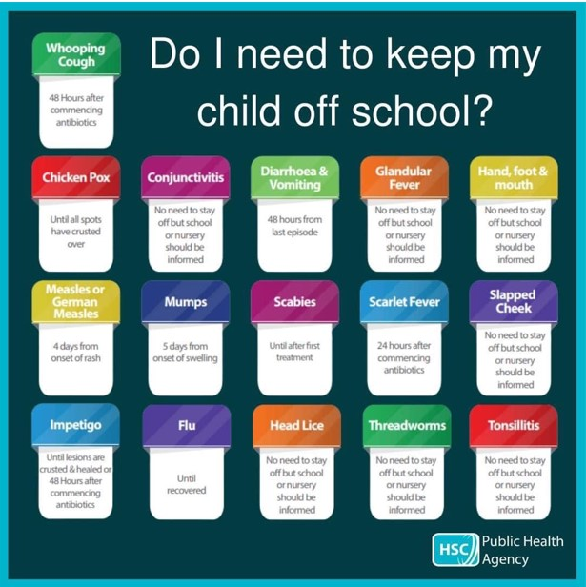
Extra-Curricular Clubs – Summer Term
Some clubs have limited capacity and places will be allocated on a first come first served basis. In the event of a club being fully booked, your child’s name will be added to a waiting list and you will be advised if a place becomes available. Booking is not required for before school or lunchtime clubs. For after school clubs run by school staff (in red type; denoted with *) please email Mrs Bacon on admin@crayke.n-yorks.sch.uk to book a place.
Before School Clubs
Club | Leader | Day and Time | Group
Run a Mile | Mrs Jackson | Monday, Tuesday Thursday & Friday  8:30am | All welcome – parents and carers included!

Lunchtime Clubs
Club | Leader | Day | Group
Skipping | Mrs Helfferich | Monday | All
School Council | Miss Walker | Tuesday | Successful candidates
Games | Miss Clarke | Friday | Max. 20 (list kept in school)

After School Clubs

We respectfully ask you to check the collection time below carefully and to collect your children promptly at the end of clubs. Clubs will run unless you are notified otherwise.
Monday | Craft* (£10 pay via ParentPay)  3:30 – 4:15pm  Years 1 – 6  Mrs Seligman and Miss Sherry
Tuesday | Indoor Multi-Sport (fee paid direct)  3:30 – 4:30pm  Years 1 – 6  Mark Cromack
Wednesday | Spanish* (no charge)  3:30 – 4:15pm  Years 2 – 6  Mrs Aristizabal |  | COMING SOON (fee paid direct)  Athletics Club  3:30 – 4:30pm  TBC
Thursday | Forest Schools* (no charge)  3:30pm – 4:15pm  Year 1-6  Mrs Helfferich | Chess* (no charge)  All abilities; Beginners welcome  3:30pm – 4:15pm  Year 1-6  Mrs Seligman | Phonics Drop In (no charge)  3:30pm – 4:15pm  Year 1 (and Year 2 by invitation)  Mrs Dobson and Miss Ford  Children must be accompanied by a parent/carer

Lunch Menu

SUMMER TERM 23 | Week 1  Served w/c 5th Jun, 26th Jun, 17th July | Week 2  Served w/c 12th Jun, 3rd Jul | Week 3  Served w/c 19th Jun, 10th Jul
Monday | Cheese & Tomato Pasta  Medley of Summer Vegetables  Garlic Flatbread  Raspberry & Apple  Doughnut Muffin  Fresh Fruit or Fruit Yoghurt | Nuggets and Ketchup  Potato Wedges  Sweetcorn & Peas  Homebaked Bread  Berry Sponge  Fresh Fruit or Fruit Yoghurt | Pizza  Potato Wedges  Coleslaw & Peas  Summer Drizzle Cake  Fresh Fruit or Fruit Yoghurt
Tuesday | Hotdog and Ketchup  Diced Potatoes  Cucumber Sticks & Grated Carrot  Summer Mousse & Shortbread Bite  Fresh Fruit or Fruit Yoghurt | BBQ Chicken Wrap with Vegetable Rice  Veggie Sticks  Tortilla Wrap  Oat Biscuit & Cheese  Fresh Fruit or Fruit Yoghurt | Beef Enchiladas with Rice  Broccoli & Sweetcorn  Crusty Bread  Cheese & Biscuit  Fresh Fruit or Fruit Yoghurt
Wednesday | Cottage Pie  Broccoli & Carrots  Crusty Bread  Cheese & Crackers  Fresh Fruit or Fruit Yoghurt | Roast Gammon  Baby Potatoes  Gravy  Medley of Summer Vegetables  Sliced Wholemeal Bread  Summer Crumble & Custard  Fresh Fruit or Fruit Yoghurt | Roast Chicken, Yorkshire Pudding & Gravy  Mashed Potato  Summer Cabbage & Carrots  Homebaked Bread  Waffle Finger & Ice-cream  Fresh Fruit or Fruit Yoghurt
Thursday | Chicken Korma  Rice  Cauliflower & Green Beans  Naan Bread  Chocolate Orange Sponge & Chocolate Sauce  Fresh Fruit or Fruit Yoghurt | Spaghetti Bolognese  Garlic Bread  Carrots & Peas  Chocolate & Vanilla Swirl Muffin  Fresh Fruit or Fruit Yoghurt | Meatballs & Pasta  Cauliflower & Green Beans  Pitta Bread  Cornflake Crispie  Fresh Fruit Yoghurt or Fruit Yoghurt
Friday | Fish Fingers  Chips  Baked Beans & Peas  Wholemeal Bread  Fruity Flapjack  Fresh Fruit or Fruit Yoghurt | Crispy Fish & Chips  Mixed Summer Salad  Sunflower Seed Bread  Jelly & Ice-Cream  Fresh Fruit or Fruit Yoghurt | Battered Fish & Chips  Ketchup  Peas & Sweetcorn  Sliced Wholemeal Bread  Custard Cookie with Apple  Fresh Fruit or Fruit Yoghurt

Crayke Church of England Primary School
Dates for your Diary – Summer Term 2023

We have tried to give you as much notice as possible about upcoming events, and will try wherever possible not to have to amend them.

Day | Date | Event | Who | Where
HALF TERM
Monday - Wednesday | 5-7 June | Residential | Year 5 | Carlton Lodge
Thursdays | 8/15/22/29 Jun; 6/13 Jul | Swimming | Apple  Beech | Thirsk Pool
Wednesday | 7 June | Times Table Rockstars Day | Holly | Class
Thursday | 8 June | CHASA meeting 3:45pm | All welcome | Hall
Monday | 12 June | Launch of Wrapround Care – Tiddlywinks@Crayke TBC | Open to all | School site
Monday | 12 June | Non-uniform day in exchange for raffle prize donations | All | Playground
Wednesday | 14 June | New starter parent meeting 17:30 | Reception ‘23 parents | Hall
w/c 19 June |  | Sports Week | All | Hall and outside
Wednesday | 21 June | Whole School photograph | All | Field
Thursday | 22 June | CHASA meeting 3:45pm | All welcome | Hall
Friday | 23 June | Football match v Alne | Year 5/6 | Field
Saturday | 24 June | CHASA Summer Fair | All welcome | School grounds
Wednesday | 28 June | New starter visit 1 of 3  9:30 – 11:30 | Rec new starters | Apple Class
Wednesday | 28 June | Football match vs Ralph Butterfield after school | Oak | Field
Friday | 30 June | Rounders Festival Competition | Cluster schools Y5/6 | Field
Monday | 3 July | Transition Visits | Year 6 | Outwood
Tuesday | 4 July | Transition Visits | Year 6 | Outwood
Tuesday | 4 July | Visit to Askham Bryan Wildlife & Conservation Park | Beech Class | Askham Bryan, York
Wednesday | 5 July | New starter visit 2 of 3  13:15 – 15:15 | Rec new starters | Apple Class
Friday | 7 July | Sports Day – First choice | All | Outside
Monday | 10 July | KS2 performance dress rehearsal | KS2 | Hall
Tuesday | 11 July | KS2 performance 2:00pm | KS2 | Hall
Wednesday | 12 July | New starter visit 3 of 3  9:30 – 12:30 (incl. lunch) | Rec new starters | Apple Class
Wednesday | 12 July | KS2 performance 6:00pm | KS2 | Hall
Friday | 14 July | Reserve Sports Day | All | Outside
w/c 17 July |  | Careers Week | Oak | Class and hall
Thursday | 20 July | Colour Run – Total Warrior | All | Outside
Friday | 21 July | Leavers service (time tbc) | All | Church
Wed, Thu, Fri | 26-28 July | Mark Cromack Sports Club | All welcome - payable | Outside
Autumn Term – Friday 6 – Sunday 8 October – Year 5 and 6 Residential Visit to Robinwood

Term Dates – Academic Year 2022/2023
Summer Term Tuesday 18th April to Friday 21st July 2023
Half Term Monday 29th May to return on Monday 5th June
INSET Days (School Closed to pupils) –
Monday 24th July 2023
Tuesday 25th July 2023

Judi Jackson
Headteacher
headteacher@crayke.n-yorks.sch.uk

FOLLOW YOUR PATHWAY AND WE GROW TOGETHER WITH CONFIDENCE
You did not choose me, I chose you that you might go and bear fruit, fruit that will last so that whatever you ask in my name the Father will give you. John 15:16

Respect Friendship Forgiveness Determination
Church News

Message from the Family Service Team
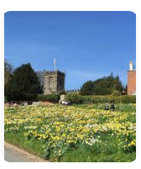

Family Service @ Crayke
In June and July, we will be back to Family Service as usual on the first Sunday of the month.

Looking forward to seeing you!

The Family Service team
Community News



Community News (cont.)

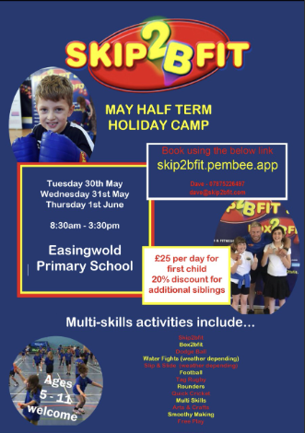



The Diocese of York has launched a new discipleship programme for young people. GROW: Youth Discipleship Ambassadors invests in young people as disciples through an academic year, exploring themes such as community, love, generosity, worship and sharing faith, shaped around our diocesan Rhythm of Life.
Young people taking part in the programme will meet in small groups for input days spread over the year facilitated by GROW Leaders, and with the support of a mentor and their church, will complete a set of tasks and challenges – all deeply rooted in how we Live Christ’s Story.
At the end of each programme, young people will be commissioned in a special service as Youth Discipleship Ambassadors.
For more information see: https://dioceseofyork.org.uk/news-events/news/diocese-launches-grow-youth-discipleship-ambassadors-programme/?fbclid=IwAR2xRxTbaZc1ap1lS0QnI-46ZGpWQqt2e_QvSJ94NXjgSzUolMmRFjrTB6c

Community News (cont.)
Youth Church @ Ampleforth meets from 6:30pm to 8:00pm on a Sunday evening, alternating between the village hall and St. Benedict's RC parish hall. We aim to explore faith through fun, fellowship and food and the group is for those who are aged 11+. This term we are particularly inviting Year 6s to come and join us to try out a session or two. Please do get in touch with Lucy for further information: lucy.willshaw@outlook.com.

Youth Church@Ampleforth for young people in the Valley and beyond…
Summer 2023

Sundays in term time 6.30 - 8.00pm
Meals with Jesus
27th May & 4th June | Half Term - no meetings
11th June | Lunch with Levi | St Ben’s Church Hall
18th June | Supper with Simon | St Ben’s Church Hall
25th June | Meal with Mary and Martha | Ampleforth Village Hall
2nd July | The Great Banquet | St Ben’s Church Hall
9th July | End of term | Start at St Ben’s & end at Ampleforth Village Hall
During the summer term we may go out to play games at the park, but we will always start and finish at the hall shown.

