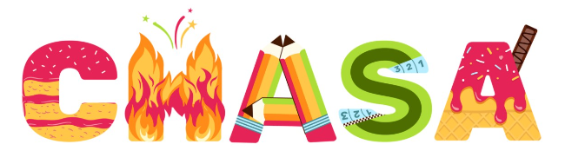
Notice of AGM – Save the Date
The CHASA AGM will be held on Thursday 21st September after school. Exact time and venue TBC.

CHASA Committee – Associate Roles
We would love to have you on board. 💙

Due to the increased amount of fundraising opportunities CHASA are taking part in, we are planning to restructure and adopt a new constitution at the AGM.
We have some exciting new associate committee roles in addition to the traditional CHASA committee roles. We hope this will share the load more fairly and give everyone an opportunity to be equally involved.
All will be up for election at the CHASA AGM so please do come along to vote and support people who are willing to take on a role. We really need everyone’s support.

Please see the attached flier which outlines in more detail the different roles available. If you would like to have an informal discussion about any of the roles, please contact Becky Stubbins on chasasecretary@crayke.n-yorks.sch.uk

Lost Property
All lost property will be brought out of the cloakroom this afternoon and anything that isn't claimed will go in to the uniform donations. Items will be available to peruse alongside the tuck shop at the end of the day today.

Gift Aid
Subject: Action Required - Gift Aid Form

Dear parent/carer,

Please take 30 seconds to fill in this form to raise more money for school!

Every donation you make to school and to CHASA could be worth more, at no extra cost to you, just by choosing to Gift Aid it.

For every £1 donated with Gift Aid, the school gets an extra 25p from the government.

If you are a UK taxpayer, please take 30 seconds to fill out this online form and maximise the support we can give to your children.

This will apply to donations such as non-uniform days, smartie tubes and sponsorship (e.g., skipping).

https://forms.gle/rJ1FmizE5WFuLPSZ9
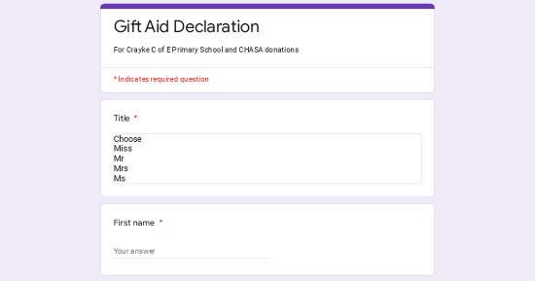 | Gift Aid Declaration  For CHASA donations  forms.gle

