

**Crayke Church of England Primary School**

**FOLLOW YOUR PATHWAY AND WE GROW TOGETHER WITH CONFIDENCE**

*You did not choose me, I chose you that you might****go and bear fruit, fruit that will last****so that whatever you ask in my name the Father will give you.*  John 15:16

*Respect Friendship Forgiveness Determination*

*Dear Parents and Carers,*

In our penultimate newsletter of the academic year, here are the highlights from a really busy and successful week in school!

**Sports Day**

Last Friday, we saw our children take part in sports activities. What a brilliant afternoon we had! A really lovely combination of healthy competition and good teamwork. This year, our focus was on the qualities of being a great ‘sportsperson’. Throughout the afternoon we observed children of all ages showing respect, determination, forgiveness and friendship to their team members.

Well done to everyone involved. A special thank you to Mrs Helfferich for all her hard work in organising this fabulous event, to all the staff who helped out and to Mr Porter our Chair of Governors who was a superbly efficient timekeeper! Mrs Dobson was a fantastic photographer and has captured some amazing shots which will be uploaded onto the website in a separate post in due course. In the meantime, I’m off to practise my egg and spoon technique!

*Message from Mrs Helfferich*

On Tuesday morning, children were awarded with special certificates in recognition of showing signs of being a great sportsperson. All of the children showed parents, governors and staff what amazing sports stars they all are. Thank you to the parents/carers for coming to support your child/ren. Thank you to the staff and governors for their help and support which enabled the afternoon to be a great success.

**Rounders Festival – Cluster WINNERS!**

There was high tension this morning and at half time we looked set to be defeated by Huby but, thanks to a SUPERB team effort, I am delighted to announce that Crayke B team are the overall cluster winners of this year’s Rounders Festival with a final score of 20-15! I am thrilled with their success in this event, and also with how well they worked as a team to support and encourage each other. WELL DONE!

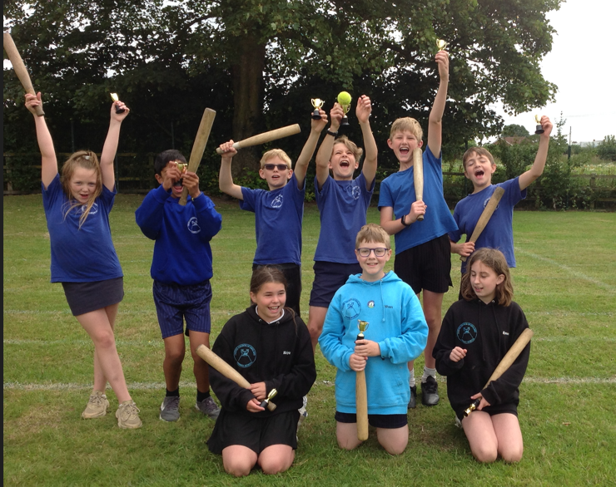

**Hagbane’s Doom**

What an absolutely fantastic effort the children in KS2 made to produce a performance to remember for many years to come. It has been so fantastic to witness the increase in confidence and real evidence of growth mindset, both in individuals and collectively. An enormous thank you to the staff involved in making the performance so amazing – Mrs Rayner, Mrs Aristizabal, Miss Walker and Miss Ayre.

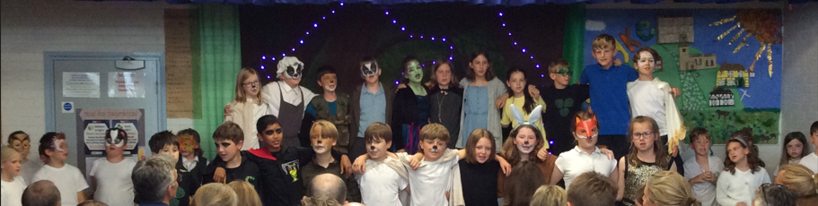

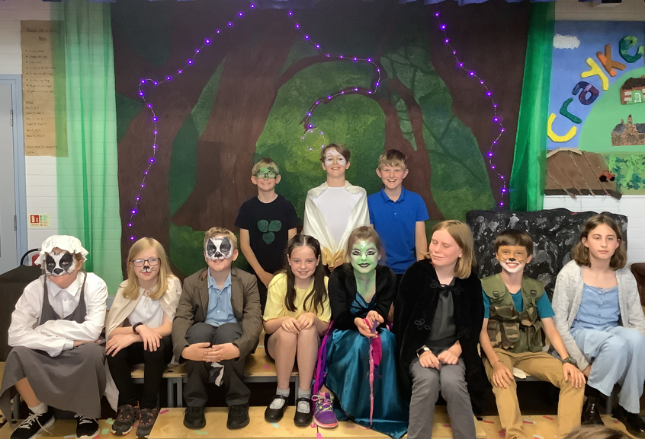

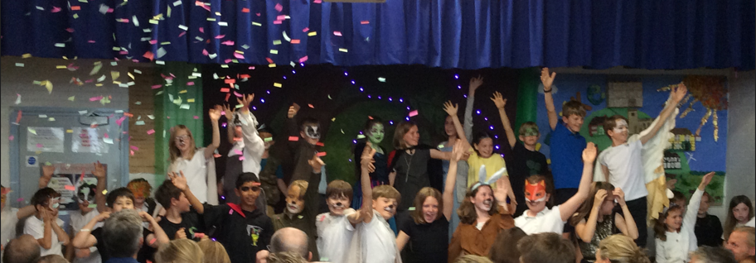

**Class Swap Morning**

It was fabulous to welcome our new starters for their final transition visit and also for everyone in school to have the opportunity to visit their new classrooms this week. There was a sea of smiley faces in each classroom I visited. Meanwhile, year 6 had a wonderful morning with Mr Shimwell (in spite of the somewhat temperamental weather). It has been lovely to hear some positive parental feedback about the class swap experience too and hopefully it will have helped to ensure that the start to the new school year goes as smoothly as possible.

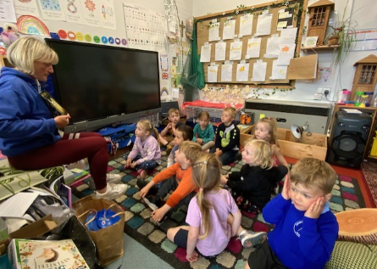

Our Reception new starters enjoying a story with Mrs Helfferich.

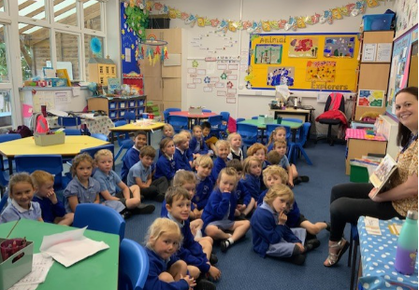

Beech class enjoying story time with Mrs Dobson.

Holly class doing an art activity with Miss Walker.

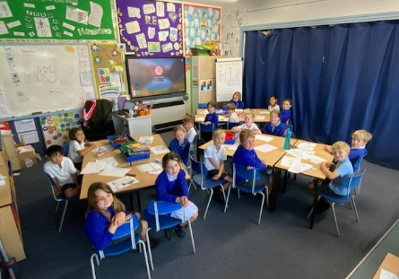 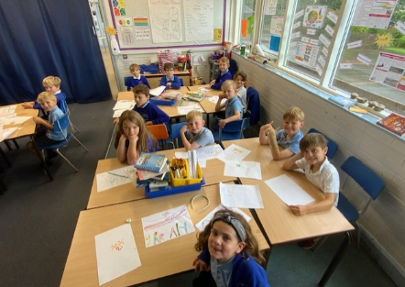

Oak class creating self-portraits with Mrs Rayner.

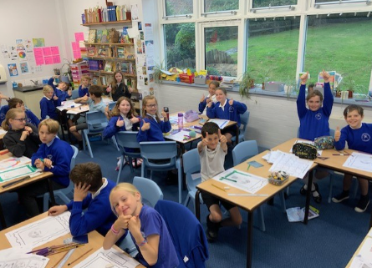 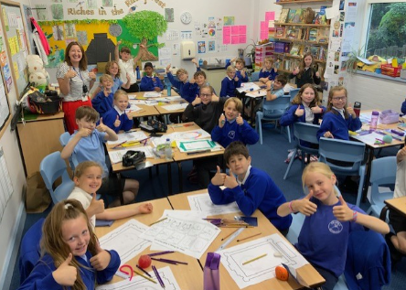

**End of year annual parent survey**

Thanks to the 47 parents and carers who took time to complete the survey - that represents 71% of our families. Please find attached the overall summary of responses in pie chart form. It is really heartening to see that the vast majority of our families have provided such a positive response and would recommend our school to others.

If anyone has expressed concerns about any aspect of our school, I would really welcome a follow-up discussion about this and would encourage you to make contact with me to discuss this in more detail.

We appreciate your comments and suggestions, as well as all the positive feedback. Many comments relate to homework, which we know can be a bit of a “marmite” topic. We will be discussing this as a staff early in the Autumn term, taking into account the comments provided.

Many good suggestions were provided for extra-curricular clubs too. It can be difficult to source external providers for clubs especially given our location but we will continue to try to do this. We’d love to be able to set up a school football team and if there are any parents/carers out there that may be able to help with this, please do get in touch. There was also a small number of comments in the survey relating to other matters in school including the newsletter, bullying, behaviour and challenge for the more able. We’ll provide more details about our approach to these matters in the new term and share our plans with you.

The newsletter will be getting a facelift over the summer but in the meantime, I have separated it into more clearly defined attachments, which I hope will help. I do appreciate that there’s a lot to digest each week!

**Walking/Sporting Inspiration**



Evangeline took part in the Mini Warrior at Bramham Park. She enjoyed it so much that she has signed up for next year, William has also decided to join her next year. Well done Evangeline.

Please email me any walks that you go on over the holidays; [chelfferich@crayke.n-yorks.sch.uk](mailto:chelfferich@crayke.n-yorks.sch.uk)

Remember to keep active during the summer holidays!

**Staffing Update**

It was lovely to welcome Mrs Chandler back into school this week. Her phased return has now begun and will continue during September. Miss Walker will continue to teach Holly class at the beginning of next term, in conjunction with Mrs Chandler. During this time, Mrs Pemberton who has been working in Beech class this half term, will be supporting Mrs Helfferich in Apple Class.

Sadly, we bid a fond farewell to Mrs Aristizabal (Mrs A) next Friday. Mrs A has worked with all children across the school in one capacity or another since she began with us in late 2019. She has a massive range of talents and I am enormously grateful for all her dedication and hard work in the classroom, across school in many different areas including her outstanding effort in prop, backdrop and costumes for the show and also in carrying out a wide variety of after school clubs which have included French, Spanish, Italian, BSL and Rounders. Her new school is incredibly fortunate to have her on their team. We are currently in the process of recruiting a replacement.

We also say farewell to Miss Ayre who has covered Mrs Peacock’s maternity leave. We would like to thank her for her flexibility in working across many year groups in school and for embracing training opportunities, especially phonics. We wish her all the very best in her new job in September. We look forward to welcoming Mrs Peacock back to school at the start of the autumn term.

**Arrangements for the End of Term**

Some final reminders ahead of next week:

* Please ensure that **ALL** reading books are returned to school by the end of Monday 17 July at the very latest. Any lost/damaged books will be subject to a charge for replacement.
* Today was the last running club of the academic year. There are **NO CLUBS NEXT WEEK**, except Multi-sports, which **WILL** be still be on, on Tuesday 18 July.
* End of the year annual reports to parents will be sent home via pupil post next week. We have used a new format this year and would be grateful for your feedback, which can be done via completing the final page of the report.
* *Message from Mrs Helfferich:* Colour/Adventure Run: On Thursday 20 July, the children will be taking part in a colour/adventure run around the school field. Please can children wear old clothes which are suitable for running in. They will get muddy and coloured so please do not send them in new trainers or expensive clothes. You might want to have a bin bag for them to sit on to protect the car seats. We are looking forward to a fun filled run.
* Year 6 have voted for their Leaver’s Meal, of Mac n Cheese followed by waffle and ice cream, which the school will enjoy on Thursday 20 July
* The Leavers’ Service will be taking place at 11am on Friday 21 July at St Cuthbert’s Church. Families of children in all year groups are welcome to attend by meeting us at the church.
* We will then return to school for a picnic lunch.
* Year 6 parents have been emailed directly to invite them to a special screening of “Life in Year 6” at 2:15pm in the school hall, after which we will say our final goodbyes to our leavers.
* **On the final day of term, Friday 21 July, we will be closing at 2:30pm.**

**PE Kits**

|  |  |  |  |  |  |
| --- | --- | --- | --- | --- | --- |
| ***PE Kits***  ***w/c 17 July*** | **Monday** | **Tuesday** | **Wednesday** | **Thursday** | **Friday** |
| APPLE (CH) |  |  |  | X | X |
| BEECH (LD) |  |  |  | X | X |
| HOLLY (EW) |  | X |  |  | X |
| OAK (LR) |  |  |  | X | X |

**Please do ensure that on PE days, the children wear their hoodies, school jumpers or cardigans alongside white or blue t-shirts and black or navy shorts or jogging bottoms.**

 **Stars of the Week** 

|  |  |  |  |  |
| --- | --- | --- | --- | --- |
| **Stars** | **Apple** | **Beech** | **Holly** | **Oak** |
| Alanna Dawson | Sophy Triffitt | Evangeline Wardle | Toby Seligman |
| Olive Beeson | Leo Bunker-Barnes | Aiden Simpson |
| **Gold Awards for Sport** | Jacob Watson | Wilfred Liddell | Lucas Stubbins | Asa Champion |

**Team Points**

|  |  |  |  |
| --- | --- | --- | --- |
| **Red** | **248** | **Yellow** | **203** |
| **Blue** | **279** | * **Green** | **305** |

**Arrangements for the Start of the Autumn Term**

Please see the attached spreadsheet for details of the term dates for next academic year.

**Tiddlywinks OOSC Crayke – Opening Date Confirmed**

Ofsted Registration Certificate was received on Wednesday so we are now in a position to confirm that we will be opening at the beginning of the new academic year.

School will reopen for pupils on Tuesday 5 September 2023. Tiddlywinks Out of School Club (OOSC) Crayke will be open for business from 7:30am on Tuesday 5 September.

**School Reopens Tuesday 5 September 2023**

The gates for ALL pupils will open at 8:50am on Tuesday 5 September and collection time for all will be 3:30pm.

**Clubs – Autumn Term**

Extra-curricular clubs will not be starting during the first week back and we will be providing further information about next term’s club offer in due course.

**Dinner Money Cost Increase from September 2023**

We have been informed by our Catering supplier - NYES Catering - that regrettably, our school meal cost will increase from £3.15 to £3.47 per day from September 2023.  We appreciate that this is a significant increase and follows an increase of 9% on 1 January this year.  This is due to the increase in food costs, energy and the minimum wage.

This was discussed at the last Full Governing Body meeting and it was agreed that the school budget would subsidise the cost of school meals from 1 September.  Therefore, the cost of a school meal to parents/carers will be **£3.30**for children in KS2 (Years 3-6) from the start of the new academic year.

**Request for Donations – Good Quality Books**

If you happen to be having a clear out of children’s books over the summer holidays, we’d be really grateful for any donations of good quality children’s books to refresh our collection in the boxes by the front door of school. Thank you!

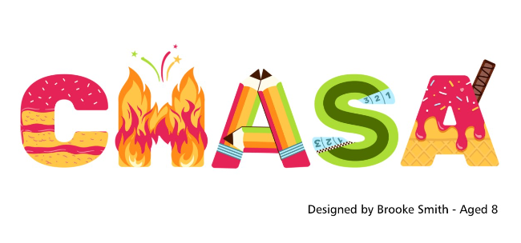

**Notice of AGM – Save the Date**

The CHASA AGM will be held on Thursday 21st September after school. Exact time and venue TBC.

**Gift Aid**

Subject: Action Required - Gift Aid Form

Dear parent/carer,

**Please take 30 seconds to fill in this form to raise more money for school!**

Every donation you make to school and to CHASA could be worth more, at no extra cost to you, just by choosing to Gift Aid it.

For every £1 donated with Gift Aid, the school gets an extra 25p from the government.

If you are a UK taxpayer, please take 30 seconds to fill out this online form and maximise the support we can give to your children.

This will apply to donations such as non-uniform days, smartie tubes and sponsorship (e.g., skipping).

<https://forms.gle/rJ1FmizE5WFuLPSZ9>

|  |  |
| --- | --- |
| [https://lh4.googleusercontent.com/AeATjZ_jj-3tUwzZs-pSMZdHs_e4A0uTKt7LkmCrk15JBbWvISU8sNCms1gOaYEhTEpA6bURzZY=w1200-h630-p](https://forms.gle/rJ1FmizE5WFuLPSZ9) | [Gift Aid Declaration](https://forms.gle/rJ1FmizE5WFuLPSZ9)  For CHASA donations  forms.gle |

**Attendance and Punctuality**

**This week’s attendance figures: 94.4% School Target: 96%**

|  |  |
| --- | --- |
| **Apple (CH):** **94.4% 0 lates** | **Beech (LD): 96.9% 2 lates (2 children)** |
| **Holly (LC):** **91.6% 2 lates (2 children)** | **Oak (LR):** **95% 1 late** |

**Attendance**

We strive for high levels of attendance at school. Please try, wherever possible, to book holidays out of term time. The impact of even one day’s absence on your child’s learning is huge. Also, please try to book medical appointments out of school hours if possible as this also minimises the time missed. If your child is very unwell and unable to attend school, please inform the office by phoning **01347 821767 no later than 9:15am**. Thank you for your support with this important matter.

**Punctuality**

It is very important that the children arrive to school on time so that:  
1. They take part in all of the learning opportunities for the day with complete focus and without interruption from late arrivals.  
2. Teachers can teach the best possible lessons without complete focus and without interruption from late arrivals.

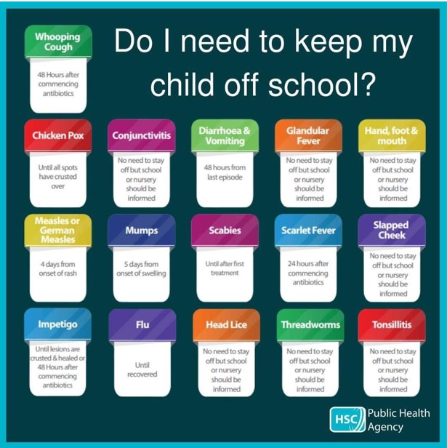

**Lunch Menu**

|  |  |
| --- | --- |
| **SUMMER TERM 23** | **Week 1**  Served w/c 17th July |
| **Monday** | Cheese & Tomato Pasta  Medley of Summer Vegetables  Garlic Flatbread  Raspberry & Apple  Doughnut Muffin  Fresh Fruit or Fruit Yoghurt |
| **Tuesday** | Hotdog and Ketchup  Diced Potatoes  Cucumber Sticks & Grated Carrot  Summer Mousse & Shortbread Bite  Fresh Fruit or Fruit Yoghurt |
| **Wednesday** | Cottage Pie  Broccoli & Carrots  Crusty Bread  Cheese & Crackers  Fresh Fruit or Fruit Yoghurt |
| **Thursday** | YEAR 6 CHOICE  Mac n Cheese  Waffle and ice cream |
| **Friday** | Fish Fingers  Chips  Baked Beans & Peas  Wholemeal Bread  Fruity Flapjack  Fresh Fruit or Fruit Yoghurt |

**Crayke Church of England Primary School**

**Dates for your Diary – Summer Term 2023**

**We have tried to give you as much notice as possible about upcoming events, and will try wherever possible not to have to amend them.**

|  |  |  |  |  |
| --- | --- | --- | --- | --- |
| **Day** | **Date** | **Event** | **Who** | **Where** |
| w/c 17 July |  | Careers Week | Oak | Class and hall |
| Monday | 17 July | Visit to Yorkshire Arboretum | Apple | Castle Howard |
| Thursday | 20 July | Colour Run – Total Warrior | All | Outside |
| Friday | 21 July | Leavers service 11am | All | Church |
| Wed, Thu, Fri | 26-28 July | Mark Cromack Sports Club | All welcome - payable | Outside |

**Autumn Term –** Friday 6 – Sunday 8 October – Year 5 and 6 Residential Visit to Robinwood

Tuesday 9 January – Year 5/6 Young Voices

**Term Dates – Academic Year 2022/2023**

**Summer Term** Tuesday 18th April to Friday 21st July 2023

**INSET Days (School Closed to pupils) –**

Monday 24th July 2023

Tuesday 25th July 2023

Judi Jackson

Headteacher

[headteacher@crayke.n-yorks.sch.uk](mailto:headteacher@crayke.n-yorks.sch.uk)

**FOLLOW YOUR PATHWAY AND WE GROW TOGETHER WITH CONFIDENCE**

*You did not choose me, I chose you that you might****go and bear fruit, fruit that will last****so that whatever you ask in my name the Father will give you.*  John 15:16

*Respect Friendship Forgiveness Determination*

**\*\*\*STANDING ITEMS\*\*\***

**Cost of Living Crisis**

We are very aware that costs continue to rise and look set to do so for some time. If you are encountering financial difficulties, we may be able to signpost support. Please get in touch.

If your circumstances have changed and you think your child may be eligible for free school meals, it has never been easier to apply. There is no stigma attached to this, it is not highlighted to the children in any way, and the school gets valuable funding too. If you would like a confidential conversation about whether you may be eligible for free school meals, please do not hesitate to speak to me. To apply directly please use this weblink: <https://www.northyorks.gov.uk/free-school-meals>

**Online Safety**

We recognise the importance of online safety and also understand that it is a fast paced, ever changing online world where parents can struggle to keep up with the technical knowledge and understanding demonstrated by their children. The National Online Safety organisation produce regular guides for parents – this week they have produced a leaflet entitled “Stay Safe Online this Summer”. Please see the attached leaflet which is also available on the Online Safety section of our website. Should you wish to access any of the other online safety parent guides available on a whole range of topics including what parents need to know about Amazon Fire Tablets, Google Chromebooks, and ways to champion equality online, please have a look at this weblink: <https://nationalonlinesafety.com/guides>

Should you wish to access more information about how to support your child/ren with online safety at home, this course is available which explains in detail the risks they might be exposed to and what you can do to support them. <https://info.nationalonlinesafety.com/myleene-uk>

**Our Safeguarding Team**

At Crayke, we have three members of staff and a governor who make up our Safeguarding Leadership Team. I am the Designated Safeguarding Lead, which means that I am the lead person responsible for child protection and safeguarding issues. Mrs Rayner and Mrs Helfferich (in Mrs Chandler’s absence) are our Deputy Designated Safeguarding Leads (Deputy DSLs); a deputy DSL supports the DSL in their role of safeguarding and child protection. Mr Hugh Porter is our Safeguarding Link Governor. The role of the Safeguarding Governor is to support the DSL as well as to regularly review, ask questions and make suggestions about our safeguarding policies and procedures and to report back to the governing body. All staff at Crayke know that safeguarding is EVERYONE’S responsibility. Find out more on our dedicated website Safeguarding page: <https://craykeschool.org/safeguarding/>

You can also report any safeguarding concerns to our DSL email: [dsl@crayke.n-yorks.sch.uk](mailto:dsl@crayke.n-yorks.sch.uk) Please also be aware that as a school we subscribe to Operation Encompass, whereby we are notified of any incidences of domestic violence where a pupil at our school has been present.

**Solar Panel Fundraising Project**

We are really excited to launch our new fundraising project for solar panels on our school roof. Please visit <https://www.gofundme.com/f/solar-panels-for-crayke-primary-school> to find out more and/or make a donation. Please do Gift Aid any donations as it increases its value by 20%. Please share this link far and wide! The donation page includes a fabulous video featuring some very familiar faces.

