

**Crayke Church of England Primary School**

**FOLLOW YOUR PATHWAY AND WE GROW TOGETHER WITH CONFIDENCE**

*You did not choose me, I chose you that you might****go and bear fruit, fruit that will last****so that whatever you ask in my name the Father will give you.*  John 15:16

*Respect Friendship Forgiveness Determination*

*Dear Parents and Carers,*

**Rounders Success!**

We were thrilled to welcome teams from Husthwaite and Linton Primaries last week to play in our Rounders Festival. We were even more thrilled that our Crayke A team came in second place and Crayke B team were our overall winners! Children from Huby and Alne were busy playing against teams from Easingwold Primary at the same time. Their winning team – Huby – will now play in a final match against our winning team, next Friday.

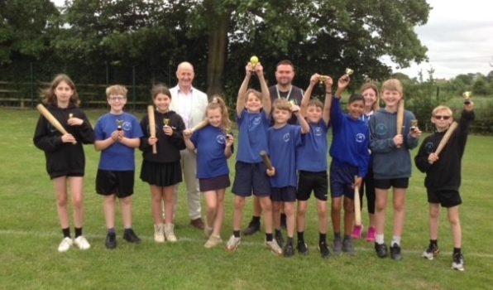

We were pleased to welcome Kevin Hollinrake MP who was able to present the cups to the winning team. He visited as part of National Sports Week and we were able to tell him all about the brilliant things we have been up to. He shared this on his social media following the visit:

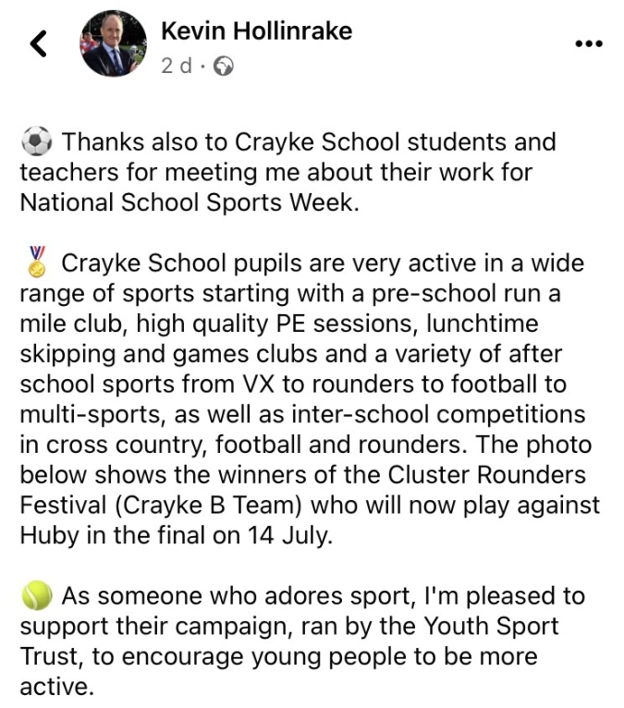

**Beech Class Visit Report**

*Message from Mrs Dobson*

Beech Class had a great trip to Askham Bryan Wildlife Park! We took part in a workshop about habitats and thought about how animals had adapted to live in the different habitats. After the workshop, we got to see a wide range of animals which live at the park. Some of our favourites included the meerkats, the parrots, the wallabies, the lemurs, the snakes and the poison dart frogs! We had a lovely sunny picnic, before a trip to the park which was enjoyed by everyone! Thank you to Beech class for a wonderful trip and to all our lovely adult helpers for coming along! 🙂

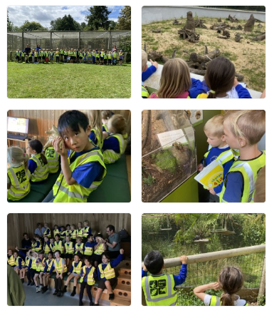

**Tiddlywinks@Crayke Update**

Thanks to the parents who attended the meeting on Wednesday. As we are still awaiting the all-important Ofsted registration documents, we will now be opening on **Tuesday 5 September**.

Also, a reminder that if you wish to obtain an enrolment form for the wraparound care, please contact Rowena Jew on [tiddlywinks.oosc.crayke@gmail.com](mailto:tiddlywinks.oosc.crayke@gmail.com)

**End of year annual parent survey**

A reminder that we would be grateful if you could spend some time completing this survey about our school.

It is available here: <https://forms.office.com/e/7VMndkEtCr> and will be live until the end of the day on Monday 10 July.

If you would prefer to receive a paper copy, please contact Mrs Bacon in the school office.

**Speaker Heroes**

I often gush about how wonderful our parent community is and how lucky we are and this week, once again, was evidence of that. Last week we had a bit of a disaster as our trusty hall speakers failed us rather spectacularly and we were in urgent need of replacement, at short notice, to enable the KS2 production to go ahead as planned. Luckily, Hannah and Ben Davies from Inspire AV (Tomas’ mum and dad) came to the rescue and were able to replace and install the speakers this week. We are all immensely grateful – thank you so much!

**Launch of Solar Panel Fundraising Project**

We are really excited to launch our new fundraising project for solar panels on our school roof. Please visit <https://www.gofundme.com/f/solar-panels-for-crayke-primary-school> to find out more and/or make a donation. Please do Gift Aid any donations as it increases its value by 20%. Please share this link far and wide! The donation page includes a fabulous video featuring some very familiar faces.



**Sutton and Huby Show**

Sutton-on-the-Forest and Huby Gardening club passed on their thanks for our participation in their schools' display "Into the recycled garden".

*Message from Mrs Helfferich*

For the second year running we entered the Gardening Clubs display using upcycled items as planters. The children in Apple Class were very enthusiastic planters and did a great job of producing the display. We hope you will take a moment to admire our entry which can now be found at the main entrance into school.

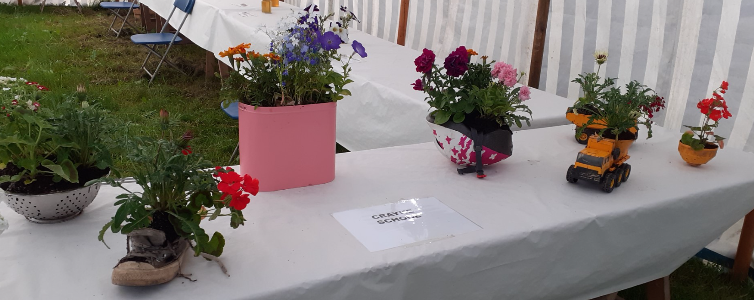 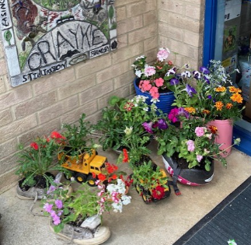

**Arrangements for the End of Term**

As we approach the end of term, I’d like to take the opportunity to outline some of our arrangements for the next two weeks.

Year 6 will be getting their SATs results on Tuesday 11 July and these will be shared with the children during the day.

The KS2 performance is taking place on Tuesday afternoon (11 July at 2pm) and Wednesday evening (12 July at 6pm) Tickets are being sent home today. Please note the evening performance is completely full so if your circumstances change and you are no longer able to attend on Wednesday, please do let us know as we are keeping a waiting list.

Class swap morning will be taking place next Wednesday 12 July. This will enable all children to spend some time in their new classes, with their new classmates. Year 6 will spend the morning with Mr Shimwell doing some sporting activities.

Next week will be the last week of extra-curricular clubs, including running club. The only exception is Multi-sports, which **WILL** be on during the final week of term, on Tuesday 18 July.

End of the year annual reports to parents will be sent home via pupil post during the final week of term. We have used a new format this year and would be grateful for your feedback, which can be done via completing the final page of the report.

The Leavers’ Service will be taking place at 11am on Friday 21 July at St Cuthbert’s Church. Families of children in all year groups are welcome to attend by meeting us at the church.

On the final day of term, Friday 21 July, we will be closing at 2:30pm.

**Request for Projector**

Mrs Rayner is hoping to show a video during the leavers service in church. If you have a free-standing projector screen that we could borrow (she has a projector,) that would be very much appreciated. We need to use it from Monday 17th July.

**Apple Class News**

*Message from Mrs Helfferich*

**Hatching update!**

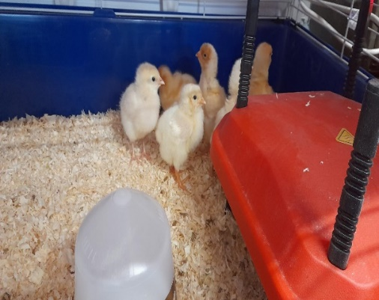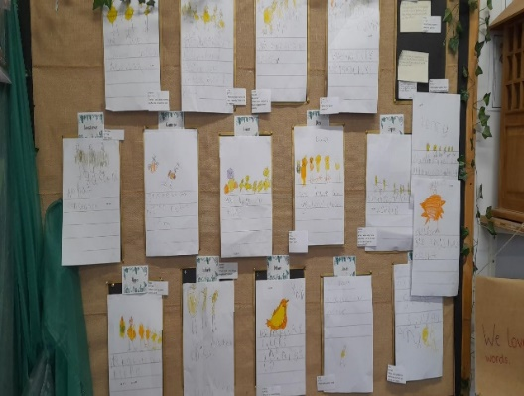

Hatching started last Thursday and continued until Sunday morning. Six out of the twenty eggs hatched. We have been using the chicks as inspiration for our writing and maths.

We think we have found a space in the forest school area to house the chickens once they are big enough to venture outside. This will be developed over the summer holidays. I am looking at putting lights in their house to encourage eggs to be laid over the winter, otherwise it’s a long wait for the children to collect the first eggs.

We have created a top ten list of things we want to do before they leave Apple Class, we will update you with our progress over the next two weeks. One request from Oliver was “Get a class hamster”, Mrs Jackson will be pleased to hear that I rejected that suggestion as Reggie had already said “This classroom is like a zoo” as he got himself ready for Forest School Club.

**Wow Walk to School Challenge Update**



Our last badge which will make some of us feel really old is ‘The World Wide Web’

Facts:

* In 1989 the World Wide Web was invented by Sir Tim Berners-Lee. He was trying to find a new way for scientists to easily share the data from their experiments.
* It allowed people to share their work and thoughts through social networking sites, blogs and video sharing.
* The first websites were made up of simple pages of words and pictures, a bit like online books or magazines!

**Walking Inspiration**



I have been asked by the children to mention to you about the junior version of the run I did at the weekend. If you buy tickets now they tend to be a lot cheaper than if you buy them next year.

Junior Warrior 22nd -23rd June 2024.

3 kilometres, 12 obstacles. [Total Warrior • Junior Warrior](https://totalwarrior.co.uk/distances/junior-warrior/)

**UPCOMING EVENTS – New/Updated this week**

**Sports Day – Today!**

The sunshine got the memo!

Should you wish to join us for the picnic, please arrive at school for 12pm **and no later than 12:15pm.** Please bring your own seating/blankets and food for yourselves. The children will be provided with a school packed lunch. We respectfully ask that you do not bring any alcohol to this event.

The children will be taken back inside at 1pm to be registered and will then come back outside to commence activities at 1:15pm. Should you wish to join us only for the sports, please arrive at school for 1pm **and no later than 1:15pm. Please note that for safety reasons, the gate will be locked at 12:15pm, reopened at 1pm and then locked again at 1:15pm. We regret that it is not possible for you to take videos or photos during the event. Photos will be made available on the school website.**

**Young Voices – January 2024**

I am thrilled to inform you that children in Year 5/6 will have the opportunity to participate in Young Voices next year! We have been successful in applying to attend Sheffield Arena on Tuesday 9 January 2024. Further information will follow in due course.

**UPCOMING EVENTS – Reminders**

**Careers Week – w/c 17 July**

If you are able to help us by coming into school to talk about your job, please complete this survey no later than next Friday in order for us to be able to make the necessary arrangements in school. <https://forms.office.com/e/S5xJkCZjdR>

**Mark Cromack Sports Club – Summer Camp**

Mark Cromack will be hosting a Sports Camp at Crayke School on **26-28 July inclusive**. Children can attend for one, two or three days. Flyers should have come home yesterday. Alternatively, see the flyer at the end of the newsletter for details on how to book a place.

**Apple Class Visit – 17 July 2023**

Mrs Helfferich and the team are really excited to be taking the class on a visit to Yorkshire Arboretum on Monday 17 July 2023. A letter was sent to parents/carers on Monday by email. If you haven’t already done so, please complete the consent form using the following link - <https://forms.office.com/e/p6Fe7CwRh8>

**PE Kits**

|  |  |  |  |  |  |
| --- | --- | --- | --- | --- | --- |
| ***PE Kits***  ***w/c 10 July*** | **Monday** | **Tuesday** | **Wednesday** | **Thursday** | **Friday** |
| APPLE (CH) |  |  |  | X (swim) | X |
| BEECH (LD) |  |  |  | X (swim) | X |
| HOLLY (EW) |  | X |  |  | X |
| OAK (LR) |  |  | X (Y6 only) | X | X |

**Please do ensure that on PE days, the children wear their hoodies, school jumpers or cardigans alongside white or blue t-shirts and black or navy shorts or jogging bottoms.**

 **Stars of the Week** 

|  |  |  |  |  |
| --- | --- | --- | --- | --- |
| **Stars** | **Apple** | **Beech** | **Holly** | **Oak** |
| Pippa Dawson | Tabi Copley | Joshua Jefferson | Alice Unsworth |
| Eva Copley | Evangeline Wardle | Ethan Hutton |
| **Gold Awards for Sport** | Milo Burnett-Armstrong | Carl Keaney | Kiera Rosa-Keyter | Sophie Sargent |



**Summer Fair – Final Total and Report**

**We are over the moon to announce that the profit from the summer fair has come in at a whopping £2744!** This is a record-breaking amount – beating last year’s total by just over £100, but beating the 2019 profit by a staggering £1000! Thanks once again for all the donations, support and sheer hard work which has gone into making this event so successful.

**Roving Reporter Emma (Year 6) has produced this fabulous article to give a behind the scenes version of the day!**

At 9:00 AM on Saturday the 24th June 2023, at Crayke Church of England Primary School, the CHASA volunteers were busy setting up the summer fair. Along with some parents that would be running stalls, and their children, the fair was ready so quickly that all of the children were able to play games with their friends, mostly playing football.

 At midday, visitors started arriving. Adults, ex-pupils now in secondary school and some year six children were running the stalls. “I actually really liked running my stall,” exclaimed Ethan Jackson, who helped run the jam jar raffle. “I liked seeing people excited about what they got.” “My favourite stall is the jam jar raffle.” Rosie Seligman told us. This stall was one of the most popular ones, because every ticket had been purchased before the fair was over. Maisy Emsley described running her stall “Hard and stressful.”

There were many events during the four hours that the fair lasted for. From the start of the fair, a fire engine was outside, in the staff car park for one hour and a quarter. At 12:30 PM, the children’s races lasting for an hour were on for half an hour on the running track, and skip 2 B fit started on the running track as soon as the fire engine left. The children’s tug of war started at 2:00 PM, as soon as skip 2 B fit finished, and lasted for half an hour. The raffle was drawn at 3:30 PM. The fair ended at 4:00 PM, but many helpers stayed back late to clear up afterwards.

This year's summer fair has been the best one yet, thanks to all the amazing CHASA volunteers.

**Attendance and Punctuality**

**This week’s attendance figures: 93.8% School Target: 96%**

|  |  |
| --- | --- |
| **Apple (CH):** **98.9% 0 lates** | **Beech (LD): 94.8% 4 lates (4 children)** |
| **Holly (LC):** **88.7% 2 lates (2 children)** | **Oak (LR):** **95.9% 1 late** |

**Attendance**

We strive for high levels of attendance at school. Please try, wherever possible, to book holidays out of term time. The impact of even one day’s absence on your child’s learning is huge. Also, please try to book medical appointments out of school hours if possible as this also minimises the time missed. If your child is very unwell and unable to attend school, please inform the office by phoning **01347 821767 no later than 9:15am**. Thank you for your support with this important matter.

**Punctuality**

It is very important that the children arrive to school on time so that:  
1. They take part in all of the learning opportunities for the day with complete focus and without interruption from late arrivals.  
2. Teachers can teach the best possible lessons without complete focus and without interruption from late arrivals.

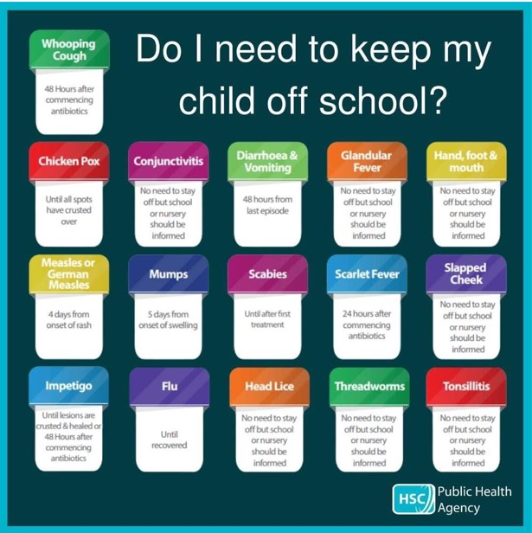

**Extra-Curricular Clubs – Summer Term**

Some clubs have limited capacity and places will be allocated on a first come first served basis. In the event of a club being fully booked, your child’s name will be added to a waiting list and you will be advised if a place becomes available. Booking is not required for before school or lunchtime clubs. For after school clubs run by school staff (in red type; denoted with *) please email Mrs Bacon on [admin@crayke.n-yorks.sch.uk](mailto:admin@crayke.n-yorks.sch.uk) to book a place.

**Before School Clubs**

|  |  |  |  |
| --- | --- | --- | --- |
| **Club** | **Leader** | **Day and Time** | **Group** |
| **Run a Mile** | Mrs Jackson | Monday, Tuesday Thursday & Friday  8:30am | All welcome – parents and carers included! |

**Lunchtime Clubs**

|  |  |  |  |
| --- | --- | --- | --- |
| **Club** | **Leader** | **Day** | **Group** |
| **Skipping** | Mrs Helfferich | Monday | All |
| **School Council** | Miss Walker | Tuesday | Successful candidates |
| **Games** | Miss Clarke | Friday | Max. 20 (list kept in school) |

**After School Clubs**

We respectfully ask you to check the collection time below carefully and to collect your children promptly at the end of clubs. **Clubs will run unless you are notified otherwise**.

|  |  |  |  |
| --- | --- | --- | --- |
| **Monday** | **Craft\*** (£10 pay via ParentPay)  3:30 – 4:15pm  Years 1 – 6  Mrs Seligman and Miss Sherry |  |  |
| **Tuesday** | **Indoor Multi-Sport** (fee paid direct)  3:30 – 4:30pm  Years 1 – 6  Mark Cromack | | |
| **Wednesday** | **Spanish\*** (no charge)  3:30 – 4:15pm  Years 2 – 6  Mrs Aristizabal |  |  |
| **Thursday** | **Forest Schools\*** (no charge)  3:30pm – 4:15pm  Year 1-6  Mrs Helfferich | **Chess\*** (no charge)  All abilities; Beginners welcome  3:30pm – 4:15pm  Year 1-6  Mrs Seligman |  |

**Lunch Menu**

|  |  |  |
| --- | --- | --- |
| **SUMMER TERM 23** | **Week 1**  Served w/c 17th July | **Week 3**  Served w/c 10th Jul |
| **Monday** | Cheese & Tomato Pasta  Medley of Summer Vegetables  Garlic Flatbread  Raspberry & Apple  Doughnut Muffin  Fresh Fruit or Fruit Yoghurt | Pizza  Potato Wedges  Coleslaw & Peas  Summer Drizzle Cake  Fresh Fruit or Fruit Yoghurt |
| **Tuesday** | Hotdog and Ketchup  Diced Potatoes  Cucumber Sticks & Grated Carrot  Summer Mousse & Shortbread Bite  Fresh Fruit or Fruit Yoghurt | Beef Enchiladas with Rice  Broccoli & Sweetcorn  Crusty Bread  Cheese & Biscuit  Fresh Fruit or Fruit Yoghurt |
| **Wednesday** | Cottage Pie  Broccoli & Carrots  Crusty Bread  Cheese & Crackers  Fresh Fruit or Fruit Yoghurt | Roast Chicken, Yorkshire Pudding & Gravy  Mashed Potato  Summer Cabbage & Carrots  Homebaked Bread  Waffle Finger & Ice-cream  Fresh Fruit or Fruit Yoghurt |
| **Thursday** | Chicken Korma  Rice  Cauliflower & Green Beans  Naan Bread  Chocolate Orange Sponge & Chocolate Sauce  Fresh Fruit or Fruit Yoghurt | **Year 6’s Menu Choice**  Mac & Cheese  Waffles & Ice-cream  Fresh Fruit Yoghurt or Fruit Yoghurt |
| **Friday** | Fish Fingers  Chips  Baked Beans & Peas  Wholemeal Bread  Fruity Flapjack  Fresh Fruit or Fruit Yoghurt | Battered Fish & Chips  Ketchup  Peas & Sweetcorn  Sliced Wholemeal Bread  Custard Cookie with Apple  Fresh Fruit or Fruit Yoghurt |

**Crayke Church of England Primary School**

**Dates for your Diary – Summer Term 2023**

**We have tried to give you as much notice as possible about upcoming events, and will try wherever possible not to have to amend them.**

|  |  |  |  |  |
| --- | --- | --- | --- | --- |
| **Day** | **Date** | **Event** | **Who** | **Where** |
| Monday | 10 July | KS2 performance dress rehearsal | KS2 | Hall |
| Tuesday | 11 July | KS2 performance 2:00pm | KS2 | Hall |
| Wednesday | 12 July | New starter visit 3 of 3  9:30 – 12:30 (incl. lunch) | Rec new starters | Apple Class |
| Wednesday | 12 July | KS2 performance 6:00pm | KS2 | Hall |
| Thursday | 13 Jul | Swimming | Apple &Beech | Thirsk Pool |
| w/c 17 July |  | Careers Week | Oak | Class and hall |
| Monday | 17 July | Visit to Yorkshire Arboretum | Apple | Castle Howard |
| Thursday | 20 July | Colour Run – Total Warrior | All | Outside |
| Friday | 21 July | Leavers service 11am | All | Church |
| Wed, Thu, Fri | 26-28 July | Mark Cromack Sports Club | All welcome - payable | Outside |

**Autumn Term –** Friday 6 – Sunday 8 October – Year 5 and 6 Residential Visit to Robinwood

Tuesday 9 January – Year 5/6 Young Voices

**Term Dates – Academic Year 2022/2023**

**Summer Term** Tuesday 18th April to Friday 21st July 2023

**INSET Days (School Closed to pupils) –**

Monday 24th July 2023

Tuesday 25th July 2023

Judi Jackson

Headteacher

[headteacher@crayke.n-yorks.sch.uk](mailto:headteacher@crayke.n-yorks.sch.uk)

**FOLLOW YOUR PATHWAY AND WE GROW TOGETHER WITH CONFIDENCE**

*You did not choose me, I chose you that you might****go and bear fruit, fruit that will last****so that whatever you ask in my name the Father will give you.*  John 15:16

*Respect Friendship Forgiveness Determination*

**Church News**

**PLEASE HELP!**

"A plea to anyone who might be able to help with the Church cleaning. Thanks to the dedicated team who do this valuable work. We have 2 or more vacancies to fill however.

The team are not all regular churchgoers but we know that everyone would all like to see a well cared for and clean Church.  You might come to the odd wedding, funeral, christening, as well as special services at Christmas and Easter so will appreciate the work of our volunteers.

If you think you could help, please email me - july7jane@hotmail.com or ring me 07976 951721 and I can team you up with a partner and explain what we do. Ideally, if we have enough volunteers, your turn would come round 7-8 times per year……or less frequently if we have more people.

Thank you.

Jane Siddars"

Message from the Family Service Team

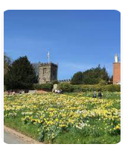

**Family Service @ Crayke**

The next Family Service will be in September. Wishing you a lovely summer!

Looking forward to seeing you next term!

The Family Service team**Community News**

*Youth Church @ Ampleforth meets from 6:30pm to 8:00pm on a Sunday evening, alternating between the village hall and St. Benedict's RC parish hall.  We aim to explore faith through fun, fellowship and food and the group is for those who are aged 11+.  This term we are particularly inviting Year 6s to come and join us to try out a session or two.  Please do get in touch with Lucy for further information:* [*lucy.willshaw@outlook.com*](mailto:lucy.willshaw@outlook.com)*.*

**Youth Church@Ampleforth for young people in the Valley and beyond…**

**Summer 2023**



**Sundays in term time 6.30 - 8.00pm**

**Meals with Jesus**

|  |  |  |
| --- | --- | --- |
| 9th July | End of term | Start at St Ben’s & end at Ampleforth Village Hall |

During the summer term we may go out to play games at the park, but we will always start and finish at the hall shown.

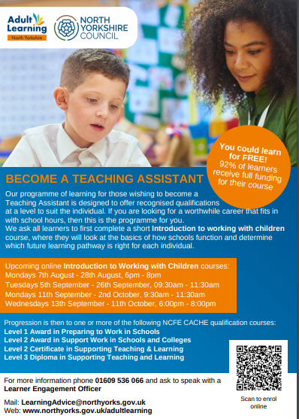

**Summer Holiday Information**

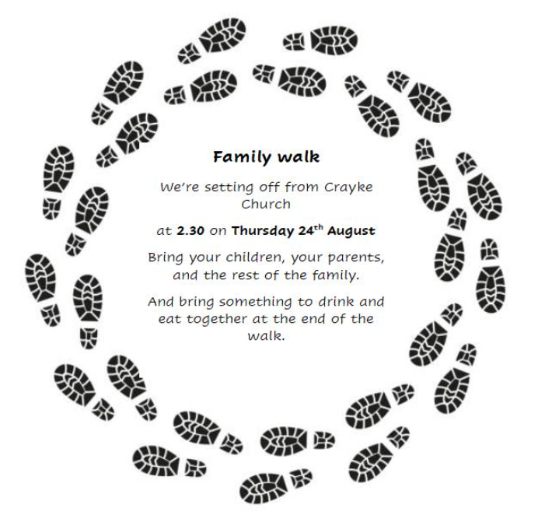

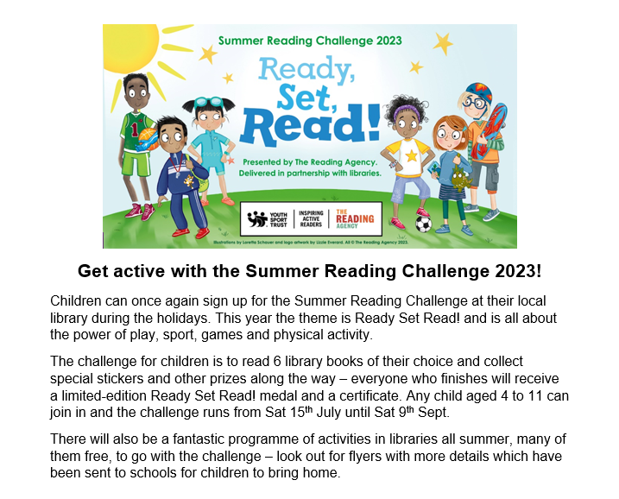

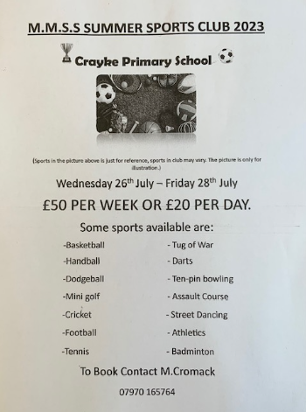

**Summer Holiday Information (cont.)**



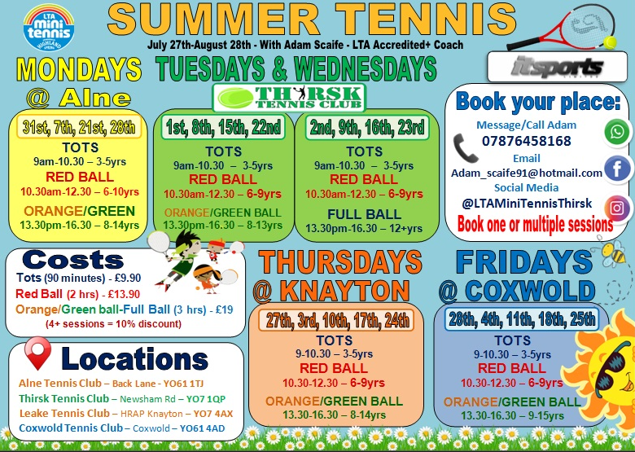



**\*\*\*STANDING ITEMS\*\*\***

**Cost of Living Crisis**

We are very aware that costs continue to rise and look set to do so for some time. If you are encountering financial difficulties, we may be able to signpost support. Please get in touch.

If your circumstances have changed and you think your child may be eligible for free school meals, it has never been easier to apply. There is no stigma attached to this, it is not highlighted to the children in any way, and the school gets valuable funding too. If you would like a confidential conversation about whether you may be eligible for free school meals, please do not hesitate to speak to me. To apply directly please use this weblink: <https://www.northyorks.gov.uk/free-school-meals>

**Online Safety**

We recognise the importance of online safety and also understand that it is a fast paced, ever changing online world where parents can struggle to keep up with the technical knowledge and understanding demonstrated by their children. The National Online Safety organisation produce regular guides for parents – this week they have produced a leaflet entitled “Guide to Rumble”. Please see the attached leaflet which is also available on the Online Safety section of our website. Should you wish to access any of the other online safety parent guides available on a whole range of topics including what parents need to know about Amazon Fire Tablets, Google Chromebooks, and ways to champion equality online, please have a look at this weblink: <https://nationalonlinesafety.com/guides>

Should you wish to access more information about how to support your child/ren with online safety at home, this course is available which explains in detail the risks they might be exposed to and what you can do to support them. <https://info.nationalonlinesafety.com/myleene-uk>

**Our Safeguarding Team**

At Crayke, we have three members of staff and a governor who make up our Safeguarding Leadership Team. I am the Designated Safeguarding Lead, which means that I am the lead person responsible for child protection and safeguarding issues. Mrs Rayner and Mrs Helfferich (in Mrs Chandler’s absence) are our Deputy Designated Safeguarding Leads (Deputy DSLs); a deputy DSL supports the DSL in their role of safeguarding and child protection. Mr Hugh Porter is our Safeguarding Link Governor. The role of the Safeguarding Governor is to support the DSL as well as to regularly review, ask questions and make suggestions about our safeguarding policies and procedures and to report back to the governing body. All staff at Crayke know that safeguarding is EVERYONE’S responsibility. Find out more on our dedicated website Safeguarding page: <https://craykeschool.org/safeguarding/>

You can also report any safeguarding concerns to our DSL email: [dsl@crayke.n-yorks.sch.uk](mailto:dsl@crayke.n-yorks.sch.uk) Please also be aware that as a school we subscribe to Operation Encompass, whereby we are notified of any incidences of domestic violence where a pupil at our school has been present.