Summer Holiday Information

Yorkshire Attractions – Voucher Booklet
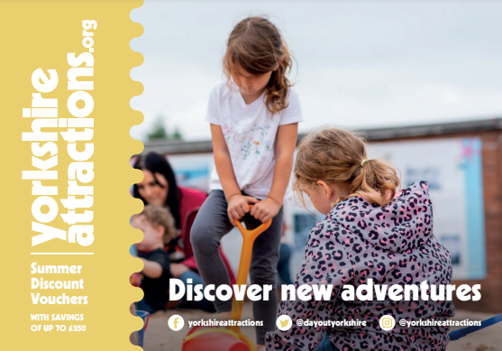
The voucher contains discount vouchers for a variety of attractions throughout Yorkshire, for use during the Summer holidays and beyond.

The booklet can be downloaded here: https://yorkshireattractions.org/wp-content/uploads/YAG-Summer-Voucher-Book-2023.pdf

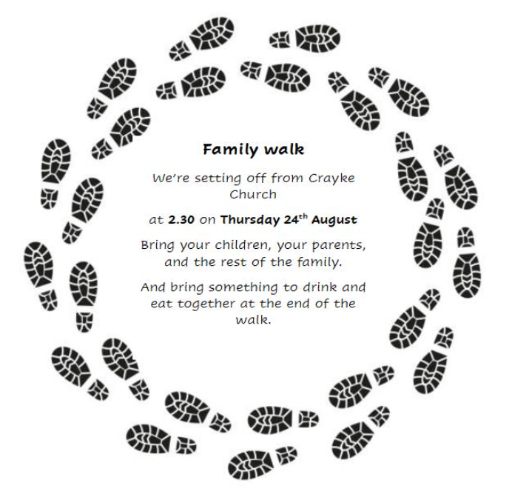
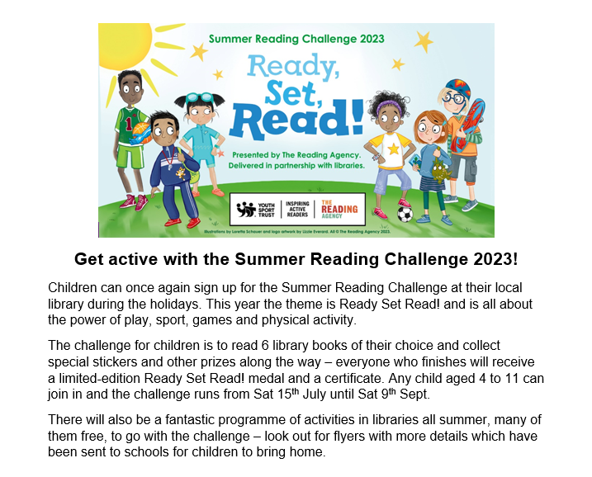
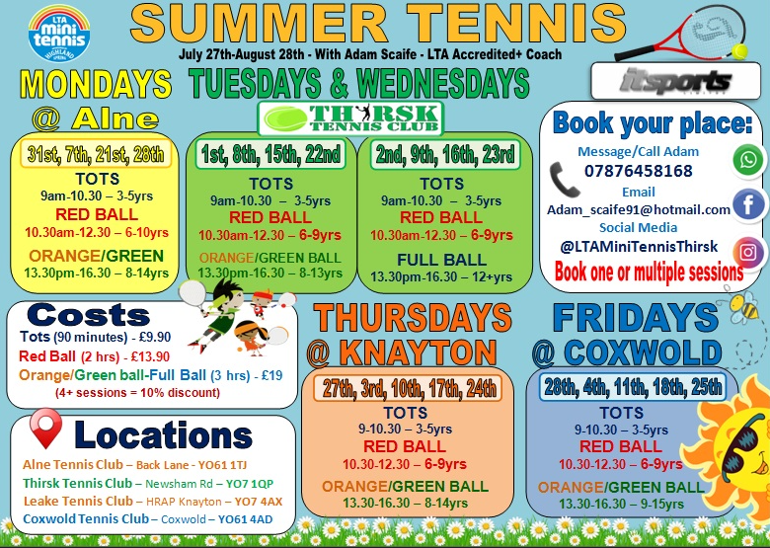
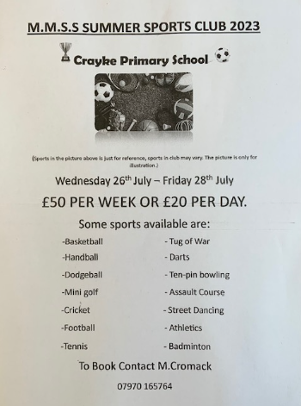

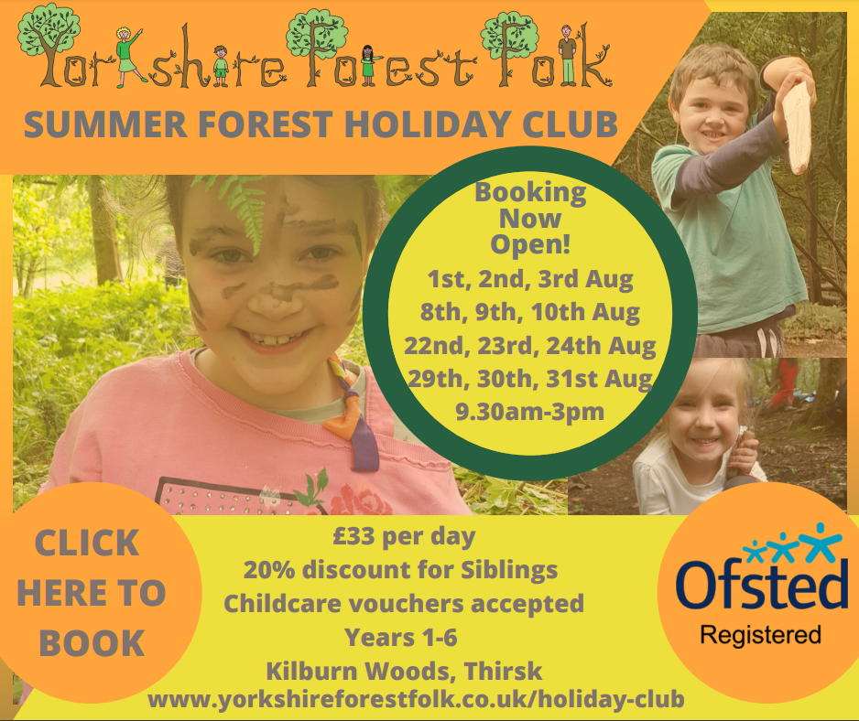

Crayke’s 4th Autumn Flower and Produce Show

