Crayke Church of England Primary School
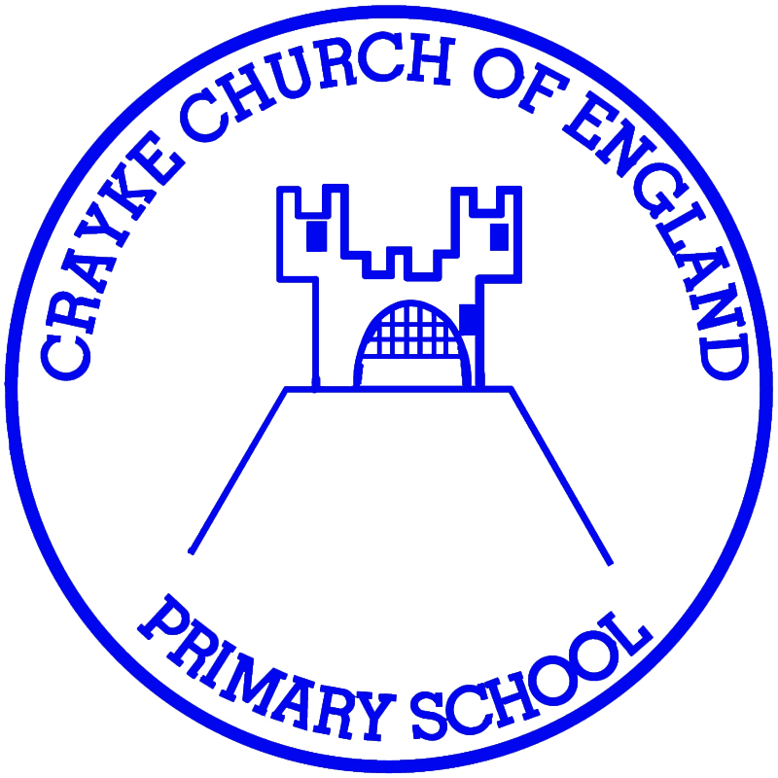
Easingwold Road
Crayke
North Yorkshire YO61 4TZ
Tel/Fax: 01347 821767
E.mail: admin@crayke.n-yorks.sch.uk
Website: craykeschool.org

HEADTEACHER – Mrs Judi Jackson

Annual Report for the Year ended 31st March 2025

The Crayke Church of England School Fund is governed by a Constitution and is a registered charity no. 1051985. Its address is at Crayke Church of England Primary School, Easingwold Road, Crayke. YO61 4TZ. The charity trustees during the year to 31st March 2025 were governors of the school namely -

Mrs Judi Jackson
Mrs Julie Cater
Mr Edgar Seligman

The object of the fund was to advance the education of the pupils of the school by providing or assisting the provision of education, recreational and other charitable facilities in augmentation of such facilities financed by the Local Authority.

During the year the main activities of the fund were school trips and petty cash. The school fund has no restricted funds.

This will be the last report of the School Fund, as it has now been incorporated within the school revenue account.

Andrea Hayes - Chair
12 November 2025
on behalf of the Board of Governors

CRAYKE CHURCH OF ENGLAND SCHOOL FUND

Income and Expenditure for
April 2024 – March 2025

Income 2024/25 2023/24
Petty Cash 1226.12 782.37
School Trips 7.38 2568.64
Residential Trips 0.00 827.15
Books 0.00 86.00 Swimming 0.00 1081.24
Young Voices 0.00 1151.63
Bob Murray 0.00 2000.00 Di Walker Foundation 10000.00 10000.00 11233.50 18497.03

Expenditure
Petty Cash 2241.34 1086.91 School Trips 0.00 2550.00
Residential Trips 0.00 1623.36
Books 0.00 189.37 Swimming 0.00 2009.10
Young Voices 0.00 1174.95
Bob Murray 0.00 2104.84 Di Walker Foundation 15802.02 2810.50
18043.36 13549.03

Excess of Expenditure over Income - £6809.86

