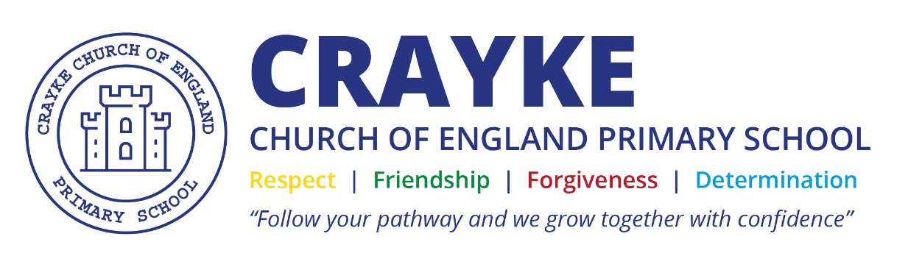

EYFS Policy
Crayke C of E Primary School

Approved by: | Full Governing Body | Date: February 2026
Reviewed: | February 2026
Next review due by: | February 2027

Contents
1. Structure of the EYFS at Crayke CE Primary School
2. Learning and development
3. Role of staff and key person.
4. Partnership with parents and carers
5. Health & safety and safeguarding
6. Nutrition and eating
1. Structure of the EYFS at Crayke CE Primary School
Our EYFS operates for children in their Reception year at school, until they begin Year 1. It is run by our EYFS Lead, supported by a teaching assistant and HLTA to maintain the required ratio and needs of the children. All of our staff are qualified to at least the level required to meet the requirement of the Early Years Framework.
Timings for EYFS children are the same as for those in the rest of school.
The layout, structure and groupings are all decided after consideration is made to ensure Early Years can be as effective as possible.

2. Learning and development.

Curriculum – What we want children to learn:
The statutory framework for the early years and foundation stage sets out 7 areas of learning
and development that are equally important and interconnected. In each area, the framework sets out the Educational Programmes that are used to create the content of our curriculum.
The framework splits those 7 areas of learning further and allocates an Early Learning Goal
to each of these. These are not the extent of our curriculum and we take the children’s and
local interests into consideration when planning what we want children to learn. To guide us
to create a progressive curriculum, we use development matters which sets out benchmarks
for the expected age of development for the children.
While there are 7 areas of learning with equal importance, 3 areas are identified as Prime
Areas which are seen as particularly important for igniting lifelong curiosity and development.

The prime areas are:
- Communication and Language
- Physical Development
- Personal, Social and Emotional Development
The specific areas are:
- Literacy
- Mathematics
- Understanding the World
- Expressive Arts and Design

Characteristics of Effective Learning – How children learn:
The Early Years Framework also includes the characteristics of effective teaching and
learning. The teachers plan activities with these in mind. They highlight the importance of a
child’s attitude to learning. The three characteristics are:
• Playing and exploring – children investigate and experience things, and ‘have a go’
• Active learning – children concentrate and keep on trying if they encounter difficulties, and enjoy achievements
• Creating and thinking critically – children have and develop their own ideas, make links between ideas, and develop strategies for doing things

We ensure there is a balance of adult led and child-initiated activities across the day. Although much of the time is spent with children self-selecting tasks, the interaction between the adult and child is essential as the adult’s response to children builds understanding and therefore guides new learning. The adult’s role is to model, demonstrate and question what the child is doing in order to extend their learning. As children develop and make progress, they will be ready to access more structured teacher led activities which not only support them to meet the end points of our curriculum, but also helps them be ready for the next stage of their learning.
Learning through play is an important part of our Early Years practice. We believe children
learn best from activities and experiences that interest and inspire them. Play gives our
children the opportunity to pursue their own interests and inspire those around them. The
children learn to adapt, negotiate, communicate, discuss, investigate and ask questions. We
believe it is important that adults take an active role in child-initiated play through observing, modelling, facilitating and extending their play. By the Summer term in Reception the children may experience more adult directed tasks as they prepare for their transition to year 1.

The Environment – Where the children learn.
Our Reception classroom have defined areas with clearly labelled resources to ensure
children can access them easily. The classroom has a writing area, maths area, creative area,
book corner, role play area, construction/small world area and area to develop their fine and
gross motor skills. Staff will add enhancements to these areas to develop specific skills or
provide opportunities for discussion and developing language. The outdoor classroom is an
important part of the Early Years Unit with many children choosing to learn outside for much
of the day. We ensure that the range of activities outside reflects the different curriculum areas as in the other classrooms.

Assessment – What the children have learnt.
Record keeping is kept to a minimum and learning is evidenced in a variety of ways including
floor books, displays and teacher knowledge. On entry to Reception, we conduct
baseline assessments. Throughout the year, the Class Teacher submits end of term
assessment data to the Senior Leadership Team showing each child’s development across
the seven areas of learning. At the end of Reception, the class teacher assesses each child
against the 17 Early Learning Goals (ELG) and comments on whether their achievement for
each goal is either ‘emerging’ or ‘expected’ This information is communicated to parents of
reception children at the end of the year.

3. Role of staff and key person
The class teacher is the named key worker for each child although all adults seek to form
positive respectful relationships with the children in their care. In the absence of the class
teacher, the class teaching assistant becomes the key person for the children. The formation
of healthy relationships between all adults and children is essential in enabling children’s wellbeing now and their future successes.

4. Partnership with parents and carers
We believe that parents and carers are a child’s first educator and therefore work very closely
to ensure they engage in what we do with their child at school. We want parents to feel they
can speak to us about their child at any time and feel comfortable in our setting. Visit days are offered to children prior to starting Reception. We offer sessions where parents and carers can visit school to see their child learning in the environment.

Starting at Crayke CE Primary School
In September all Reception children start full-time straight away. Parents and carers are invited to attend a Stay and Play session during the year, to Parent Consultation evenings in October and March and teachers are available most mornings and evenings to talk and to discuss more urgent matters.

Transition
Reception children play in the playground with the rest of school at break and lunchtime and begin to join in with whole school events, which makes the transition to year 1 smooth and
familiar to them. The school puts in place transition opportunities to work in the next class
before the end of the year and teachers spend quality time discussing the transition with the
next teacher.

Year 6 Buddies
All Reception new starters are allocated a buddy from Year 6 – a named pupil who is there to support and help younger members of our school especially at lunchtime and playtimes.

5. Health & safety and safeguarding
We follow the safeguarding and welfare requirements detailed in current Early Years Foundation Stage Statutory Guidance.
EYFS follow all policies and Health and Safety guidance as the rest of the school. These are available on our website. We follow whole school procedures for child protection (see separate policy).

6. Nutrition and eating

School will ensure that:
• Staff are aware of each child’s allergies.
• Foods are clearly labelled.
• Foods and items containing allergens are stored separately from other foods.
• Avoid cross-contamination by washing hands, using colour-coded equipment and utensils, or practices such as labelling a child’s cup with their name if they have a milk allergy, have separate preparation areas for foods that are allergens, have rules about visitors bringing food into the setting.
• Children are within sight and sound of an adult when eating.
• Food is prepared in a way to prevent choking

