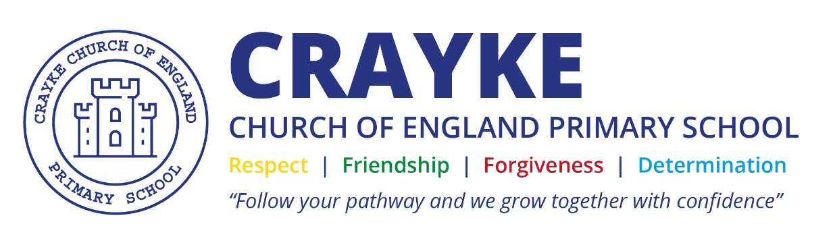

Marking and Feedback Policy
Crayke C of E Primary School

Approved by: | Full Governing Body | Date: February 2026
Reviewed: | February 2026
Next review due by: | February 2029

Marking Policy
Ensuring access to a rich, broad and balanced curriculum, based upon and framed by our school values of Respect, Determination, Friendship and Forgiveness, is at the heart of Crayke's provision.

Rationale:
The fundamental aim of Crayke Church of England Primary School is to provide opportunities for children to develop as independent, confident, successful learners with high aspirations; creating citizens of the future who know how to make a positive contribution to their community and the wider society.

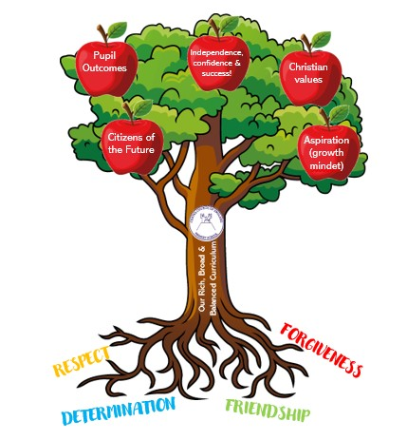

Marking intent:
Effective marking is an essential part of the education process. At its heart, it is an interaction between adult and pupil: a way of acknowledging pupils’ work, checking the outcomes and making decisions about what staff and pupils need to do next, with the primary aim of driving pupil progress.
At Crayke, a balance is struck between a core and consistent approach and trusting staff to focus on what is best for their pupils and circumstances.
All marking will be:
- Manageable
If teachers are spending more time on marking than the children are on a piece of work then the proportion is wrong and should be changed. (Eliminating unnecessary workload around marking Report of the Independent Teacher Workload Review Group March 2016)
- Meaningful
Marking should serve a single purpose – to advance pupil progress and outcomes! (Eliminating unnecessary workload around marking Report of the Independent Teacher Workload Review Group March 2016)
- Motivating
An important element of marking is to acknowledge the work a pupil has done, to value their efforts and achievement, and to celebrate progress. (Eliminating unnecessary workload around marking Report of the Independent Teacher Workload Review Group March 2016)
- Moves learning forward.
Marking should help to motivate pupils to progress! (Eliminating unnecessary workload around marking Report of the Independent Teacher Workload Review Group March 2016)

Marking implementation:
EYFS:
Feedback in the EYFS mainly takes the form of verbal feedback ‘in the moment’.
Learning objective checklists will be completed using the following:
- Pupil work will be marked in green pen.
- Errors / areas to improve will be annotated in orange.
- Evidence of meeting the learning objective may be highlighted in green.
- VF is used to show that verbal feedback has been given during the lesson.
- The following letters will be recorded next to the learning objective to show how the pupil has worked:
- I = independently
- S = supported
- G = guided.
KS1 and KS2:
- Pupils’ work will be marked in green pen.
- Errors / areas to improve will be annotated in orange.
- Evidence of meeting the learning objective may be highlighted in green.
- Evidence of ‘exceeding’ the learning objective may be highlighted in blue (greater depth)
- VF is used to show that verbal feedback has been given during the lesson.
- The following letters will be recorded next to the learning objective to show how the pupil has worked:
- I = independently
- S = supported
- G = guided.
- These letters will then be highlighted using the colour coding on Insight:
Working towards
Working at the expected standard
- Self assessment, where deemed necessary and meaningful, may take a arrange of forms including hand-up, thumbs up/straight/down, use of faces e.g. 
Marking rewards sit alongside our relational behaviour policy. Stars on the recognition board, texts home, team points, stickers, head teacher stickers etc.. may be used.
Marking impact:
The Marking and Feedback Policy at Crayke CE Primary School ensures that feedback is a purposeful and manageable interaction between adults and children, aimed at advancing pupil progress and outcomes in alignment with our school values of Respect, Determination, Friendship, and Forgiveness.
By implementing a consistent yet flexible approach to marking, which includes clear coding and colour highlighting to indicate levels of achievement and areas for improvement, the policy promotes a culture of meaningful and motivating feedback. This encourages children to take ownership of their learning through self-assessment and reflection, fostering independence and confidence.
The policy’s emphasis on balancing teacher workload with impactful marking ensures sustainable practises that support high-quality teaching and learning. The structured feedback system, including verbal feedback and targeted marking strategies across EYFS, KS1, and KS2, directly contributes to improved engagement, understanding, and progress for all pupils, including those with additional support needs.
Overall, the policy underpins the school’s commitment to providing a rich, broad, and balanced curriculum and supports the development of compassionate, confident, and resilient learners who are motivated to achieve their unique potential.

What marking and feedback looks like at Crayke
 |  | Your work will be marked in green pen.
 |  | Your errors / areas to improve will be highlighted orange.
 |  | Good things may be highlighted in green.
 |  | Brilliant things may be highlighted in blue.
VF |  | VF means verbal feedback; the adult you have been working with has talked to you about your learning during the lesson.
I S G |  | These letters show if you have worked:  - I = independently  - S = supported  - G = guided.
The letters will then be highlighted as follows:
Working towards
Working at the expected standard

 |  | Your teacher might ask you to ‘self-assess’ using hands-up, thumbs up/sideways/down or using faces.

