 | NORTH YORKSHIRE POLICE | 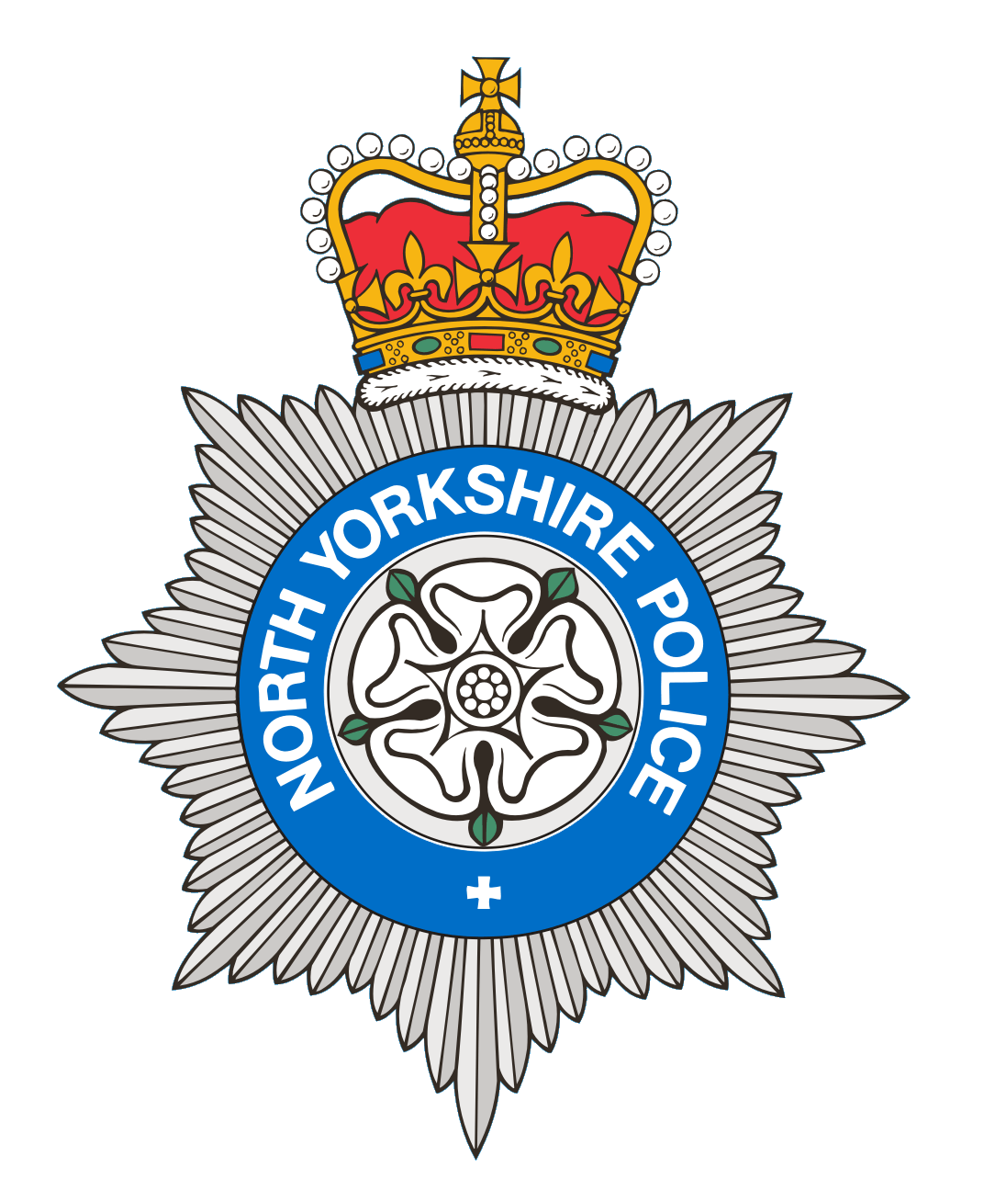

Date: 07/07/2026

Dear Parents / Guardians

As the weather is getting better and the school holidays are nearly upon us, we kindly request that you speak to your children about respecting your neighbours and their boundaries and not causing a nuisance. We are also concerned about children using e-scooters and have provided a leaflet for your information.

I am writing this letter to you in the interest of the safety/welfare of your child and in the hope that you can talk to your child about anti-social behaviour and the impact this can have on the neighbourhood.

If you have any questions, please feel free to contact your local Neighbourhood Policing Team on npthambleton@northyorkshire.police.uk

PCSO 3798 Kate Dennis
NPT Easingwold

